Supplementary Material

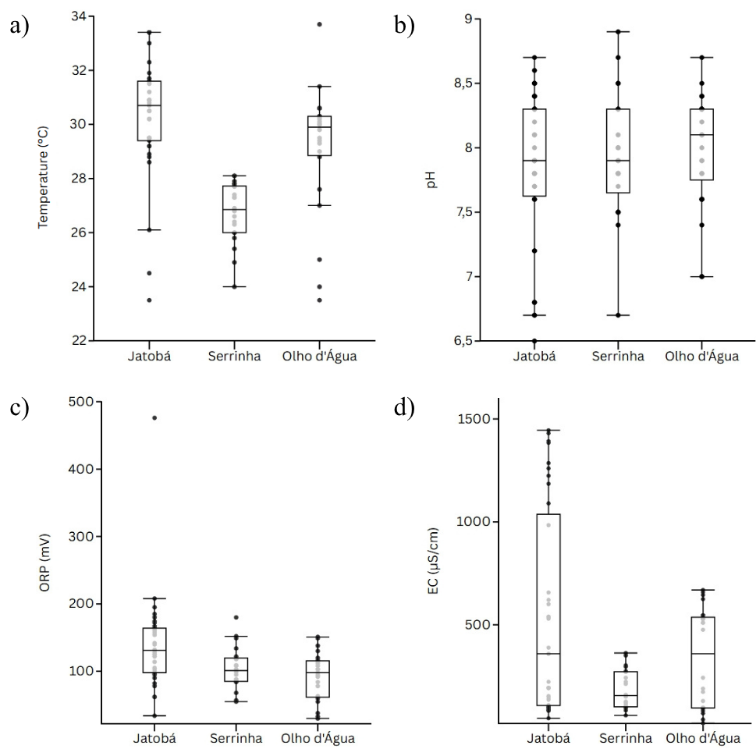
Fig. 1 Boxplots comparing physicochemical parameters in inter-community analyses.

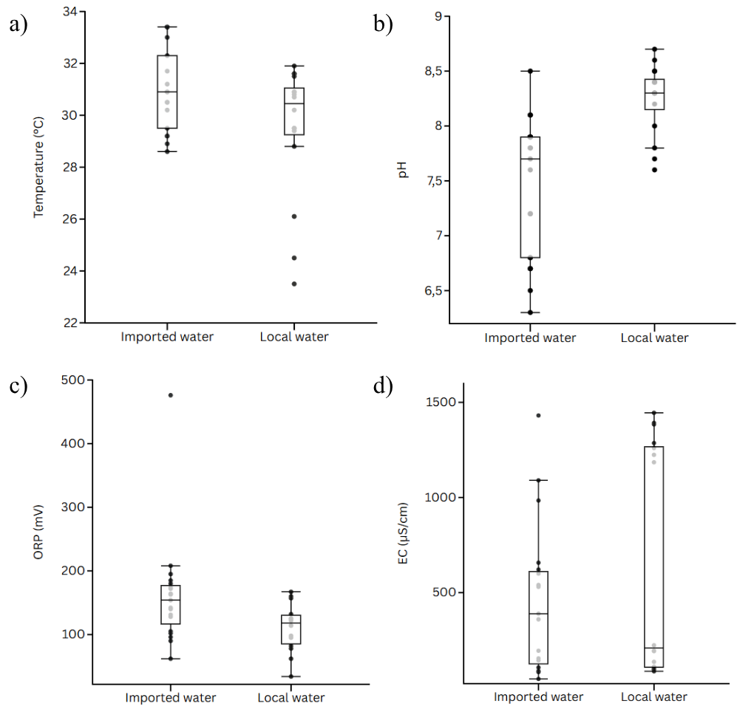
Fig. 2 Boxplots comparing physicochemical parameters in local water versus imported water in the Jatobá community

