Supplementary Table S5 ROC curve analysis of obesity-related indices for detecting prediabetes (ADA criteria)
Variables | AUC (95%CI) | Cut-off value | Sensitivity (%) | Specificity (%) | Youden’s index | P-value
Men
BMI | 0.588 (0.568, 0.608) | 23.55 | 73.2 | 40.5 | 0.137 | <0.001
WC | 0.585 (0.565,0.605) | 82.45 | 70.6 | 43.6 | 0.142 | <0.001
WHR | 0.610 (0.590 0.630) | 0.88 | 71.8 | 44.9 | 0.167 | <0.001
WHtR | 0.610 (0.590, 0.630) | 0.50 | 65.8 | 50.4 | 0.162 | <0.001
LAP | 0.576 (0.556, 0.597) | 22.61 | 65.2 | 47.8 | 0.130 | <0.001
VAI | 0.532 (0.512, 0.553) | 0.96 | 68.7 | 37.1 | 0.058 | 0.002
CVAI | 0.609 (0.589, 0.629) | 76.48 | 68.9 | 48.5 | 0.174 | <0.001
RFM | 0.610 (0.590, 0.630) | 23.84 | 65.7 | 50.5 | 0.162 | <0.001
Women
BMI | 0.640 (0.623, 0.656) | 23.78 | 67.3 | 54.7 | 0.220 | <0.001
WC | 0.635 (0.618, 0.652) | 80.15 | 58.7 | 61.9 | 0.206 | <0.001
WHR | 0.614 (0.596, 0.631) | 0.85 | 59.3 | 58.1 | 0.174 | <0.001
WHtR | 0.647 (0.630,0.664) | 0.50 | 65.8 | 56.5 | 0.223 | <0.001
LAP | 0.649 (0.632, 0.665) | 21.79 | 65.7 | 57.0 | 0.227 | <0.001
VAI | 0.606 (0.589, 0.623) | 1.39 | 59.4 | 57.7 | 0.171 | <0.001
CVAI | 0.700 (0.684, 0.716) | 66.12 | 69.3 | 61.3 | 0.306 | <0.001
RFM | 0.647 (0.630, 0.664) | 36.26 | 65.1 | 57.2 | 0.223 | <0.001
BMI, body mass index; WC, waist circumference; WHR, waist-to-hip ratio; WHtR, waist-to-height ratio; LAP, lipid accumulation product index; VAI, visceral adiposity index; CVAI, Chinese visceral adiposity index; RFM, relative fat mass.

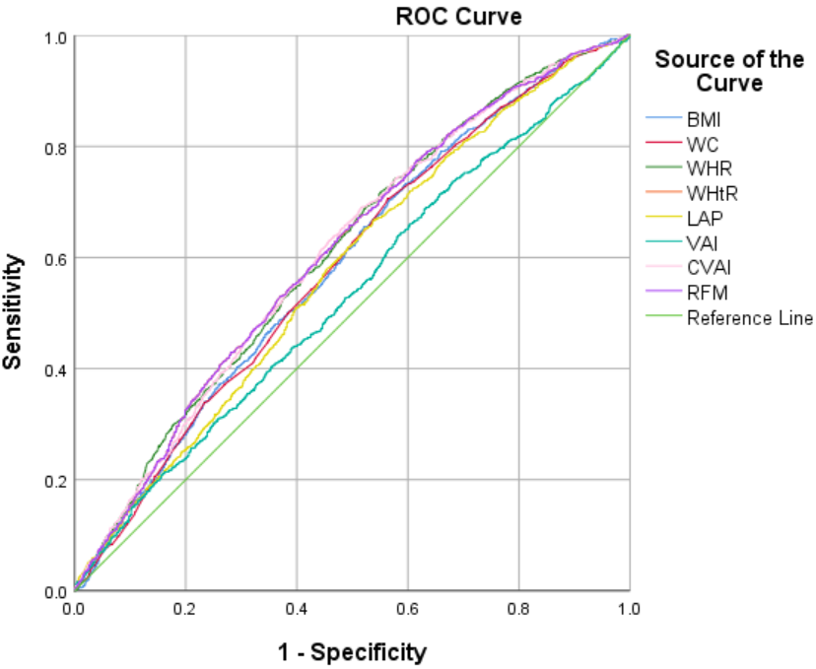
Supplementary Fig. S1 ROC curves of obesity-related indices for detecting prediabetes in men (ADA criteria).
BMI, body mass index; WC, waist circumference; WHR, waist-to-hip ratio; WHtR, waist-to-height ratio; LAP, lipid accumulation product index; VAI, visceral adiposity index; CVAI, Chinese visceral adiposity index; RFM, relative fat mass.

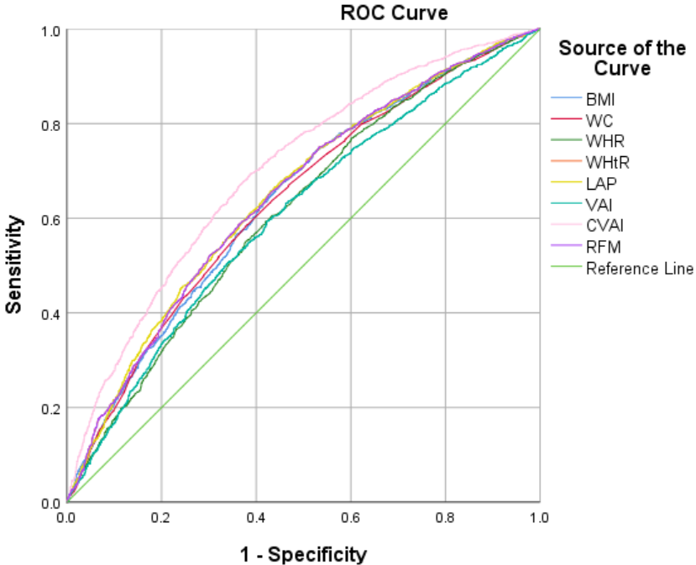
Supplementary Fig. S2 ROC curves of obesity-related indices for detecting prediabetes in women (ADA criteria).
BMI, body mass index; WC, waist circumference; WHR, waist-to-hip ratio; WHtR, waist-to-height ratio; LAP, lipid accumulation product index; VAI, visceral adiposity index; CVAI, Chinese visceral adiposity index; RFM, relative fat mass.

Supplementary Table S6 Pairwise comparison of AUCs in women using Delong test (ADA criteria)
Pairwise comparison | Z | P-value
BMI-WC | 0.500 | 0.617
BMI-WHR | -2.456 | 0.014
BMI - WHtR | -3.983 | <0.001
BMI - LAP | 1.490 | 0.136
BMI - VAI | 5.152 | <0.001
BMI - CVAI | -3.605 | <0.001
BMI - RFM | -3.987 | <0.001
WC - WHR | -3.765 | <0.001
WC - WHtR | -6.921 | <0.001
WC - LAP | 1.286 | 0.198
WC - VAI | 4.990 | <0.001
WC - CVAI | -9.676 | <0.001
WC - RFM | -6.927 | <0.001
WHR - WHtR | -0.012 | 0.990
WHR - LAP | 3.799 | <0.001
WHR - VAI | 6.773 | <0.001
WHR - CVAI | 0.059 | 0.953
WHR - RFM | -0.015 | 0.988
WHtR - LAP | 4.487 | <0.001
WHtR - VAI | 7.116 | <0.001
WHtR - CVAI | 0.123 | 0.902
WHtR - RFM | -1.560 | 0.119
LAP - VAI | 8.341 | <0.001
LAP - CVAI | -5.766 | <0.001
LAP - RFM | -4.489 | <0.001
VAI - CVAI | -8.309 | <0.001
VAI - RFM | -7.118 | <0.001
CVAI - RFM | -0.128 | 0.898
BMI, body mass index; WC, waist circumference; WHR, waist-to-hip ratio; WHtR,waist-to-height ratio; LAP, lipid accumulation product index; VAI, visceral adiposity index; CVAI, Chinese visceral adiposity index; RFM, relative fat mass. P < 0.05 indicates a statistically significant difference in diagnostic performance between the two indices.

Supplementary Table S7 Pairwise comparison of AUCs in women using Delong test (ADA criteria)
Pairwise comparison | Z | P-value
BMI-WC | 0.735 | 0.462
BMI-WHR | 2.917 | 0.004
BMI - WHtR | -1.466 | 0.143
BMI - LAP | -1.276 | 0.202
BMI - VAI | 3.391 | 0.001
BMI - CVAI | -10.729 | <0.001
BMI - RFM | -1.466 | 0.143
WC - WHR | 3.422 | 0.001
WC - WHtR | -4.183 | <0.001
WC - LAP | -2.222 | 0.026
WC - VAI | 3.091 | 0.002
WC - CVAI | -11.704 | <0.001
WC - RFM | -4.182 | <0.001
WHR - WHtR | -5.277 | <0.001
WHR - LAP | -4.535 | <0.001
WHR - VAI | 0.769 | 0.442
WHR - CVAI | -11.267 | <0.001
WHR - RFM | -5.277 | <0.001
WHtR - LAP | -0.225 | 0.822
WHtR - VAI | 4.335 | <0.001
WHtR - CVAI | -10.367 | <0.001
WHtR - RFM | 0 | 1.000
LAP - VAI | 8.579 | <0.001
LAP - CVAI | -10.273 | <0.001
LAP - RFM | 0.225 | 0.822
VAI - CVAI | -12.116 | <0.001
VAI - RFM | -4.335 | <0.001
CVAI - RFM | 10.367 | <0.001
BMI, body mass index; WC, waist circumference; WHR, waist-to-hip ratio; WHtR,waist-to-height ratio; LAP, lipid accumulation product index; VAI, visceral adiposity index; CVAI, Chinese visceral adiposity index; RFM, relative fat mass. P < 0.05 indicates a statistically significant difference in diagnostic performance between the two indices.

