Appendix A
Study Audit Trail
Assemble Guidance Group

The first stage of a photovoice study involves selecting and recruiting a target audience of policymakers or community leaders who can serve as agents of change and amplify participant voices (1). To support this stage and the broader research collaboration, the principal investigator submitted an FY25 Arts Project Support (APS) grant proposal to the Indiana Arts Commission in March of 2024, which was evaluated on three criteria: project quality and planning; community benefit, inclusion, and accessibility; and project management. The grant was awarded in June 2024. The Indy Arts Council was invited to participate as a community partner in July of 2024. A research team planning meeting was held in July 2024 at the research institution, which included the principal investigator, one graduate research assistant, and two undergraduate research assistants. In January 2025, a venue partnership was established with the 10 East Arts Hub, an Eastside community arts space, who generously donated its space for all photovoice activities: the In-Person Kick-Off Session, Problem-Identifying and Solution Posing Session, and the Exhibition. The study protocol was approved by the institutional review board on December 2, 2024 (IRB: #21973).

Participant Recruitment

Recruitment for this study was conducted in collaboration with the Indy Arts Council (“Indy Arts”). Indy Arts promoted a “Call for Artists” via their organizational listserv and website on three occasions: December 18, 2024, January 8, 2025, and January 23, 2025. To reach potential participants through additional channels, printed flyers were posted to community bulletin boards at Indianapolis Public Library locations serving the Far Eastside, Martindale–Brightwood, Arlington Woods, and Near Eastside communities. These two recruitment methods (see Figures D1 and D2 in Appendix D for recruitment materials), digital outreach and physical flyer distribution, were used to reach a broad pool of community members in the study area.

Individuals over the age of 18 residing in or connected to the Far Eastside, Martindale–Brightwood, Arlington Woods, or Near Eastside communities were eligible to participate. Applicants submitted their materials via a Qualtrics form, which asked respondents to confirm their eligibility by responding to the following: (1) “I am over the age of 18,” (2) “I am available to participate in this project for two in-person meetings on the following days and times: Saturday, March 8th at 1–3 pm EST and Saturday, April 12th at 1–3 pm EST,” and (3) “Participants must have a personal smartphone with a camera and access to mobile data, or wifi, to participate in this art and research collaboration. Please indicate below if you meet this eligibility criteria.” The application also included open-ended prompts asking applicants to briefly describe their interest in participating, discuss their connection with the target communities, and upload a sample of their work.

Candidate screening occurred in February 2025. Applicants who met the eligibility criteria were emailed an invitation to participate in the study. The email invitation included information about the In-Person Kick-Off Session and provided a PDF of the Informed Consent for review prior to the meeting and training. Of the eleven individuals who applied, seven met the eligibility criteria, five attended the In-Person Kick-Off Session, and four participants completed the study.

Participants were compensated $300 for their participation, distributed in two installments. Initial recruitment materials advertised $250, but budget adjustments and a subsequent IRB amendment allowed for an additional $50 in compensation. The first stipend of $50 was issued in early March 2025 and distributed by mail following the Kick-Off Session held on March 8, 2025. The second stipend of $250 was provided following the In-Person Problem-Identifying and Solution Posing Session. Remaining funds from the Indiana Arts Commission grant covered expenses associated with artwork production, exhibition materials, and supplies.

Orientation

Figure A1
In-person Photovoice Kick-Off Session at the 10 East Arts Hub
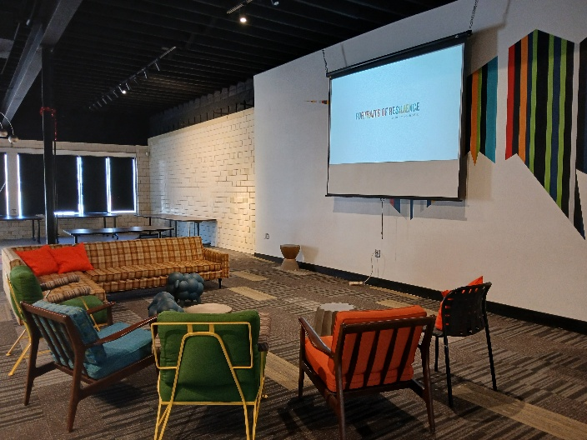
Source: Author

An in-person Photovoice Kick-Off Session was held on Saturday, March 8, 2025, at the 10 East Arts Hub (see Figure A1). The session began with research team introductions and the distribution of printed study materials, which included the informed consent form (IRB: #21973), the research recipient payment form required by the research institution, the photovoice SHOWeD interpretation framework, and a photovoice factsheet, offering an overview of the project prompts and the photovoice method. The SHOWeD Method is a common interpretation framework used in photovoice studies to guide critical discussion of photographs (2-5), consisting of five questions: “What do we See here?”, “What is really Happening here?”, “How does this relate to Our lives?”, “Why does this situation, concern, or strength exist?”, and “What can we Do about it?”

An in-person presentation introduced participants to the photovoice methodology, the goals of photovoice, the objectives of the study, photo collection procedures, potential risks and procedures for minimizing risk, and the SHOWeD interpretation framework. The date and location of the Photovoice Exhibition were finalized during this session.

During this session, participants were introduced to the project’s two photovoice prompts to guide the photo collection phase: (1) “What are your community’s sources of resilience?” and (2) “What are your community’s sources of risk?” Informed consent was obtained from all participants at the Kick-Off Session. Following consent, participants were provided with an individualized photovoice portal link to upload photographs and narratives. Refrigerator magnets and a laminated wallet-sized QR code card linked to their photovoice portal were provided. Photovoice portal links were also emailed to each participant. The project officially commenced on Saturday, March 8, 2025, following the Kick-Off Session and training.

Photo Collection

During the photo collection phase, participants captured photographs using their mobile phones or alternative camera equipment to document sources of community risk and resilience. Photo collection occurred over five weeks, from Saturday, March 8, 2025, to Friday, April 11, 2025. Participants were instructed to capture photographs that characterized their community’s sources of risk and resilience and upload them to their individual photovoice portal throughout the photo collection period. Participants were instructed to refrain from including identifying photographs of individuals, unless the individual was a public figure, a common convention in photovoice studies (6). Photographing minors was not permitted. Participants were also instructed to refrain from entering dangerous spaces or situations and to capture photographs that accurately and truthfully portrayed their community, avoiding images that could be taken out of context, and to avoid ‘false light,’ a common ethical standards in photovoice studies (7, 8). Participants could upload their photographs and an optional accompanying typed or voice-recorded narrative following the SHOWeD Method: “What do we See here?”, “What is really Happening here?”, “How does this relate to Our lives?”, “Why does this situation, concern, or strength exist?”, and “What can we Do about it?”

Problem-Identifying and Solution Posing Session

The In-Person Problem-Identifying and Solution Posing Session was held on Saturday, April 12, 2025, at the 10 East Arts Hub. At the session, participants were provided with printed copies of all photographs they captured during the photo collection phase. Participants were first prompted to sort and pile their photographs, a common approach (9-12) into two broad categories, risk and resilience, corresponding to the two guiding prompts introduced at the Kick-Off Session. Following this initial categorization, participants were then prompted to further sort and pile their photographs into participant-generated subthemes within risk and resilience categories.

Following the sorting activity, participants participated in a one-on-one semi-structured interview (see Appendix F for interview instrument) in a researcher-participant pair. Semi-structured interviews are a common method used in photovoice studies to further contextualize participant narratives and photographs (13-15). A researcher provided each participant with a printed copy of the SHOWeD framework to guide the discussion of their photographs (see Appendix F) and informed participants that key subthemes would be actively documented by the researcher throughout the interview on sticky notes. Participants were prompted to determine how they wished to discuss their photographs, either individually, photograph-by-photograph, or by cluster (when a group of photographs captured the same place or object from different angles or on different days). Using the SHOWeD interpretation framework, participants discussed their photographs by photograph or by cluster while facilitators actively documented emerging subthemes on sticky notes.

Following each individual interview, researcher-participant pairs placed thematic sticky notes along with supporting photos on a shared table to identify unique themes across the study. After all photographs had been discussed, all photographs had been piled and sorted, and thematic sticky notes were placed on the shared table, participants were then invited to collectively discuss and assess subthemes to revise, exclude, merge, or add to the key subthemes. This member-checking practice centers participant voice in theme construction to increase the study’s participatory rigor and ensure the trustworthiness of the findings, as commonly employed in photovoice studies (16-19).

In the second portion of the In-Person Problem-Identifying and Solution Posing Session was held on Saturday, April 12, 2025, research facilitators posed a series of questions to participants as a group to solicit their vision and expectations for the public Exhibition of their work (see Appendix B for a complete list of exhibition vision questions). At the conclusion of the Problem-Identifying and Solution Posing Session, participants were provided with 50 paper exhibition invitations to share with members of their community. The researcher emailed invitations to elected officials who represented the communities documented by photovoice participants. This publicly engaged stage of the research is consistent with photovoice methodology. According to Wang and Burris (1997), photovoice provides community members the opportunity to creatively document their concerns and simultaneously act as “catalysts for change” (p. 369).

Exhibition

A local community exhibition, titled “Portraits of Resilience,” was held on May 18, 2025, at the 10 East Arts Hub. The Exhibition featured a series of installations designed by one of the photovoice participants, who volunteered to curate the Exhibition. In collaboration with project participants, she translated the project’s photographs and themes into powerful narratives into five mixed-media installations created through participatory arts-based methods (see Table B1 in Appendix B for a list of installations with complete descriptions and mediums).

Figure 2
Portraits of Resilience exhibition installations
(a) Whispering Veils | (b) Connection Cluster
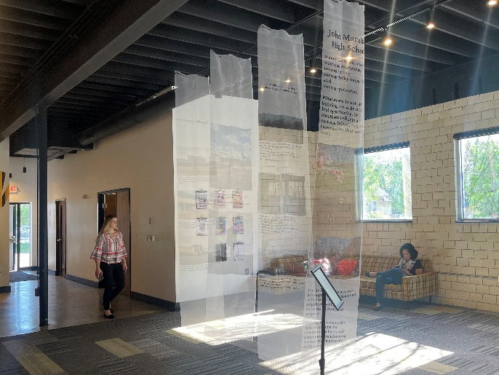 | 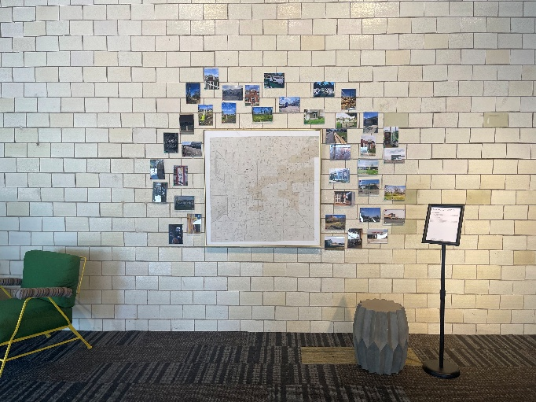
(c) Plywood Display I | (d) Plywood Display II
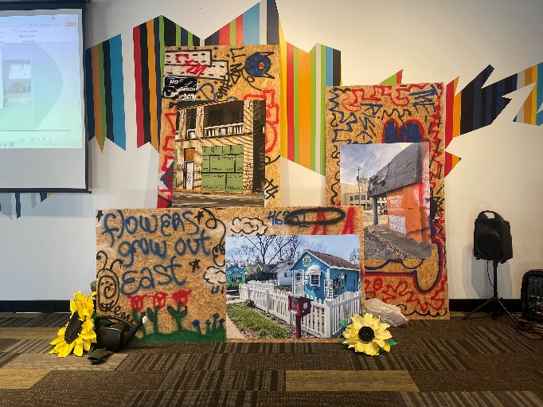 | 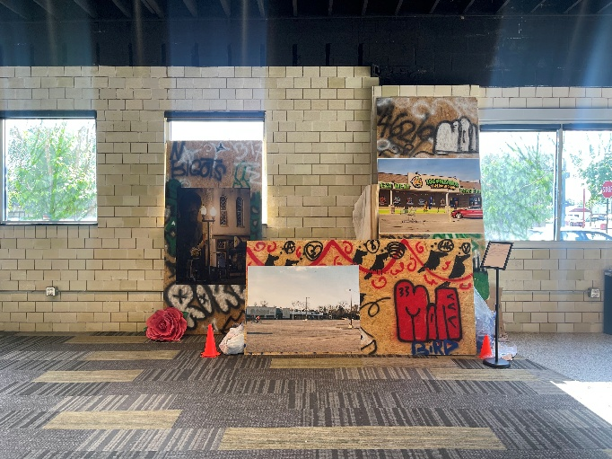
(e) Photo Collage | (f) Community Action Hub
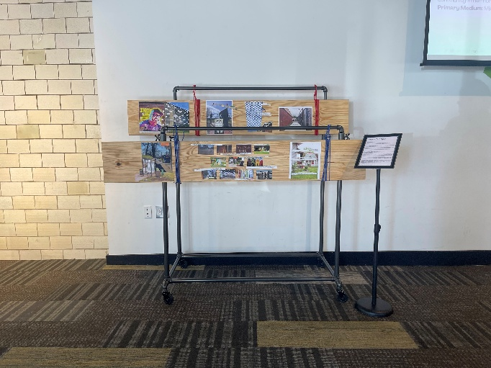 | 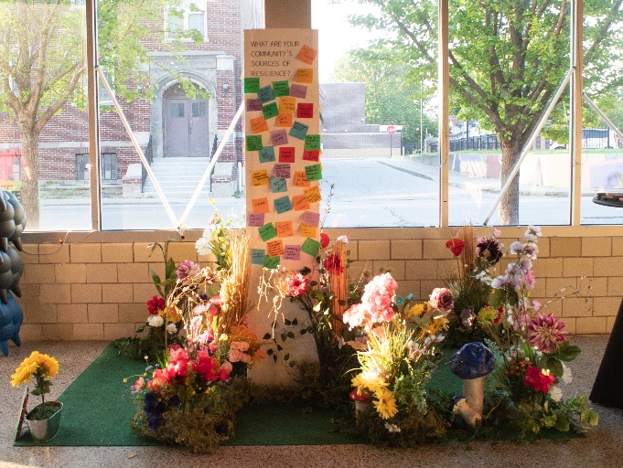

Each installation translated documented sources of community risk and resilience into visual and interactive formats designed to engage community members beyond traditional academic dissemination. (f) Community Action Hub (see Figure 2f) was an interactive station for exhibition attendees to contribute the study’s prompts with sticky notes (see Figures C1, C2, and C3 in Appendix C) for exhibition attendee contributions). Collectively, these installations served dual purposes: communicating research findings to diverse audiences and creating spaces for continued community dialogue and knowledge co-production.

The following installations were developed as part of a photovoice participatory arts-based research project documenting risk and resilience on Indianapolis’s Eastside. Installations were featured in the Portraits of Resilience Exhibition on May 18, 2025. Each piece represents a collaborative effort to visualize and communicate the complex interplay between community vulnerabilities and assets, drawing on place-based photography, community narratives, and mixed-media approaches to make visible what often remains unseen in daily life.

Table A1
Art Installation Descriptions
Installation | Description | Medium
Whispering Veils | This installation draws from the recognition that both risk and resilience can remain nearly invisible in the fabric of daily life. The work invites viewers to pause and truly see their community—to recognize both the challenges and strengths that often go unnoticed. Printed on translucent organza fabric, the scrolls document vacant spaces that carry untold histories, honoring those whose voices have been absent from decisions shaping their neighborhoods. The documentation of vacancy serves as a record of community needs, prompting reflection on who these spaces once served and who has been displaced. | Photography and text printed on organza fabric
Connection Cluster | Inspired by network mapping methodologies, this installation visualizes the spatial distribution of risk and resilience across Indianapolis. Using a map of the city as its foundation, the piece employs red thread to denote areas of documented risk and green thread to represent sources of resilience. Upon closer examination, the installation reveals the nuanced and often complex relationship between these forces—demonstrating how neighborhood green spaces, street trees, public transit access, and community expression through graffiti serve as counterweights to environmental and social stressors. | Archival prints, embroidery thread, canvas
Plywood Display | Drawing direct inspiration from the boarded-up vacant buildings documented throughout the study area, this installation brings the physical markers of disinvestment into the gallery space. The use of plywood as a structural element—a material associated with abandonment and neglect—creates a dimensional conversation about the economic and social forces shaping Indy’s Eastside. The installation juxtaposes contrasting imagery: photographs of resilience (such as local business storefronts) suggesting what these spaces could become, alongside documentation of risk that amplifies the current reality of vacancy and abandonment. | OSB, archival prints, spray paint, mixed media
Photo Collage | This multimedia installation juxtaposes images highlighting both the challenges faced by Eastside residents and the community’s capacity to overcome adversity. Displayed on 2×6 pine beams—which symbolize the enduring foundation upon which the community is built—the collages present themes of thriving local enterprises and intentional neighborhood design alongside evidence of disinvestment and mobility barriers. Artists’ voices are woven throughout, providing context, commentary, and personal narratives that transform static images into dynamic storytelling. This integration of text and image allows viewers to connect with subjects on a more intimate level, accessing firsthand accounts of the challenges and triumphs depicted. | Mixed media on pine
Community Action Hub: Share Your Story, Shape Our Future | This interactive installation invites attendees to contribute their perspectives and lived experiences to a growing portrait of community resilience and risk. Participants use sticky notes to identify sources of community resilience (strengths, assets, and resources), sources of community risk (challenges, vulnerabilities, and threats), and ideas for action (policy recommendations, community projects, or personal commitments). Through shared stories and collaborative brainstorming, the Hub serves as a platform for dialogue, empowerment, and collective action. Contributions inform future initiatives and advocacy efforts aimed at fostering a more thriving and equitable community. | Pine, sticky notes
Source: Author.
Note: Installations were designed by a participant in the photovoice study in consultation with all participants.

Appendix B

The following questions were posed to participants as a group during the Problem-Identifying and Solution Posing Session on April 12, 2025, to solicit their vision and expectations for the public Exhibition of their work.

Table B1
Exhibition Vision Questions
Question | Exhibition Vision Question
1 | What do you envision for the Exhibition?
2 | What are some absolute must-haves for the Exhibition, if any?
3 | How would you like your photographs displayed?
4 | What role would you like in the production process, if any?
5 | What is the most important part of the Exhibition for you?
6 | What are you hoping to get out of the Exhibition?
7 | If this became a temporary exhibition, where would you like to see it featured?
8 | What do you hope attendees will get out of the Exhibition?
9 | Do you plan on attending the Exhibition?
10 | Do you plan on inviting family, friends, or community members to the Exhibition?
11 | Is there anyone you would like the research team to invite to the Exhibition?
Note: Questions were designed by the author to ensure participant input guided all aspects of the exhibition planning and production process.

Appendix C

Figure C1
Exhibition Attendee Resilience Community Action Hub Posts: Participants were invited to use sticky notes to identify: “Sources of Community Resilience: What strengths, assets, and resources does your community possess?”
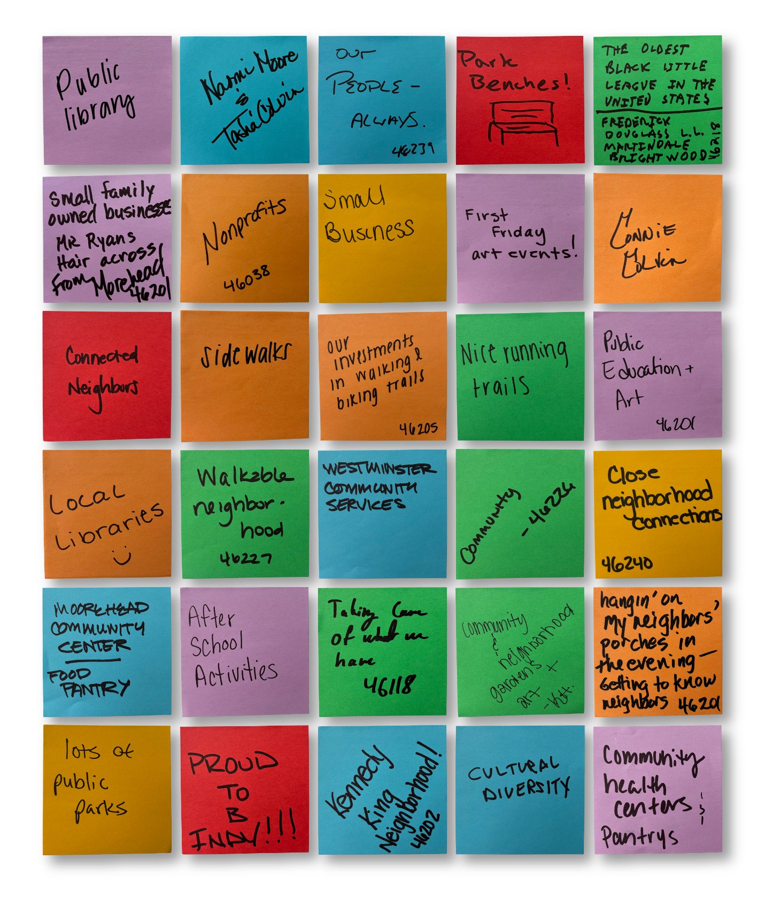
Source: Sticky notes were contributed by community members who attended the Portraits of Resilience Exhibition at 10 East Arts, E 10th St, Indianapolis, IN 46201, on May 18th, 2025.
Figure C2
Exhibition Attendee Risk Community Action Hub Posts: Participants were invited to use sticky notes to identify: “Sources of Community Risk: What challenges, vulnerabilities, or threats does our community face?”
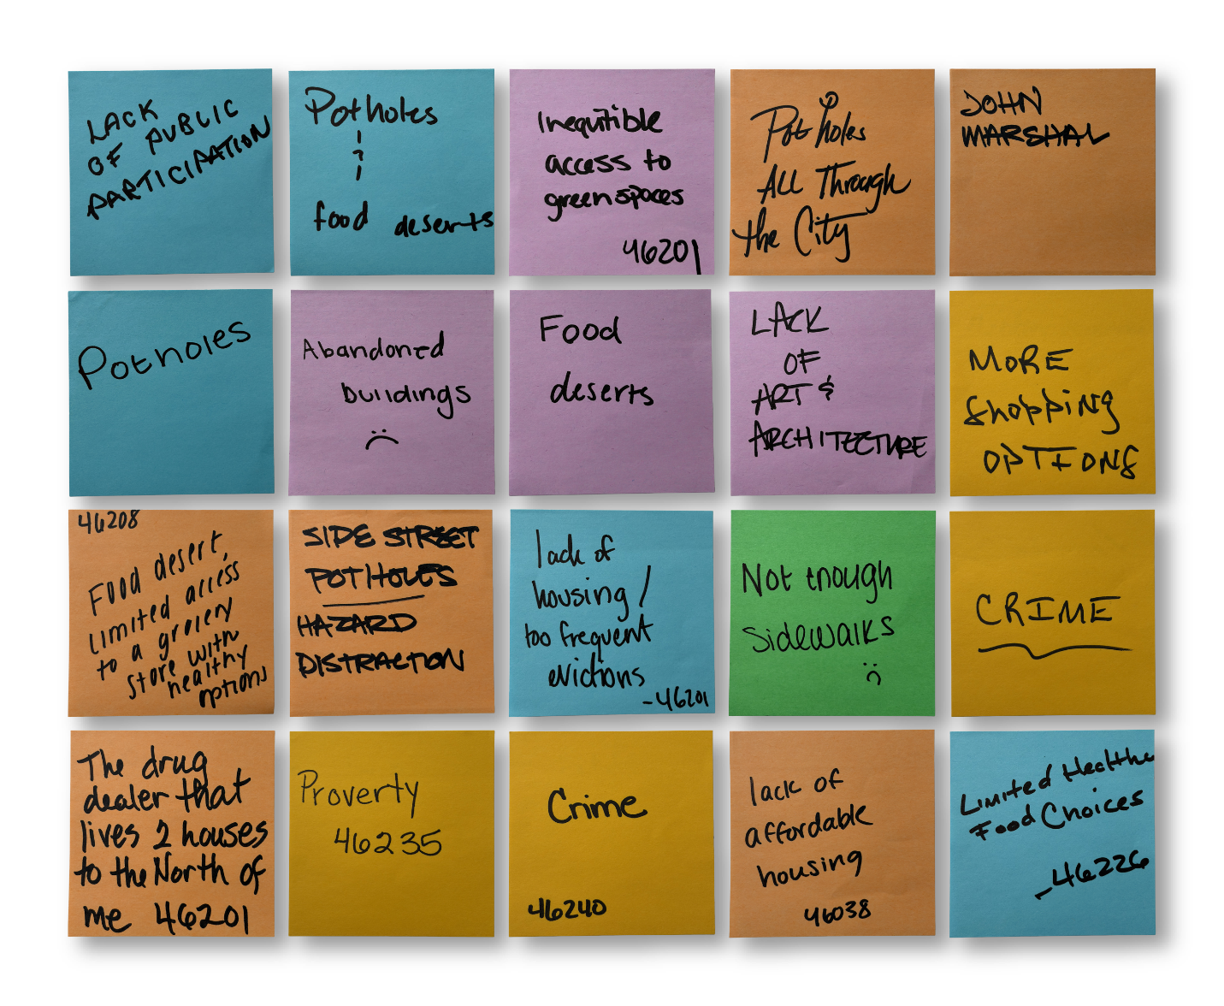
Source: Sticky notes were contributed by community members who attended the Portraits of Resilience Exhibition at 10 East Arts, E 10th St, Indianapolis, IN 46201, on May 18th, 2025.

Figure C3
Exhibition Attendee Action Community Action Hub Posts: Participants were invited to use sticky notes to identify: “Ideas for Action: What steps can we take, individually or collectively, to enhance resilience and mitigate risk? This could involve policy recommendations, community projects, innovative solutions, or personal commitments.”
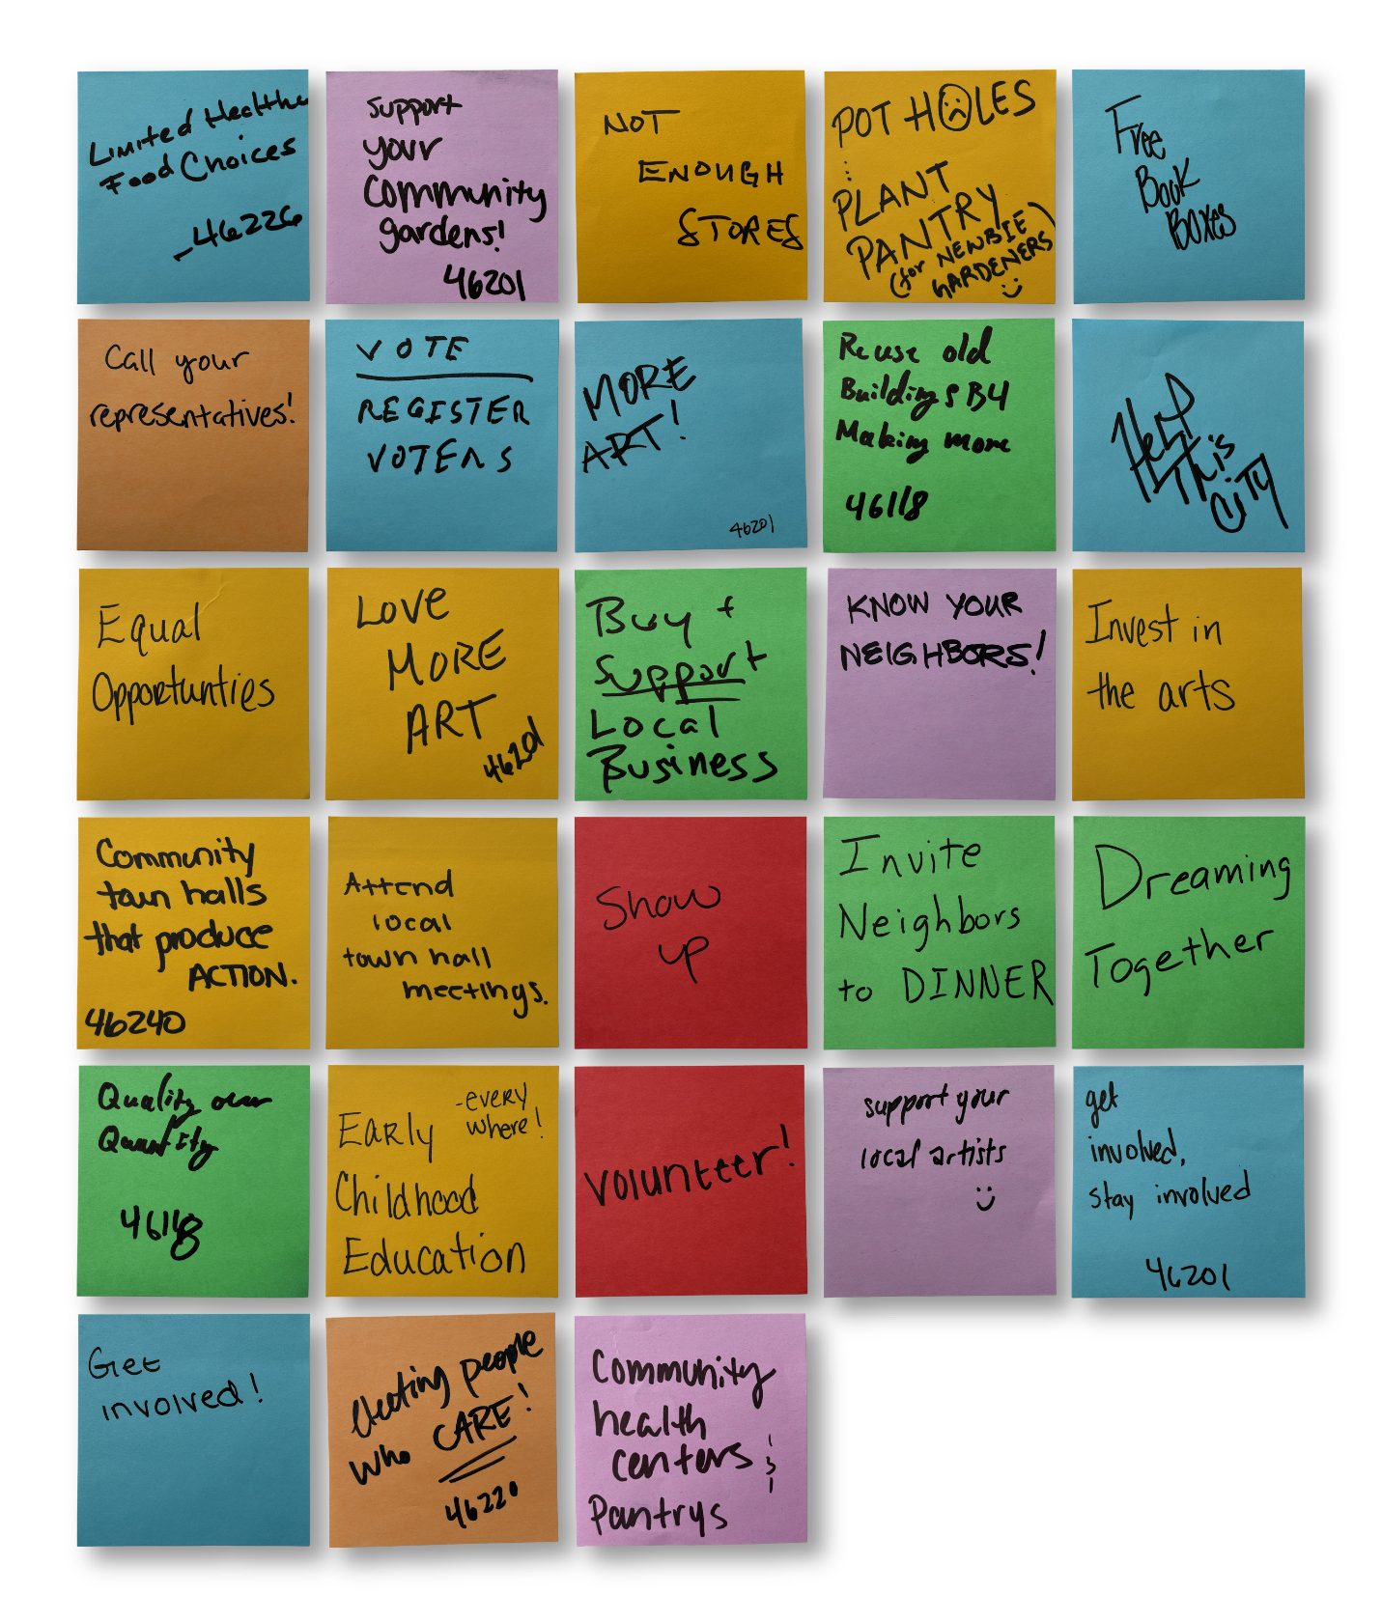
Source: Sticky notes were contributed by community members who attended the Portraits of Resilience Exhibition at 10 East Arts, E 10th St, Indianapolis, IN 46201, on May 18th, 2025.

Appendix D

Figure D1
Call for Local Artists in the Far Eastside, Martindale – Brightwood, Arlington Woods, and the Near Eastside
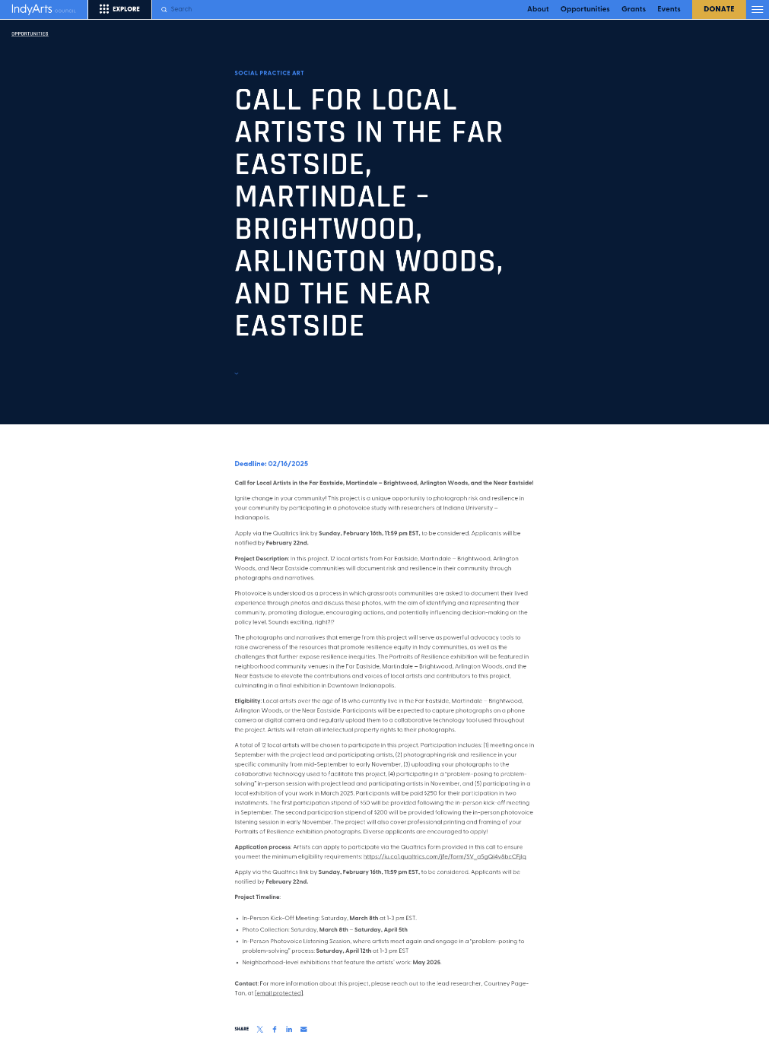
Source: Indy Arts Council. (2025). Call for local artists in the Far Eastside, Martindale–Brightwood, Arlington Woods, and the Near Eastside. https://indyarts.org/opportunity/call-for-local-artists-in-the-far-eastside-martindale-brightwood-arlington-woods-and-the-near-eastside/

Figure D2
Printed Call for Local Artists in the Far Eastside, Martindale – Brightwood, Arlington Woods, and the Near Eastside Poster
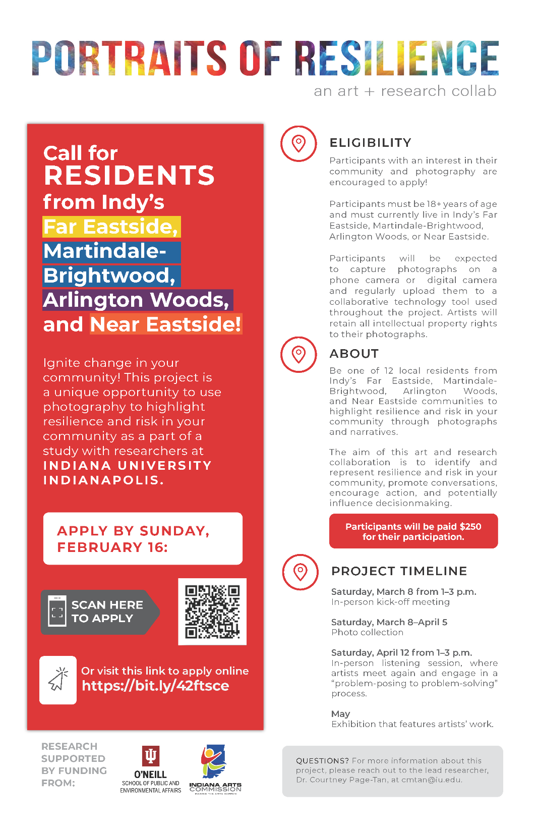
Source: Author

Appendix E

Research instrument:
Semi-structured interview instrument
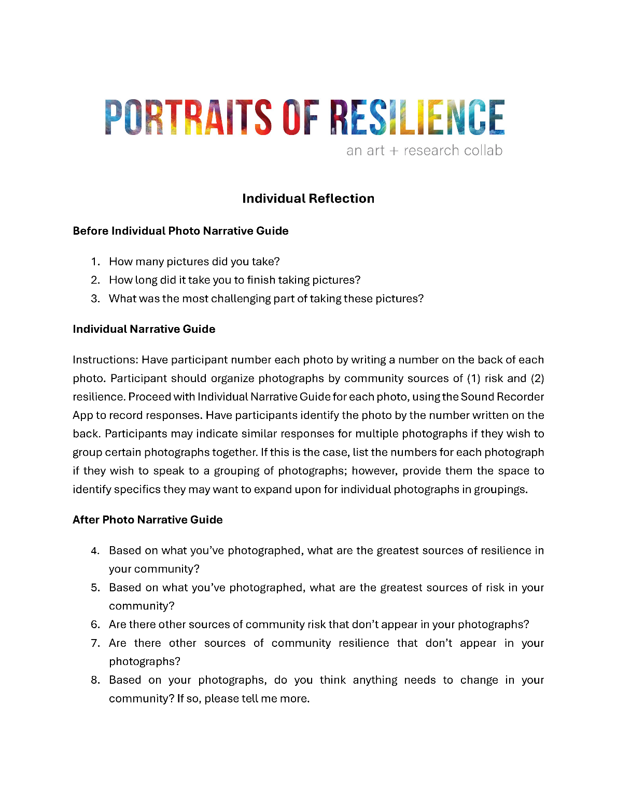
Source: Author.

Research instrument:
SHOWeD framework guide.
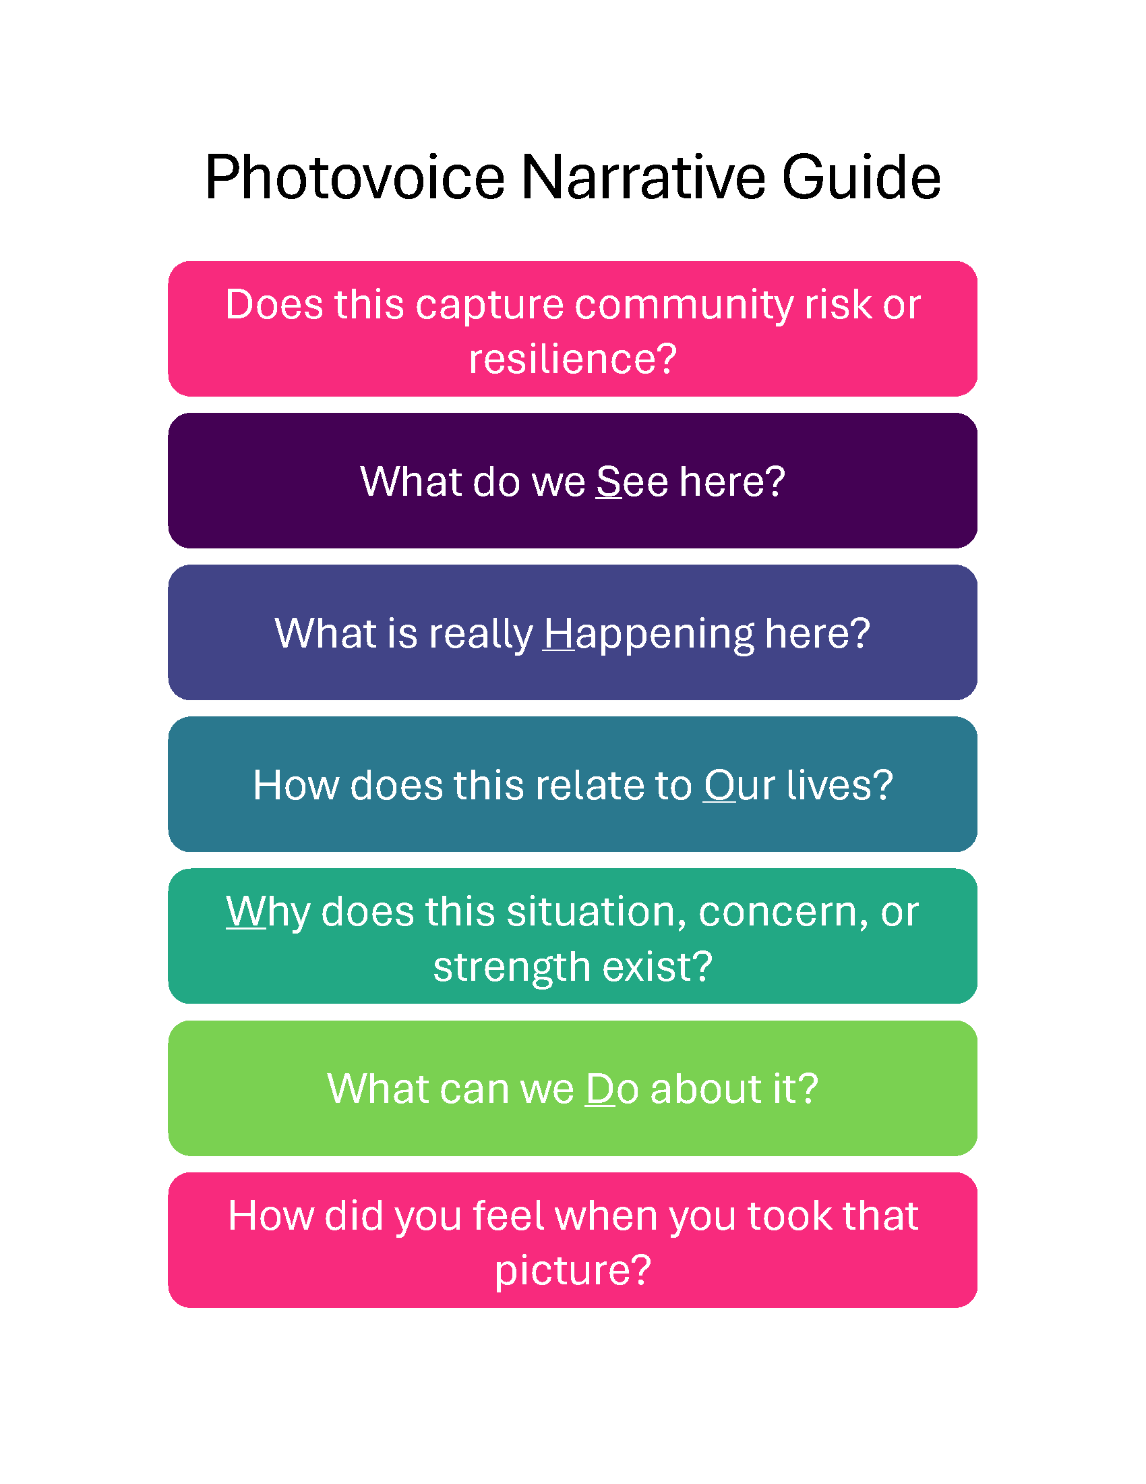
Source: Author.

Appendix F
Table F1
Nine constituent elements of community resilience as conceptualized by Patel et al. (2017).
Element | Description
Local Knowledge | Factual knowledge base (e.g., knowledge of treatment; lessons from past disasters; knowledge of basic life support techniques; risk knowledge; assessment or accountability of vulnerabilities; knowledge of expertise; response; knowledge and skills translatable to disaster preparedness, mitigation, response, and recovery; disaster and risk information; integrated knowledge base); collective efficacy and empowerment (e.g., knowledge of self-reliance, self-help, and self-sufficiency; self-reliance; recovery mechanisms; sense of coherence; capacity for generative experiences and positive emotions; self-efficacy; community competence; collective efficacy; empowerment; belief that one has the resources needed to deal with challenging situations); training and education (e.g., knowledge and education; community education and training; continual and effective learning; learning in response to events; knowledge transfer; risk awareness training; social, lifestyle, and community competence; learning based on prior experience; practice).
Community Networks and Relationships | Connectedness (e.g., community networks and relationships; connectedness; social networks and capital; self-sufficiency; social or cross-community links; social relationships; connection and caring; social and cultural networks; social and cultural capital; partnership and activating networks; neighborhoods, family, and kinship networks); cohesion (e.g., social capacity, social support systems, and social cohesion; collective social support and collective efficacy; social support; social capital; community cohesion; social connectedness; social capital including trust and social cohesion; building trust and strong ties; social networks and capital; commitment and shared values; collective cohesion and self-efficacy; community pride).
Communication | Risk communication (e.g., risk communication; information resilience; risk awareness; public risk communications; risk information and awareness; communications infrastructure and technology; coordinated communication systems or networks); crisis communication (e.g., effective coordination during response; open communication during crises; real-time information flow; communications infrastructure and technology; coordinated communication systems or networks); effective communication (e.g., memoranda of understanding; information and communication processes that create shared meanings and understanding and provide opportunities for members to articulate needs, views, and attitudes; communication practices; strong communication networks).
Health | Health services (e.g., healthcare services; medical and mental health services; health and mental health resilience; healthcare and related social services; medical care; emergency response capabilities); physical health (e.g., physical health; physical functioning); mental health (e.g., psychological health; psychological functioning; mental health; coping; mental health wellness; trauma; post-traumatic stress symptoms; depression; post-traumatic stress disorder; clinical distress).
Governance and Leadership | Infrastructure and services (e.g., good governance; infrastructure; organized governmental services; analysis and management of causal risk factors; presence of community structures and leadership; effective governance and institutions; ensuring the reservation, restoration, or improvement of essential basic structures and functions; management capacity; leadership; leadership that improves organizational performance and problem solving; response capabilities; capacity to respond and recover a full range of functions; ability to function and sustain critical systems under stress; preparedness and response capacity; global response capacity; capacity to deal with disturbance; development of infrastructure; capable governance; exposure related to the built environment; leadership that supports effective coping and successful outcomes); public involvement and support (e.g., community leadership and mutual support; partnerships and engagement; public involvement; community engagement; credibility of leadership representing community uniqueness and aspirations; clear structures, roles, and responsibilities; self-organization to maximize risk reduction; leadership, participation, and representation; community processes such as strategic thinking, participation, and action; community empowerment; integration of government and nongovernmental organizations in planning and response; active engagement of community stakeholders in planning and preparedness; collective action and decision-making; collective action; decision-support systems).
Resources | Adequate resourcing; harnessing local resources; awareness and use of community resources; availability of resources; community-level resources; resource management; distribution of tangible resources; social resources; natural and economic resources; access to financial resources and assets; diverse economic resources; physical infrastructure; food services and distribution; effective use of physical and economic resources to support recovery.
Economic Investment | Economic development (e.g., economic capacity and diversification; economic equity; economic development; economic well-being; localized economies within ecological limits; economic rehabilitation; proactive investments and policy decisions to reduce loss of life, costs, and long-term socioeconomic impacts; economic resilience; access to financial resources and assets; diverse economic resources); economic programming (e.g., cost-effective programming; distribution of economic resources; employment-seeking behavior; livelihood and economic development interventions; employment and occupational diversity; economic access to support coping and stability; economic resilience; economic education).
Preparedness | Planning and mitigation (e.g., preparedness activities; planning and procedures; application of lessons learned from past disasters to forward-looking preparedness; mitigation measures; planning for sustainable response and recovery; distribution of disaster mitigation projects; disaster prevention and mitigation, preparedness, and capacity to withstand disasters; hazard mitigation and planning; planning that improves disaster-related organizational performance and problem-solving; disaster preparedness; capacity to plan, buffer, and protect essential functions; active engagement of community stakeholders in health event planning and personal preparedness; risk management practices; hazard risk assessment; anticipating risk and limiting impacts).
Mental Outlook | Hope (e.g., hope and the ability to persevere in spite of adversity; shared vision of a better future or horizon of hope; meaning-making in one’s own life; sense of hope and community pride); adaptability (e.g., coping with and acceptance of uncertainty and change; adaptability; adaptive capacity; responses to disturbance such as adapt, survive, cope, recover, learn, transform, and bounce back; transformability; belief that one has the resources needed to deal with challenging situations; drawing on previous experiences; adapting to changes in the physical, social, or economic environment; survival, evolution, and growth from experience and impacts; positive outcomes despite adversity; speed of recovery).
Source: Table adapted from ‘Supplementary Material Table 2’ in Patel, S. S., Rogers, M. B., Amlôt, R., & Rubin, G. J. (2017). What do we mean by ‘community resilience’? A systematic literature review of how it is defined in the literature. PLoS Currents, 9. Reproduced and adapted with permission of the original author.

Appendices Works Cited

1. Wang C, Burris MA. Photovoice: Concept, Methodology, and Use for Participatory Needs Assessment. Health Education & Behavior. 1997;24(3):369-87.
2. Bonati ML, Elga A. Amplifying children's voices within photovoice: Emerging inclusive education practices in Indonesia. British Journal of Learning Disabilities. 2021;49(4):409-23.
3. Bukowski K, Buetow S. Making the invisible visible: A Photovoice exploration of homeless women's health and lives in central Auckland. SOCIAL SCIENCE & MEDICINE. 2011;72(5):739-46.
4. Bulla B, Steelman T. Farming through change: Using photovoice to explore climate change on small family farms. Agroecology and Sustainable Food Systems. 2016;40(10):1106-32.
5. Gutiérrez M, Marisol M, Stephanie L-P, David B, M. MF, A. RL, et al. Virtual Photovoice and Social Work: Unveiling CRT and LatCrit Insights into Latinx Communities in the Southwest During COVID-19. Journal of Community Practice. 2024;32(4):417-41.
6. Chapman MV, Wu S, Zhu M. What is a picture worth? A primer for coding and interpreting photographic data. Qualitative Social Work. 2017;16(6):810-24.
7. Lindhout P, Teunissen T, Reniers G. What about Using Photovoice for Health and Safety? International Journal of Environmental Research and Public Health. 2021;18(22):11985.
8. Adams RM, Karlin B, Eisenman DP, Blakley J, Glik D. Who Participates in the Great ShakeOut? Why Audience Segmentation Is the Future of Disaster Preparedness Campaigns. International Journal of Environmental Research and Public Health. 2017;14(11):1407.
9. Cameranesi M, Piotrowski CC. A Mixed Methods Synthesis Investigating the Personal and Ecological Resources Promoting Mental Health and Resilience in Youth Exposed to Intimate Partner Violence. Youth. 2024;4(4):1610-27.
10. Grant N, Neville H, Ogunfemi N, Smith A, Groth S, Rodriguez N. An emerging youth-centered model of community resilience in communities impacted by gun violence: Power through Black Community and Unity. American Journal of Community Psychology. 2023;71(3-4):355-70.
11. Morton D, Bird-Naytowhow K, Pearl T, Hatala AR. “Just because they aren't human doesn't mean they aren't alive”: The methodological potential of photovoice to examine human-nature relations as a source of resilience and health among urban Indigenous youth. Health and Place. 2020.
12. Malka M, Edelstein OE, Huss E, Hillel Lavian R. Boosting Resilience: Photovoice as a Tool for Promoting Well-Being, Social Cohesion, and Empowerment Among the Older Adult During the COVID-19 Pandemic. Journal of Applied Gerontology. 2024.
13. Tan Y, Pinder D, Bayoumi I, Carter R, Cole M, Jackson L, et al. Family and community resilience: a Photovoice study. International Journal for Equity in Health. 2024;23(1):1-13.
14. Baldwin C, Smith T, Jacobson C. Love of the land: Social-ecological connectivity of rural landholders. Journal of rural studies. 2017;51:37-52.
15. Thomas FC, Roberts B, Luitel NP, Upadhaya N, Tol WA. Resilience of refugees displaced in the developing world: A qualitative analysis of strengths and struggles of urban refugees in Nepal. Conflict and Health. 2011.
16. Rivas-Quarneti N, Viana-Moldes I, Veiga-Seijo S, Canabal-López M, Magalhaes L. Politicizing Children's ' s Play A Community Photovoice Process to Transform a School Playground. AMERICAN JOURNAL OF OCCUPATIONAL THERAPY. 2024;78(4).
17. Torres-Slimming PA, Wright CJ, Lancha G, Carcamo CP, Garcia PJ, Ford JD, et al. Climatic Changes, Water Systems, and Adaptation Challenges in Shawi Communities in the Peruvian Amazon. Sustainability. 2020;12(8):3422.
18. Palinkas LA, Springgate B, Cabassa LJ, Shin M, Garcia S, Crabtree BF, et al. Methods for community-engaged data collection and analysis in implementation research. IMPLEMENTATION SCIENCE COMMUNICATIONS. 2025;6(1).
19. Houle J, Coulombe S, Radziszewski S, Leloup X, Saïas T, Torres J, et al. An intervention strategy for improving residential environment and positive mental health among public housing tenants: rationale, design and methods of Flash on my neighborhood! BMC PUBLIC HEALTH. 2017;17.

