Table S1. Logistic Regression Analysis of TPA and Circadian Syndrome risk
TPA | Crude model |  | Model 1 |  | Model 2 |  | Model 3
TPA | OR  (95% CI) | P-value | OR  (95% CI) | P-value | OR  (95% CI) | P-value | OR  (95% CI) | P-value
Q1 | — | — | — | — | — | — | — | —
Q2 | 0.66(0.49, 0.87) | 0.003** | 0.60(0.45, 0.81) | <0.001*** | 0.60(0.45, 0.80) | <0.001*** | 0.59(0.44, 0.80) | <0.001***
Q3 | 0.64(0.48, 0.85) | 0.003** | 0.65(0.48, 0.88) | 0.005** | 0.65(0.48, 0.88) | 0.005** | 0.63(0.46, 0.86) | 0.003**
Q4 | 0.39(0.29, 0.54) | <0.001*** | 0.44(0.32, 0.62) | <0.001*** | 0.46(0.33, 0.64) | <0.001*** | 0.45(0.32, 0.63) | <0.001***
Note: Model 1: age, gender, residential area, marital status and education level; Model 2: Model 1, current smoking status, current drinking status; Model 3: Model 2, Health insurance, Number of children.. OR, odds ratio; CI, confidence intervals; Total Physical Activity; TPA *p < 0.05, **p < 0.01*** p < 0.001.

Table S2. Logistic Regression Analysis of TPA and Circadian Syndrome risk excluding participants with cancer
TPA | Crude model |  | Model 1 |  | Model 2 |  | Model 3
TPA | OR  (95% CI) | P-value | OR  (95% CI) | P-value | OR  (95% CI) | P-value | OR  (95% CI) | P-value
Q1 | — | — | — | — | — | — | — | —
Q2 | 0.63(0.47, 0.83) | 0.001** | 0.57(0.43, 0.77) | <0.001*** | 0.57(0.43, 0.76) | <0.001*** | 0.56(0.42, 0.75) | <0.001***
Q3 | 0.62(0.47, 0.83) | 0.001** | 0.63(0.47, 0.85) | 0.003** | 0.63(0.46, 0.85) | 0.002** | 0.62(0.45, 0.83) | 0.002**
Q4 | 0.38(0.28, 0.52) | <0.001*** | 0.42(0.30, 0.59) | <0.001*** | 0.44(0.31, 0.62) | <0.001*** | 0.43(0.30, 0.60) | <0.001***
Note: Model 1: age, gender, residential area, marital status and education level; Model 2: Model 1, current smoking status, current drinking status; Model 3: Model 2, Health insurance, Number of children.. OR, odds ratio; CI, confidence intervals; Total Physical Activity; TPA *p < 0.05, **p < 0.01*** p < 0.001.
Table S3. Logistic Regression Analysis of TPA and Circadian Syndrome risk excluding participants with cardiac and renal diseases.
TPA | Crude model |  | Model 1 |  | Model 2 |  | Model 3
TPA | OR  (95% CI) | P-value | OR  (95% CI) | P-value | OR  (95% CI) | P-value | OR  (95% CI) | P-value
Q1 | — | — | — | — | — | — | — | —
Q2 | 0.66(0.47, 0.93) | 0.019* | 0.61(0.43, 0.87) | 0.007** | 0.60(0.41, 0.85) | 0.005** | 0.59(0.41, 0.84) | 0.004**
Q3 | 0.70(0.50, 0.99) | 0.047* | 0.70(0.49, 1.00) | 0.050* | 0.69(0.48, 0.99) | 0.043* | 0.67(0.46, 0.96) | 0.031*
Q4 | 0.40(0.27, 0.58) | <0.001*** | 0.42(0.28, 0.63) | <0.001*** | 0.45(0.30, 0.67) | <0.001*** | 0.43(0.28, 0.64) | <0.001***
Note: Model 1: age, gender, residential area, marital status and education level; Model 2: Model 1, current smoking status, current drinking status; Model 3: Model 2, Health insurance, Number of children. OR, odds ratio; CI, confidence intervals; Total Physical Activity; TPA *p < 0.05, **p < 0.01*** p < 0.001.
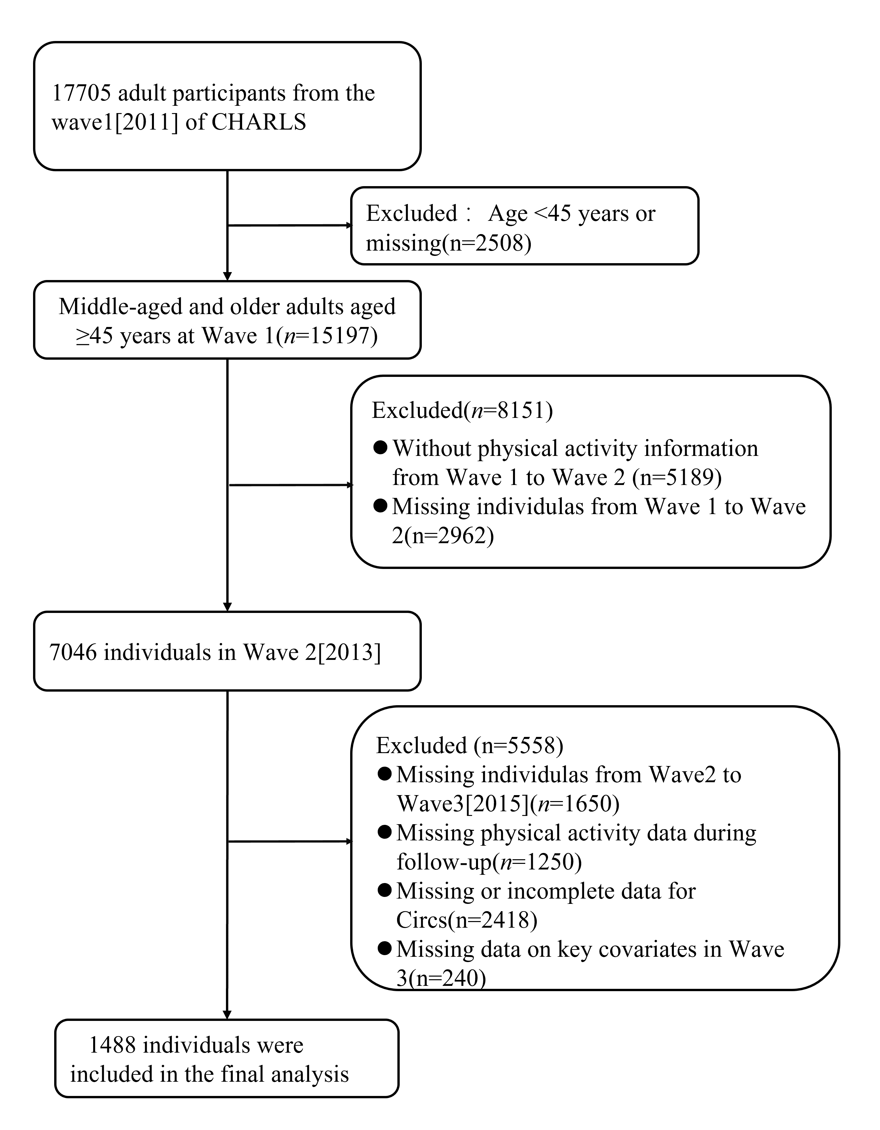
Figure S1. Flow of eligible participants selection.
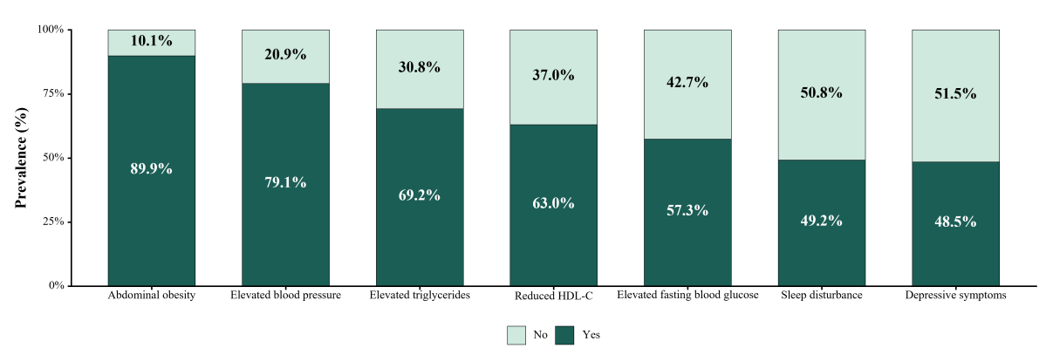
Figure S2. Stacked bar chart showing the prevalence of different CircS components among participants diagnosed with CircS (n = 565).
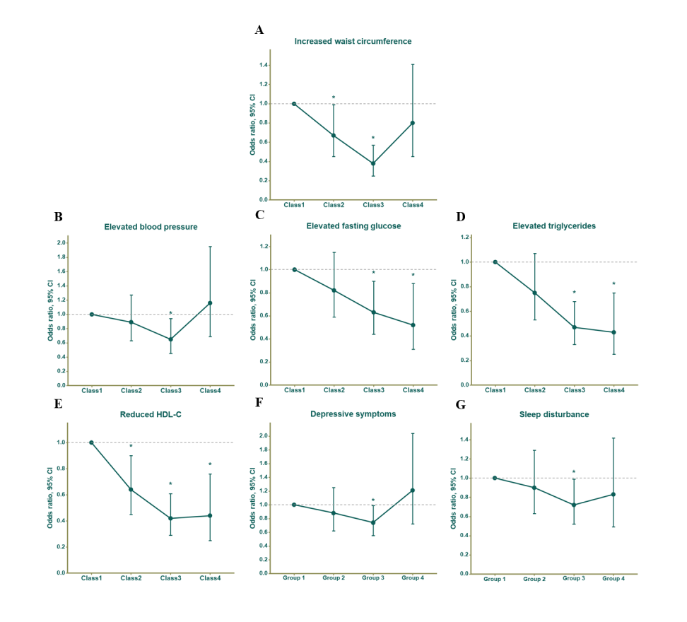
Figure S3. Associations between physical activity (PA) trajectories and Circadian Syndrome (CircS) and its components.Associations of different physical activity (PA) trajectories with (A) abdominal obesity, (B) elevated blood pressure, (C) elevated fasting glucose, (D) elevated triglycerides, (E) reduced high-density lipoprotein cholesterol (HDL-C), (F) depressive symptoms, and (G) Sleep disturbance.PA trajectories were derived based on longitudinal patterns of physical activity across repeated survey waves.Multivariable logistic regression models were used to estimate odds ratios (ORs) and 95% confidence intervals (CIs) for CircS and its individual components across PA trajectory groups.All models were adjusted for age, gender, residential area , marital status, educational level, current smoking status, current drinking status, health insurance, and number of childrenGroup 1 = Stable low; Group 2 = Stable Middle; Group 3 = Stable High; Group 4 = High-decreasing with modest rebound trajectory.
Table S3A. Associations between physical activity trajectories and Circadian Syndrome components
CircS component  (events/N) | PA trajectory group | Group N | Events, n (%) | Adjusted OR (95% CI) | P value
Increased waist circumference | Group 1 | 184 | 137 (74.5%) | Reference
(936/1488) | Group 2 | 595 | 408 (68.6%) | 0.67 (0.45, 0.99) | 0.044*
 | Group 3 | 606 | 319 (52.6%) | 0.38 (0.25, 0.57) | <0.001***
 | Group 4 | 103 | 72 (69.9%) | 0.80 (0.45, 1.41) | 0.435
Elevated triglycerides | Group 1 | 184 | 83 (45.1%) | Reference
(530/1488) | Group 2 | 595 | 243 (40.8%) | 0.75 (0.53, 1.07) | 0.110
 | Group 3 | 606 | 175 (28.9%) | 0.47 (0.33, 0.68) | <0.001***
 | Group 4 | 103 | 29 (28.2%) | 0.43 (0.25, 0.75) | 0.003**
Reduced HDL-C | Group 1 | 184 | 93 (50.5%) | Reference
(547/1488) | Group 2 | 595 | 248 (41.7%) | 0.64 (0.45, 0.90) | 0.012*
 | Group 3 | 606 | 174 (28.7%) | 0.42 (0.29, 0.61) | <0.001***
 | Group 4 | 103 | 32 (31.1%) | 0.44 (0.25, 0.76) | 0.003**
Elevated blood pressure | Group 1 | 184 | 111 (60.3%) | Reference
(758/1488) | Group 2 | 595 | 325 (54.6%) | 0.89 (0.63, 1.27) | 0.523
 | Group 3 | 606 | 262 (43.2%) | 0.65 (0.45, 0.94) | 0.022*
 | Group 4 | 103 | 60 (58.3%) | 1.16 (0.69, 1.95) | 0.576
Elevated fasting glucose | Group 1 | 184 | 90 (48.9%) | Reference
(599/1488) | Group 2 | 595 | 260 (43.7%) | 0.82 (0.59, 1.15) | 0.258
 | Group 3 | 606 | 216 (35.6%) | 0.63 (0.44, 0.90) | 0.011*
 | Group 4 | 103 | 33 (32.0%) | 0.52 (0.31, 0.88) | 0.014*
Sleep disturbance | Group 1 | 184 | 67 (36.4%) | Reference
(482/1488) | Group 2 | 595 | 196 (32.9%) | 0.90 (0.63, 1.29) | 0.581
 | Group 3 | 606 | 187 (30.9%) | 0.72 (0.52, 0.99) | 0.046*
 | Group 4 | 103 | 32 (31.1%) | 0.83 (0.49, 1.42) | 0.504
Depressive symptoms | Group 1 | 184 | 58 (31.5%) | Reference
(508/1488) | Group 2 | 595 | 180 (30.3%) | 0.88 (0.62, 1.25) | 0.475
 | Group 3 | 606 | 226 (37.3%) | 0.74(0.55, 0.99) | 0.045*
 | Group 4 | 103 | 44 (42.7%) | 1.21 (0.72, 2.04) | 0.473
Note. The total analytic sample included 1,488 participants. Values are presented as odds ratios (ORs) and 95% confidence intervals (CIs), with the Stable low group as the reference. Models were adjusted for age, gender, residential area, marital status, education level, current smoking status, current drinking status, health insurance, and number of children. Group 1 = Stable low; Group 2 = Stable Middle; Group 3 = Stable High; Group 4 = High-decreasing with modest rebound trajectory.
OR, odds ratio; CI, confidence interval ;CircS, Circadian Syndrome; HDL-C, high-density lipoprotein cholesterol; PA, physical activity.p < 0.05, **p < 0.01*** p < 0.001.

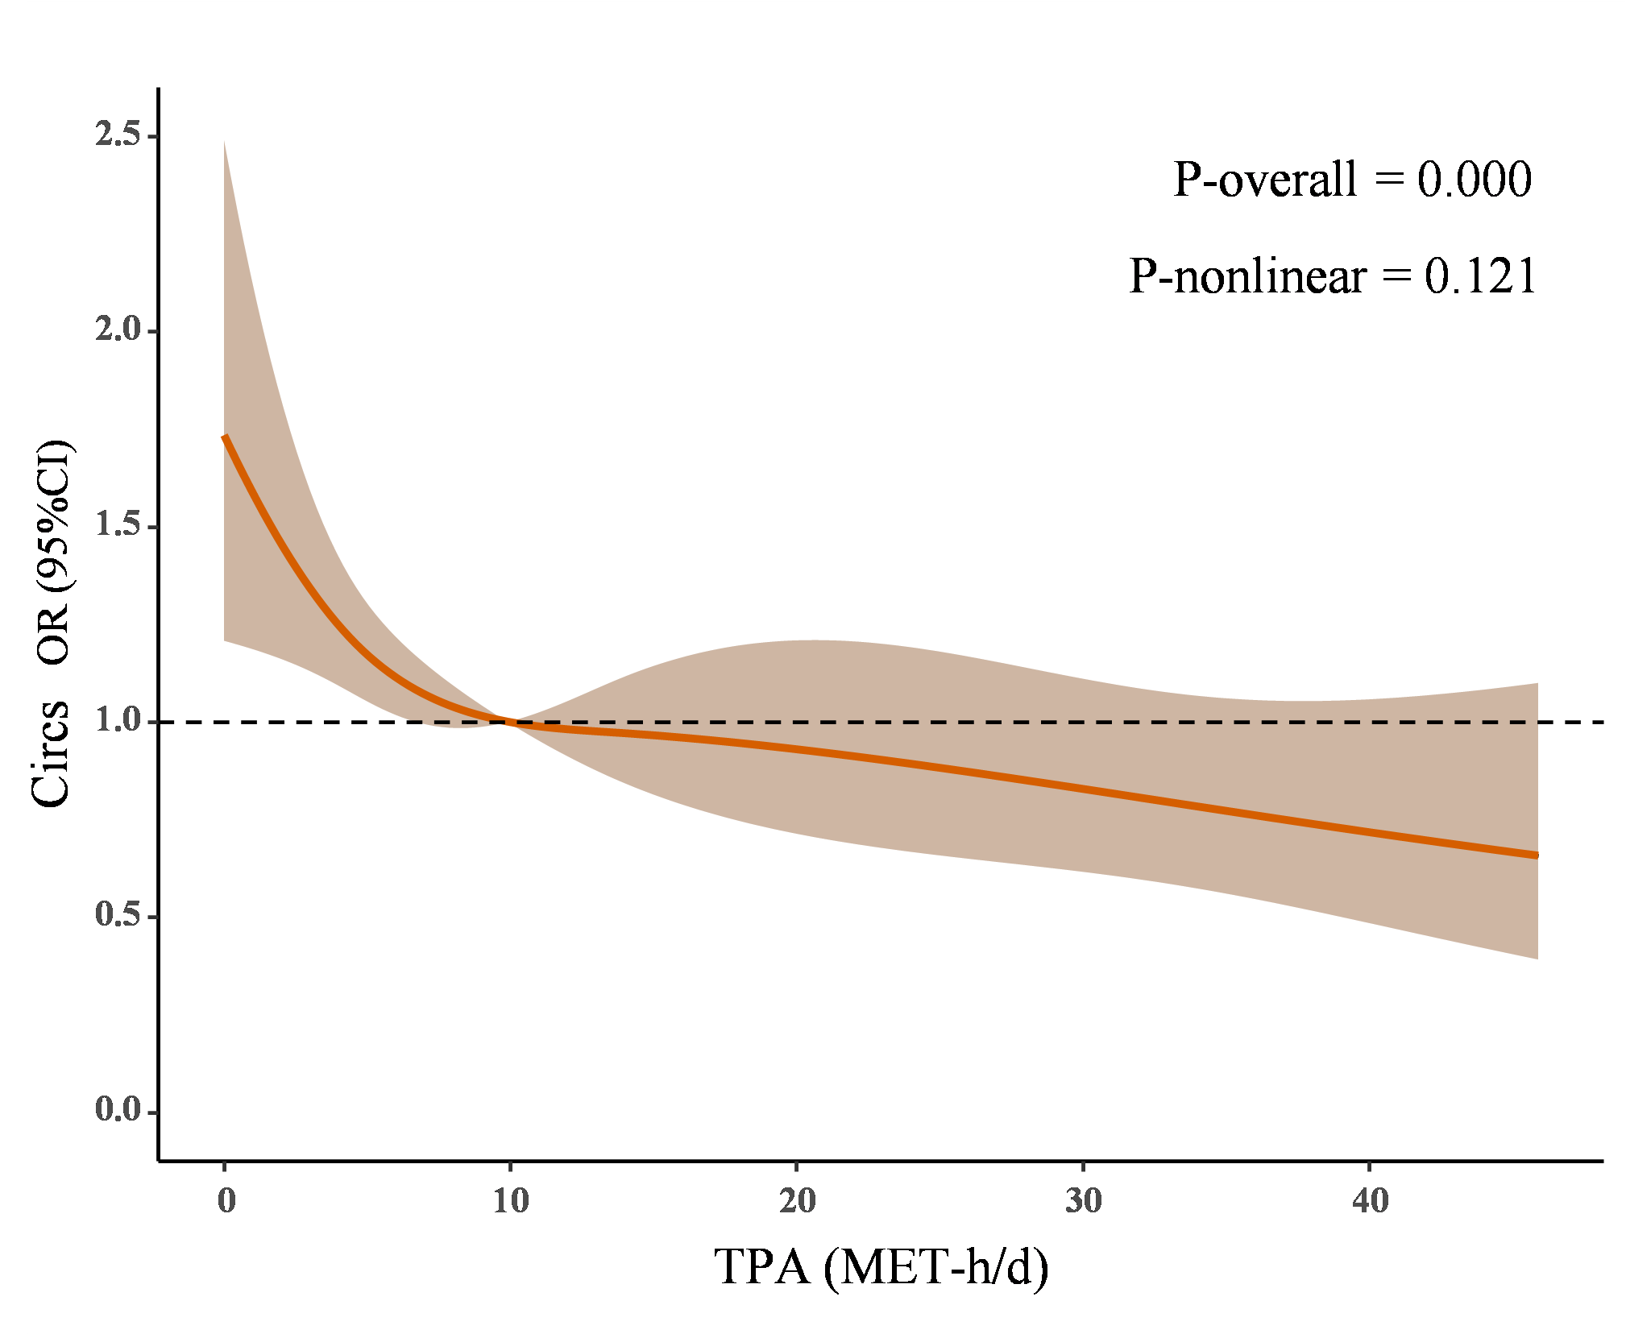
Figure S4. Dose-response relationship between TPA and Circadian Syndrome risk using an RCS model with four knots (5th, 35th, 65th, and 95th percentiles). Solid lines and orange areas represent adjusted odds ratios (OR) and 95% confidence intervals (CI), respectively. The model adjusted for age, gender, residential area, marital status, education level, current smoking status, current drinking status, Health insurance, Number of children. OR: odds ratio; CI: confidence interval; TPA: total PA; MET: metabolic equivalent.

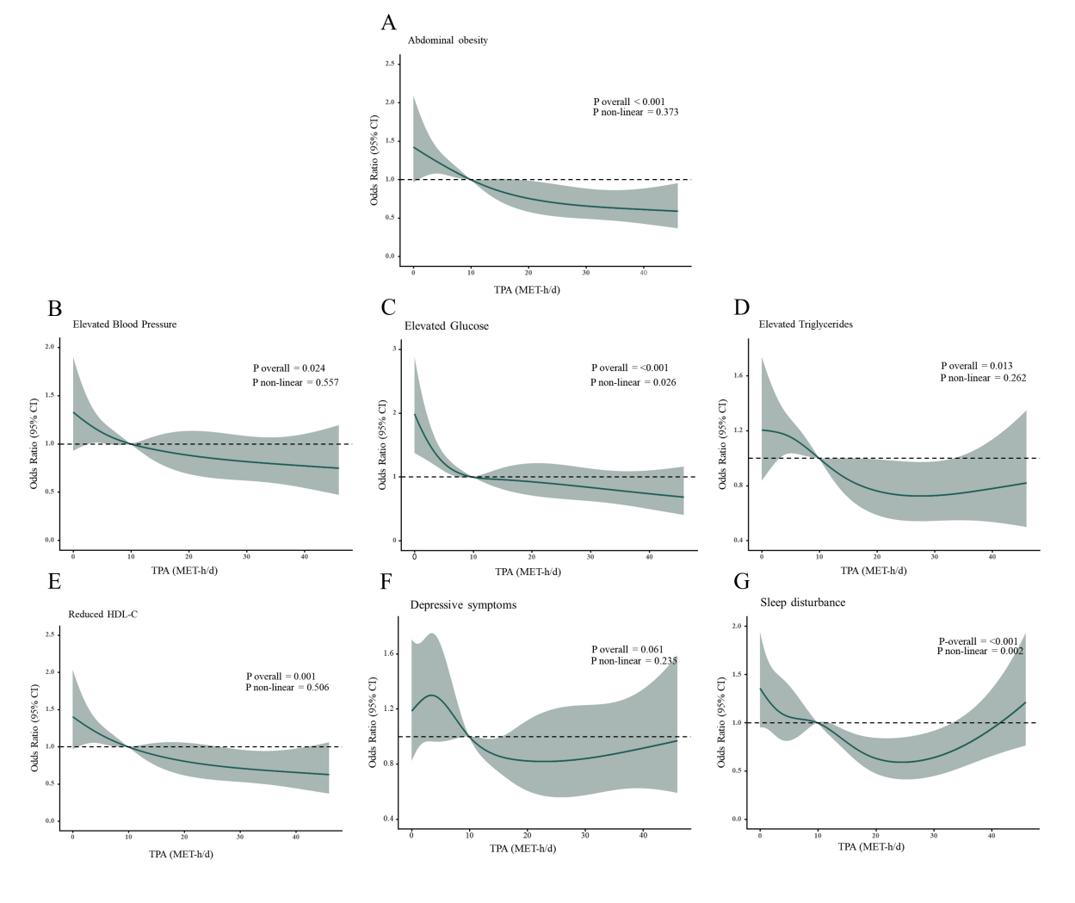
Figure S5. Restricted cubic spline curves for the associations of TPA with components of CircS among all study participants.(A) The RCS curve of the association between TPA and abdominal obesity; (B) the RCS curve of the association between TPA and elevated blood pressure; (C) the RCS curve of the association between TPA and elevated glucose; (D) the RCS curve of the association between TPA and elevated triglycerides; (E) the RCS curve of the association between TPA and reduced HDL-C; (F) the RCS curve of the association between TPA and depressive symptoms; and (G) the RCS curve of the association between TPA and sleep disturbance. The solid line represents the adjusted odds ratio (OR), and the shaded area represents the 95% confidence interval (CI). The horizontal dashed line indicates an OR of 1.0. P values for the overall and nonlinear associations are shown in each panel. The RCS regression models were adjusted for Age, Gender, Residential area, Marital status, Education level, Current smoking status, Current drinking status, Health insurance, and Number of children. RCS, restricted cubic spline; TPA, total physical activity; CircS, circadian syndrome; HDL-C, high-density lipoprotein cholesterol; OR, odds ratio; CI, confidence interval.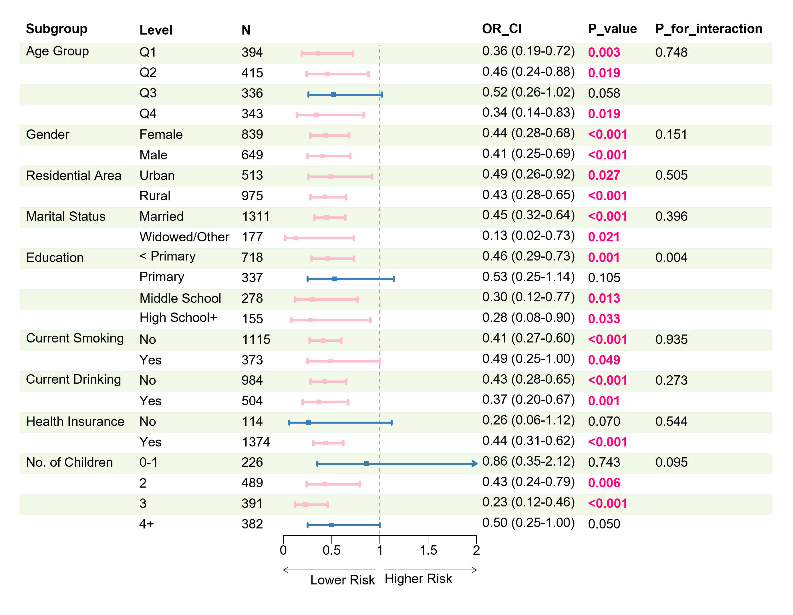
Figure S6. Subgroup analysis and interaction between TPA and Circadian Syndrome.The subgroup analysis was based on Model 3, adjusted for age, gender, residential area, marital status, education level, current smoking status, current drinking status, health insurance, and number of children. The highest quartile of TPA (Q4) was compared with the lowest quartile of TPA (Q1), which served as the reference category. OR, odds ratio; CI, confidence interval; TPA, total physical activity.

