Supplemental e-material
Table S1: Search Strategy
Table S2: Detailed characteristics of the interventions
Table S3: Assessment of heterogeneity for depressive symptoms
Table S4: League table for depressive symptoms
Table S5: Assessment of inconsistency for depressive symptoms
Table S6: Assessment of heterogeneity for anxiety symptoms
Table S7: League table for anxiety symptoms
Table S8: Assessment of inconsistency for anxiety symptoms
Table S9: Sensitivity analysis excluding studies at high risk of bias
Table S10: Sensitivity analysis excluding studies without mental health outcomes as the primary outcomes
Table S11: Certainty of evidence of depression outcome in network meta-analysis
Table S12: Certainty of evidence of anxiety outcome in network meta-analysis
Figure S1: Study selection flowchart of randomized controlled trials
Figure S2: Network plot from the Bayesian network meta-analysis of depression outcomes
Figure S3: Network plot from the Bayesian network meta-analysis of anxiety outcomes
Figure S4: Risk of bias summary
Figure S5: Risk of bias graph

Table S1: Search Strategy

MEDLINE (adapted for EMBASE, CENTRAL)
1 | exp Diet/
2 | exp Diet, Food, and Nutrition/ or exp Dietary Supplement/
3 | exp Nutrition Therapy/ or exp Diet Therapy/
4 | (Diet* or Dietar*).ab,kw,ti.
5 | 1 or 2 or 3 or 4
6 | exp Depression/ or exp Depressive Disorder/ or exp Anxiety/ or exp Anxiety Disorders/
7 | (Depression* or Depressive or Anxiety or Mood).ab,kw,ti.
8 | 6 or 7
9 | exp Cardiovascular Diseases/ or exp Cardiometabolic Risk Factors/ or exp Metabolic Syndrome/ or exp Overweight/ or exp Obesity/ or exp Hypertension/ or exp Hyperlipidemias/ or exp Diabetes Mellitus/
10 | (cardiometabolic or cardiovascular).ab,kw,ti.
11 | 9 or 10
12 | ((randomized controlled trial or controlled clinical trial or clinical trial).pt. or randomized.ab. or randomised.ab. or placebo.ab. or randomly.ab. or trial.ti. or groups.ab.) not (animals/ not humans/)
13 | 5 and 8 and 11 and 12

PUBMED
1 | "Diet"[Mesh] OR "Diet, Food, and Nutrition"[Mesh] OR "Dietary Supplements"[Mesh]
2 | "Nutrition Therapy"[Mesh]
3 | "Diet Therapy"[Mesh]
4 | Diets[Title/Abstract] OR Diet Therapies[Title/Abstract]
5 | 1 OR 2 OR 3 OR 4
6 | "Cardiometabolic Risk Factors"[Mesh] OR "Cardiovascular Diseases"[Mesh]
7 | "Metabolic Syndrome"[Mesh]
8 | "Overweight"[Mesh] OR "Diabetes Mellitus"[Mesh] OR "Obesity"[Mesh] OR "Hypertension"[Mesh] OR "Hyperlipidemias"[Mesh]
9 | cardiometabolic[Title/Abstract] OR cardiovascular risk [Title/Abstract]
10 | 6 OR 7 OR 8 OR 9
11 | "Depression"[Mesh] OR "Depressive Disorder"[Mesh] OR "Anxiety"[Mesh] OR "Anxiety Disorders"[Mesh] OR Depression[Title/Abstract] OR Depressive[Title/Abstract] OR Anxiety[Title/Abstract] OR Mood[Title/Abstract]
12 | "randomized controlled trial" [Publication Type] OR "controlled clinical trial" [Publication Type] OR "randomly" [Title/Abstract] OR "randomized" [Title/Abstract] OR "trial" [Title/Abstract]
13 | 5 AND 10 AND 11 AND 12

Table S2: Detailed characteristics of the interventions
Trial | Intervention | Intervention duration | Dietary targets/intervention characteristics | Compliance rate
Özbey-Yücel et al., 2023 | Hypocaloric diet | 12 weeks | Macronutrient distribution: 10–20% protein, 45–60% carbohydrate, and 20–35% fat; achieve sufficient weight loss (≈5–10%) | 87.0%
Kakoschke et al., 2021 | Low-fat diet | 2 years | Diet composition: 53% carbohydrate, 17% protein, and 30% fat (<10% saturated fat) | 93.0%
Bot et al., 2019 | Mediterranean-style diet | 1 year | Mediterranean-style dietary pattern combined with food-related behavioral activation and dietary habit modification | 91.0%
Tan et al., 2016 | Hypocaloric diet | 6 months | Energy-restricted diet with gradual reduction of 300–500 kcal/day; target macronutrient distribution: 40–45% carbohydrate, 20% protein, and 35–40% fat | 85.7%
Agarwal et al., 2015 | Low-fat diet | 18 weeks | Low-fat plant-based diet emphasizing fruits, vegetables, whole grains, and legumes; fat intake target <3 g per serving | 63.5%
Senna et al., 2012 | Hypocaloric diet | 6 months | Conventional energy-restricted diet (~1,200 kcal/day): 15–20% protein, 50–55% carbohydrate, and ~30% fat | 95.3%
Imayama et al., 2011 | Hypocaloric diet | 24 weeks | Reduced-calorie weight-loss intervention (1,200–2,000 kcal/day according to baseline weight); ≤30% energy from fat; target 10% weight loss | 89.0%
Einvik et al., 2010 | Low-fat diet | 3 years | Increased intake of vegetable oils, vegetables, fruits, and fish; reduced meat and animal fat intake; calorie restriction recommended for participants with overweight | Not reported
Jenkinson et al., 2009 | Hypocaloric diet | 24 months | Individualized dietary counseling targeting a 600 kcal/day energy deficit and weight loss of 0.5–1.0 kg/week through reduced fat/sugar intake and increased fruit and vegetable consumption | 45%
Brinkworth et al., 2009 | Low-fat diet | 52 weeks | Energy-restricted diet (~1,433 kcal/day for women and 1,672 kcal/day for men); 46% carbohydrate, 24% protein, and 30% fat (<8% saturated fat) | Not reported
Hyyppä et al., 2003 | Mediterranean-style diet | 12 weeks | Mediterranean-style dietary pattern | Not reported
Kiernan et al., 2001 | Low-fat diet | 1 year | Low-fat dietary program based on National Cholesterol Education Program Step 1 recommendations, including reduction of saturated fat intake | Not reported
Nieman et al., 2000 | Hypocaloric diet | 12 weeks | Energy-restricted diet (1,200–1,300 kcal/day) based on dietary exchange system with individualized dietitian guidance | Not reported
Wardle et al., 2000 | Low-fat diet | 12 weeks | Reduced-fat dietary pattern targeting fat intake <20% of total energy, mainly through reduction of saturated fat | Not reported

Table S3: Assessment of heterogeneity for depressive symptoms
Intervention | pairwise I² | consistency I²
Global I-squared | 0 | 0
Compared with control
Hypocaloric diet | 39.69% | 39.74%
Low-fat diet | 0 | 0
Mediterranean-style diet | 0 | 0
Low-carbohydrate diet | NA | NA
Compared with low-carbohydrate diet
Hypocaloric diet | NA | NA
Low-fat diet | 0 | 0
Mediterranean-style diet | NA | NA
Compared with mediterranean-style diet
Hypocaloric diet | NA | NA
Low-fat diet | 0 | 0
Compared with low-fat diet
Hypocaloric diet | NA | NA

Table S4: League table for depressive symptoms
Hypocaloric diet
-0.21 (-0.47, 0.045) | Low-fat diet
-0.265 (-0.552, -0.014) | -0.058 (-0.307, 0.165) | Mediterranean-style diet
-0.467 (-0.892, -0.067) | -0.26 (-0.589, 0.059) | -0.202 (-0.596, 0.201) | Low‑carbohydrate diet
-0.314 (-0.519, -0.124) | -0.104 (-0.271, 0.062) | -0.049 (-0.209, 0.144) | 0.153 (-0.205, 0.522) | Control

Table S5: Assessment of inconsistency for depressive symptoms
Comparison |  |  | Network estimate (95% CrI) | P for inconsistency
  Direct estimate (95% CrI)
  Indirect estimate (95% CrI)
Mediterranean-style diet vs.  Low-fat diet | 0.02 (-0.60,0.61) | 0.06 (-0.22,0.43) | 0.06 (-0.17,0.31) | 0.884

Table S6: Assessment of heterogeneity for anxiety symptoms
Intervention | pairwise I² | consistency I²
Global I-squared | 0 | 0
Compared with control
Hypocaloric diet | 39.71% | 39.68%
Low-fat diet | 0 | 0
Mediterranean-style diet | 0 | 0
Low-carbohydrate diet | NA | NA
Compared with low-carbohydrate diet
Hypocaloric diet | NA | NA
Low-fat diet | 0 | 0
Mediterranean-style diet | NA | NA
Compared with mediterranean-style diet
Hypocaloric diet | NA | NA
Low-fat diet | 0 | 0
Compared with low-fat diet
Hypocaloric diet | NA | NA

Table S7: League table for anxiety symptoms
Hypocaloric diet
-0.03 (-0.356, 0.267) | Low-fat diet
-0.038 (-0.385, 0.254) | -0.005 (-0.278, 0.221) | Mediterranean-style diet
-0.518 (-0.993, -0.065) | -0.485 (-0.829, -0.144) | -0.481 (-0.886, -0.039) | Low‑carbohydrate diet
-0.092 (-0.358, 0.157) | -0.061 (-0.24, 0.119) | -0.057 (-0.215, 0.158) | 0.427 (0.038, 0.816) | Control

Table S8: Assessment of inconsistency for anxiety symptoms
Comparison |  |  | Network estimate (95% CrI) | P for inconsistency
  Direct estimate (95% CrI)
  Indirect estimate (95% CrI)
Mediterranean-style diet vs.  Low-fat diet | -0.07 (-0.70, 0.56) | 0.01 (-0.30, 0.44) | 0.01 (-0.22, 0.28) | 0.823

Table S9: Sensitivity analysis excluding studies at high risk of bias
Intervention | Depression | Anxiety
Compared with control
Hypocaloric diet | -0.35 (-0.96, 0.23) | NA
Low-fat diet | -0.11 (-0.52, 0.26) | -0.06 (-0.46, 0.32)
Mediterranean-style diet | -0.04 (-0.44, 0.46) | -0.05 (-0.43, 0.47)
Low-carbohydrate diet | 0.26 (-0.59, 1.08) | 0.64 (-0.23, 1.47)
Compared with low-carbohydrate diet
Hypocaloric diet | -0.61 (-1.62, 0.42) | NA
Low-fat diet | -0.38 (-1.11, 0.38) | -0.7 (-1.44, 0.06)
Mediterranean-style diet | -0.29 (-1.18, 0.73) | -0.67 (-1.57, 0.36)
Compared with mediterranean-style diet
Hypocaloric diet | -0.31 (-1.11, 0.37) | NA
Low-fat diet | -0.08 (-0.74, 0.45) | -0.02 (-0.69, 0.51)
Compared with low-fat diet
Hypocaloric diet | -0.23 (-0.94, 0.45) | NA

NA: not applicable

Table S10: Sensitivity analysis excluding studies without mental health outcomes as the primary outcomes
Intervention | Depression | Anxiety
Compared with control
Hypocaloric diet | -0.38 (-0.66, -0.12) | -0.22 (-0.6, 0.14)
Low-fat diet | -0.1 (-0.29, 0.07) | -0.06 (-0.24, 0.12)
Mediterranean-style diet | -0.05 (-0.22, 0.17) | -0.06 (-0.22, 0.17)
Low-carbohydrate diet | 0.16 (-0.23, 0.55) | 0.42 (0.03, 0.82)
Compared with low-carbohydrate diet
Hypocaloric diet | -0.54 (-1.03, -0.09) | -0.64 (-1.19, -0.13)
Low-fat diet | -0.27 (-0.61, 0.08) | -0.48 (-0.84, -0.13)
Mediterranean-style diet | -0.2 (-0.62, 0.23) | -0.48 (-0.9, -0.03)
Compared with mediterranean-style diet
Hypocaloric diet | -0.34 (-0.71, -0.02) | -0.17 (-0.61, 0.22)
Low-fat diet | -0.06 (-0.34, 0.18) | -0.01 (-0.29, 0.23)
Compared with low-fat diet
Hypocaloric diet | -0.28 (-0.61, 0.04) | -0.16 (-0.58, 0.24)

Table S11: Certainty of evidence of depression outcome in network meta-analysis
 | Risk of bias | Indirectness | Publication bias | Intransitivity | Incoherence | Imprecision | CoE

Control as reference
Hypocaloric diet | Serious | Not serious | Undetected | NA | NA | Not serious | Moderate
Low-fat diet | Serious | Not serious | Undetected | Not serious | Not serious | Not serious | Moderate
Mediterranean-style diet | Serious | Not serious | Undetected | Not serious | Not serious | Serious | Low
Low-carbohydrate diet | NA | Serious | NA | Not serious | NA | Very serious | Very low

Low-carbohydrate diet as reference
Hypocaloric diet | NA | Serious | NA | Not serious | NA | Serious | Low
Low-fat diet | Serious | Not serious | Undetected | NA | NA | Serious | Low
Mediterranean-style diet | NA | Serious | NA | Not serious | NA | Serious | Low

Mediterranean-style diet as reference
Hypocaloric diet | NA | Serious | NA | Not serious | NA | Serious | Low
Low-fat diet | Serious | Not serious | Undetected | Not serious | Not serious | Serious | Low

Low-fat diet as reference
Hypocaloric diet | NA | Serious | NA | Not serious | NA | Serious | Low

a. Risk of bias: Downgraded by one level because none of the included trials were judged to be at low risk of bias.
b. Indirectness: Downgraded by one level because most network comparisons were informed by indirect evidence, and limited direct head-to-head comparisons were available.
c. Publication bias: Not downgraded because no evidence of small-study effects or publication bias was detected by Egger’s test.
d. Intransitivity: Not downgraded because the included studies were considered sufficiently comparable in terms of key effect modifiers. Participants across studies generally had overweight or obesity (BMI ≥25 kg/m²) and fulfilled the criteria for elevated cardiometabolic risk.
e. Incoherence: Not downgraded because node-splitting analyses showed no statistically significant disagreement between direct and indirect evidence.
f. Imprecision: Downgraded by one or two levels depending on the comparison. One-level downgrading was applied when the number of contributing studies was limited and the credible intervals were relatively wide. Two-level downgrading was applied for comparisons with very limited evidence, where estimates were based on indirect evidence and the 95% credible intervals were wide, resulting in substantial uncertainty regarding the magnitude and direction of the effect estimates.
Table S12: Certainty of evidence of anxiety outcome in network meta-analysis
 | Risk of bias | Indirectness | Publication bias | Intransitivity | Incoherence | Imprecision | CoE

Control as reference
Hypocaloric diet | Serious | Not serious | Undetected | NA | NA | Serious | Low
Low-fat diet | Serious | Not serious | Undetected | Not serious | Not serious | Not serious | Moderate
Mediterranean-style diet | Serious | Not serious | Undetected | Not serious | Not serious | Serious | Low
Low-carbohydrate diet | NA | Serious | NA | Not serious | NA | Very serious | Very low

Low-carbohydrate diet as reference
Hypocaloric diet | NA | Serious | NA | Not serious | NA | Serious | Low
Low-fat diet | Serious | Not serious | Undetected | NA | NA | Serious | Low
Mediterranean-style diet | NA | Serious | NA | Not serious | NA | Serious | Low

Mediterranean-style diet as reference
Hypocaloric diet | NA | Serious | NA | Not serious | NA | Serious | Low
Low-fat diet | Serious | Not serious | Undetected | Not serious | Not serious | Serious | Low

Low-fat diet as reference
Hypocaloric diet | NA | Serious | NA | Not serious | NA | Serious | Low

a. Risk of bias: Downgraded by one level because none of the included trials were judged to be at low risk of bias.
b. Indirectness: Downgraded by one level because most network comparisons were informed by indirect evidence, and limited direct head-to-head comparisons were available.
c. Publication bias: Not downgraded because no evidence of small-study effects or publication bias was detected by Egger’s test.
d. Intransitivity: Not downgraded because the included studies were considered sufficiently comparable in terms of key effect modifiers. Participants across studies generally had overweight or obesity (BMI ≥25 kg/m²) and fulfilled the criteria for elevated cardiometabolic risk.
e. Incoherence: Not downgraded because node-splitting analyses showed no statistically significant disagreement between direct and indirect evidence.
f. Imprecision: Downgraded by one or two levels depending on the comparison. One-level downgrading was applied when the number of contributing studies was limited and the credible intervals were relatively wide. Two-level downgrading was applied for comparisons with very limited evidence, where estimates were based on indirect evidence and the 95% credible intervals were wide, resulting in substantial uncertainty regarding the magnitude and direction of the effect estimates.

Figure S1: Study selection flowchart of randomized controlled trials

Figure S2: Network plot from the Bayesian network meta-analysis of depression outcomes. The width of each connecting line is proportional to the number of studies comparing each pair of interventions, and the size of each node reflects the total number of participants.
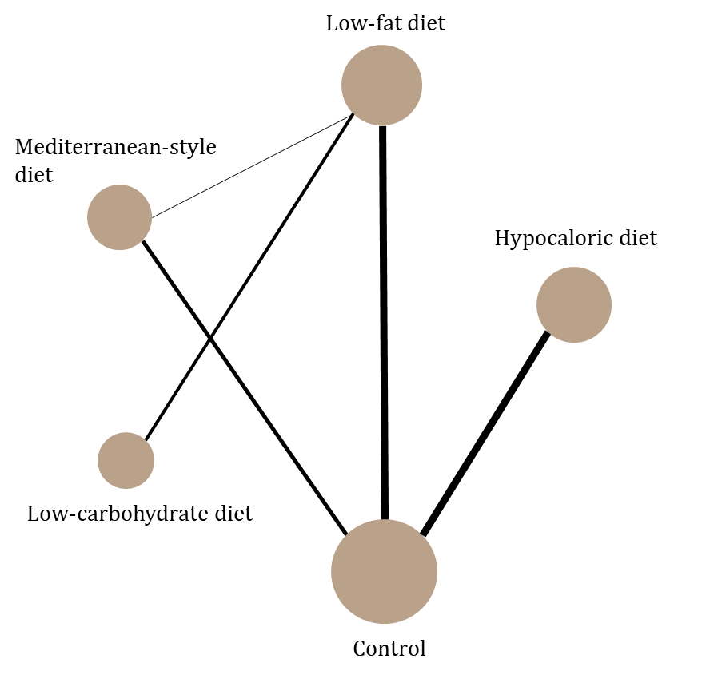

Figure S3: Network plot from the Bayesian network meta-analysis of anxiety outcomes. The width of each connecting line is proportional to the number of studies comparing each pair of interventions, and the size of each node reflects the total number of participants.
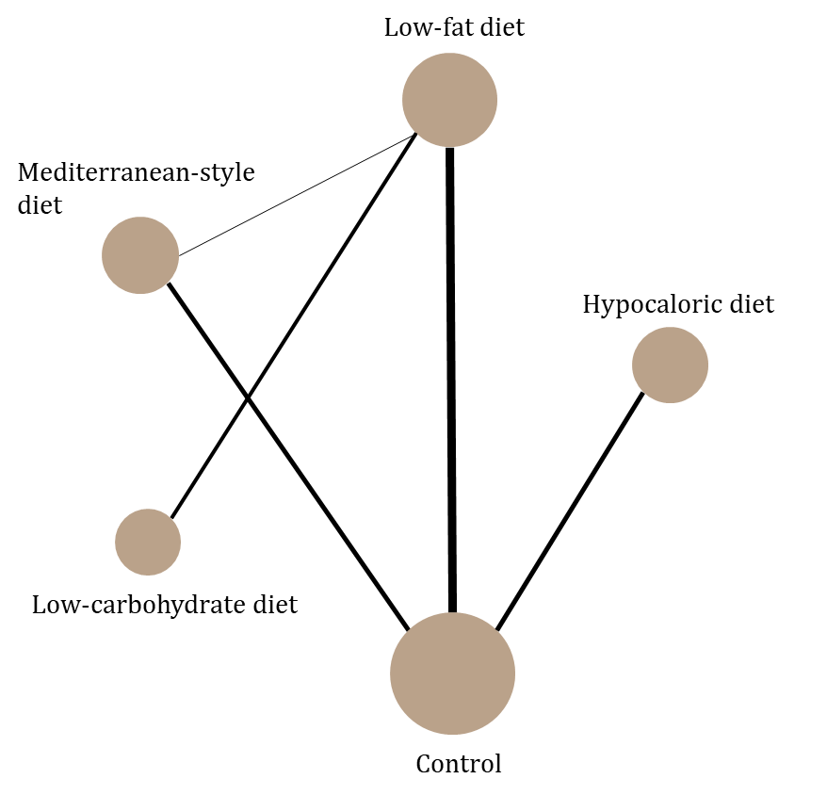

Figure S4: Risk of bias summary
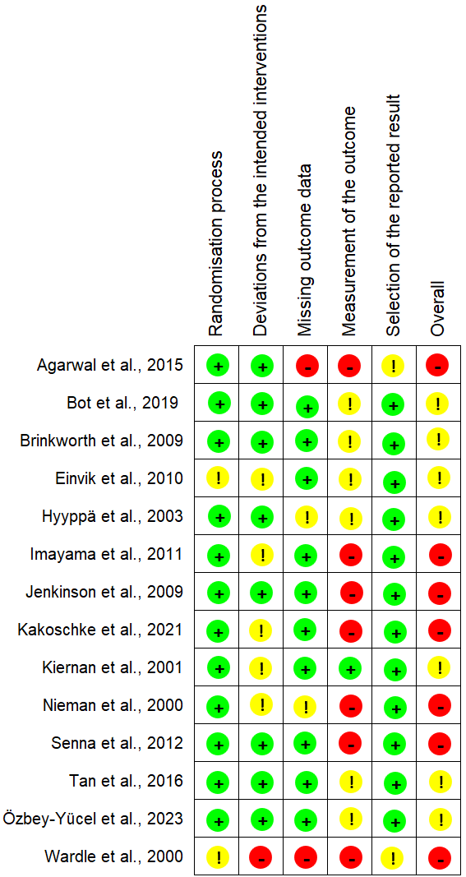

Figure S5: Risk of bias graph

