Additional file 3: Supplementary figures
Article title: Physical activity and sleep associations with episodic memory across four ageing cohorts: a coordinated within-person analysis
This file contains Supplementary Figures S1-S7.
Conventions used throughout
Points and whiskers show coefficients and 95% confidence intervals unless stated otherwise. Physical activity and the cohort-specific sleep indicator retain the same low-saturation colours across figures, with black text and redundant marker shapes. Random-effects summaries use restricted maximum-likelihood estimation and Hartung-Knapp-Sidik-Jonkman (HKSJ) inference unless stated otherwise.
List of supplementary figures
Figure | Title
Figure S1 | Record-level missingness and participant characteristics by eligibility for repeated-measures analysis
Figure S2 | HRS sleep-item construction and sensitivity to alternative source fields
Figure S3 | Current and next-observed exposure coefficients in the temporal-ordering sensitivity analysis
Figure S4 | Country-specific within-person associations within SHARE
Figure S5 | Observational lagged indirect associations through depression over two consecutive two-year intervals
Figure S6 | Transition-specific inverse-probability-of-censoring weighting diagnostics
Figure S7 | Sleep-item overlap, item information, and residual-dependence diagnostics

Figure S1. Record-level missingness and participant characteristics by eligibility for repeated-measures analysis
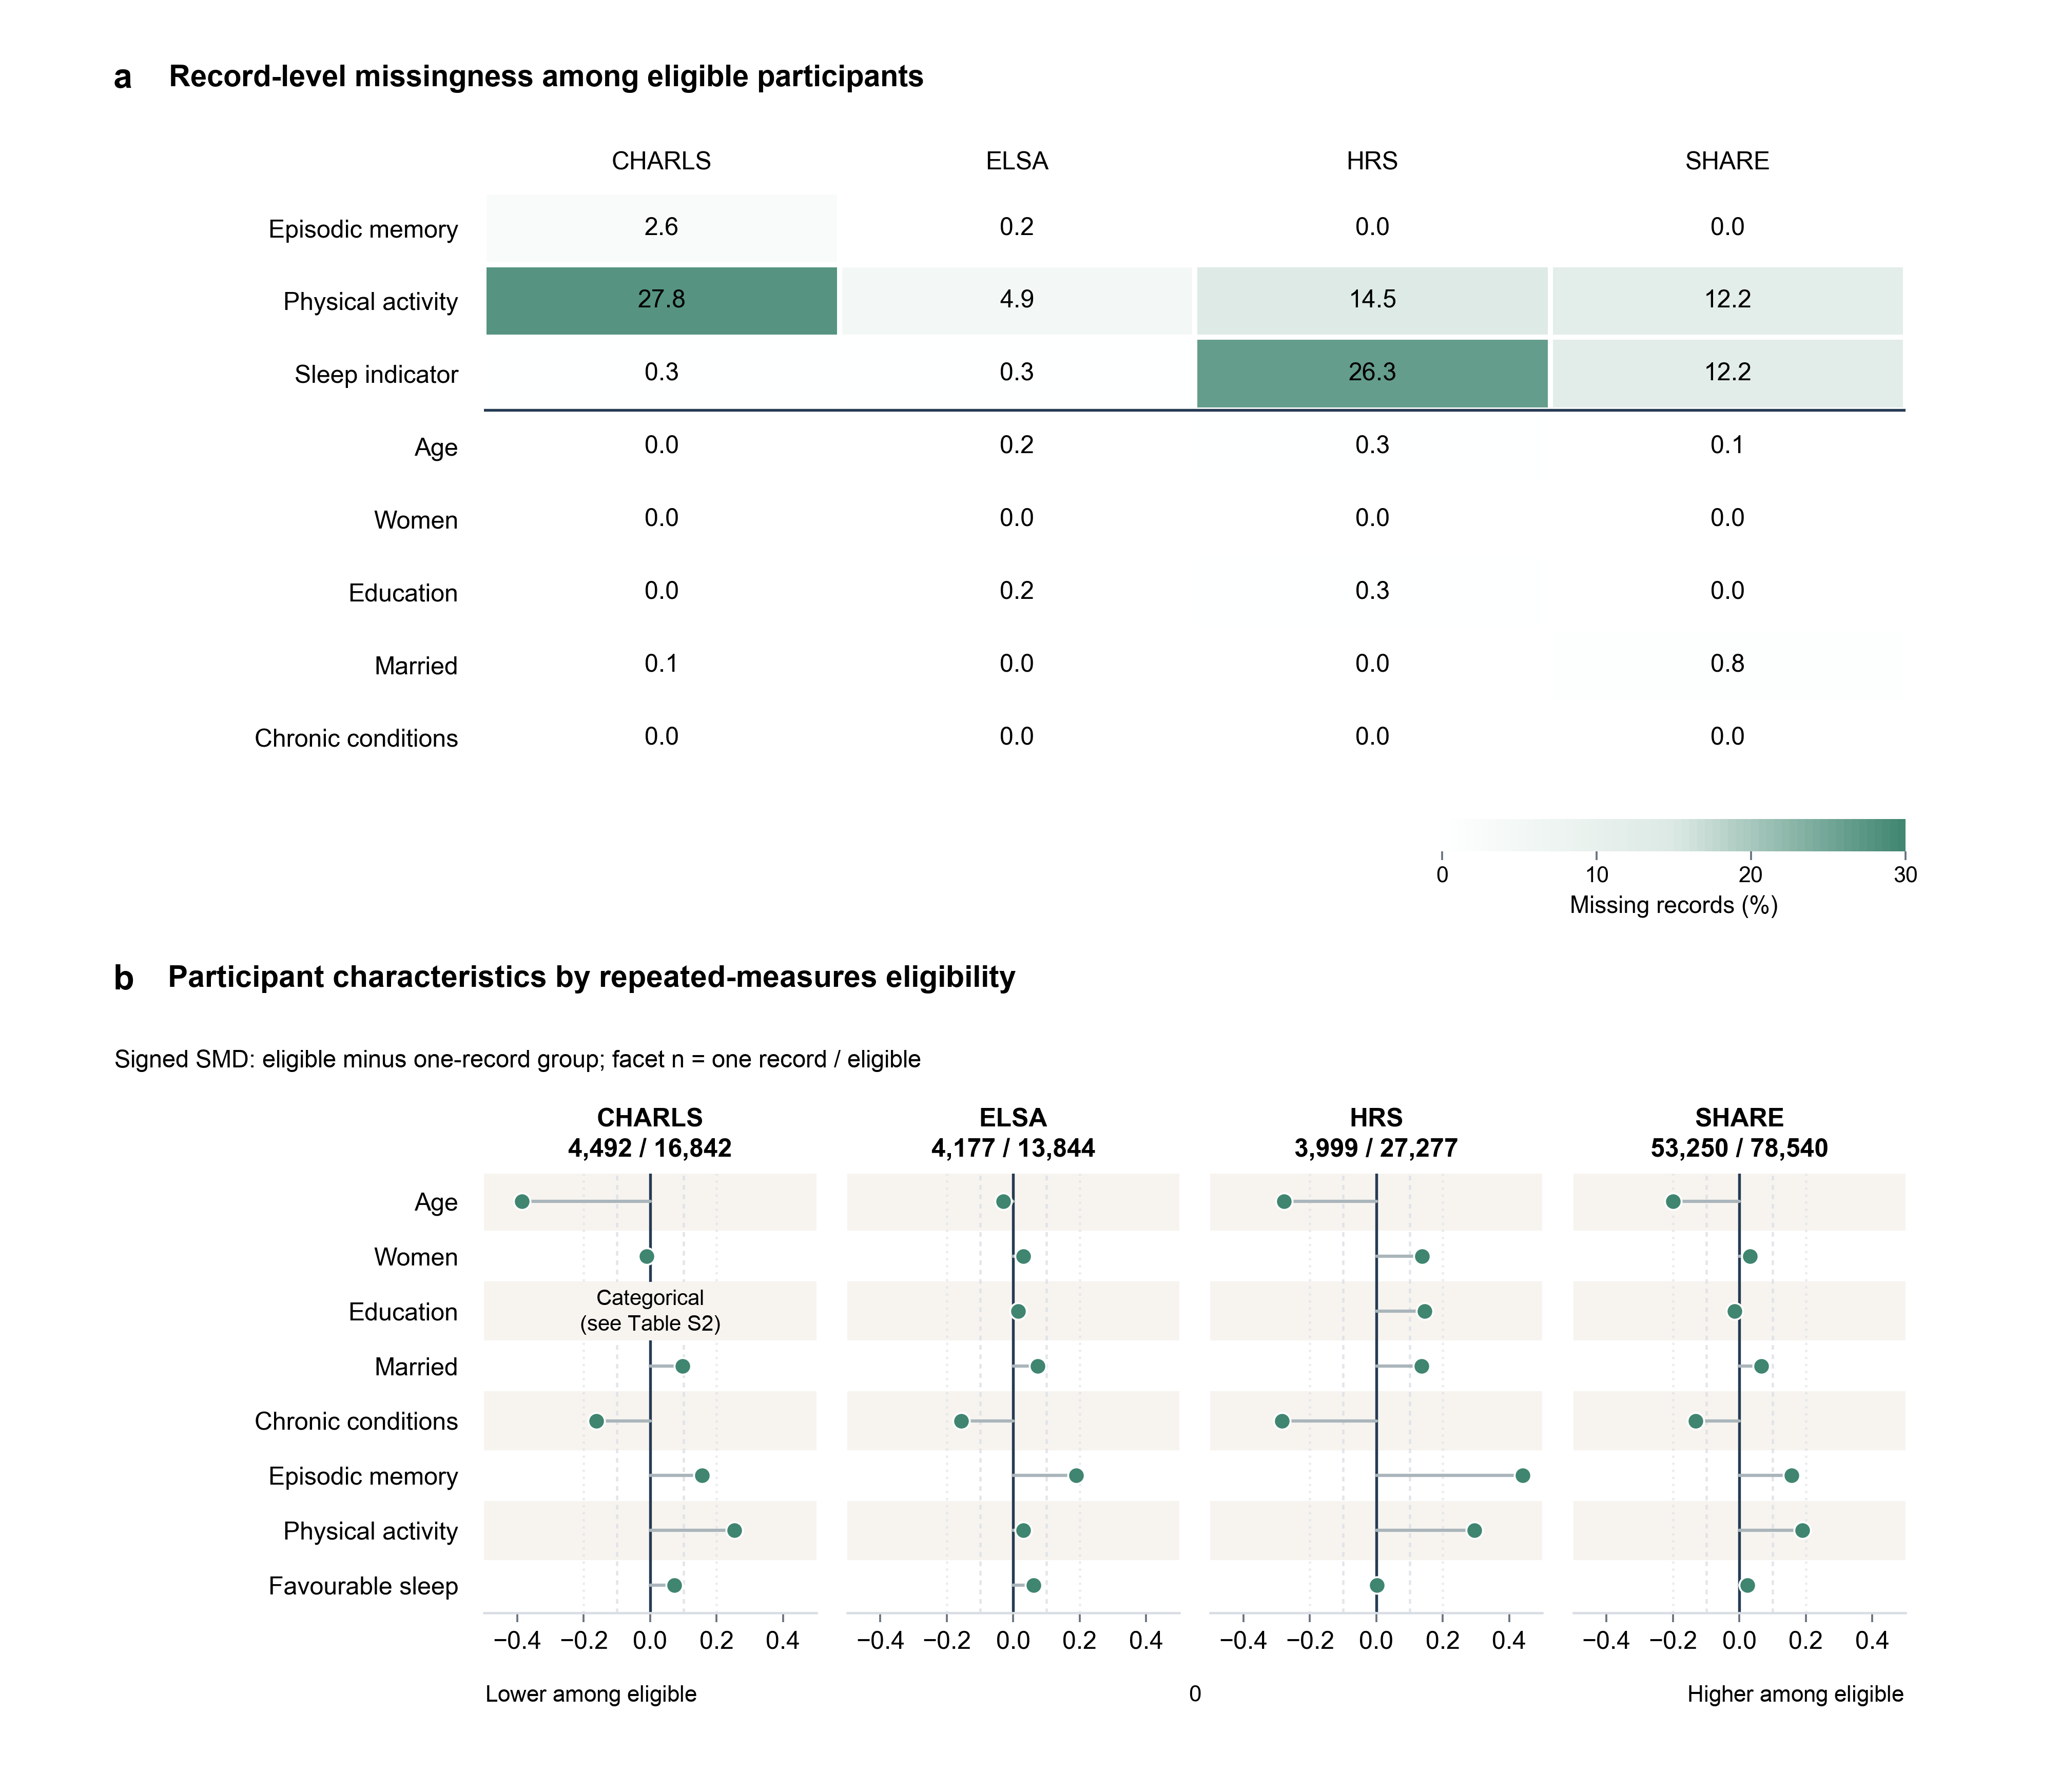
Figure S1. Record-level missingness and participant characteristics by eligibility for repeated-measures analysis. Panel a shows the percentage of survey records with missing values among participants who contributed at least two jointly complete records. The sleep row refers to the cohort-specific sleep indicator, and the horizontal rule separates the three focal study measures from the covariates. Panel b shows signed standardised mean differences comparing participants with at least two jointly complete records with those who contributed exactly one jointly complete record. Positive values indicate higher values in the eligible group, and negative values indicate lower values. Continuous variables were standardised using the square root of the mean of the two group variances; binary variables used the corresponding Bernoulli variance. CHARLS education was recorded in three categories, so no continuous education SMD is shown for this cohort; category frequencies are reported in Table S2. Cohort headings give the numbers of participants in the one-record and eligible groups. Vertical reference lines mark absolute standardised differences of 0.10 and 0.20 and are descriptive guides rather than hypothesis-test thresholds. SMD, standardised mean difference.

Figure S2. HRS sleep-item construction and sensitivity to alternative source fields
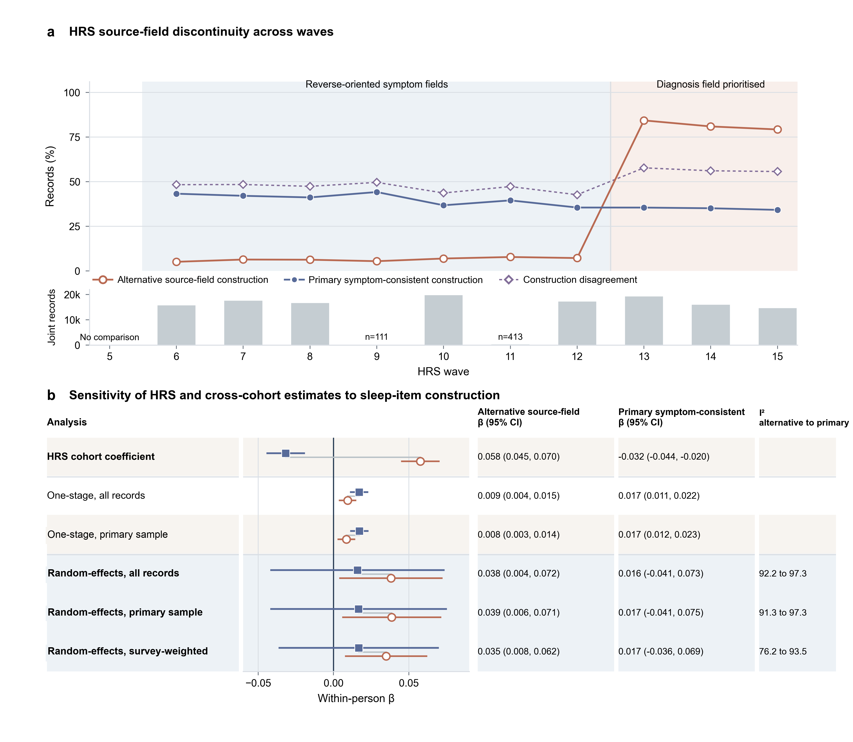
Figure S2. HRS sleep-item construction and sensitivity to alternative source fields. Panel a shows the percentage of favourable records under an alternative source-field construction, the percentage under the primary symptom-consistent construction, and the percentage for which the two indicators disagreed. Percentages use the non-missing records for each construction; disagreement is calculated among records in which both indicators were observed. The alternative construction combined reverse-oriented insomnia responses in waves 6 to 12 and prioritised a physician-diagnosed sleep-disorder field in waves 13 to 15. The primary construction applies a consistent direction to the three insomnia-symptom items and is used in all current analyses. Bars show the number of records in which both constructions were observed. Lines join wave summaries only to aid reading. Panel b compares within-person coefficients and 95% confidence intervals using the same episodic-memory outcome, which required both immediate and delayed recall. The comparison therefore isolates sensitivity to the HRS sleep-item construction. Rows labelled ‘primary sample’ apply the main eligibility requirement of at least two jointly complete records. One-stage estimates and random-effects summaries with HKSJ inference address different pooling estimands. HKSJ, Hartung-Knapp-Sidik-Jonkman; HRS, Health and Retirement Study.

Figure S3. Current and next-observed exposure coefficients in the temporal-ordering sensitivity analysis
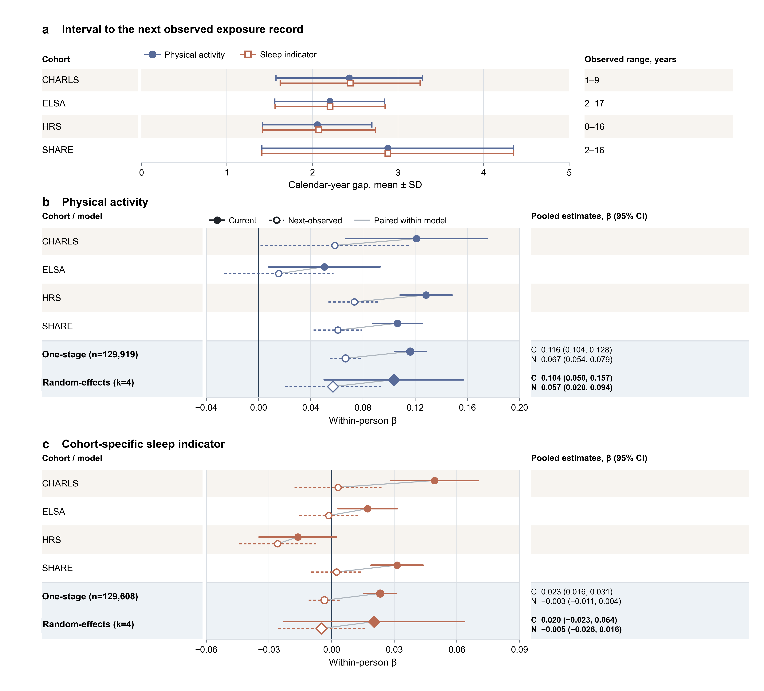
Figure S3. Current and next-observed exposure coefficients in the temporal-ordering sensitivity analysis. Panel a shows the mean calendar-year interval to the next observed exposure record, with whiskers indicating the standard deviation; the aligned text gives the observed minimum and maximum. Panels b and c show within-person coefficients and 95% confidence intervals for the current and next-observed values of physical activity and the cohort-specific sleep indicator. Both exposure values were included in the same model. Filled markers denote current values and open markers denote next-observed values. Circles show cohort-specific and one-stage estimates, and diamonds show four-cohort random-effects summaries with HKSJ confidence intervals. Lines between paired markers aid comparison and do not represent a statistical test. Observation intervals were not fixed lags. HRS included 209 transitions between distinct waves recorded in the same calendar year; excluding these transitions left the one-stage next-observed estimates nearly unchanged. An association between current memory and exposure measured at the next observed survey limits a causal interpretation of the contemporaneous association. It does not distinguish current memory predicting later exposure, time-varying confounding, or persistence of exposure and memory over time. The coefficient axes differ between panels b and c.

Figure S4. Country-specific within-person associations within SHARE
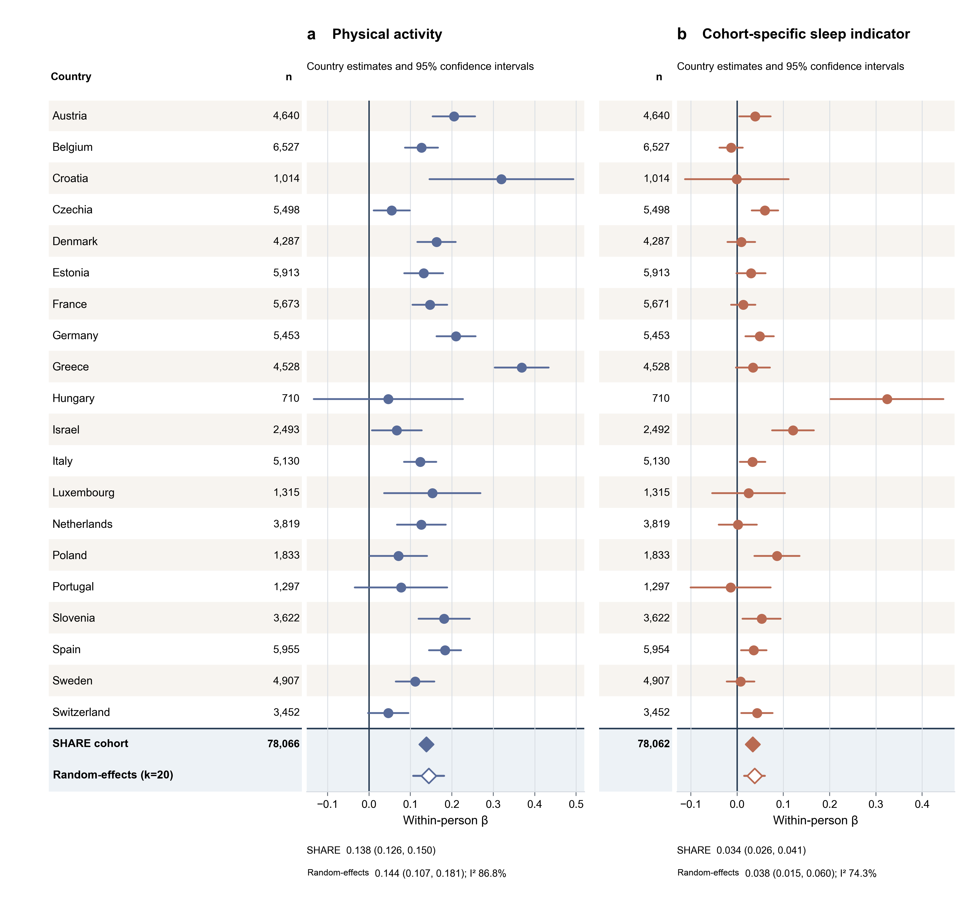
Figure S4. Country-specific within-person associations within SHARE. Points and horizontal lines show within-person coefficients and 95% confidence intervals for physical activity (panel a) and the cohort-specific sleep indicator (panel b) across the 20 countries for which country-specific models could be fitted. Coefficients are expressed in cohort-standardised episodic-memory units. The aligned n columns give exposure-specific participant counts. Circles show country estimates, filled diamonds show the SHARE cohort estimate, and open diamonds show the descriptive random-effects summary across countries with its HKSJ confidence interval. The country-level summaries are not additional primary pooled effects. Countries are listed alphabetically, and the coefficient axes differ between panels. No country-specific model could be fitted for nine countries because no participant met the repeated-measures eligibility criterion. HKSJ, Hartung-Knapp-Sidik-Jonkman; SHARE, Survey of Health, Ageing and Retirement in Europe.

Figure S5. Observational lagged indirect associations through depression over two consecutive two-year intervals
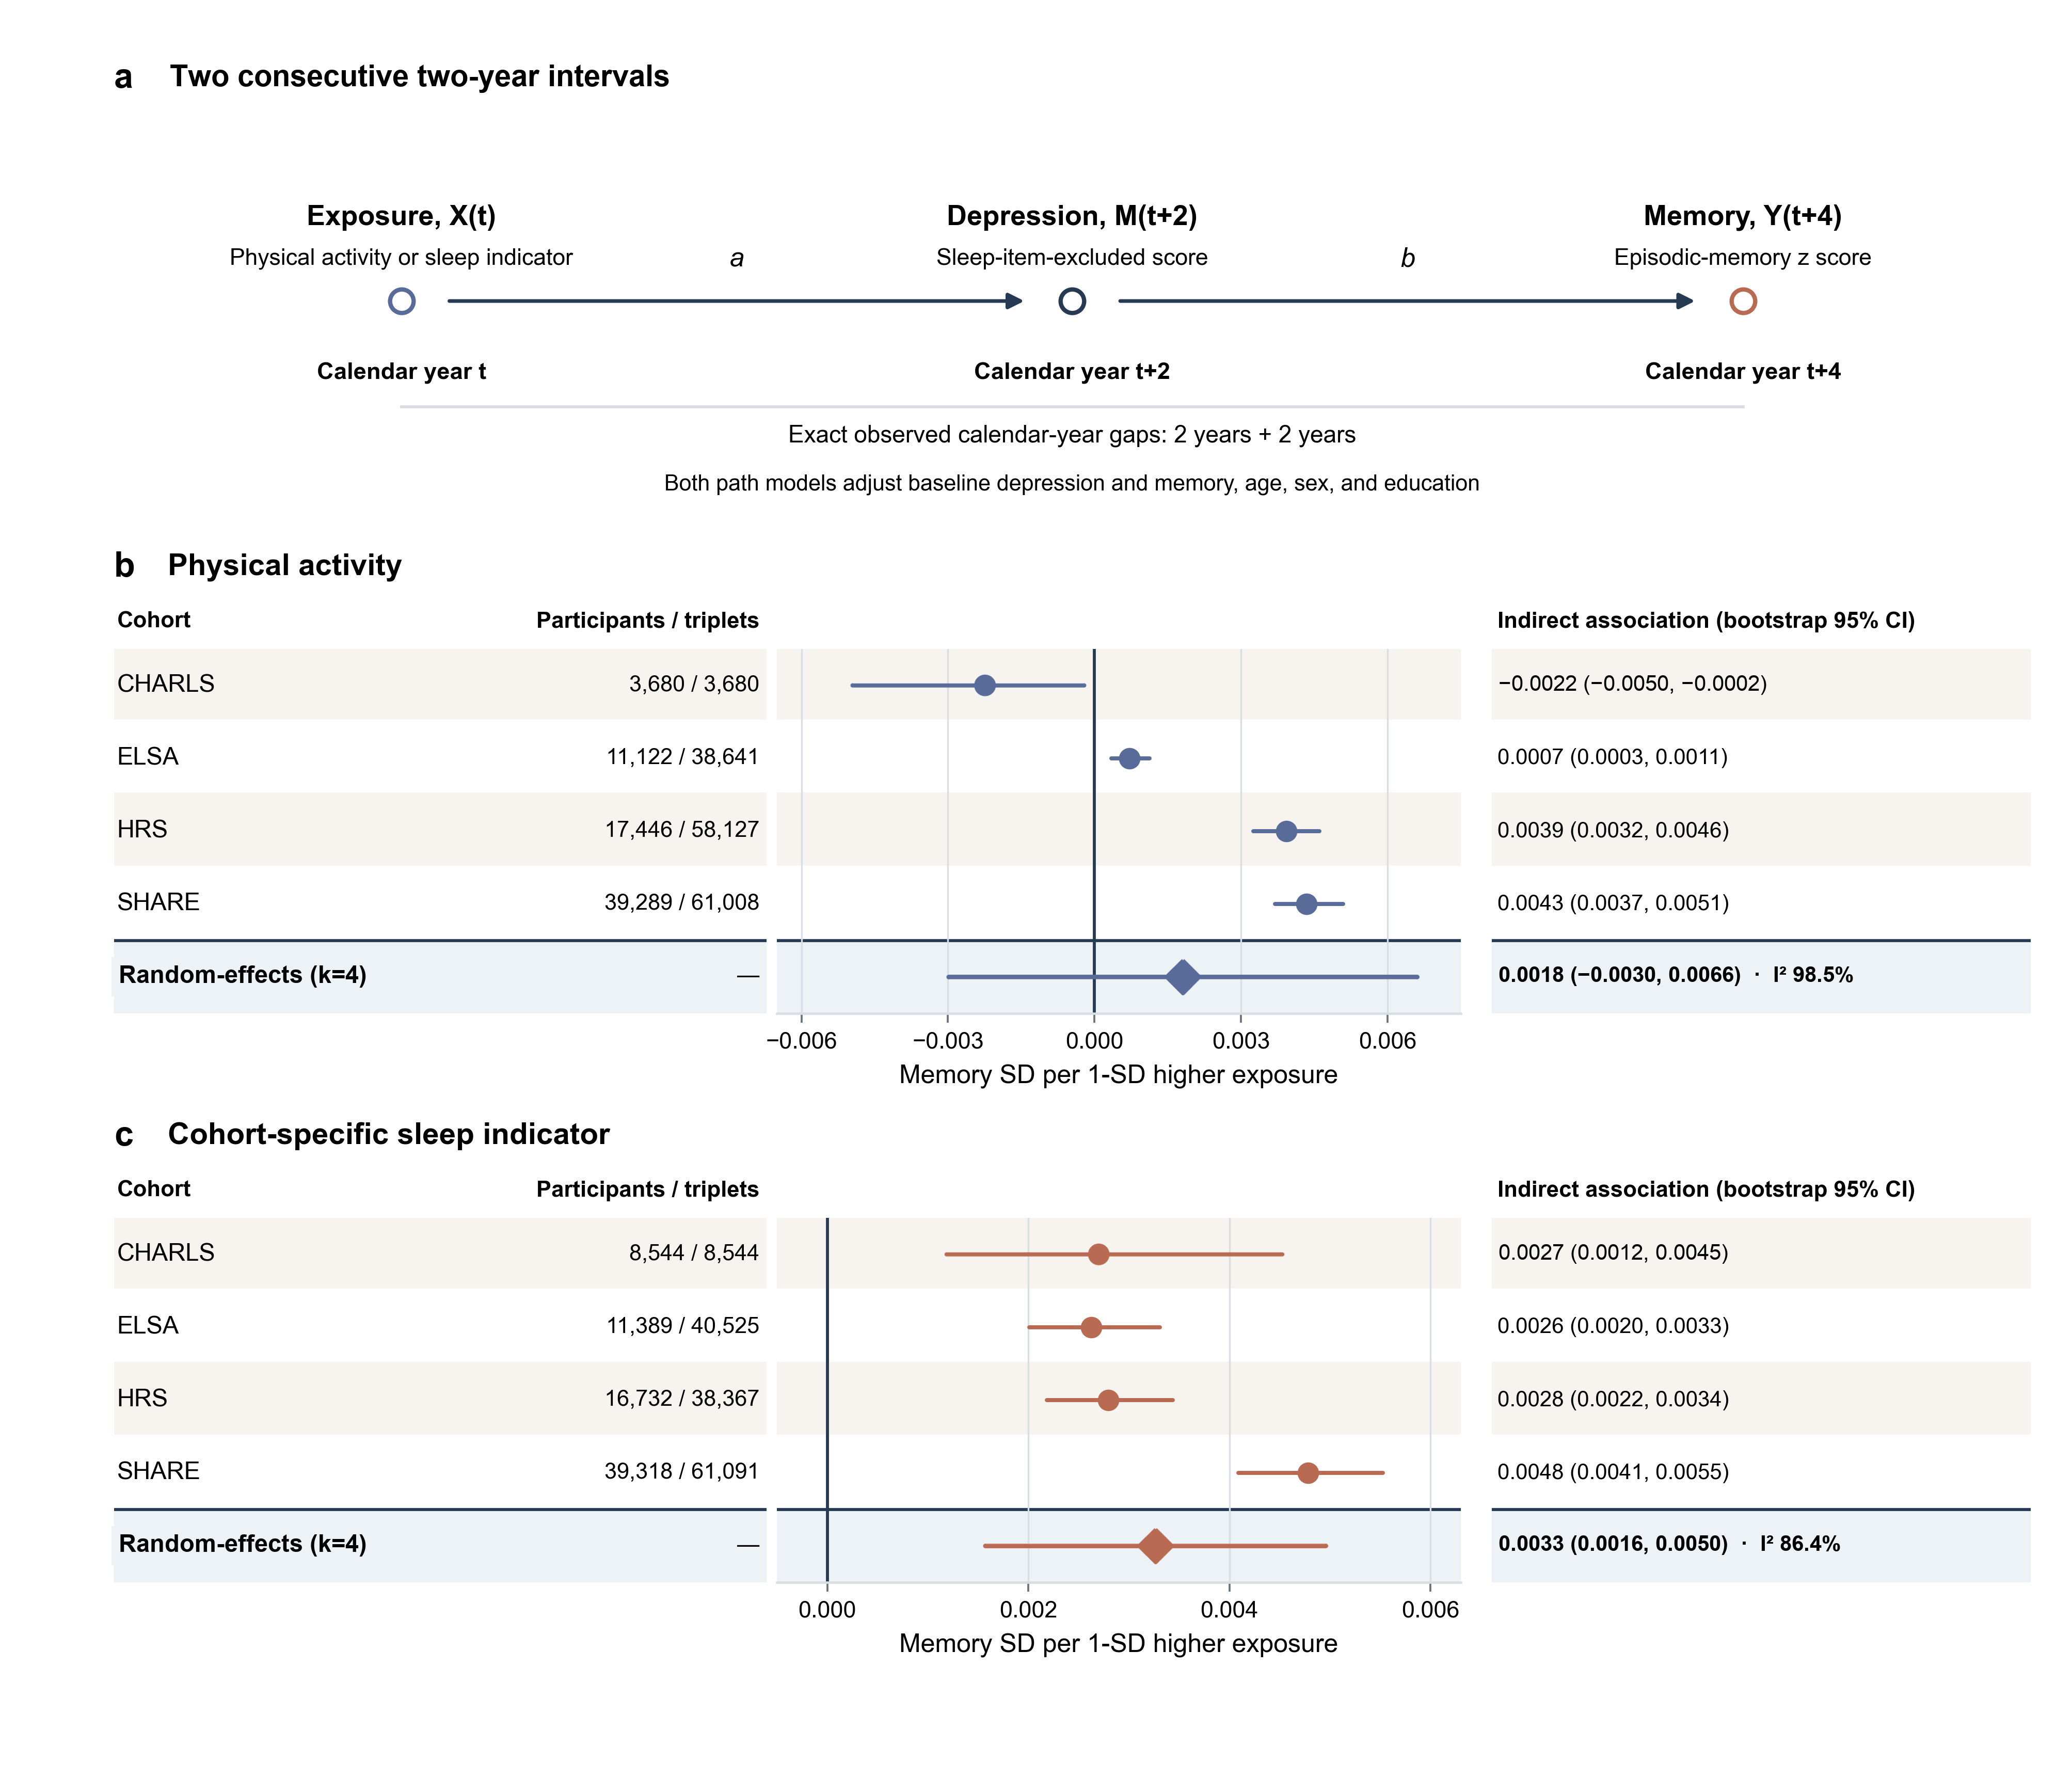
Figure S5. Observational lagged indirect associations through depression over two consecutive two-year intervals. Panel a shows the analytical sequence: physical activity or the cohort-specific sleep indicator at calendar year t, the depressive-symptom score without sleep items at t+2, and episodic memory at t+4. Both path models adjusted for baseline depressive symptoms and memory, age, sex, and education. Panels b and c show the product of the exposure-to-depression path and the depression-to-memory path for physical activity and sleep. Coefficients are memory standard-deviation units per one-standard-deviation higher exposure. Circles and horizontal lines show cohort estimates and participant-level bootstrap percentile 95% confidence intervals, with participants as the resampling unit. Diamonds show four-cohort random-effects summaries calculated using HKSJ inference and the bootstrap standard errors of the cohort estimates. The aligned columns report participants and eligible triplets. These estimates are observational lagged indirect associations and do not establish causal mediation.

Figure S6. Transition-specific inverse-probability-of-censoring weighting diagnostics
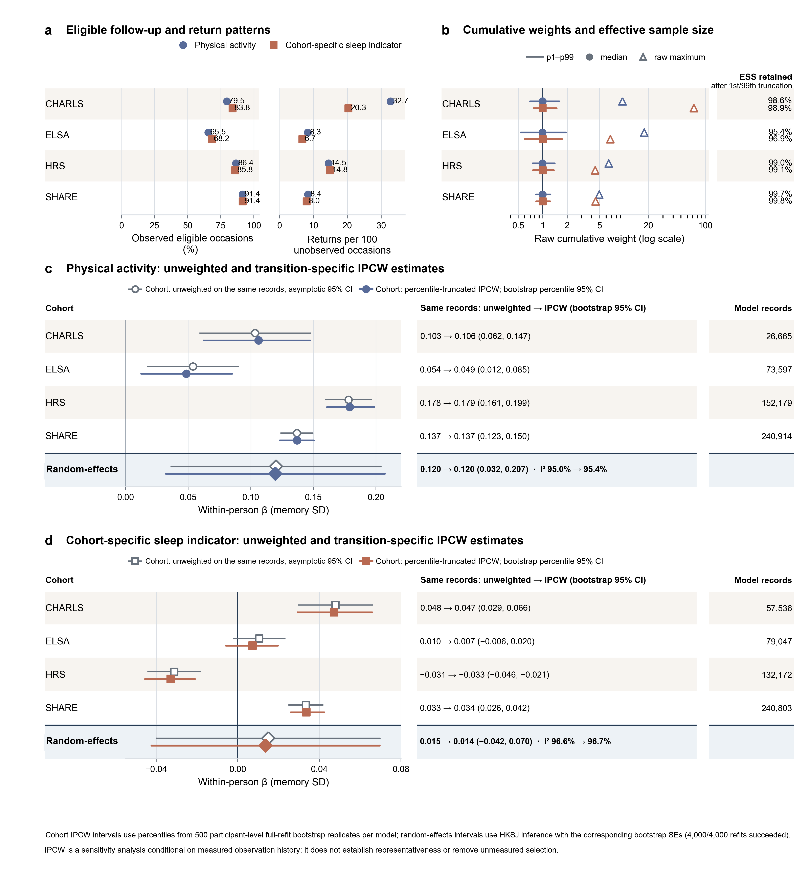
Figure S6. Transition-specific inverse-probability-of-censoring weighting diagnostics. Panel a shows the proportion of eligible follow-up occasions with an observed outcome and return events per 100 unobserved occasions. Panel b shows the raw cumulative-weight median and 1st to 99th percentile range on a logarithmic scale; open triangles mark raw maxima, and the aligned column gives effective sample size retained after truncation. Panels c and d compare unweighted and truncated transition-IPCW estimates for physical activity and the cohort-specific sleep indicator using the same eligible follow-up records. Coefficients are in memory standard-deviation units per one-unit increase in the 0-to-1 physical-activity index or a change from unfavourable to favourable sleep. Open markers and grey lines show unweighted estimates and asymptotic 95% confidence intervals; filled markers and coloured lines show transition-IPCW estimates and participant-level full-refit bootstrap percentile 95% confidence intervals. Diamonds show four-cohort random-effects summaries with HKSJ inference. Each model, one for each combination of cohort and exposure, used 500 bootstrap refits, and all 4,000 refits succeeded. This analysis assesses sensitivity to measured observation history; it does not establish population representativeness or remove bias from unmeasured selection factors. ESS, effective sample size; IPCW, inverse probability of censoring weighting.

Figure S7. Sleep-item overlap, item information, and residual-dependence diagnostics
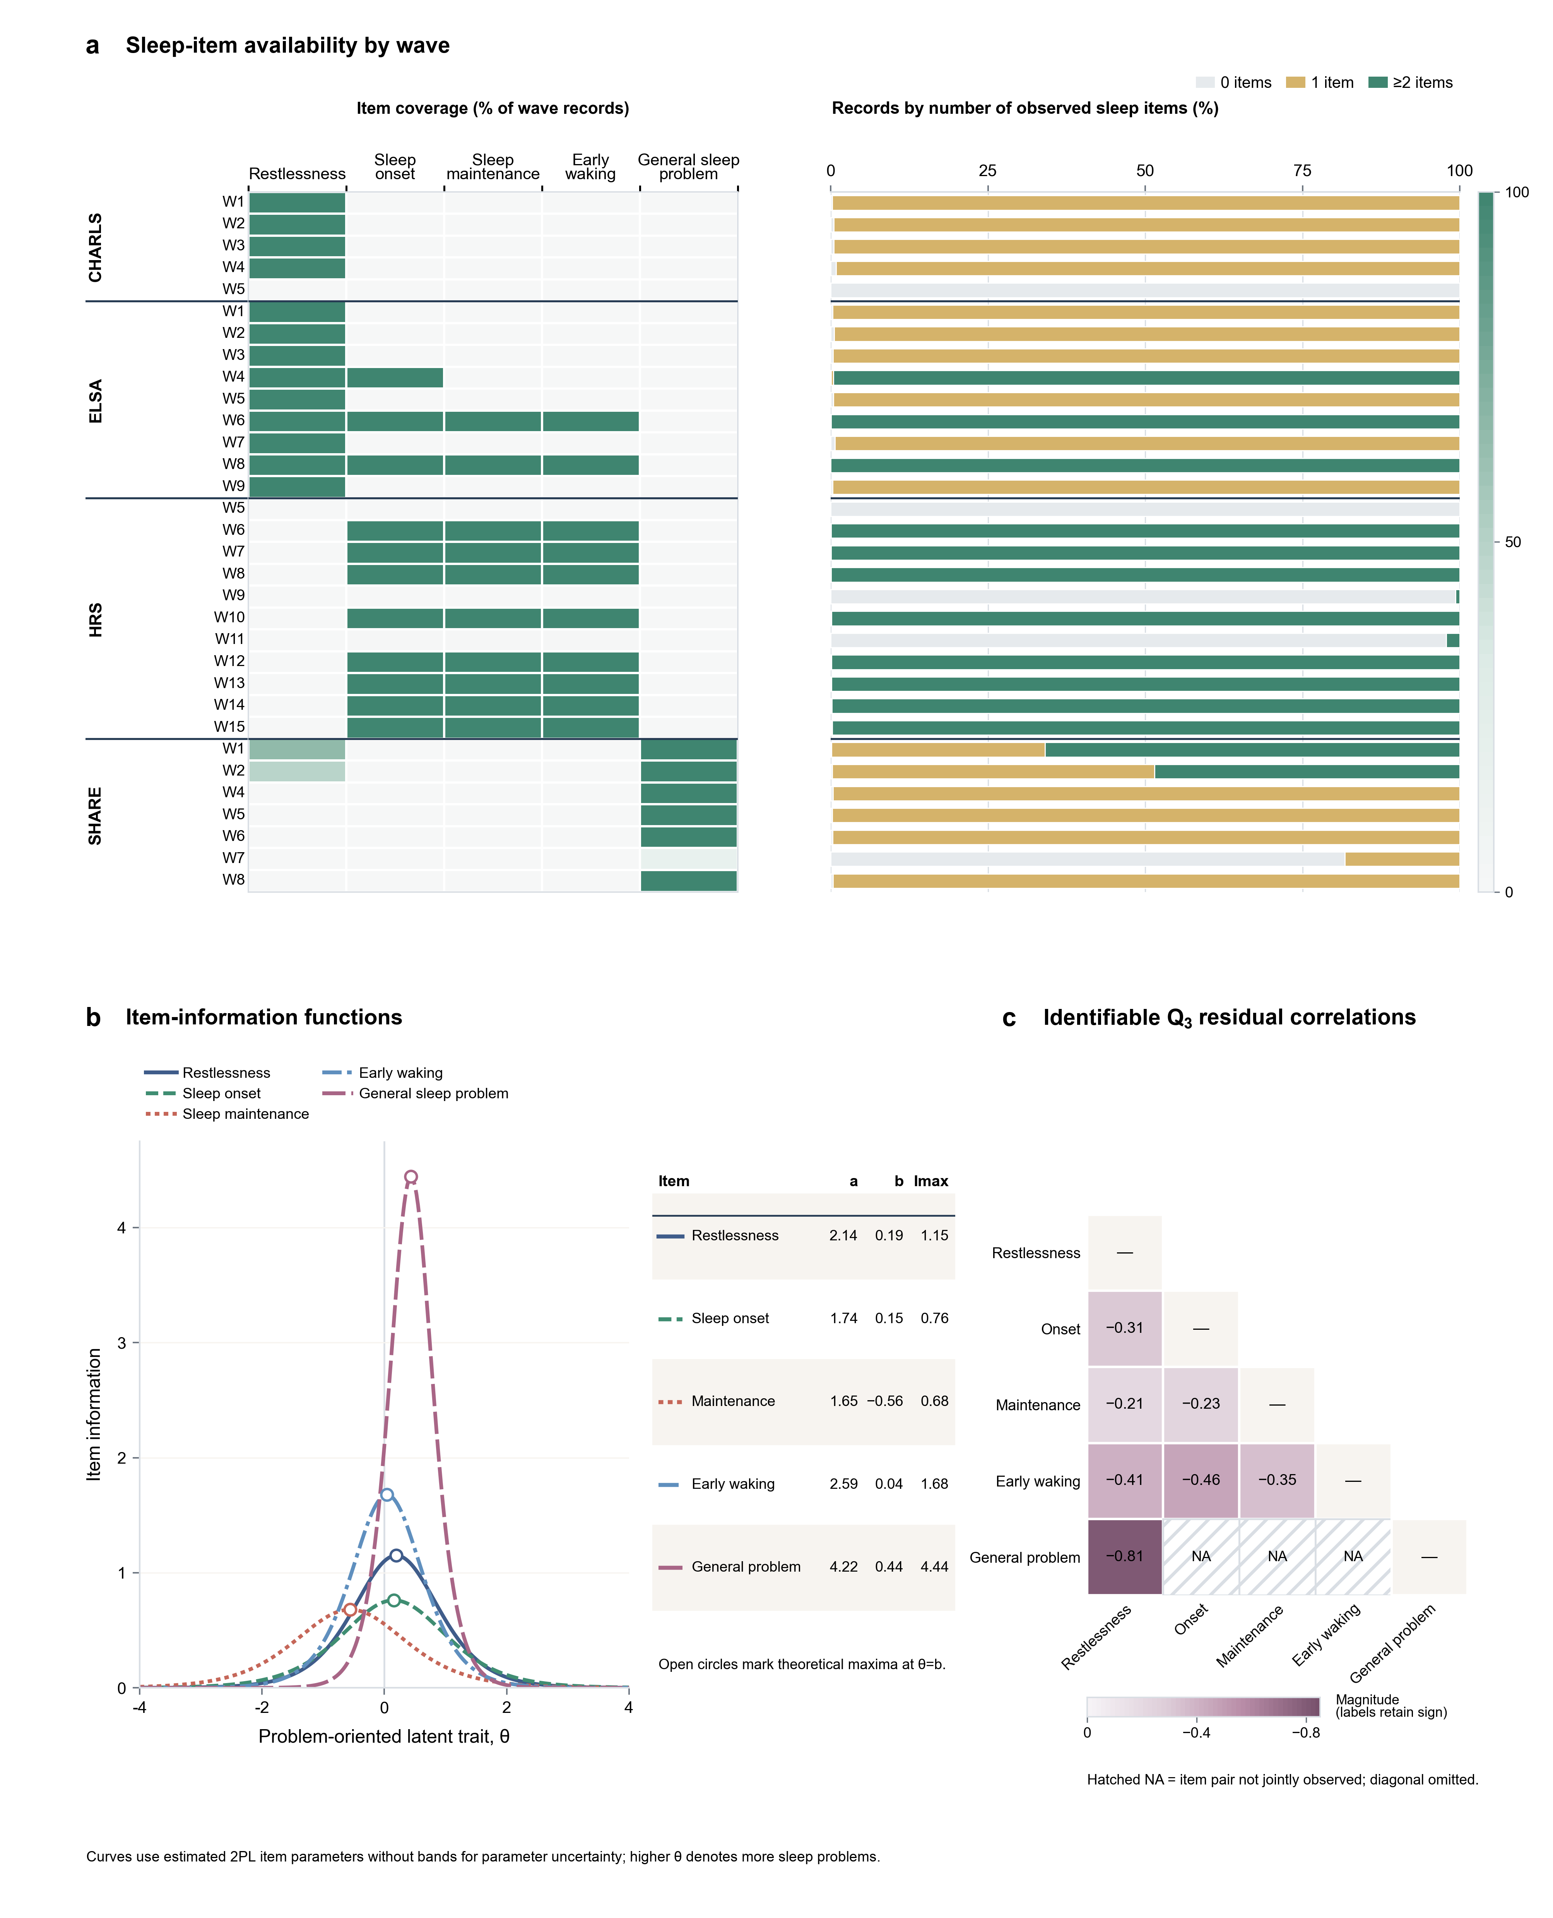
Figure S7. Sleep-item overlap, item information, and residual-dependence diagnostics. Panel a shows item availability for each observed cohort-wave occasion. The heatmap gives the percentage of wave records containing each sleep item included in the item-response analysis, and the aligned bars give the percentage containing zero, one, or at least two such items. Survey-wave labels identify categorical occasions and do not imply equal calendar spacing. Panel b shows item-information functions from the binary two-parameter logistic model. Higher values of theta denote more sleep problems. Open circles mark the theoretical maximum for each item at theta equal to the item difficulty parameter. The curves are based on point estimates and do not include bands for parameter uncertainty. Panel c shows the identifiable lower triangle of Yen's Q₃ residual-correlation matrix. Hatched cells marked NA indicate planned missingness where item pairs were not jointly observed. The item-response model uses overlap among problem-oriented indicators across cohorts; it does not establish a measurement-equivalent common sleep scale or measurement invariance. NA, not available.

