Supplementary File
Supplementary File 1. General Information Questionnaire (English Version)
Section I. The following questions are designed to collect your basic information. Please fill in or select the option that best reflects your actual situation.
Item | Question | Response options
A1 | Your age | _____ years
A2 | Your ethnicity | ① Han  ② Li  ③ Other ethnic minority
A3 | Your place of residence | ① Urban  ② Rural
A4 | Your native place (residence of your grandfather when you were born) | ① Hainan local  ② Non-Hainan
A5 | Occupation | ① Unemployed  ② Worker  ③ Farmer  ④ Self-employed  ⑤ Enterprise/institution employee  ⑥ Other
A6 | Spouse's occupation | ① Unemployed  ② Worker  ③ Farmer  ④ Self-employed  ⑤ Enterprise/institution employee  ⑥ Other
A7 | Educational level | ① Primary school or below  ② Junior middle school  ③ Senior high school or college  ④ Bachelor degree  ⑤ Postgraduate degree or above
A8 | Spouse's educational level | ① Primary school or below  ② Junior middle school  ③ Senior high school or college  ④ Bachelor degree  ⑤ Postgraduate degree or above
A9 | Annual household income | ① <30,000 CNY  ② 30,000–60,000 CNY  ③ 60,000–90,000 CNY  ④ 90,000–120,000 CNY  ⑤ 120,000–150,000 CNY  ⑥ ≥160,000 CNY
A10 | Marital status | ① Unmarried  ② Married  ③ Cohabiting  ④ Divorced  ⑤ Separated
A11 | Household living arrangement | ① Couple living alone  ② Living with parents-in-law  ③ Living with own parents  ④ Other
A12 | How many children do you currently have? | ① No child  ② One child  ③ Two children  ④ Three children
A13 | Cause of infertility diagnosis | ① Female factor  ② Male factor  ③ Both male and female factors  ④ Unknown cause
A14 | How long has it been since you were diagnosed with infertility? | ① <6 months  ② 6–12 months  ③ 1–3 years  ④ 3–5 years  ⑤ ≥5 years
A15 | How long have you received infertility treatment? | ① <3 months  ② 3–6 months  ③ 6–12 months  ④ ≥12 months
A16 | Have you experienced any of the following adverse pregnancy outcomes? (Multiple choices allowed) | ① None  ② Stillbirth or fetal death  ③ Spontaneous abortion  ④ Induced abortion
A17 | Do you feel economic/financial pressure? | ① None  ② Very little  ③ Some  ④ Relatively high  ⑤ Very high
A18 | Do you smoke? | ① No  ② 1–5 cigarettes/day  ③ 6–10 cigarettes/day  ④ 11–29 cigarettes/day  ⑤ ≥20 cigarettes/day
A19 | Does your spouse smoke? | ① No  ② 1–5 cigarettes/day  ③ 6–10 cigarettes/day  ④ 11–29 cigarettes/day  ⑤ ≥20 cigarettes/day
A20 | Have you consumed alcohol in the past year? | ① No alcohol consumption  ② Occasional drinking  ③ Frequent drinking  ④ Daily drinking  ⑤ Drank before but not currently
A21 | Has your spouse consumed alcohol in the past year? | ① No alcohol consumption  ② Occasional drinking  ③ Frequent drinking  ④ Daily drinking  ⑤ Drank before but not currently
Note: CNY = Chinese Yuan. Unless otherwise specified, please select one option for each item.

Supplementary Tables
Supplementary Table S1. Intercorrelation matrix among the main study variables.
Variable | ISS1 | ISS2 | ISS3 | ISS4 | FPI1 | FPI2 | FPI3 | FPI4 | FPI5 | PHQ-9 total | Family APGAR
ISS1 | —
ISS2 | 0.758*** | —
ISS3 | 0.784*** | 0.763*** | —
ISS4 | 0.744*** | 0.710*** | 0.849*** | —
FPI1 | 0.463*** | 0.415*** | 0.491*** | 0.502*** | —
FPI2 | 0.375*** | 0.306*** | 0.404*** | 0.471*** | 0.641*** | —
FPI3 | 0.391*** | 0.368*** | 0.361*** | 0.341*** | 0.225*** | 0.206*** | —
FPI4 | 0.064* | 0.016 | 0.029 | 0.035 | 0.047 | 0.067* | 0.052 | —
FPI5 | 0.459*** | 0.396*** | 0.489*** | 0.494*** | 0.677*** | 0.681*** | 0.354*** | 0.040 | —
PHQ-9 total | 0.350*** | 0.360*** | 0.292*** | 0.315*** | 0.222*** | 0.162*** | 0.136*** | -0.001 | 0.217*** | —
Family APGAR | -0.281*** | -0.226*** | -0.283*** | -0.305*** | -0.303*** | -0.322*** | -0.079** | -0.057* | -0.286*** | -0.254*** | —
Notes: This table show the degree of association among the studied scales/subscales. Values are Spearman correlation coefficients. The matrix includes the nine indicators used for latent profile analysis plus PHQ-9 total and Family APGAR total. *P < 0.05, **P < 0.01, ***P < 0.001

Supplementary Table S2. Raw means and standardized means of LPA indicators by retained stigma-stress profile.
Indicator | Mean  (SD) | Raw means |  |  | Standardized means
Indicator | Mean  (SD) | Low stigma-low stress | Moderate stigma-moderate stress | High stigma-high stress | Low stigma-low stress | Moderate stigma-moderate stress | High stigma-high stress
ISS1 Self-devaluation | 13.54 (6.43) | 8.51 | 15.35 | 23.28 | -0.78 | 0.28 | 1.51
ISS2 Social withdrawal | 11.42 (5.04) | 7.52 | 13.2 | 17.91 | -0.77 | 0.35 | 1.29
ISS3 Public stigma | 16.42 (7.76) | 9.67 | 18.84 | 29.49 | -0.87 | 0.31 | 1.68
ISS4 Family stigma | 10.81 (5.12) | 6.38 | 12.45 | 19.25 | -0.86 | 0.32 | 1.65
FPI1 Social concern | 27.51 (7.48) | 23.66 | 28.81 | 35.19 | -0.52 | 0.17 | 1.03
FPI2 Relationship concern | 27.79 (7.42) | 24.31 | 29.1 | 34.34 | -0.47 | 0.18 | 0.88
FPI3 Need for parenthood | 36.70 (9.14) | 33.25 | 37.96 | 43.33 | -0.38 | 0.14 | 0.72
FPI4 Rejection of childfree lifestyle | 30.02 (6.73) | 29.63 | 30.46 | 29.95 | -0.06 | 0.06 | -0.01
FPI5 Sexual concern | 20.38 (6.86) | 16.77 | 21.67 | 27.34 | -0.53 | 0.19 | 1.01
Notes: Profiles were derived from the standardized ISS and FPI subscale indicators. Raw means are shown to aid interpretation of profile severity. Standardized means are z-score means for the nine indicators included in the latent profile analysis

Supplementary Table S3. K-means clustering sensitivity analysis for k=2 to k=8.
k | Total within-cluster SS | Between-cluster SS | Total SS | Between/total SS | Average silhouette | ARI with LPA-3
2 | 7565.319 | 4071.798 | 11637.117 | 0.350 | 0.295 | 0.417
3 | 6557.653 | 5079.465 | 11637.117 | 0.436 | 0.194 | 0.247
4 | 5839.696 | 5797.421 | 11637.117 | 0.498 | 0.181 | 0.543
5 | 5371.504 | 6265.613 | 11637.117 | 0.538 | 0.183 | 0.405
6 | 5020.646 | 6616.472 | 11637.117 | 0.569 | 0.183 | 0.349
7 | 4736.645 | 6900.473 | 11637.117 | 0.593 | 0.168 | 0.311
8 | 4495.596 | 7141.521 | 11637.117 | 0.614 | 0.177 | 0.256
Notes: ARI, adjusted Rand index comparing K-means classifications with the retained three-profile LPA solution.
Supplementary Table S4. The cross-tabulation of the LPA and K-means clustering
LPA profile | K-means low | K-means moderate | K-means high
LPA high | 0 | 0 | 191，100%
LPA low | 311，55.24% | 252，44.76% | 0
LPA moderate | 64，11.85% | 257，47.59% | 219，40.56%

Supplementary Table S5. Full node-level metrics for the full-sample EBICglasso network.
Label | Predictability | Expected influence | EI rank | Strength | Strength rank | Bridge EI | Bridge EI rank | No. of nonzero edges
ISS1:Self-devaluation | 0.708 | 1.059 | 2 | 1.059 | 7 | 0.314 | 1 | 8
ISS2:Social withdrawal | 0.647 | 0.885 | 11 | 0.936 | 13 | 0.221 | 3 | 9
ISS3:Public stigma | 0.786 | 1.104 | 1 | 1.168 | 3 | 0.044 | 10 | 9
ISS4:Family stigma | 0.743 | 0.933 | 7 | 1.027 | 9 | 0.175 | 4 | 10
FPI1:Social concern | 0.544 | 0.787 | 13 | 0.937 | 12 | 0.171 | 5 | 11
FPI2:Relationship concern | 0.539 | 0.653 | 16 | 1.23 | 2 | -0.023 | 15 | 12
FPI3:Need for parenthood | 0.218 | 0.399 | 17 | 0.564 | 17 | 0.24 | 2 | 9
FPI4:Rejection of childfree lifestyle | 0.017 | 0.022 | 18 | 0.283 | 19 | -0.064 | 17 | 7
FPI5:Sexual concern | 0.597 | 0.98 | 5 | 1 | 10 | 0.107 | 7 | 8
PHQ1:Anhedonia | 0.417 | 0.776 | 14 | 0.977 | 11 | -0.038 | 16 | 12
PHQ2:Sad mood | 0.465 | 1.029 | 3 | 1.088 | 4 | 0.069 | 8 | 12
PHQ3:Sleep | 0.42 | 0.905 | 10 | 0.915 | 15 | 0.034 | 11 | 8
PHQ4:Fatigue | 0.426 | 0.877 | 12 | 1.047 | 8 | -0.085 | 18 | 10
PHQ5:Appetite | 0.297 | 0.703 | 15 | 0.703 | 16 | 0 | 13 | 7
PHQ6:Guilty | 0.418 | 0.929 | 8 | 1.064 | 6 | 0.136 | 6 | 12
PHQ7:Concentration | 0.409 | 0.916 | 9 | 0.916 | 14 | 0.019 | 12 | 9
PHQ8:Motor | 0.442 | 0.974 | 6 | 1.081 | 5 | -0.006 | 14 | 11
PHQ9:Suicide | 0.286 | 0.997 | 4 | 1.406 | 1 | 0.05 | 9 | 12
F:Family function | 0.164 | -0.371 | 19 | 0.427 | 18 | -0.371 | 19 | 12
Notes: Predictability is the variance in each node explained by its neighboring node. EI, expected influence; Bridge EI, bridge expected influence. Expected influence and bridge expected influence retain the sign of edge weights.
Supplementary Figures
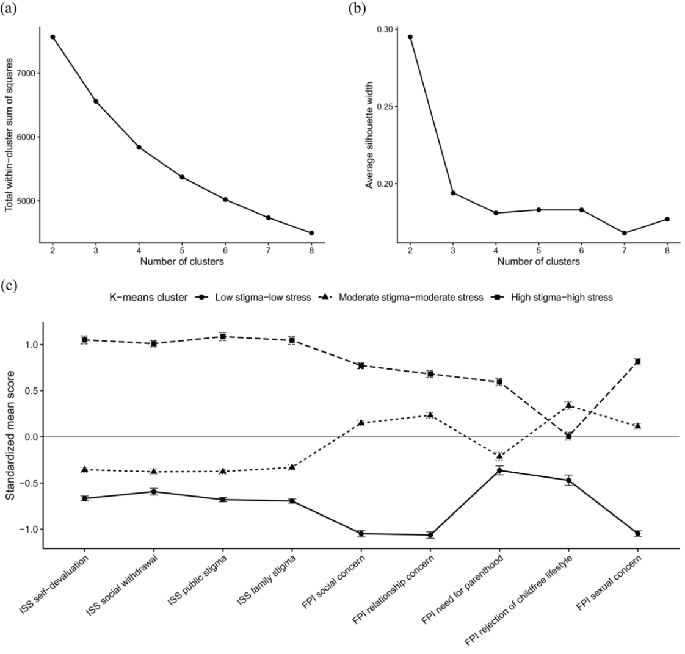
Supplementary Figure S1. K-means clustering sensitivity analyses.
Notes: (a) Elbow and (b) silhouette plots and the (c) three-cluster K-means profile plot are shown.
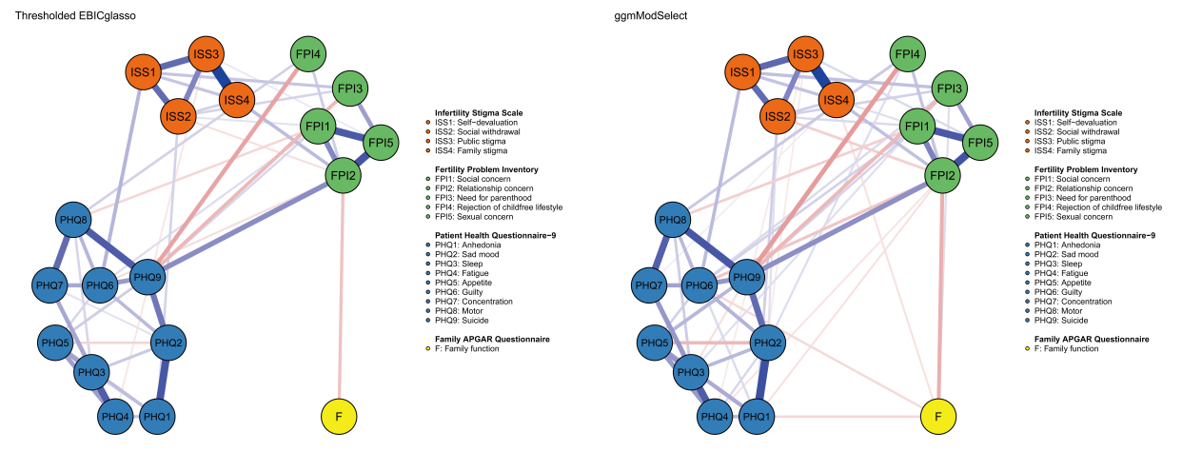
Supplementary Figure S2. Network estimator sensitivity plots.
Notes: Networks estimated using EBICglasso (Fig.2), thresholded EBICglasso, and ggmModSelect are shown using the same fixed grouped layout.
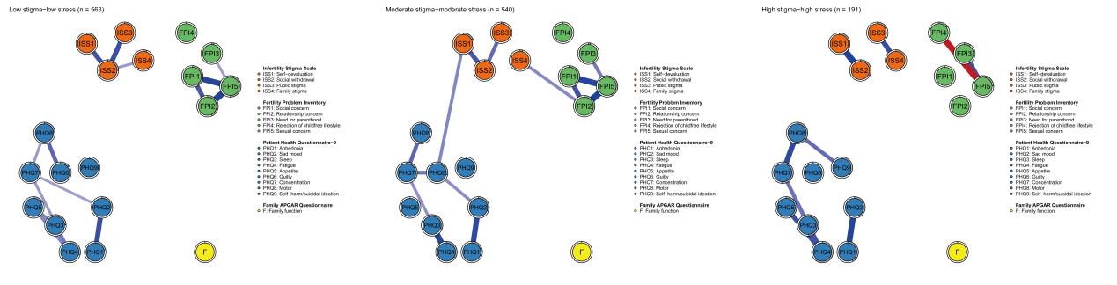
Supplementary Figure S3. Exploratory profile-specific networks.
Notes: Profile-specific networks were estimated using Spearman-based thresholded EBICglasso.
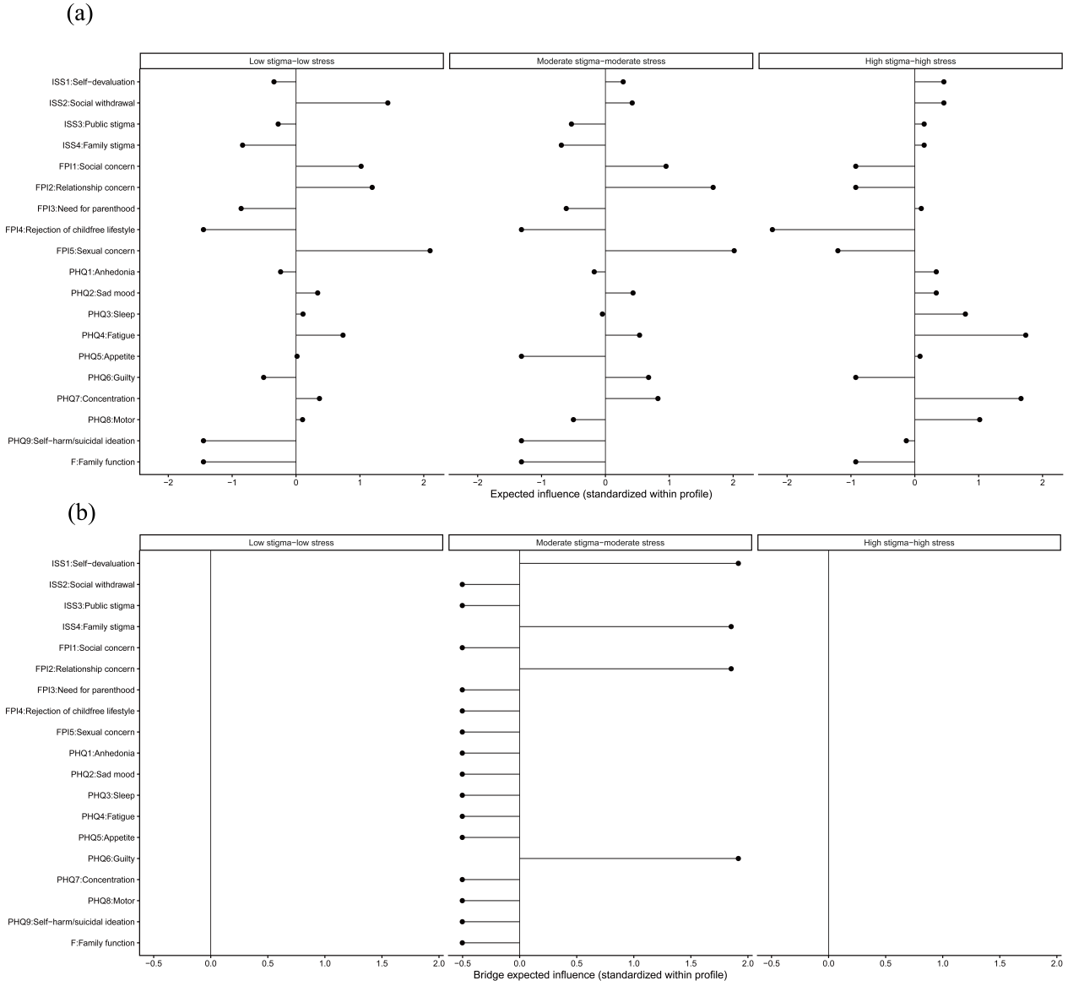
Supplementary Figure S4. (a) Expected influence and (b) bridge expected influence in profile-specific networks.
Notes: Centrality indices are standardized within each profile.

