A Systematic Review and Meta-analysis of Physician Resident Burnout in Egypt
Supplementary Figure 1. Meta-analysis of low depersonalization (A), emotional exhaustion (B), and reduced personal accomplishment (C).
Supplementary Figure 2. Meta-analysis of average (or moderate) depersonalization (A), emotional exhaustion (B), and reduced personal accomplishment (C).
Supplementary Figure 3. Meta-analysis of the mean difference of depersonalization (A), emotional exhaustion (B), and reduced personal accomplishment (C) scores.
Supplementary Table 1. The checklist of the 2020 Preferred Reporting Items for Systematic Review and Meta-Analysis (PRISMA) reporting guidelines (1).
Supplementary Table 2. Summary of the literature search for the evidence and causes of burnout in physicians in Egypt in the five databases.
Supplementary Table 3. The items of the National Heart, Lung, and Blood Institute (NHLBI) Quality Assessment tools for Observational Cohort and Cross-sectional Studies (2) to assess the quality of the included studies.

A | 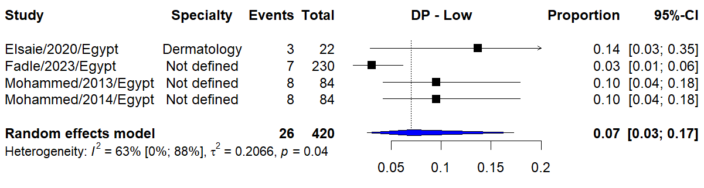
B | 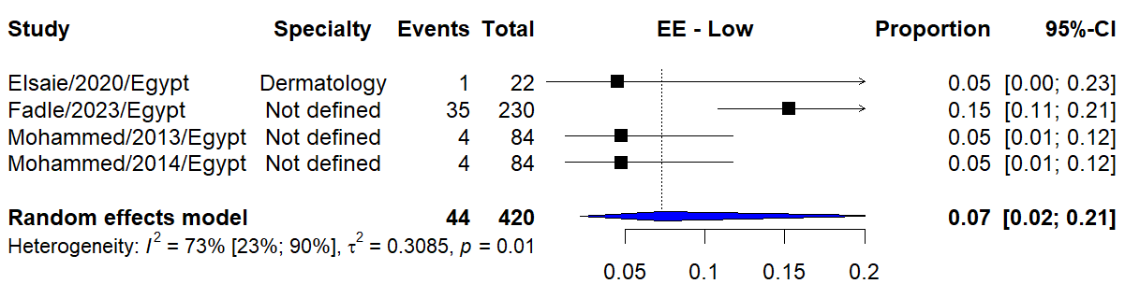
C | 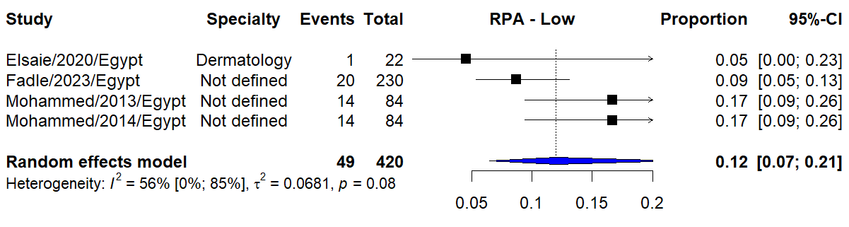
Supplementary Figure 1. Meta-analysis of low depersonalization (A), emotional exhaustion (B), and reduced personal accomplishment (C).

A | 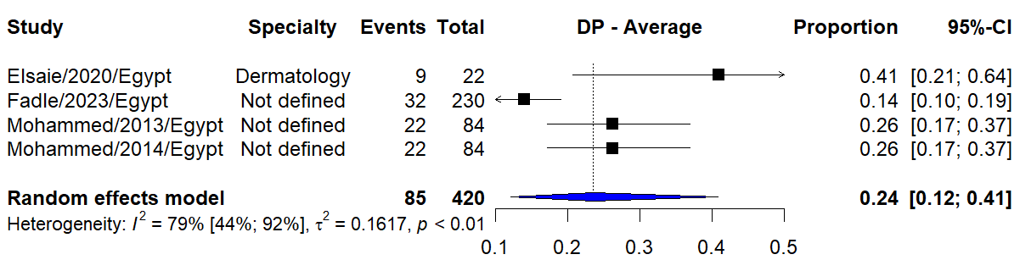
B | 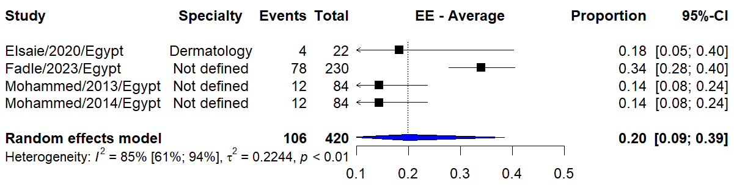
C | 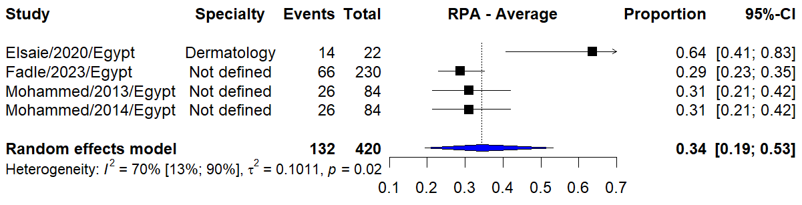
Supplementary Figure 2. Meta-analysis of average (moderate) depersonalization (A), emotional exhaustion (B), and reduced personal accomplishment (C).

A | 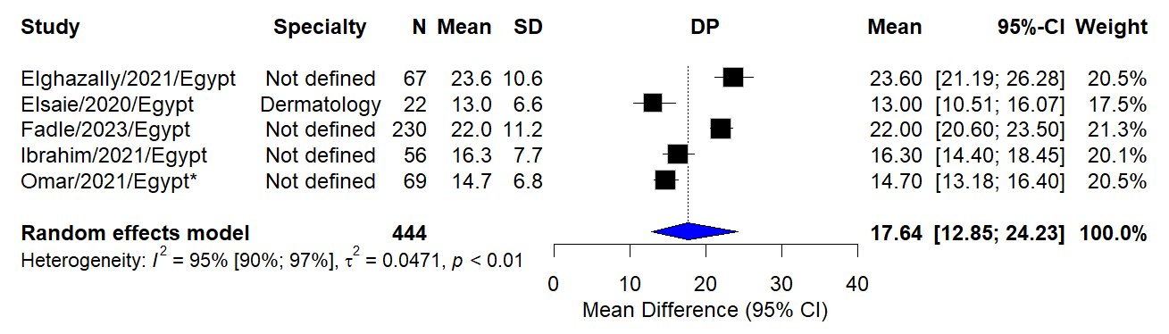
B | 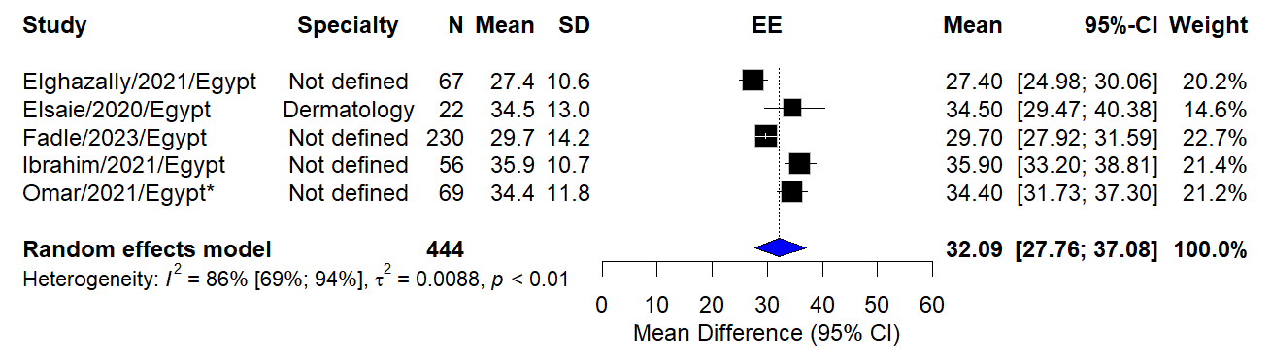
C | 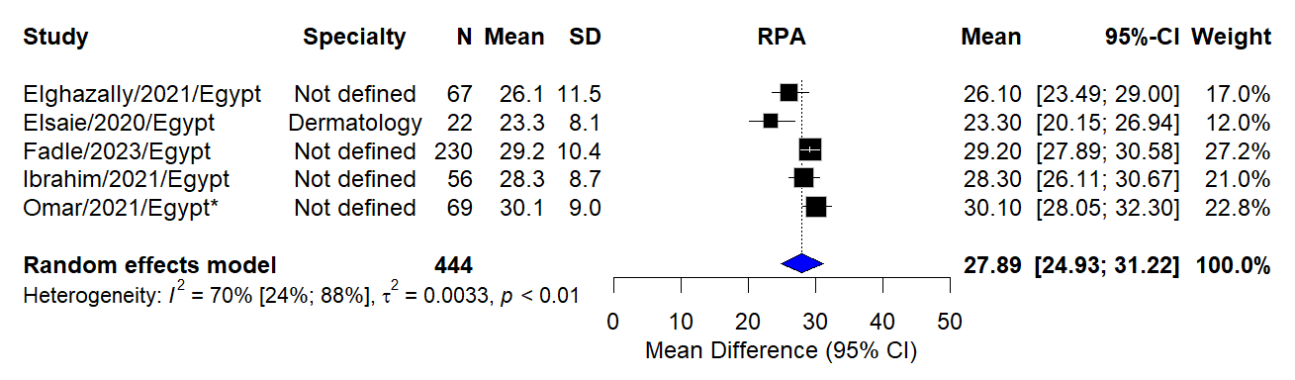
Supplementary Figure 3. Meta-analysis of the mean difference of depersonalization (A), emotional exhaustion (B), and reduced personal accomplishment (C) scores.

Supplementary Table 1. The checklist of the 2020 Preferred Reporting Items for Systematic Review and Meta-Analysis (PRISMA) reporting guidelines (1).
Section and Topic | Item # | Checklist item | Where the item is reported
TITLE
Title | 1 | Identify the report as a systematic review. | Page 1
ABSTRACT
Abstract | 2 | See the PRISMA 2020 for Abstracts checklist. | Page 3
INTRODUCTION
Rationale | 3 | Describe the rationale for the review in the context of existing knowledge. | Page 4
Objectives | 4 | Provide an explicit statement of the objective(s) or question(s) the review addresses. | Page 4
METHODS
Eligibility criteria | 5 | Specify the inclusion and exclusion criteria for the review and how studies were grouped for the syntheses. | Page 5
Information sources | 6 | Specify all databases, registers, websites, organisations, reference lists and other sources searched or consulted to identify studies. Specify the date when each source was last searched or consulted. | Page 6
Search strategy | 7 | Present the full search strategies for all databases, registers and websites, including any filters and limits used. | Page 6  Supplementary Table 2
Selection process | 8 | Specify the methods used to decide whether a study met the inclusion criteria of the review, including how many reviewers screened each record and each report retrieved, whether they worked independently, and if applicable, details of automation tools used in the process. | Page 6
Data collection process | 9 | Specify the methods used to collect data from reports, including how many reviewers collected data from each report, whether they worked independently, any processes for obtaining or confirming data from study investigators, and if applicable, details of automation tools used in the process. | Page 7
Data items | 10a | List and define all outcomes for which data were sought. Specify whether all results that were compatible with each outcome domain in each study were sought (e.g. for all measures, time points, analyses), and if not, the methods used to decide which results to collect. | Page 7
Data items | 10b | List and define all other variables for which data were sought (e.g. participant and intervention characteristics, funding sources). Describe any assumptions made about any missing or unclear information. | Page 7
Study risk of bias assessment | 11 | Specify the methods used to assess risk of bias in the included studies, including details of the tool(s) used, how many reviewers assessed each study and whether they worked independently, and if applicable, details of automation tools used in the process. | Page 7
Effect measures | 12 | Specify for each outcome the effect measure(s) (e.g. risk ratio, mean difference) used in the synthesis or presentation of results. | Pages 7 and 8
Synthesis methods | 13a | Describe the processes used to decide which studies were eligible for each synthesis (e.g. tabulating the study intervention characteristics and comparing against the planned groups for each synthesis (item #5)). | N/A
Synthesis methods | 13b | Describe any methods required to prepare the data for presentation or synthesis, such as handling of missing summary statistics, or data conversions. | Pages 7 and 8
Synthesis methods | 13c | Describe any methods used to tabulate or visually display results of individual studies and syntheses. | Page 8
Synthesis methods | 13d | Describe any methods used to synthesize results and provide a rationale for the choice(s). If meta-analysis was performed, describe the model(s), method(s) to identify the presence and extent of statistical heterogeneity, and software package(s) used. | Pages 7 and 8
Synthesis methods | 13e | Describe any methods used to explore possible causes of heterogeneity among study results (e.g. subgroup analysis, meta-regression). | N/A
Synthesis methods | 13f | Describe any sensitivity analyses conducted to assess robustness of the synthesized results. | N/A
Reporting bias assessment | 14 | Describe any methods used to assess risk of bias due to missing results in a synthesis (arising from reporting biases). | N/A
Certainty assessment | 15 | Describe any methods used to assess certainty (or confidence) in the body of evidence for an outcome. | Page 8
RESULTS
Study selection | 16a | Describe the results of the search and selection process, from the number of records identified in the search to the number of studies included in the review, ideally using a flow diagram. | Page 8
Study selection | 16b | Cite studies that might appear to meet the inclusion criteria, but which were excluded, and explain why they were excluded. | N/A
Study characteristics | 17 | Cite each included study and present its characteristics. | Pages 8 and 9  Table 1  Table 2
Risk of bias in studies | 18 | Present assessments of risk of bias for each included study. | Page 14  Supplementary Table 3
Results of individual studies | 19 | For all outcomes, present, for each study: (a) summary statistics for each group (where appropriate) and (b) an effect estimate and its precision (e.g. confidence/credible interval), ideally using structured tables or plots. | Table 2  Figure 3  Figure 4  Supplementary Figure 1  Supplementary Figure 2  Supplementary Figure 3
Results of syntheses | 20a | For each synthesis, briefly summarise the characteristics and risk of bias among contributing studies. | N/A
Results of syntheses | 20b | Present results of all statistical syntheses conducted. If meta-analysis was done, present for each the summary estimate and its precision (e.g. confidence/credible interval) and measures of statistical heterogeneity. If comparing groups, describe the direction of the effect. | Page 9
Results of syntheses | 20c | Present results of all investigations of possible causes of heterogeneity among study results. | Page 9  Figure 3  Figure 4  Supplementary Figure 1  Supplementary Figure 2  Supplementary Figure 3
Results of syntheses | 20d | Present results of all sensitivity analyses conducted to assess the robustness of the synthesized results. | N/A
Reporting biases | 21 | Present assessments of risk of bias due to missing results (arising from reporting biases) for each synthesis assessed. | N/A
Certainty of evidence | 22 | Present assessments of certainty (or confidence) in the body of evidence for each outcome assessed. | Page 9
DISCUSSION
Discussion | 23a | Provide a general interpretation of the results in the context of other evidence. | Pages 14 – 15
Discussion | 23b | Discuss any limitations of the evidence included in the review. | Pages 16 and 17
Discussion | 23c | Discuss any limitations of the review processes used. | Pages 16 and 17
Discussion | 23d | Discuss implications of the results for practice, policy, and future research. | Pages 16 and 17
OTHER INFORMATION
Registration and protocol | 24a | Provide registration information for the review, including register name and registration number, or state that the review was not registered. | Page 5
Registration and protocol | 24b | Indicate where the review protocol can be accessed, or state that a protocol was not prepared. | Page 5
Registration and protocol | 24c | Describe and explain any amendments to information provided at registration or in the protocol. | N/A
Support | 25 | Describe sources of financial or non-financial support for the review, and the role of the funders or sponsors in the review. | To be determined
Competing interests | 26 | Declare any competing interests of review authors. | To be determined
Availability of data, code and other materials | 27 | Report which of the following are publicly available and where they can be found: template data collection forms; data extracted from included studies; data used for all analyses; analytic code; any other materials used in the review. | To be determined
Abbreviations: N/A (not applicable).

Supplementary Table 2. Summary of the literature search done on the 11th of May 2024 for the evidence and causes of burnout in physicians in Egypt in the five databases.
Databases searched | Search terms |  | Results
- Ovid Medline | 1 | exp Health Personnel/ | 632,728
- Ovid Medline | 2 | (resident*1 or physician* or doctor*1 or surgeon* or medic*1 or intern*1 or clinician*).mp. | 1,514,659
- Ovid Medline | 3 | (medicine or medical or health or healthcare or health-care) and (worker* or personnel or professional*1).mp. | 755,389
- Ovid Medline | 4 | 1 or 2 or 3 | 2,327,147
- Ovid Medline | 5 | exp Burnout, Professional/ | 18,010
- Ovid Medline | 6 | exp Burnout, Psychological/ | 18,795
- Ovid Medline | 7 | (burnout or stress or exhaust* or depress* or anxiety or anxious or tired* or helpless or defeat* or procrastinat* or overwhelm* or doubt or irritab*).mp. | 2,109,185
- Ovid Medline | 8 | 5 or 6 or 7 | 2,109,185
- Ovid Medline | 9 | exp Egypt/ | 18,070
- Ovid Medline | 10 | (Egypt* or Cairo or Giza or Alexandria or Assiut or Assyut or Tanta or Helwan or Ain Shams or Ain-Shams or Zagazig or Mansoura or Fayoum or Fayyum or Beni Suef or Beni-Suef or Minia or Aswan or Suez or Ismailia or Banha or Benha or Sohag).mp. | 36,538
- Ovid Medline | 11 | 9 or 10 | 36,538
- Ovid Medline | 12 | 4 and 8 and 11 | 240

- Embase | 1 | exp health practitioner/ | 63,698
- Embase | 2 | exp health care personnel/ | 2,137,559
- Embase | 3 | (resident*1 or physician* or doctor*1 or surgeon* or medic*1 or intern*1 or clinician*).mp. | 2,270,958
- Embase | 4 | (medicine or medical or health or healthcare or health-care) and (worker* or personnel or professional*1).mp. | 1,067,840
- Embase | 5 | 1 or 2 or 3 or 4 | 3,895,106
- Embase | 6 | exp burnout/ | 32,379
- Embase | 7 | (burnout or stress or exhaust* or depress* or anxiety or anxious or tired* or helpless or defeat* or procrastinat* or overwhelm* or doubt or irritab*).mp. | 3,103,868
- Embase | 8 | 6 or 7 | 3,103,868
- Embase | 9 | exp Egypt/ | 27,333
- Embase | 10 | (Egypt* or Cairo or Giza or Alexandria or Assiut or Assyut or Tanta or Helwan or Ain Shams or Ain-Shams or Zagazig or Mansoura or Fayoum or Fayyum or Beni Suef or Beni-Suef or Minia or Aswan or Suez or Ismailia or Banha or Benha or Sohag).mp. | 59,825
- Embase | 11 | 9 or 10 | 59,825
- Embase | 12 | 5 and 8 and 11 | 603

- APA PsycInfo | 1 | exp Health Personnel/ | 201,203
- APA PsycInfo | 2 | (resident*1 or physician* or doctor*1 or surgeon* or medic*1 or intern*1 or clinician*).mp. | 285,325
- APA PsycInfo | 3 | (medicine or medical or health or healthcare or health-care) and (worker* or personnel or professional*1).mp. | 271,364
- APA PsycInfo | 4 | 1 or 2 or 3 | 583,072
- APA PsycInfo | 5 | exp Burnout/ | 29,542
- APA PsycInfo | 6 | (burnout or stress or exhaust* or depress* or anxiety or anxious or tired* or helpless or defeat* or procrastinat* or overwhelm* or doubt or irritab*).mp. | 880,883
- APA PsycInfo | 7 | 5 or 6 | 881,064
- APA PsycInfo | 8 | (Egypt* or Cairo or Giza or Alexandria or Assiut or Assyut or Tanta or Helwan or Ain Shams or Ain-Shams or Zagazig or Mansoura or Fayoum or Fayyum or Beni Suef or Beni-Suef or Minia or Aswan or Suez or Ismailia or Banha or Benha or Sohag).mp. | 4,237
- APA PsycInfo | 9 | 4 and 7 and 8 | 111

- Scopus | TITLE-ABS-KEY((burnout OR stress OR exhaustion OR exhausted OR depression OR depressed OR anxiety OR anxious OR irritability OR irritable) AND ((resident OR physician OR doctor OR surgeon OR medic OR intern OR clinician) OR ((medicine OR medical OR health OR healthcare OR health-care) AND (worker OR personnel OR professional))) AND Egypt) | 332
- Web of Science | ((TS=(burnout OR stress OR exhaustion OR exhausted OR depression OR depressed OR anxiety OR anxious OR irritability OR irritable) AND ((resident OR physician OR doctor OR surgeon OR medic OR intern OR clinician) OR ((medicine OR medical OR health OR healthcare OR health-care) AND (worker OR personnel OR professional))) AND (Egypt* or Cairo or Giza or Alexandria or Assiut or Assyut or Tanta or Helwan or Ain Shams or Ain-Shams or Zagazig or Mansoura or Fayoum or Fayyum or Beni Suef or Beni-Suef or Minia or Aswan or Suez or Ismailia or Banha or Benha or Sohag))) | 567
Total |  | 1853

Supplementary Table 3. The items of the National Heart, Lung, and Blood Institute (NHLBI) Quality Assessment tools for Observational Cohort and Cross-sectional Studies (2) to assess the quality of the included studies.
Item | Abbas 2012 (3) | El-Shafei 2018 (4) | Elghazally 2021 (5) | Elsaie 2020 (6) | Fadle 2023 (7) | Ibrahim 2021 (8) | Mohammed 2013 (9) | Mohammed 2014 (10) | Omar 2021 (11) | Omar 2021* (12) | Shams 2013 (13)
1 | Yes | Yes | Yes | Yes | Yes | Yes | Yes | Yes | Yes | Yes | Yes
2 | No | Yes | Yes | No | Yes | Yes | Yes | Yes | Yes | Yes | Yes
3 | CD | Yes | No | CD | No | Yes | Yes | Yes | Yes | CD | No
4 | Yes | Yes | Yes | CD | Yes | Yes | Yes | Yes | Yes | Yes | Yes
5 | Yes | Yes | Yes | No | Yes | Yes | Yes | Yes | No | No | No
6 | Yes | Yes | Yes | No | Yes | No | No | No | Yes | Yes | Yes
7 | No | Yes | No | No | No | No | No | No | No | No | No
8 | Yes | Yes | No | Yes | Yes | Yes | No | Yes | No | Yes | No
9 | Yes | Yes | Yes | No | Yes | Yes | Yes | Yes | Yes | Yes | Yes
10 | No | No | No | No | No | No | No | No | No | No | No
11 | Yes | Yes | Yes | Yes | Yes | Yes | Yes | Yes | No | Yes | Yes
12 | CD | No | Yes | Yes | Yes | No | CD | CD | Yes | Yes | Yes
13 | No | No | No | No | No | CD | No | No | No | No | No
14 | Yes | Yes | No | Yes | No | Yes | No | No | No | Yes | No
Rating | Fair | Good | Fair | Poor | Fair | Fair | Fair | Fair | Fair | Fair | Fair
Abbreviations: CD (cannot determine).
*This study has the same ID as another one; hence, the asterisk denotes that both studies differ.
1: Was the research question or objective in this paper clearly stated?
2: Was the study population clearly specified and defined?
3: Was the participation rate of eligible persons at least 50%?
4: Were all the subjects selected or recruited from the same or similar populations (including the same time period)? Were inclusion and exclusion criteria for being in the study prespecified and applied uniformly to all participants?
5: Was a sample size justification, power description, or variance and effect estimates provided?
6: For the analyses in this paper, were the exposure(s) of interest measured prior to the outcome(s) being measured?
7: Was the timeframe sufficient so that one could reasonably expect to see an association between exposure and outcome if it existed?
8: For exposures that can vary in amount or level, did the study examine different levels of exposure as related to the outcome (e.g., categories of exposure, or exposure measured as continuous variable)?
9: Were the exposure measures (independent variables) clearly defined, valid, reliable, and implemented consistently across all study participants?
10: Was the exposure(s) assessed more than once over time?
11: Were the outcome measures (dependent variables) clearly defined, valid, reliable, and implemented consistently across all study participants?
12: Were the outcome assessors blinded to the exposure status of participants?
13: Was loss to follow-up after baseline 20% or less?
14: Were key potential confounding variables measured and adjusted statistically for their impact on the relationship between exposure(s) and outcome(s)?

References
1. Page MJ, McKenzie JE, Bossuyt PM, Boutron I, Hoffmann TC, Mulrow CD, et al. The PRISMA 2020 statement: An updated guideline for reporting systematic reviews. PLoS Med. 2021; 18(3): e1003583. doi: 10.1371/journal.pmed.1003583.
2. National Institutes of Health. Quality Assessment Tool for Case Reports and Case Series. https://www.nhlbi.nih.gov/health-topics/study-quality-assessment-tools [Accessed 17/02/2023].
3. Abbas A, Shouman W, Ali A, Bahgat SM. Prevalence, associated factors, and consequences of burnout among ICU healthcare workers: an Egyptian experience. The Egyptian Journal of Chest Diseases and Tuberculosis. 2019; 68(4): 514-525. doi: 10.4103/ejcdt.ejcdt_188_18.
4. El-Shafei DA, Abdelsalam AE, Hammam RAM, Elgohary H. Professional quality of life, wellness education, and coping strategies among emergency physicians. Environ Sci Pollut Res Int. 2018; 25(9): 9040-9050. doi: 10.1007/s11356-018-1240-y.
5. Elghazally SA, Alkarn AF, Elkhayat H, Ibrahim AK, Elkhayat MR. Burnout Impact of COVID-19 Pandemic on Health-Care Professionals at Assiut University Hospitals, 2020. Int J Environ Res Public Health. 2021; 18(10). doi: 10.3390/ijerph18105368.
6. Elsaie ML, Hussein SM, Zaky MS, Hanafy NS, Jafferany M. Therapeutic implications of prevalence and predictor risk factors for burn out syndrome in Egyptian dermatologists: A cross sectional study. Dermatol Ther. 2020; 33(6): e14327. doi: 10.1111/dth.14327.
7. Fadle AA, Khalifa AA, Mahran DG, Khidr SS, Said HG, Farouk O. Burnout syndrome (BOS) among resident doctors in an Egyptian tertiary care university hospital: Prevalence and determinants during the COVID-19 pandemic. Int J Soc Psychiatry. 2023; 69(2): 396-405. doi: 10.1177/00207640221104698.
8. Ibrahim AB, Mostafa M, Hussein SM. Professional quality of life among physicians of tertiary care hospitals: An Egyptian cross-sectional study. J Public Health Res. 2021; 11(2). doi: 10.4081/jphr.2021.2436.
9. Mohammed KA, Ali EG, Youssef IM. Burnout and Personality among Egyptian Residents. The Arab Journal of Psychiatry. 2013; 24(2): 148-160. doi: 10.12816/0001373.
10. Mohammed KA, Ali EG, Youssef IM. Depression and Burnout among Residents. The Arab Journal of Psychiatry. 2014; 25(1): 40-51. doi: 10.12816/0004114.
11. Omar AMA, Ramadan MM, Khamis Y, Ismail AA. The impact of COVID-19 on the occupational health of oncologists: a descriptive analysis of occupational safety, perceived burnout and social support among practicing oncologists in Alexandria, Egypt. Ecancermedicalscience. 2021; 15: 1273. doi: 10.3332/ecancer.2021.1273.
12. Omar DI, Hani BM, Abd-Ellatif EE. Burnout among Physicians in Egypt during COVID-19 Pandemic. The Egyptian Journal of Hospital Medicine. 2021; 82(4): 599-608.
13. Shams T, El-Masry R. Job Stress and Burnout among Academic Career Anaesthesiologists at an Egyptian University Hospital. Sultan Qaboos Univ Med J. 2013; 13(2): 287-295. doi: 10.12816/0003236.

