Supplementary material

Six decades of trends in BMI, thinness, overweight, and obesity among 210,927 Swedish children in different socioeconomic contexts

Maria Bygdell, Klara Hemmed, Jari Martikainen, Carl Bonander, Lovisa Sjögren, Claes Ohlsson, Jenny M Kindblom

Supplemental tables

Table S1. Number of included children in schools in Gothenburg municipality, Sweden, by gender and for every year.

Year | Boys | Girls | Total
1952 | 1368 | 1295 | 2663
1953 | 1572 | 1690 | 3262
1954 | 2221 | 1912 | 4133
1955 | 2186 | 1872 | 4058
1956 | 2687 | 2471 | 5158
1957 | 2531 | 2412 | 4943
1958 | 2438 | 2749 | 5187
1959 | 2516 | 2307 | 4823
1960 | 2642 | 2546 | 5188
1961 | 2752 | 2801 | 5553
1962 | 2460 | 2795 | 5255
1963 | 3086 | 2948 | 6034
1964 | 3090 | 3025 | 6115
1965 | 3076 | 2881 | 5957
1966 | 2944 | 2727 | 5671
1967 | 2884 | 2837 | 5721
1968 | 3048 | 2931 | 5979
1969 | 3136 | 2923 | 6059
1970 | 3408 | 3139 | 6547
1971 | 3608 | 3301 | 6909
1972 | 3700 | 3273 | 6973
1973 | 3650 | 3240 | 6890
1974 | 3571 | 3172 | 6743
1975 | 2808 | 2603 | 5411
1978 | 595 | 1006 | 1601
1983 | 422 | 789 | 1211
1988 | 524 | 751 | 1275
1993 | 536 | 992 | 1528
1998 | 1435 | 1823 | 3258
1999 | 356 | 469 | 825
2000 | 1063 | 1023 | 2086
2001 | 1161 | 1194 | 2355
2002 | 1217 | 1204 | 2421
2003 | 1348 | 1308 | 2656
2004 | 1832 | 1830 | 3662
2005 | 2123 | 2090 | 4213
2006 | 2200 | 2185 | 4385
2008 | 2489 | 2312 | 4801
2009 | 2101 | 2154 | 4255
2010 | 2321 | 2282 | 4603
2011 | 2411 | 2193 | 4604
2012 | 2402 | 2305 | 4707
2013 | 2572 | 2446 | 5018
2014 | 2579 | 2505 | 5084
2015 | 2544 | 2360 | 4904
2016 | 2602 | 2480 | 5082
2017 | 2631 | 2530 | 5161
Total | 106,846 | 104,081 | 210,927

Table S2. Mean childhood BMI and prevalence of BMI categories at the age of seven measured between 1952 and 2017 for 210,927 children in schools in Gothenburg municipality, Sweden, by gender and for every year.

Year | BMI  Mean (SEM) |  | Thinness¹  n (%) |  | Normal weight²  n (%) |  | Overweight³  n (%) |  | Obesity⁴  n (%)
 | Boys | Girls | Boys | Girls | Boys | Girls | Boys | Girls | Boys | Girls
1952 | 15.52 ± 0.04 | 15.42 ± 0.04 | 127 (9.3%) | 132 (10.2%) | 1,171 (85.6%) | 1,077 (83.2%) | 64 (4.7%) | 71 (5.5%) | 6 (0.4%) | 15 (1.2%)
1953 | 15.50 ± 0.03 | 15.45 ± 0.04 | 125 (8.0%) | 195 (11.5%) | 1,390 (88.4%) | 1,361 (80.5%) | 49 (3.1%) | 118 (7.0%) | 8 (0.5%) | 16 (0.9%)
1954 | 15.52 ± 0.03 | 15.48 ± 0.03 | 190 (8.6%) | 169 (8.8%) | 1,939 (87.3%) | 1,617 (84.6%) | 80 (3.6%) | 107 (5.6%) | 12 (0.5%) | 19 (1.0%)
1955 | 15.37 ± 0.03 | 15.30 ± 0.03 | 221 (10.1%) | 231 (12.3%) | 1,891 (86.5%) | 1,525 (81.5%) | 66 (3.0%) | 106 (5.7%) | 8 (0.4%) | 10 (0.5%)
1956 | 15.55 ± 0.03 | 15.40 ± 0.03 | 244 (9.1%) | 266 (10.8%) | 2,319 (86.3%) | 2,058 (83.3%) | 104 (3.9%) | 134 (5.4%) | 20 (0.7%) | 13 (0.5%)
1957 | 15.43 ± 0.02 | 15.44 ± 0.03 | 259 (10.2%) | 275 (11.4%) | 2,178 (86.1%) | 1,973 (81.8%) | 88 (3.5%) | 140 (5.8%) | 6 (0.2%) | 24 (1.0%)
1958 | 15.46 ± 0.03 | 15.45 ± 0.03 | 249 (10.2%) | 301 (10.9%) | 2,084 (85.5%) | 2,235 (81.3%) | 84 (3.4%) | 184 (6.7%) | 21 (0.9%) | 29 (1.1%)
1959 | 15.41 ± 0.03 | 15.37 ± 0.03 | 299 (11.9%) | 282 (12.2%) | 2,101 (83.5%) | 1,869 (81.0%) | 102 (4.1%) | 130 (5.6%) | 14 (0.6%) | 26 (1.1%)
1960 | 15.45 ± 0.03 | 15.51 ± 0.03 | 273 (10.3%) | 241 (9.5%) | 2,249 (85.1%) | 2,110 (82.9%) | 107 (4.0%) | 164 (6.4%) | 13 (0.5%) | 31 (1.2%)
1961 | 15.57 ± 0.03 | 15.52 ± 0.03 | 244 (8.9%) | 308 (11.0%) | 2,358 (85.7%) | 2,237 (79.9%) | 128 (4.7%) | 230 (8.2%) | 22 (0.8%) | 26 (0.9%)
1962 | 15.63 ± 0.03 | 15.57 ± 0.03 | 216 (8.8%) | 301 (10.8%) | 2,086 (84.8%) | 2,238 (80.1%) | 140 (5.7%) | 222 (7.9%) | 18 (0.7%) | 34 (1.2%)
1963 | 15.55 ± 0.03 | 15.49 ± 0.03 | 310 (10.0%) | 345 (11.7%) | 2,627 (85.1%) | 2,357 (80.0%) | 118 (3.8%) | 214 (7.3%) | 31 (1.0%) | 32 (1.1%)
1964 | 15.57 ± 0.03 | 15.53 ± 0.03 | 282 (9.1%) | 300 (9.9%) | 2,650 (85.8%) | 2,449 (81.0%) | 131 (4.2%) | 246 (8.1%) | 27 (0.9%) | 30 (1.0%)
1965 | 15.53 ± 0.03 | 15.47 ± 0.03 | 307 (10.0%) | 338 (11.7%) | 2,597 (84.4%) | 2,297 (79.7%) | 150 (4.9%) | 208 (7.2%) | 22 (0.7%) | 38 (1.3%)
1966 | 15.60 ± 0.03 | 15.54 ± 0.03 | 261 (8.9%) | 294 (10.8%) | 2,517 (85.5%) | 2,175 (79.8%) | 139 (4.7%) | 216 (7.9%) | 27 (0.9%) | 42 (1.5%)
1967 | 15.55 ± 0.03 | 15.54 ± 0.03 | 288 (10.0%) | 345 (12.2%) | 2,441 (84.6%) | 2,224 (78.4%) | 134 (4.6%) | 225 (7.9%) | 21 (0.7%) | 43 (1.5%)
1968 | 15.53 ± 0.03 | 15.49 ± 0.03 | 296 (9.7%) | 336 (11.5%) | 2,592 (85.0%) | 2,310 (78.8%) | 141 (4.6%) | 246 (8.4%) | 19 (0.6%) | 39 (1.3%)
1969 | 15.46 ± 0.02 | 15.48 ± 0.03 | 309 (9.9%) | 360 (12.3%) | 2,683 (85.6%) | 2,316 (79.2%) | 124 (4.0%) | 204 (7.0%) | 20 (0.6%) | 43 (1.5%)
1970 | 15.64 ± 0.02 | 15.66 ± 0.03 | 260 (7.6%) | 281 (9.0%) | 2,934 (86.1%) | 2,537 (80.8%) | 185 (5.4%) | 275 (8.8%) | 29 (0.9%) | 46 (1.5%)
1971 | 15.65 ± 0.02 | 15.58 ± 0.03 | 297 (8.2%) | 347 (10.5%) | 3,071 (85.1%) | 2,631 (79.7%) | 196 (5.4%) | 278 (8.4%) | 44 (1.2%) | 45 (1.4%)
1972 | 15.61 ± 0.02 | 15.63 ± 0.03 | 302 (8.2%) | 297 (9.1%) | 3,184 (86.1%) | 2,673 (81.7%) | 184 (5.0%) | 252 (7.7%) | 30 (0.8%) | 51 (1.6%)
1973 | 15.63 ± 0.02 | 15.61 ± 0.03 | 297 (8.1%) | 303 (9.4%) | 3,129 (85.7%) | 2,608 (80.5%) | 199 (5.5%) | 276 (8.5%) | 25 (0.7%) | 53 (1.6%)
1974 | 15.64 ± 0.02 | 15.65 ± 0.03 | 317 (8.9%) | 311 (9.8%) | 3,066 (85.9%) | 2,560 (80.7%) | 165 (4.6%) | 246 (7.8%) | 23 (0.6%) | 55 (1.7%)
1975 | 15.66 ± 0.03 | 15.62 ± 0.03 | 223 (7.9%) | 267 (10.3%) | 2,419 (86.1%) | 2,085 (80.1%) | 144 (5.1%) | 217 (8.3%) | 22 (0.8%) | 34 (1.3%)
1978 | 15.84 ± 0.05 | 15.84 ± 0.05 | 27 (4.5%) | 65 (6.5%) | 532 (89.4%) | 818 (81.3%) | 33 (5.5%) | 106 (10.5%) | 3 (0.5%) | 17 (1.7%)
1983 | 15.95 ± 0.08 | 15.86 ± 0.06 | 30 (7.1%) | 71 (9.0%) | 351 (83.2%) | 610 (77.3%) | 35 (8.3%) | 89 (11.3%) | 6 (1.4%) | 19 (2.4%)
1988 | 15.95 ± 0.08 | 15.92 ± 0.07 | 42 (8.0%) | 59 (7.9%) | 426 (81.3%) | 581 (77.4%) | 43 (8.2%) | 94 (12.5%) | 13 (2.5%) | 17 (2.3%)
1993 | 16.17 ± 0.08 | 16.27 ± 0.06 | 32 (6.0%) | 55 (5.5%) | 430 (80.2%) | 741 (74.7%) | 56 (10.4%) | 149 (15.0%) | 18 (3.4%) | 47 (4.7%)
1998 | 16.37 ± 0.05 | 16.24 ± 0.05 | 82 (5.7%) | 145 (8.0%) | 1,101 (76.7%) | 1,289 (70.7%) | 176 (12.3%) | 305 (16.7%) | 76 (5.3%) | 84 (4.6%)
1999 | 16.20 ± 0.10 | 16.47 ± 0.11 | 25 (7.0%) | 33 (7.0%) | 280 (78.7%) | 333 (71.0%) | 37 (10.4%) | 69 (14.7%) | 14 (3.9%) | 34 (7.2%)
2000 | 16.26 ± 0.06 | 16.43 ± 0.08 | 79 (7.4%) | 79 (7.7%) | 813 (76.5%) | 694 (67.8%) | 124 (11.7%) | 178 (17.4%) | 47 (4.4%) | 72 (7.0%)
2001 | 16.41 ± 0.06 | 16.31 ± 0.07 | 77 (6.6%) | 91 (7.6%) | 873 (75.2%) | 858 (71.9%) | 154 (13.3%) | 170 (14.2%) | 57 (4.9%) | 75 (6.3%)
2002 | 16.33 ± 0.06 | 16.23 ± 0.06 | 87 (7.1%) | 77 (6.4%) | 918 (75.4%) | 901 (74.8%) | 148 (12.2%) | 172 (14.3%) | 64 (5.3%) | 54 (4.5%)
2003 | 16.32 ± 0.06 | 16.42 ± 0.06 | 100 (7.4%) | 80 (6.1%) | 1,001 (74.3%) | 934 (71.4%) | 188 (13.9%) | 210 (16.1%) | 59 (4.4%) | 84 (6.4%)
2004 | 16.16 ± 0.05 | 16.16 ± 0.05 | 144 (7.9%) | 136 (7.4%) | 1,414 (77.2%) | 1,357 (74.2%) | 212 (11.6%) | 253 (13.8%) | 62 (3.4%) | 84 (4.6%)
2005 | 16.08 ± 0.04 | 16.10 ± 0.04 | 169 (8.0%) | 163 (7.8%) | 1,687 (79.5%) | 1,583 (75.7%) | 202 (9.5%) | 257 (12.3%) | 65 (3.1%) | 87 (4.2%)
2006 | 16.08 ± 0.04 | 16.09 ± 0.04 | 146 (6.6%) | 178 (8.1%) | 1,756 (79.8%) | 1,620 (74.1%) | 231 (10.5%) | 292 (13.4%) | 67 (3.0%) | 95 (4.3%)
2008 | 16.09 ± 0.04 | 16.02 ± 0.04 | 201 (8.1%) | 178 (7.7%) | 1,940 (77.9%) | 1,760 (76.1%) | 268 (10.8%) | 290 (12.5%) | 80 (3.2%) | 84 (3.6%)
2009 | 16.02 ± 0.04 | 16.04 ± 0.04 | 174 (8.3%) | 154 (7.1%) | 1,658 (78.9%) | 1,652 (76.7%) | 203 (9.7%) | 276 (12.8%) | 66 (3.1%) | 72 (3.3%)
2010 | 16.07 ± 0.04 | 16.06 ± 0.04 | 192 (8.3%) | 166 (7.3%) | 1,819 (78.4%) | 1,747 (76.6%) | 234 (10.1%) | 278 (12.2%) | 76 (3.3%) | 91 (4.0%)
2011 | 16.08 ± 0.04 | 16.13 ± 0.04 | 181 (7.5%) | 174 (7.9%) | 1,901 (78.8%) | 1,633 (74.5%) | 245 (10.2%) | 294 (13.4%) | 84 (3.5%) | 92 (4.2%)
2012 | 16.05 ± 0.04 | 16.10 ± 0.04 | 184 (7.7%) | 181 (7.9%) | 1,915 (79.7%) | 1,727 (74.9%) | 230 (9.6%) | 298 (12.9%) | 73 (3.0%) | 99 (4.3%)
2013 | 16.03 ± 0.04 | 15.99 ± 0.04 | 206 (8.0%) | 193 (7.9%) | 2,021 (78.6%) | 1,866 (76.3%) | 259 (10.1%) | 293 (12.0%) | 86 (3.3%) | 94 (3.8%)
2014 | 16.00 ± 0.04 | 16.07 ± 0.04 | 237 (9.2%) | 195 (7.8%) | 2,017 (78.2%) | 1,892 (75.5%) | 244 (9.5%) | 315 (12.6%) | 81 (3.1%) | 103 (4.1%)
2015 | 16.12 ± 0.04 | 16.13 ± 0.04 | 239 (9.4%) | 193 (8.2%) | 1,925 (75.7%) | 1,724 (73.1%) | 271 (10.7%) | 346 (14.7%) | 109 (4.3%) | 97 (4.1%)
2016 | 16.06 ± 0.04 | 16.08 ± 0.04 | 242 (9.3%) | 212 (8.5%) | 1,970 (75.7%) | 1,835 (74.0%) | 286 (11.0%) | 340 (13.7%) | 104 (4.0%) | 93 (3.8%)
2017 | 16.12 ± 0.04 | 16.08 ± 0.04 | 228 (8.7%) | 195 (7.7%) | 1,990 (75.6%) | 1,872 (74.0%) | 312 (11.9%) | 364 (14.4%) | 101 (3.8%) | 99 (3.9%)
Total |  |  | 9,320 (8.7%) | 9,898 (9.5%) | 88,414 (82.7%) | 81,549 (78.4%) | 7,213 (6.8%) | 10,147 (9.7%) | 1,899 (1.8%) | 2,487 (2.4%)
¹Thinness for boys <14.00 kg/m² and for girls <13.83 kg/m²,
²Normal Weight for boys ≥14.00<17.88 kg/m² and for girls ≥13.83<17.69 kg/m²,
³Overweight for boys ≥17.88<20.59 kg/m² and for girls ≥17.69<20.39 kg/m²,
⁴Obesity for boys ≥20.59 kg/m² and for girls ≥20.39 kg/m² according to International Obesity Task Force (1)

Table S3. Correlations between the parental socioeconomic variables showed by Pearson’s correlation coefficient. The study population included 65,556 children in schools in Gothenburg municipality, Sweden

 | Parental country of birth | Parental educational level | Parental income
Parental country of birth | 1 | 0.23 | 0.43
Parental educational level | 0.23 | 1 | 0.33
Parental income | 0.43 | 0.33 | 1

Table S4. Number of children with BMI at the age of seven between 2002 and 2017 for 65,556 children in schools in Gothenburg municipality, Sweden, by gender and parental socioeconomic strata.

Year | Parental country of birth¹ |  |  |  | Parental educational level¹ |  |  |  | Parental income¹
 | Sweden  n (%) |  | Not Sweden  n (%) |  | High  n (%) |  | Low  n (%) |  |  | High  n (%) |  |  | Low  n (%)
 | Boys | Girls | Boys | Girls | Boys | Girls | Boys | Girls | Boys |  | Girls | Boys |  | Girls
2002 | 702 (57.7%) | 711 (59.1%) | 515 (42.3%) | 493 (40.9%) | 612 (50.3%) | 591 (49.1%) | 596 (49.0%) | 589 (48.9%) | 618 (50.8%) |  | 584 (48.5%) | 595 (48.9%) |  | 609 (50.6%)
2003 | 806 (59.8%) | 817 (62.5%) | 542 (40.2%) | 491 (37.5%) | 701 (52.0%) | 653 (49.9%) | 634 (47.0%) | 631 (48.2%) | 668 (49.6%) |  | 648 (49.5%) | 673 (49.9%) |  | 645 (49.3%)
2004 | 1,143 (62.4%) | 1,071 (58.5%) | 689 (37.6%) | 759 (41.5%) | 996 (54.4%) | 934 (51.0%) | 819 (44.7%) | 872 (47.7%) | 919 (50.2%) |  | 898 (49.1%) | 903 (49.3%) |  | 917 (50.1%)
2005 | 1,265 (59.6%) | 1,229 (58.8%) | 858 (40.4%) | 861 (41.2%) | 1,130 (53.2%) | 1,106 (52.9%) | 971 (45.7%) | 956 (45.7%) | 1,059 (49.9%) |  | 1,034 (49.5%) | 1,057 (49.8%) |  | 1,039 (49.7%)
2006 | 1,298 (59.0%) | 1,274 (58.3%) | 902 (41.0%) | 911 (41.7%) | 1,154 (52.5%) | 1,170 (53.5%) | 1,019 (46.3%) | 992 (45.4%) | 1,106 (50.3%) |  | 1,074 (49.2%) | 1,084 (49.3%) |  | 1,103 (50.5%)
2008 | 1,449 (58.2%) | 1,362 (58.9%) | 1,040 (41.8%) | 950 (41.1%) | 1,413 (56.8%) | 1,284 (55.5%) | 1,054 (42.3%) | 1,001 (43.3%) | 1,238 (49.7%) |  | 1,150 (49.7%) | 1,241 (49.9%) |  | 1,154 (49.9%)
2009 | 1,140 (54.3%) | 1,187 (55.1%) | 961 (45.7%) | 967 (44.9%) | 1,229 (58.5%) | 1,276 (59.2%) | 844 (40.2%) | 854 (39.6%) | 1,056 (50.3%) |  | 1,058 (49.1%) | 1,031 (49.1%) |  | 1,086 (50.4%)
2010 | 1,285 (55.4%) | 1,235 (54.1%) | 1,036 (44.6%) | 1,047 (45.9%) | 1,384 (59.6%) | 1,359 (59.6%) | 907 (39.1%) | 896 (39.3%) | 1,153 (49.7%) |  | 1,130 (49.5%) | 1,154 (49.7%) |  | 1,138 (49.9%)
2011 | 1,278 (53.0%) | 1,205 (54.9%) | 1,133 (47.0%) | 988 (45.1%) | 1,471 (61.0%) | 1,346 (61.4%) | 918 (38.1%) | 820 (37.4%) | 1,177 (48.8%) |  | 1,109 (50.6%) | 1,220 (50.6%) |  | 1,070 (48.8%)
2012 | 1,297 (54.0%) | 1,201 (52.1%) | 1,105 (46.0%) | 1,104 (47.9%) | 1,463 (60.9%) | 1,397 (60.6%) | 909 (37.8%) | 873 (37.9%) | 1,198 (49.9%) |  | 1,137 (49.3%) | 1,186 (49.4%) |  | 1,150 (49.9%)
2013 | 1,344 (52.3%) | 1,320 (54.0%) | 1,228 (47.7%) | 1,126 (46.0%) | 1,573 (61.2%) | 1,489 (60.9%) | 964 (37.5%) | 918 (37.5%) | 1,272 (49.5%) |  | 1,216 (49.7%) | 1,277 (49.7%) |  | 1,211 (49.5%)
2014 | 1,360 (52.7%) | 1,301 (51.9%) | 1,219 (47.3%) | 1,204 (48.1%) | 1,665 (64.6%) | 1,556 (62.1%) | 879 (34.1%) | 910 (36.3%) | 1,323 (51.3%) |  | 1,199 (47.9%) | 1,240 (48.1%) |  | 1,283 (51.2%)
2015 | 1,329 (52.2%) | 1,180 (50.0%) | 1,215 (47.8%) | 1,180 (50.0%) | 1,618 (63.6%) | 1,482 (62.8%) | 892 (35.1%) | 845 (35.8%) | 1,252 (49.2%) |  | 1,176 (49.8%) | 1,269 (49.9%) |  | 1,159 (49.1%)
2016 | 1,322 (50.8%) | 1,304 (52.6%) | 1,280 (49.2%) | 1,176 (47.4%) | 1,675 (64.4%) | 1,593 (64.2%) | 890 (34.2%) | 856 (34.5%) | 1,286 (49.4%) |  | 1,233 (49.7%) | 1,292 (49.7%) |  | 1,231 (49.6%)
2017 | 1,317 (50.1%) | 1,287 (50.9%) | 1,314 (49.9%) | 1,243 (49.1%) | 1,691 (64.3%) | 1,629 (64.4%) | 918 (34.9%) | 876 (34.6%) | 1,331 (50.6%) |  | 1,242 (49.1%) | 1,294 (49.2%) |  | 1,281 (50.6%)
Total | 18,335 (54.9%) | 17,684 (54.9%) | 15,037 (45.1%) | 14,500 (45.1%) | 19,775 (59.3%) | 18,865 (58.6%) | 13,214 (39.6%) | 12,889 (40.0%) | 16,656 (49.9%) |  | 15,888 (49.4%) | 16,516 (49.5%) |  | 16,076 (50.0%)
¹Number of children with missing data in parental country of birth (n=0), parental educational level (n=813), and parental income (n=420).

Supplemental figures

Figure S1. Flow chart of the inclusion process of the study population.

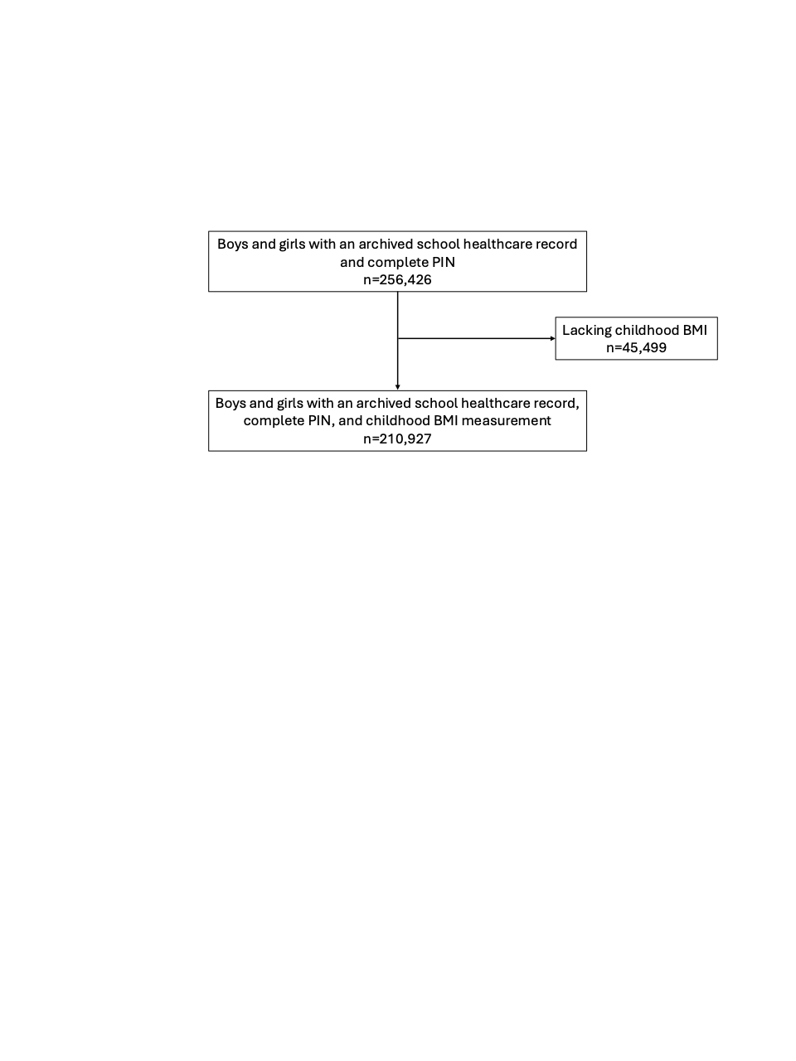
Figure S2. Mean (dots) and standard error (lines) of childhood BMI at the age of seven measured between 1952 and 2017 for 210,927 children in schools in Gothenburg municipality, Sweden, by gender and for every year.

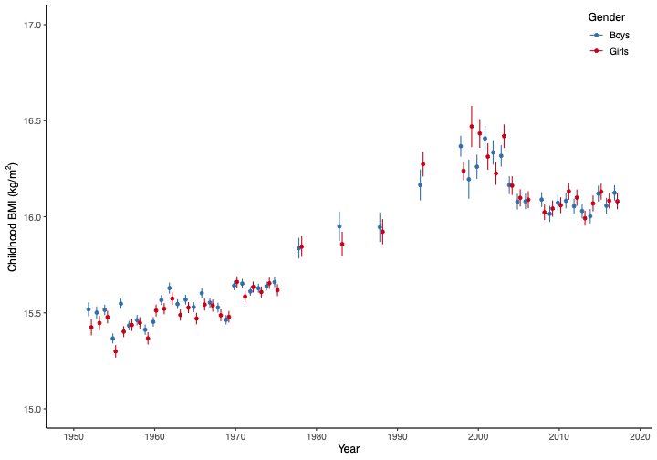
Figure S3. Childhood BMI at the age of seven measured between 1952 and 2017 for 210,927 children in schools in Gothenburg municipality, Sweden, for the 5th, 25th, 50th, 75th, 85th, 95th, and 99th percentiles in each year and splines between the years obtained from quantile regression. Dotted lines indicate thinness, overweight, and obesity categorized using the definitions proposed by the International Obesity Task Force (1).

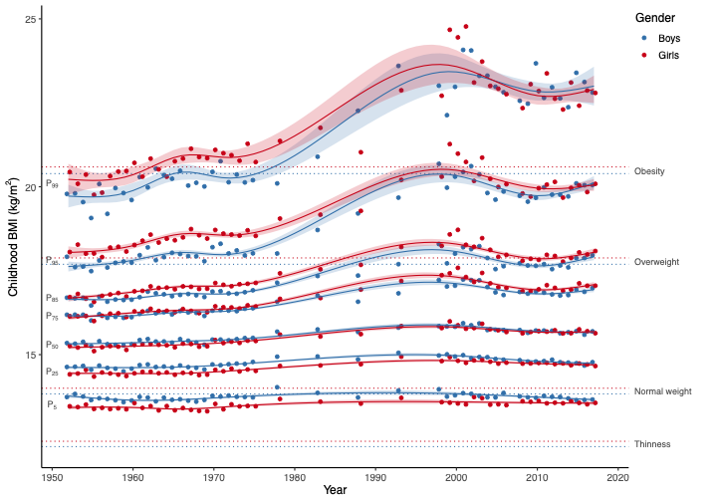

Figure S4. Trend in BMI categories at the age of seven between 1952 and 2017 for 210,927 children in schools in Gothenburg municipality, Sweden. Proportions according to BMI categories each year (dots) and raw data fitted with splines and their 95% confidence intervals. Cut-offs for the BMI groups were derived from the International Obesity Task Force (1). Note that the y-axis has another dimension for the plot of normal weight compared to the others.
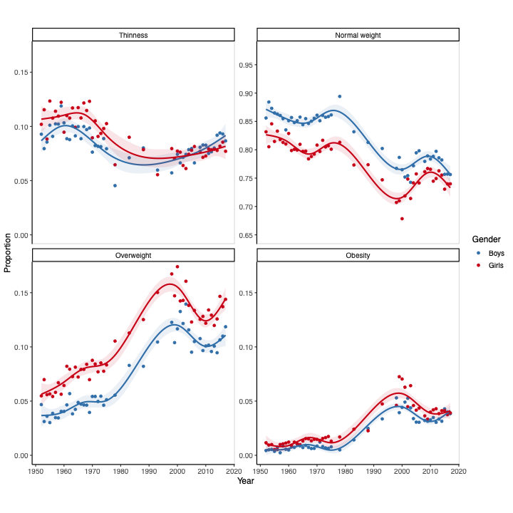
Figure S5. Cross-sectional analysis of the associations between different socioeconomic variables (parental country of birth, parental educational level, and parental income) and childhood BMI at the age of seven between 2002 and 2017 for 65,556 children in schools in Gothenburg municipality, Sweden. Beta and 95% confidence intervals from linear regression including all three socioeconomic components as well as gender, parental age at childbirth, and year (linear and non-linear) in the same model.

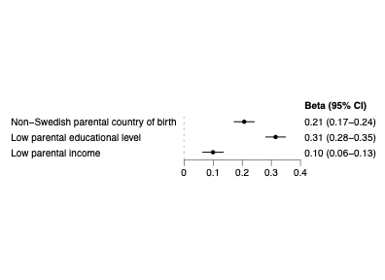
Parental country of birth (reference: Sweden), educational level (reference: high), and income (reference: high).

Figure S6. The trend in BMI at the age of seven between 2002 and 2017 for 63,888 children in schools in Gothenburg municipality, Sweden, by parental country of birth. Regression lines and their 95% confidence intervals from a piecewise linear regression model with one breakpoint and including gender, parents’ age at childbirth, and the socioeconomic variables not stratified on.

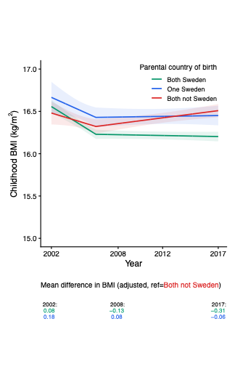

Figure S7. The odds for overweight and obesity at the age of seven between 2002 and 2017 for 63,888 children in schools in Gothenburg municipality, Sweden, by parental country of birth. Odds ratio and their 95% confidence intervals per five years from logistic regression models in the two phases and including gender, parents’ age at childbirth, and the socioeconomic variables not stratified on. Overweight and obesity compared to not overweight and not obesity, respectively.

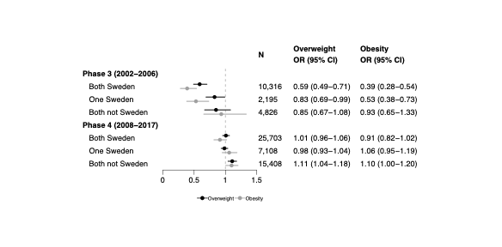
References
1. Cole TJ, Lobstein T. Extended international (IOTF) body mass index cut-offs for thinness, overweight and obesity. Pediatr Obes. 2012 Aug;7(4):284-94.

