Supplementary Table legends
Supplementary Table 1 Baseline demographic characteristics of study participants by quartiles of WSI among male steelworkers
Variable | Total  (N=4345) | Q1：<273.75  (N=1051) | Q2：273.75~  (N=1053) | Q3：1581.71~  (N=1130) | Q4：2798.41~  (N=1111) | 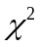 | P value
Age(year) |  |  |  |  |  | 711.64 | <0.001
<30 | 320(7.36) | 146(13.89) | 140(13.30) | 13(1.15) | 21(1.89)
30~ | 1360(31.30) | 277(26.36) | 395(37.51) | 566(50.09) | 122(10.98)
40~ | 1623(37.35) | 390(37.11) | 271(25.74) | 380(33.63) | 582(52.39)
50~60 | 1042(23.98) | 238(22.65) | 247(23.46) | 171(15.13) | 386(34.74)
Marital Status |  |  |  |  |  | 93.91 | <0.001
Unmarried | 170(3.91) | 86(8.18) | 50(4.75) | 8(0.71) | 26(2.34)
Married | 4114(94.68) | 954(90.77) | 985(93.54) | 1109(98.14) | 1066(95.95)
Other | 61(1.40) | 11(1.05) | 18(1.71) | 13(1.15) | 19(1.71)
Educational Level |  |  |  |  |  | 234.39 | <0.001
Elementary school and below | 50(1.15) | 11(1.05) | 7(0.66) | 6(0.53) | 26(2.34)
Middle school | 3265(75.14) | 707(67.27) | 734(69.71) | 824(72.92) | 1000(90.01)
College and above | 1030(23.71) | 333(31.68) | 312(29.63) | 300(26.55) | 85(7.65)
Monthly Household Income |  |  |  |  |  | 76.63 | <0.001
<5000 | 573(13.19) | 182(17.32) | 116(11.02) | 105(9.29) | 170(15.30)
5000~ | 912(20.99) | 200(19.03) | 225(21.37) | 225(19.91) | 262(23.58)
8000~ | 1837(42.28) | 409(38.92) | 444(42.17) | 490(43.36) | 494(44.46)
11000~ | 1023(23.54) | 260(24.74) | 268(25.45) | 310(27.43) | 185(16.65)
Family history of hypertension |  |  |  |  |  | 3.74 | 0.291
No | 2670(61.45) | 668(63.56) | 641(60.87) | 674(59.65) | 687 (61.84)
Yes | 1675(38.55) | 383(36.44) | 412(39.13) | 456(40.35) | 424 (38.16)
Family history of hyperlipidemia |  |  |  |  |  | 5.25 | 0.155
No | 2932(67.48) | 736(70.03) | 714(67.81) | 742(65.66) | 740(66.61)
Yes | 1413(32.52) | 315(29.97) | 339(32.19) | 388(34.34) | 371(33.39)
Smoking status |  |  |  |  |  | 18.45 | 0.005
Never | 1550(35.67) | 399(37.96) | 379(35.99) | 429(37.96) | 343(30.87)
former | 251(5.78) | 49(4.66) | 63(5.98) | 68(6.02) | 71(6.39)
current | 2544(58.55) | 603(57.37) | 611(58.02) | 633(56.02) | 697(62.74)
Alcohol Consumption |  |  |  |  |  | 46.16 | <0.001
Never | 2538(58.41) | 629(59.85) | 660(62.68) | 690(61.06) | 559(50.32)
former | 86(1.98) | 16(1.52) | 18(1.71) | 18(1.59) | 34(3.06)
current | 1721(39.61) | 406(38.63) | 375(35.61) | 422(37.35) | 518(46.62)
Tea Consumption |  |  |  |  |  | 5.94 | 0.115
No | 1830(42.12) | 468(44.53) | 455(43.21) | 465(41.15) | 442(39.78)
Yes | 2515(57.88) | 583(55.47) | 598(56.79) | 665(58.85) | 669(60.22)
Iodized salt |  |  |  |  |  | 5.00 | 0.544
Never | 39(0.90) | 8(0.76) | 11(1.04) | 9(0.80) | 11(0.99)
Always | 4204(96.75) | 1027(97.72) | 1016(96.49) | 1091(96.55) | 1070(96.31)
Previously | 102(2.35) | 16(1.52) | 26(2.47) | 30(2.65) | 30(2.70)
Dietary Quality (DASH Score) |  |  |  |  |  | 5.77 | 0.123
<24 | 2200(50.63) | 544 (51.76) | 500 (47.48) | 577 (51.06) | 579 (52.12)
≥24 | 2145(49.37) | 507 (48.24) | 553 (52.52) | 553 (48.94) | 532 (47.88)
Insomnia Severity Index (AIS) |  |  |  |  |  | 5.08 | 0.827
No insomnia | 1206(27.76) | 271(25.78) | 291(27.64) | 322(28.50) | 322(28.98)
Mild insomnia | 1207(27.78) | 297(28.26) | 289(27.45) | 315(27.88) | 306(27.54)
Moderate insomnia | 1028(23.66) | 261(24.83) | 261(24.79) | 257(22.74) | 249(22.41)
Severe insomnia | 904(20.81) | 222(21.12) | 212(20.13) | 236(20.88) | 234(21.06)
Shift Work Status |  |  |  |  |  | 2542.55 | <0.001
Never worked shifts | 955(21.98) | 807(76.78) | 39(3.70) | 29(2.57) | 80(7.20)
Previously worked shifts | 751(17.28) | 87(8.28) | 293(27.83) | 242(21.42) | 129(11.61)
Currently working shifts | 2639(60.74) | 157(14.94) | 721(68.47) | 859(76.02) | 902(81.19)
Shift Types |  |  |  |  |  | 3226.02 | <0.001
Day Shift Only | 955(21.98) | 822(78.21) | 13(1.23) | 27(2.39) | 93(8.37)
Four Shifts, Three Rotations | 2618(60.25) | 138(13.13) | 576(54.70) | 922(81.59) | 982(88.39)
Three Shifts, Two Rotations | 772(17.77) | 91(8.66) | 464(44.06) | 181(16.02) | 36(3.24)
Shift Rotation Duration (Years) |  |  |  |  |  | 3486.97 | <0.001
<10.00 | 1156(26.61) | 416(39.58) | 687(65.24) | 30(2.65) | 23(2.07)
10.00~ | 998(22.97) | 76(7.23) | 359(34.09) | 553(48.94) | 10(0.90)
19.00~ | 1118(25.73) | 211(20.08) | 7(0.66) | 510(45.13) | 390(35.10)
27.25~ | 1073(24.70) | 348(33.11) | 0(0.00) | 37(3.27) | 688(61.93)
High-temperature exposure |  |  |  |  |  | 71.33 | <0.001
No | 2098(48.29) | 593(56.42) | 548(52.04) | 446(39.47) | 511(45.99)
Yes | 2247(51.71) | 458(43.58) | 505(47.96) | 684(60.53) | 600(54.01)
Noise exposure |  |  |  |  |  | 67.34 | <0.001
No | 2256(51.92) | 654(62.23) | 515(48.91) | 514(45.49) | 573(51.58)
Yes | 2089(48.08) | 397(37.77) | 538(51.09) | 616(54.51) | 538(48.42)
Dust exposure |  |  |  |  |  | 5.40 | 0.145
No | 3745(86.19) | 913(86.87) | 908(86.23) | 988(87.43) | 936(84.25)
Yes | 600(13.81) | 138(13.13) | 145(13.77) | 142(12.57) | 175(15.75)
CO exposure |  |  |  |  |  | 47.09 | <0.001
No | 3700(85.16) | 827(78.69) | 908(86.23) | 990(87.61) | 975(87.76)
Yes | 645(14.84) | 224(21.31) | 145(13.77) | 140(12.39) | 136(12.24)
TyG-WWI |  |  |  |  |  | 60.88 | <0.001
<269.36 | 950(21.86) | 227(21.60) | 214(20.32) | 288(25.49) | 221(19.89)
269.36～ | 1141(26.26) | 259(24.64) | 262(24.88) | 298(26.37) | 322(28.98)
306.52～ | 1098(25.27) | 237(22.55) | 244(23.17) | 301(26.64) | 316(28.44)
354.16～ | 1156(26.61) | 328(31.21) | 333(31.62) | 243(21.50) | 252(22.68)
TyG-WHtR |  |  |  |  |  | 30.66 | <0.001
<12.48 | 1096(25.22) | 277(26.36) | 291(27.64) | 306(27.08) | 222(19.98)
12.48～ | 1077(24.79) | 260(24.74) | 271(25.74) | 260(23.01) | 286(25.74)
18.12～ | 1081(24.88) | 263(25.02) | 235(22.32) | 265(23.45) | 318(28.62)
24.65～ | 1091(25.11) | 251(23.88) | 256(24.31) | 299(26.46) | 285(25.65)
TyG-BMI |  |  |  |  |  | 24.10 | 0.004
<228.124 | 1113(25.62) | 276(26.26) | 278(26.40) | 291(25.75) | 268(24.12)
228.124～ | 1065(24.51) | 277(26.36) | 285(27.07) | 259(22.92) | 244(21.96)
276.848～ | 1044(24.03) | 265(25.21) | 228(21.65) | 267(23.63) | 284(25.56)
305.994～ | 1123(25.85) | 233(22.17) | 262(24.88) | 313(27.70) | 315(28.35)
TyG-WC |  |  |  |  |  | 27.86 | 0.001
<2502.24 | 1035(23.82) | 240(22.84) | 236(22.41) | 300(26.55) | 259(23.31)
2502.24～ | 1138(26.19) | 284(27.02) | 314(29.82) | 288(25.49) | 252(22.68)
2915.92～ | 1086(24.99) | 258(24.55) | 252(23.93) | 253(22.39) | 323(29.07)
3315.68～ | 1086(24.99) | 269(25.59) | 251(23.84) | 289(25.58) | 277(24.93)
TyG-CVAI |  |  |  |  |  | 36.77 | <0.001
<1067.68 | 1099(25.29) | 275(26.17) | 258(24.50) | 301(26.64) | 265(23.85)
1067.68～ | 1093(25.16) | 219(20.84) | 256(24.31) | 327(28.94) | 291(26.19)
1999.92～ | 1096(25.22) | 261(24.83) | 302(28.68) | 259(22.92) | 274(24.66)
2501.68～ | 1057(24.33) | 296(28.16) | 237(22.51) | 243(21.50) | 281(25.29)

Supplementary Table 2 Proportional Hazards Hypothesis Test Based on the Schoenfeld Residual Method
Variable | Model 1 |  |  | Model 2 |  |  | Model3
Variable |  | df | P value |  | df | P value |  | df | P value
TyG-WWI | 2.91 | 5 | 0.09 | 2.85 | 11 | 0.10 | 2.66 | 15 | 0.12
TyG-WHtR | 3.24 | 5 | 0.32 | 3.21 | 11 | 0.34 | 3.14 | 15 | 0.35
TyG-BMI | 3.57 | 5 | 0.17 | 3.33 | 11 | 0.20 | 3.41 | 15 | 0.23
TyG-WC | 3.77 | 5 | 0.45 | 3.65 | 11 | 0.47 | 3.60 | 15 | 0.49
TyG-CVAI | 2.98 | 5 | 0.09 | 2.92 | 11 | 0.10 | 2.87 | 15 | 0.11
Shift Work Status | 2.08 | 5 | 0.15 | 2.02 | 11 | 0.15 | 1.97 | 15 | 0.16
Shift Work Type | 2.31 | 5 | 0.13 | 2.26 | 11 | 0.15 | 2.13 | 15 | 0.17
Duration of Shift Work (years) | 1.39 | 5 | 0.23 | 1.24 | 11 | 0.31 | 1.11 | 15 | 0.33
WSI | 0.38 | 5 | 0.54 | 0.36 | 11 | 0.55 | 0.32 | 15 | 0.61
GLOBAL | 5.32 | 13 | 0.26 | 5.24 | 20 | 0.29 | 5.11 | 24 | 0.31
Note. This table presents the global test results for the proportional hazards assumption of the Cox proportional hazards model (via Schoenfeld residuals). (1) Model 1 was adjusted for age, marital status, household monthly income, and education level; (2) Model 2 was further adjusted for smoking status, alcohol consumption, family history of hypertension, family history of hyperlipidemia, DASH score, and AIS; (3) Model 3 was additionally adjusted for high temperature, noise, dust, and carbon monoxide. For brevity, the Schoenfeld residual test results for the above covariates have been omitted, and only the global test statistics of the overall model for exposure factors are reported. The global Schoenfeld residual tests for all models did not violate the proportional hazards assumption (all p-values > 0.05).
Supplementary Table 3 Analysis of Multiplicative Interaction between WSI and TyG-Metabolic Obesity Indicators (Uncorrected)
Interaction Term | Model 1 |  | Model 2 |  | Model 3
 | HR(95%CI) | P value | HR(95%CI) | P value | HR(95%CI) | P value
WSI*TyG-WWI |  | <0.001 |  | <0.001 |  | <0.001
WSIQ1*TyG-WWIQ1 | ref | ref | ref | ref | ref | ref
WSIQ2*TyG-WWIQ2 | 1.284(1.031,1.600) | 0.026 | 1.154(1.023,1.302) | 0.020 | 1.138(1.076,1.203) | <0.001
WSIQ2*TyG-WWIQ3 | 1.668(1.366,2.038) | <0.001 | 1.523(1.245,1.864) | <0.001 | 1.404(1.146,1.721) | 0.001
WSIQ2*TyG-WWIQ4 | 1.520(1.257,1.837) | <0.001 | 1.665(1.371,2.022) | <0.001 | 1.636(1.346,1.989) | <0.001
WSIQ3*TyG-WWIQ2 | 1.532(1.254,1.872) | <0.001 | 1.514(1.236,1.853) | <0.001 | 1.398(1.141,1.713) | 0.001
WSIQ3*TyG-WWIQ3 | 1.550(1.279,1.878) | <0.001 | 1.386(1.141,1.682) | 0.001 | 1.287(1.060,1.564) | 0.011
WSIQ3*TyG-WWIQ4 | 1.762(1.447,2.145) | <0.001 | 1.709(1.399,2.088) | <0.001 | 1.603(1.310,1.962) | <0.001
WSIQ4*TyG-WWIQ2 | 1.324(1.092,1.605) | 0.004 | 1.251(1.028,1.523) | 0.025 | 1.213(0.995,1.478) | 0.055
WSIQ4*TyG-WWIQ3 | 1.602(1.339,1.917) | <0.001 | 1.535(1.281,1.840) | <0.001 | 1.420(1.182,1.705) | <0.001
WSIQ4*TyG-WWIQ4 | 1.966(1.636,2.361) | <0.001 | 1.547(1.285,1.861) | <0.001 | 1.578(1.310,1.900) | <0.001
WSI*TyG-WHtR |  | <0.001 |  | <0.001 |  | <0.001
WSIQ1*TyG-WHtRQ1 | ref | ref | ref | ref | ref | ref
WSIQ2*TyG-WHtRQ2 | 1.106(0.887,1.380) | 0.372 | 1.092(0.876,1.363) | 0.433 | 1.037(0.831,1.294) | 0.746
WSIQ2*TyG-WHtRQ3 | 1.200(0.967,1.488) | 0.098 | 1.125(0.906,1.396) | 0.286 | 1.068(0.860,1.328) | 0.551
WSIQ2*TyG-WHtRQ4 | 1.205(0.980,1.482) | 0.077 | 1.142(0.928,1.405) | 0.209 | 1.206(0.981,1.484) | 0.076
WSIQ3*TyG-WHtRQ2 | 1.437(1.155,1.788) | 0.001 | 1.265(1.017,1.575) | 0.035 | 1.211(0.973,1.509) | 0.087
WSIQ3*TyG-WHtRQ3 | 1.131(0.905,1.413) | 0.279 | 1.086(0.870,1.356) | 0.466 | 1.024(0.819,1.280) | 0.836
WSIQ3*TyG-WHtRQ4 | 1.484(1.237,1.779) | <0.001 | 1.177(0.981,1.413) | 0.079 | 1.143(0.952,1.373) | 0.153
WSIQ4*TyG-WHtRQ2 | 1.685(1.402,2.023) | <0.001 | 1.468(1.220,1.767) | <0.001 | 1.376(1.143,1.658) | 0.001
WSIQ4*TyG-WHtRQ3 | 1.482(1.236,1.777) | <0.001 | 1.343(1.120,1.612) | 0.001 | 1.257(1.047,1.509) | 0.014
WSIQ4*TyG-WHtRQ4 | 1.619(1.360,1.926) | <0.001 | 1.423(1.195,1.694) | <0.001 | 1.330(1.118,1.585) | 0.001
WSI*TyG-BMI |  | <0.001 |  | <0.001 |  | <0.001
WSIQ1*TyG-BMIQ1 | ref | ref | ref | ref | ref | ref
WSIQ2*TyG-BMIQ2 | 1.244(0.770,2.008) | 0.372 | 1.096(0.687,1.749) | 0.700 | 1.051(0.757,1.459) | 0.767
WSIQ2*TyG-BMIQ3 | 1.243(0.990,1.561) | 0.061 | 1.400(1.113,1.762) | 0.004 | 1.379(1.096,1.735) | 0.006
WSIQ2*TyG-BMIQ4 | 1.721(1.430,2.071) | <0.001 | 1.529(1.268,1.842) | <0.001 | 1.461(1.210,1.763) | <0.001
WSIQ3*TyG-BMIQ2 | 1.430(1.169,1.750) | 0.001 | 1.410(1.153,1.724) | 0.001 | 1.411(1.155,1.725) | 0.001
WSIQ3*TyG-BMIQ3 | 1.682(1.379,2.052) | <0.001 | 1.485(1.213,1.818) | <0.001 | 1.465(1.197,1.793) | <0.001
WSIQ3*TyG-BMIQ4 | 1.567(1.304,1.884) | <0.001 | 1.544(1.286,1.855) | <0.001 | 1.565(1.303,1.880) | <0.001
WSIQ4*TyG-BMIQ2 | 1.596(1.336,1.907) | <0.001 | 1.473(1.233,1.761) | <0.001 | 1.499(1.254,1.792) | <0.001
WSIQ4*TyG-BMIQ3 | 1.721(1.430,2.071) | <0.001 | 1.529(1.268,1.842) | <0.001 | 1.552(1.287,1.871) | <0.001
WSIQ4*TyG-BMIQ4 | 1.790(1.516,2.114) | <0.001 | 1.590(1.347,1.878) | <0.001 | 1.619(1.371,1.911) | <0.001
WSI*TyG-WC |  | <0.001 |  | <0.001 |  | <0.001
WSIQ1*TyG-WCQ1 | ref | ref | ref | ref | ref | ref
WSIQ2*TyG-WCQ2 | 1.104(0.889,1.370) | 0.371 | 1.080(0.868,1.343) | 0.491 | 1.104(0.888,1.372) | 0.375
WSIQ2*TyG-WCQ3 | 1.290(1.047,1.591) | 0.017 | 1.244(1.007,1.537) | 0.043 | 1.189(0.961,1.469) | 0.110
WSIQ2*TyG-WCQ4 | 1.418(1.153,1.743) | 0.001 | 1.262(1.025,1.554) | 0.028 | 1.357(1.102,1.672) | 0.004
WSIQ3*TyG-WCQ2 | 1.143(1.082,1.208) | <0.001 | 1.106(0.998,1.226) | 0.054 | 1.056(1.010,1.104) | 0.016
WSIQ3*TyG-WCQ3 | 1.261(1.014,1.567) | 0.037 | 1.286(1.034,1.599) | 0.024 | 1.226(0.985,1.527) | 0.069
WSIQ3*TyG-WCQ4 | 1.427(1.187,1.715) | <0.001 | 1.400(1.165,1.683) | <0.001 | 1.421(1.182,1.709) | <0.001
WSIQ4*TyG-WCQ2 | 1.859(1.551,2.229) | <0.001 | 1.634(1.360,1.963) | <0.001 | 1.530(1.273,1.840) | <0.001
WSIQ4*TyG-WCQ3 | 1.505(1.253,1.806) | <0.001 | 1.420(1.183,1.705) | <0.001 | 1.311(1.092,1.576) | 0.004
WSIQ4*TyG-WCQ4 | 1.715(1.439,2.043) | <0.001 | 1.686(1.413,2.012) | <0.001 | 1.550(1.297,1.852) | <0.001
WSI*TyG-CVAI |  | <0.001 |  | <0.001 |  | <0.001
WSIQ1*TyG-CVAIQ1 | ref | ref | ref | ref | ref | ref
WSIQ2*TyG-CVAIQ2 | 1.129(0.894,1.426) | 0.309 | 1.104(1.798,1.529) | 0.550 | 1.094(0.866,1.382) | 0.449
WSIQ2*TyG-CVAIQ3 | 1.229(1.004,1.506) | 0.046 | 1.186(0.967,1.454) | 0.102 | 1.096(0.893,1.345) | 0.382
WSIQ2*TyG-CVAIQ4 | 1.249(1.017,1.533) | 0.034 | 1.128(0.916,1.389) | 0.257 | 1.116(0.906,1.374) | 0.303
WSIQ3*TyG-CVAIQ2 | 1.215(0.983,1.503) | 0.072 | 1.389(1.123,1.718) | 0.002 | 1.407(1.137,1.741) | 0.002
WSIQ3*TyG-CVAIQ3 | 1.479(1.217,1.797) | <0.001 | 1.295(1.065,1.575) | 0.010 | 1.404(1.154,1.709) | 0.001
WSIQ3*TyG-CVAIQ4 | 1.550(1.269,1.892) | <0.001 | 1.581(1.295,1.931) | <0.001 | 1.492(1.221,1.822) | <0.001
WSIQ4*TyG-CVAIQ2 | 1.554(1.278,1.889) | <0.001 | 1.450(1.192,1.764) | <0.001 | 1.352(1.110,1.646) | 0.003
WSIQ4*TyG-CVAIQ3 | 1.857(1.568,2.199) | <0.001 | 1.726(1.457,2.044) | <0.001 | 1.613(1.361,1.912) | <0.001
WSIQ4*TyG-CVAIQ4 | 1.841(1.530,2.214) | <0.001 | 1.715(1.423,2.066) | <0.001 | 1.650(1.368,1.999) | <0.001

Supplementary Table 4 Multicollinearity Diagnostics for Variables in the Hypertension Risk Model Among Male Steelworkers
Variable | Tolerance | Variance Inflation Factor
Age(year) | 0.614 | 1.628
Marital Status | 0.876 | 1.141
Educational Level | 0.812 | 1.232
Monthly Household Income | 0.891 | 1.123
Family history of hypertension | 0.769 | 1.300
Family history of hyperlipidemia | 0.814 | 1.228
Smoking status | 0.910 | 1.098
Alcohol Consumption | 0.929 | 1.076
Tea Consumption | 0.972 | 1.029
Iodized salt | 0.991 | 1.009
Dietary Quality (DASH Score) | 0.834 | 1.199
Insomnia Severity Index (AIS) | 0.985 | 1.015
Shift Work Status | 0.378 | 2.647
Shift Types | 0.464 | 2.156
Shift Rotation Duration (Years) | 0.539 | 1.854
Weighted Shift Index (WSI) | 0.633 | 1.580
High-temperature exposure | 0.902 | 1.109
Noise exposure | 0.890 | 1.124
Dust exposure | 0.854 | 1.171
CO exposure | 0.834 | 1.199
TyG-WWI | 0.828 | 1.207
TyG-WHtR | 0.711 | 1.407
TyG-BMI | 0.879 | 1.138
TyG-WC | 0.974 | 1.027
TyG-CVAI | 0.697 | 1.435
Note. All variance inflation factor (VIF) values were < 5, indicating the absence of significant multicollinearity among the predictor variables.
Supplementary Table 5 Subgroup analysis of the association between WSI and hypertension incidence in male steelworkers
Subgroup |  | Q1 | Q2 |  | Q3 |  | Q4
Subgroup |  | Q1 | HR(95%CI) | P value | HR(95%CI) | P value | HR(95%CI) | P value
Age(year)
 | <30 | Ref | 1.190(0.685,2.065) | 0.537 | 2.451(1.094,5.491) | 0.029 | 4.039(1.726,9.452) | 0.001
 | 30~ | Ref | 1.154(0.678,1.961) | 0.598 | 1.231(0.865,1.752) | 0.249 | 1.408(1.011,1.960) | 0.043
 | 40~ | Ref | 1.371(1.098,1.713) | 0.005 | 1.483(1.208,1.820) | <0.001 | 1.702(1.350,2.146) | <0.001
 | 50~60 | Ref | 1.063(0.955,1.184) | 0.265 | 1.105(0.690,1.772) | 0.677 | 1.310(1.039,1.652) | 0.023
Smoking status
 | Never | Ref | 1.258(0.952,1.662) | 0.107 | 1.385(1.059,1.810) | 0.017 | 1.481(1.115,1.966) | 0.007
 | Former | Ref | 1.157(0.602,2.223) | 0.663 | 1.297(1.096,1.536) | 0.003 | 1.425(1.205,1.685) | <0.001
 | Current | Ref | 1.181(1.043,1.337) | 0.009 | 1.557(0.908,2.670) | 0.108 | 1.867(1.642,2.123) | <0.001
Alcohol Consumption
 | Never | Ref | 1.084(0.896,1.312) | 0.405 | 1.237(1.023,1.495) | 0.028 | 1.351(1.116,1.636) | 0.002
 | Former | Ref | 1.110(0.880,1.401) | 0.377 | 1.339(1.087,1.648) | 0.006 | 1.839(1.557,2.172) | <0.001
 | Current | Ref | 1.139(0.974,1.331) | 0.103 | 1.392(1.130,1.715) | 0.002 | 2.029(1.762,2.336) | <0.001
DASH Score
 | <24 | Ref | 1.252(0.990,1.583) | 0.061 | 1.328(1.049,1.682) | 0.018 | 1.725(1.211,2.456) | 0.003
 | ≥24 | Ref | 1.067(0.990,1.150) | 0.092 | 1.125(0.951,1.330) | 0.168 | 1.557(1.362,1.779) | <0.001
Insomnia Severity (AIS)
 | None | Ref | 1.077(0.808,1.435) | 0.614 | 1.154(0.874,1.524) | 0.312 | 1.357(1.078,1.709) | 0.009
 | Mild | Ref | 1.093(0.823,1.450) | 0.540 | 1.284(1.027,1.606) | 0.028 | 1.544(1.116,2.136) | 0.009
 | Moderate | Ref | 1.258(0.958,1.652) | 0.098 | 1.367(1.023,1.827) | 0.034 | 1.598(1.139,2.242) | 0.007
 | Severe | Ref | 1.302(1.028,1.649) | 0.029 | 1.636(1.046,2.561) | 0.031 | 1.813(1.004,3.273) | 0.049

Supplementary Table 6 Subgroup analysis of the association between TyG-WWI and hypertension incidence in male steelworkers
Subgroup |  | Q1 | Q2 |  | Q3 |  | Q4
Subgroup |  | Q1 | HR(95%CI) | P value | HR(95%CI) | P value | HR(95%CI) | P value
Age(year)
 | <30 | Ref | 1.083(0.539,2.178) | 0.822 | 1.095(0.634,1.891) | 0.745 | 1.140(0.574,2.262) | 0.709
 | 30~ | Ref | 1.035(0.828,1.293) | 0.763 | 1.164(0.861,1.576) | 0.324 | 1.383(1.120,1.707) | 0.003
 | 40~ | Ref | 1.042(0.834,1.302) | 0.719 | 1.382(1.122,1.703) | 0.002 | 1.385(1.122,1.710) | 0.002
 | 50~60 | Ref | 1.181(0.904,1.542) | 0.222 | 1.448(1.129,1.857) | 0.004 | 1.640(1.274,2.110) | <0.001
Smoking status
 | Never | Ref | 1.019(0.810,1.283) | 0.871 | 1.162(1.061,1.273) | 0.001 | 1.449(1.167,1.798) | 0.001
 | Former | Ref | 1.076(0.713,1.625) | 0.727 | 1.307(1.086,1.573) | 0.005 | 1.537(1.415,1.670) | <0.001
 | Current | Ref | 1.201(0.996,1.216) | 0.968 | 1.356(1.088,1.691) | 0.007 | 1.703(1.471,1.971) | <0.001
Alcohol Consumption
 | Never | Ref | 1.039(0.862,1.253) | 0.685 | 1.197(1.004,1.426) | 0.045 | 1.299(1.033,1.632) | 0.025
 | Former | Ref | 1.275(0.868,1.872) | 0.216 | 1.287(1.029,1.610) | 0.027 | 1.401(1.118,1.756) | 0.003
 | Current | Ref | 1.299(1.033,1.632) | 0.025 | 1.374(1.102,1.713) | 0.005 | 1.455(1.006,2.104) | 0.046
DASH Score
 | <24 | Ref | 1.362(1.073,1.730) | 0.011 | 1.739(1.361,2.222) | <0.001 | 1.831(1.435,2.335) | <0.001
 | ≥24 | Ref | 1.183(0.992,1.411) | 0.062 | 1.264(1.015,1.574) | 0.037 | 1.656(1.379,1.988) | <0.001
Insomnia Severity Index (AIS)
 | None | Ref | 1.032(0.486,2.193) | 0.934 | 1.267(0.970,1.654) | 0.082 | 1.287(0.982,1.686) | 0.067
 | Mild | Ref | 1.141(0.866,1.504) | 0.348 | 1.367(1.023,1.827) | 0.034 | 1.545(1.161,2.055) | 0.003
 | Moderate | Ref | 1.221(0.930,1.604) | 0.151 | 1.355(1.036,1.773) | 0.027 | 1.598(1.139,2.242) | 0.007
 | Severe | Ref | 1.258(0.958,1.652) | 0.098 | 1.387(1.031,1.866) | 0.031 | 1.813(1.004,3.273) | 0.049
Supplementary Table 7 Subgroup analysis of the association between TyG-WHtR and hypertension incidence in male steelworkers
Subgroup |  | Q1 | Q2 |  | Q3 |  | Q4
Subgroup |  | Q1 | HR(95%CI) | P value | HR(95%CI) | P value | HR(95%CI) | P value
Age(year)
 | <30 | Ref | 1.373(0.705,2.674) | 0.351 | 1.715(0.909,3.236) | 0.096 | 1.874(1.443,2.432) | <0.001
 | 30~ | Ref | 1.158(0.844,1.591) | 0.363 | 1.238(0.897,1.709) | 0.193 | 1.664(1.207,2.294) | 0.002
 | 40~ | Ref | 1.140(0.893,1.454) | 0.293 | 1.355(1.069,1.719) | 0.012 | 1.701(1.359,2.129) | <0.001
 | 50~60 | Ref | 1.171(0.880,1.557) | 0.279 | 1.390(1.054,1.834) | 0.020 | 1.578(1.211,2.056) | 0.001
Smoking status
 | Never | Ref | 1.125(0.852,1.485) | 0.406 | 1.280(0.972,1.685) | 0.079 | 1.766(1.357,2.299) | <0.001
 | Former | Ref | 1.147(0.979,1.344) | 0.089 | 1.336(1.143,1.561) | <0.001 | 1.663(1.435,1.926) | <0.001
 | Current | Ref | 1.189(0.979,1.443) | 0.081 | 1.325(1.095,1.603) | 0.004 | 1.631(1.360,1.955) | <0.001
Alcohol Consumption
 | Never | Ref | 1.138(0.930,1.393) | 0.210 | 1.223(1.000,1.495) | 0.050 | 1.682(1.394,2.029) | <0.001
 | Former | Ref | 1.149(0.838,1.574) | 0.388 | 1.254(0.990,1.590) | 0.061 | 1.624(1.294,2.038) | <0.001
 | Current | Ref | 1.207(0.947,1.539) | 0.129 | 1.413(1.117,1.786) | 0.004 | 1.955(1.503,2.542) | <0.001
DASH Score
 | <24 | Ref | 1.049(0.846,1.302) | 0.661 | 1.170(0.947,1.445) | 0.145 | 1.211(0.994,1.476) | 0.058
 | ≥24 | Ref | 1.062(0.848,1.330) | 0.601 | 1.157(0.923,1.450) | 0.206 | 1.552(1.225,1.967) | <0.001
Insomnia Severity Index (AIS)
 | None | Ref | 1.899(1.542,2.339) | <0.001 | 1.231(0.918,1.651) | 0.165 | 1.346(1.016,1.782) | 0.038
 | Mild | Ref | 1.199(0.919,1.564) | 0.181 | 1.217(0.978,1.514) | 0.078 | 1.277(1.040,1.568) | 0.020
 | Moderate | Ref | 1.245(0.916,1.692) | 0.162 | 1.296(0.952,1.764) | 0.100 | 1.540(1.138,2.086) | 0.005
 | Severe | Ref | 1.270(0.916,1.761) | 0.152 | 1.357(0.978,1.881) | 0.067 | 1.679(1.228,2.294) | 0.001
Supplementary Table 8 Subgroup analysis of the association between TyG-BMI and hypertension incidence in male steelworkers
Subgroup |  | Q1 | Q2 |  | Q3 |  | Q4
Subgroup |  | Q1 | HR(95%CI) | P value | HR(95%CI) | P value | HR(95%CI) | P value
Age(year)
 | <30 | Ref | 1.218(0.900,1.647) | 0.201 | 1.797(1.358,2.378) | <0.001 | 1.725(1.306,2.280) | <0.001
 | 30~ | Ref | 1.042(0.730,1.487) | 0.821 | 1.620(1.156,2.271) | 0.005 | 2.202(1.607,3.017) | <0.001
 | 40~ | Ref | 1.328(0.625,2.823) | 0.461 | 1.565(1.269,1.930) | <0.001 | 1.629(1.326,2.001) | <0.001
 | 50~60 | Ref | 1.256(0.930,1.695) | 0.137 | 1.880(1.425,2.479) | <0.001 | 1.832(1.391,2.412) | <0.001
Smoking status
 | Never | Ref | 1.582(1.201,2.082) | 0.001 | 1.817(1.396,2.364) | <0.001 | 1.882(1.528,2.318) | <0.001
 | Former | Ref | 1.116(0.695,1.792) | 0.650 | 1.506(0.756,3.000) | 0.244 | 1.990(1.264,3.134) | 0.003
 | Current | Ref | 1.027(0.836,1.261) | 0.799 | 1.593(1.325,1.916) | <0.001 | 1.731(1.448,2.069) | <0.001
Alcohol Consumption
 | Never | Ref | 1.212(0.972,1.511) | 0.087 | 1.598(1.324,1.929) | <0.001 | 1.632(1.346,1.977) | <0.001
 | Former | Ref | 1.377(1.150,1.650) | 0.001 | 1.655(0.544,5.031) | 0.375 | 1.884(1.499,2.368) | <0.001
 | Current | Ref | 1.159(0.891,1.506) | 0.271 | 1.687(1.334,2.133) | <0.001 | 1.198(1.044,1.374) | 0.010
DASH Score
 | <24 | Ref | 1.173(0.940,1.463) | 0.158 | 1.413(1.170,1.707) | <0.001 | 1.468(1.210,1.780) | <0.001
 | ≥24 | Ref | 1.177(0.810,1.709) | 0.393 | 1.633(1.296,2.059) | <0.001 | 2.000(1.596,2.506) | <0.001
Insomnia Severity Index (AIS)
 | None | Ref | 1.309(0.973,1.761) | 0.076 | 1.550(1.167,2.057) | 0.002 | 1.792(1.365,2.353) | <0.001
 | Mild | Ref | 1.240(0.604,2.545) | 0.557 | 1.461(1.098,1.945) | 0.009 | 1.732(1.315,2.280) | <0.001
 | Moderate | Ref | 1.265(0.906,1.767) | 0.167 | 1.987(1.468,2.690) | <0.001 | 2.122(1.596,2.840) | <0.001
 | Severe | Ref | 1.441(1.028,2.021) | 0.034 | 2.027(1.477,2.781) | <0.001 | 2.161(1.590,2.938) | <0.001
Supplementary Table 9 Subgroup analysis of the association between TyG-WC and hypertension incidence in male steelworkers
Subgroup |  | Q1 | Q2 |  | Q3 |  | Q4
Subgroup |  | Q1 | HR(95%CI) | P value | HR(95%CI) | P value | HR(95%CI) | P value
Age(year)
 | <30 | Ref | 1.131(0.699,1.828) | 0.616 | 1.369(0.694,2.701) | 0.365 | 1.703(1.222,2.373) | 0.002
 | 30~ | Ref | 1.125(0.804,1.575) | 0.491 | 1.277(0.902,1.806) | 0.168 | 1.991(1.447,2.740) | <0.001
 | 40~ | Ref | 1.150(0.912,1.450) | 0.238 | 1.146(0.920,1.427) | 0.224 | 1.659(1.353,2.035) | <0.001
 | 50~60 | Ref | 1.562(1.156,2.111) | 0.004 | 1.632(1.214,2.195) | 0.001 | 1.871(1.402,2.497) | <0.001
Smoking status
 | Never | Ref | 1.189(0.971,1.457) | 0.094 | 1.196(0.976,1.466) | 0.084 | 1.798(1.486,2.174) | <0.001
 | Former | Ref | 1.125(0.284,4.461) | 0.867 | 1.589(0.462,5.528) | 0.459 | 1.780(1.422,2.227) | <0.001
 | Current | Ref | 1.382(1.089,1.755) | 0.008 | 1.429(1.127,1.812) | 0.003 | 1.948(1.495,2.538) | <0.001
Alcohol Consumption
 | Never | Ref | 1.189(0.971,1.457) | 0.094 | 1.196()0.976,1.466 | 0.084 | 1.798(1.486,2.174) | <0.001
 | Former | Ref | 1.125(0.284,4.461) | 0.867 | 1.504(0.781,2.894) | 0.222 | 1.764(1.192,2.611) | 0.005
 | Current | Ref | 1.382(1.089,1.755) | 0.008 | 1.429(1.127,1.812) | 0.003 | 1.780(1.422,2.227) | <0.001
DASH Score
 | <24 | Ref | 1.126(0.922,1.376) | 0.244 | 1.197(0.984,1.457) | 0.072 | 1.302(1.086,1.560) | 0.004
 | ≥24 | Ref | 1.303(1.024,1.657) | 0.031 | 1.326(1.041,1.691) | 0.023 | 2.376(1.870,3.019) | <0.001
Insomnia Severity Index (AIS)
 | None | Ref | 1.093(0.813,1.471) | 0.555 | 1.123(0.834,1.512) | 0.445 | 1.532(1.159,2.026) | 0.003
 | Mild | Ref | 1.199(0.890,1.616) | 0.232 | 1.263(0.935,1.708) | 0.128 | 1.749(1.319,2.319) | <0.001
 | Moderate | Ref | 1.239(0.907,1.692) | 0.177 | 1.355(0.998,1.841) | 0.052 | 1.871(1.404,2.493) | <0.001
 | Severe | Ref | 1.505(1.089,2.079) | 0.013 | 1.599(1.156,2.210) | 0.005 | 2.160(1.591,2.932) | <0.001
Supplementary Table 10 Subgroup analysis of the association between TyG-CVAI and hypertension incidence in male steelworkers
Subgroup |  | Q1 | Q2 |  | Q3 |  | Q4
Subgroup |  | Q1 | HR(95%CI) | P value | HR(95%CI) | P value | HR(95%CI) | P value
Age(year)
 | <30 | Ref | 1.081(0.859,1.360) | 0.507 | 1.373(1.103,1.708) | 0.005 | 2.067(1.687,2.531) | <0.001
 | 30~ | Ref | 1.514(1.067,2.149) | 0.020 | 1.937(1.380,2.721) | <0.001 | 2.801(1.970,3.983) | <0.001
 | 40~ | Ref | 1.077(0.856,1.357) | 0.526 | 1.359(1.092,1.693) | 0.006 | 1.850(1.508,2.271) | <0.001
 | 50~60 | Ref | 1.484(1.114,1.979) | 0.007 | 1.592(1.198,2.117) | 0.001 | 1.906(1.466,2.477) | <0.001
Smoking status
 | Never | Ref | 1.166(0.885,1.535) | 0.275 | 1.222(0.919,1.625) | 0.167 | 1.842(1.543,2.200) | <0.001
 | Former | Ref | 1.501(0.760,2.961) | 0.242 | 1.829(1.001,3.341) | 0.050 | 1.936(1.002,3.740) | 0.049
 | Current | Ref | 1.263(1.040,1.534) | 0.019 | 1.385(1.148,1.671) | 0.001 | 2.181(1.693,2.810) | <0.001
Alcohol Consumption
 | Never | Ref | 1.096(0.781,1.538) | 0.595 | 1.389(1.138,1.697) | 0.001 | 1.863(1.495,2.323) | <0.001
 | Former | Ref | 1.182(0.923,1.514) | 0.185 | 1.290(1.016,1.637) | 0.037 | 2.163(1.506,3.105) | <0.001
 | Current | Ref | 1.296(0.925,1.815) | 0.132 | 1.383(1.096,1.747) | 0.006 | 2.380(1.829,3.097) | <0.001
DASH Score
 | <24 | Ref | 1.095(0.904,1.325) | 0.353 | 1.153(0.948,1.404) | 0.154 | 1.303(1.097,1.548) | 0.003
 | ≥24 | Ref | 1.383(1.078,1.774) | 0.011 | 1.806(1.417,2.302) | <0.001 | 2.998(2.348,3.828) | <0.001
Insomnia Severity Index (AIS)
 | None | Ref | 1.168(0.858,1.591) | 0.324 | 1.503(1.116,2.023) | 0.007 | 1.885(1.419,2.503) | <0.001
 | Mild | Ref | 1.397(1.039,1.880) | 0.027 | 1.405(1.043,1.892) | 0.025 | 1.929(1.451,2.564) | <0.001
 | Moderate | Ref | 1.131(0.829,1.542) | 0.438 | 1.202(0.892,1.620) | 0.226 | 1.887(1.435,2.482) | <0.001
 | Severe | Ref | 1.401(1.014,1.936) | 0.041 | 1.607(1.173,2.201) | 0.003 | 2.242(1.672,3.008) | <0.001
Supplementary Table 11 Multivariate logistic analysis of the association between TyG-metabolic obesity indices and hypertension incidence
Variable |  | Model 1 |  | Model 2 |  | Model 3
Variable |  | OR(95%CI) | P value | OR(95%CI) | P value | OR(95%CI) | P value
TyG-WWI
 | <269.36 | ref | ref | ref | ref | ref | ref
 | 269.36～ | 2.050(1.665,2.525) | <0.001 | 1.986(1.492,2.642) | <0.001 | 1.909(1.423,2.560) | <0.001
 | 306.52～ | 2.620(2.125,3.229) | <0.001 | 2.321(1.749,3.081) | <0.001 | 2.216(1.654,2.968) | <0.001
 | 354.16～ | 3.006(2.443,3.698) | <0.001 | 2.961(2.231,3.931) | <0.001 | 2.808(2.096,3.761) | <0.001
TyG-WHtR
 | <12.48 | ref | ref | ref | ref | ref | ref
 | 12.48～ | 1.269(1.040,1.549) | 0.019 | 1.242(1.016,1.518) | 0.034 | 1.022(0.776,1.348) | <0.001
 | 18.12～ | 1.603(1.315,1.954) | <0.001 | 1.567(1.284,1.914) | <0.001 | 1.464(1.191,1.798) | <0.001
 | 24.65～ | 2.983(2.445,3.640) | <0.001 | 2.835(2.318,3.467) | <0.001 | 1.837(1.398,2.414) | <0.001
TyG-BMI
 | <228.124 | ref | ref | ref | ref | ref | ref
 | 228.124～ | 2.284(1.571,3.321) | <0.001 | 1.608(1.114,2.323) | 0.011 | 1.418(1.155,1.739) | 0.001
 | 276.848～ | 2.575(2.114,3.137) | <0.001 | 2.152(1.663,2.786) | <0.001 | 2.047(1.566,2.675) | <0.001
 | 305.994～ | 3.054(2.512,3.713) | <0.001 | 2.499(1.914,3.264) | <0.001 | 2.264(1.718,2.983) | <0.001
TyG-WC
 | <2502.24 | ref | ref | ref | ref | ref | ref
 | 2502.24～ | 1.465(1.105,1.942) | 0.008 | 1.402(1.070,1.837) | 0.014 | 1.344(1.102,1.641) | 0.004
 | 2915.92～ | 1.524(1.166,1.991) | 0.002 | 1.513(1.148,1.994) | 0.003 | 1.442(1.180,1.762) | <0.001
 | 3315.68～ | 3.138(2.566,3.838) | <0.001 | 2.675(2.054,3.485) | <0.001 | 2.355(1.789,3.099) | <0.001
TyG-CVAI
 | <1067.68 | ref | ref | ref | ref | ref | ref
 | 1067.68～ | 1.373(1.125,1.677) | 0.002 | 1.334(1.018,1.749) | 0.037 | 1.301(0.980,1.725) | 0.068
 | 1999.92～ | 1.700(1.395,2.072) | <0.001 | 1.499(1.148,1.959) | 0.003 | 1.611(1.219,2.128) | 0.001
 | 2501.68～ | 3.614(2.959,4.413) | <0.001 | 2.876(2.200,3.759) | <0.001 | 2.650(2.003,3.506) | <0.001
Note.(1) Model 1 was adjusted for age, marital status, household monthly income, and education level.(2) Model 2 was further adjusted for smoking status, alcohol consumption, family history of hypertension, family history of hyperlipidemia, DASH diet score, and AIS.(3) Model 3 was additionally adjusted for occupational exposures (high temperature, noise, dust, and CO)

Supplementary Table 12 Multivariate logistic analysis of the association between shift work indices and hypertension incidence
Variable |  | Model 1 |  | Model 2 |  | Model 3
Variable |  | OR(95%CI) | P value | OR(95%CI) | P value |  | OR(95%CI) | P value
Shift Work Status
 | Never worked shifts | ref | ref | ref | ref | ref |  | ref
 | Previously worked shifts | 1.383(1.190,1.607) | <0.001 | 1.315(1.078,1.604) | 0.007 | 1.162(1.015,1.331) |  | 0.030
 | Currently working shifts | 3.057(2.502,3.736) | <0.001 | 2.642(2.247,3.105) | <0.001 | 2.513(2.190,2.883) |  | <0.001
Shift Types
 | Day Shift Only | ref | ref | ref | ref | ref |  | ref
 | Four Shifts, Three Rotations | 1.904(1.507,2.405) | <0.001 | 1.768(1.381,2.263) | <0.001 | 1.239(1.045,1.470) |  | 0.014
 | Three Shifts, Two Rotations | 1.652(1.236,2.207) | 0.001 | 1.638(1.212,2.215) | 0.001 | 1.344(1.084,1.667) |  | 0.007
Shift Rotation Duration (Years)
 | <10.00 | ref | ref | ref | ref | ref |  | ref
 | 10.00~ | 1.482(1.274,1.724) | <0.001 | 1.330(1.242,1.424) | <0.001 | 1.265(1.067,1.501) |  | 0.007
 | 19.00~ | 1.553(1.241,1.945) | <0.001 | 1.425(1.316,1.543) | <0.001 | 1.326(1.193,1.475) |  | <0.001
 | 27.25~ | 2.922(2.405,3.550) | <0.001 | 2.615(2.111,3.239) | <0.001 | 2.578(2.226,2.986) |  | <0.001
WSI
 | <273.75 | ref | ref | ref | ref | ref |  | ref
 | 273.75～ | 1.458(1.194,1.781) | <0.001 | 1.161(0.994,1.356) | 0.060 | 1.120(0.959,1.308) |  | 0.152
 | 1581.71～ | 1.545(1.263,1.890) | <0.001 | 1.315(1.130,1.530) | <0.001 | 1.358(1.167,1.580) |  | <0.001
 | 2798.41～ | 1.812(1.570,2.090) | <0.001 | 1.721(1.491,1.997) | <0.001 | 1.578(1.295,1.924) |  | <0.001
Note.(1) Model 1 was adjusted for age, marital status, household monthly income, and education level.(2) Model 2 was further adjusted for smoking status, alcohol consumption, family history of hypertension, family history of hyperlipidemia, DASH diet score, and AIS.(3) Model 3 was additionally adjusted for occupational exposures (high temperature, noise, dust, and CO)
Supplementary Table 13 Multivariate Cox Proportional Hazards Analysis of RCS Reclassification Indicators
Variable |  | Model 1 |  | Model 2 |  | Model 3
Variable |  | HR(95%CI) | P value | HR(95%CI) | P value | HR(95%CI) | P value
TyG-WWI
 | <223.58 | ref | ref | ref | ref | ref | ref
 | 223.58～ | 1.178(1.024,1.355) | 0.022 | 1.035(0.895,1.198) | 0.641 | 1.069(0.927,1.233) | 0.361
 | 306.53～ | 1.277(1.114,1.465) | <0.001 | 1.173(1.019,1.349) | 0.026 | 1.151(1.001,1.324) | 0.048
 | 448～ | 2.452(2.028,2.964) | <0.001 | 1.858(1.532,2.253) | <0.001 | 1.698(1.399,2.059) | <0.001
TyG-WHtR
 | <7.68 | ref | ref | ref | ref | ref | ref
 | 7.68～ | 1.358(1.104,1.671) | 0.004 | 1.295(1.050,1.598) | 0.016 | 1.286(1.042,1.586) | 0.019
 | 17.55～ | 1.789(1.464,2.187) | <0.001 | 1.548(1.258,1.904) | <0.001 | 1.533(1.246,1.886) | <0.001
 | 21.76～ | 2.272(1.813,2.848) | <0.001 | 1.633(1.289,2.069) | <0.001 | 1.598(1.260,2.026) | <0.001
TyG-BMI
 | <154.36 | ref | ref | ref | ref | ref | ref
 | 154.36～ | 1.170(0.958,1.429) | 0.125 | 1.150(0.944,1.400) | 0.166 | 1.115(0.913,1.361) | 0.287
 | 276.57～ | 1.265(1.040,1.538) | 0.019 | 1.263(1.074,1.485) | 0.005 | 1.222(1.040,1.436) | 0.015
 | 344.82～ | 1.356(1.157,1.589) | <0.001 | 1.278(1.087,1.503) | 0.003 | 1.247(1.060,1.466) | 0.008
TyG-WC
 | <1930.41 | ref | ref | ref | ref | ref | ref
 | 1930.41～ | 1.098(0.929,1.297) | 0.273 | 1.082(0.915,1.279) | 0.356 | 1.074(0.909,1.269) | 0.403
 | 2915.03～ | 1.193(1.010,1.409) | 0.038 | 1.146(0.970,1.353) | 0.110 | 1.136(0.962,1.343) | 0.133
 | 3549.27～ | 1.513(1.244,1.840) | <0.001 | 1.390(1.141,1.691) | <0.001 | 1.257(1.031,1.531) | 0.023
TyG-CVAI
 | <263.09 | ref | ref | ref | ref | ref | ref
 | 263.09～ | 1.225(1.007,1.492) | 0.043 | 1.158(0.950,1.411) | 0.147 | 1.160(0.951,1.414) | 0.142
 | 1987.75～ | 1.362(1.119,1.657) | 0.002 | 1.229(1.010,1.497) | 0.040 | 1.240(1.018,1.511) | 0.032
 | 3400.16～ | 3.754(3.046,4.628) | <0.001 | 2.168(1.747,2.690) | <0.001 | 2.142(1.725,2.659) | <0.001
WSI
 | <811.13 | ref | ref | ref | ref | ref | ref
 | 811.13～ | 1.018(0.924,1.122) | 0.721 | 1.127(0.990,1.2840 | 0.072 | 1.233(1.082,1.405) | 0.002
 | 2324.87～ | 1.058(0.963,1.163) | 0.238 | 1.222(1.073,1.392) | 0.002 | 1.257(1.063,1.485) | 0.007
 | 3812.33～ | 1.184(0.993,1.413) | 0.060 | 1.547(1.309,1.828) | <0.001 | 1.536(1.300,1.816) | <0.001
Note.(1) Model 1 was adjusted for age, marital status, household monthly income, and education level.(2) Model 2 was further adjusted for smoking status, alcohol consumption, family history of hypertension, family history of hyperlipidemia, DASH diet score, and AIS.(3) Model 3 was additionally adjusted for occupational exposures (high temperature, noise, dust, and CO)

Supplementary Table 14 E-values for the association between quartiles of TyG-metabolic obesity indices, weighted shift index (WSI), and incident hypertension among male steelworkers
Variable |  | E value
TyG-WWI
 | <269.36 | ref
 | 269.36～ | 2.04
 | 306.52～ | 2.26
 | ≥354.16 | 2.56
TyG-WHtR
 | <12.48 | ref
 | 12.48～ | 1.83
 | 18.12～ | 1.89
 | ≥24.65 | 2.36
TyG-BMI
 | <228.124 | ref
 | 228.124～ | 1.20
 | 276.848～ | 2.51
 | ≥305.994 | 2.40
TyG-WC
 | <2502.24 | ref
 | 2502.24～ | 1.82
 | 2915.92～ | 1.85
 | ≥3315.68 | 2.48
TyG-CVAI
 | <1067.68 | ref
 | 1067.68～ | 1.46
 | 1999.92～ | 1.99
 | ≥2501.68 | 2.94
WSI
 | <273.75 | ref
 | 273.75~ | 1.75
 | 1581.71~ | 1.76
 | 2798.41~ | 1.93

Supplementary Figure legends
Supplementary Figure 1 TyG-Metabolic Obesity Indice and Dose-Response Relationship with Hypertension Risk
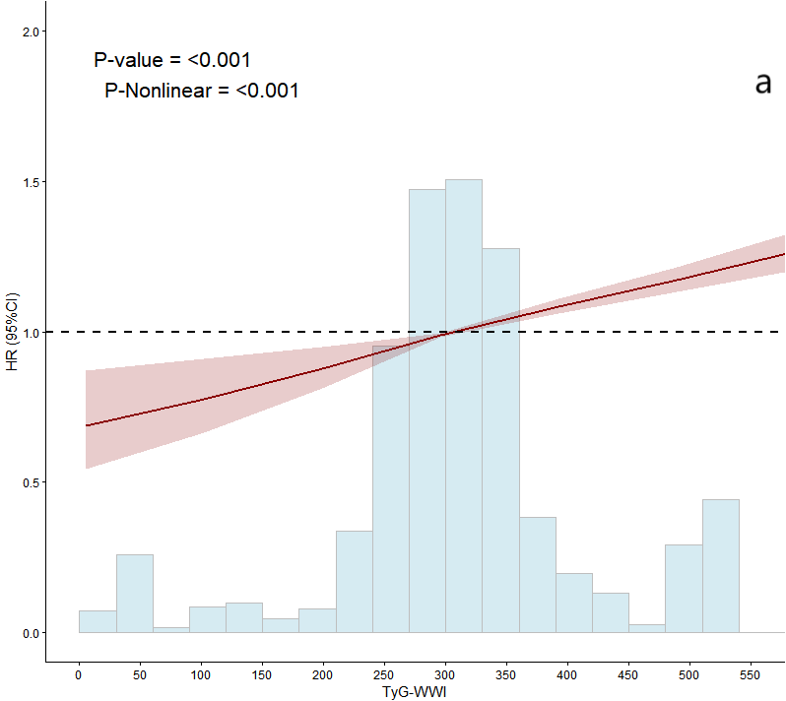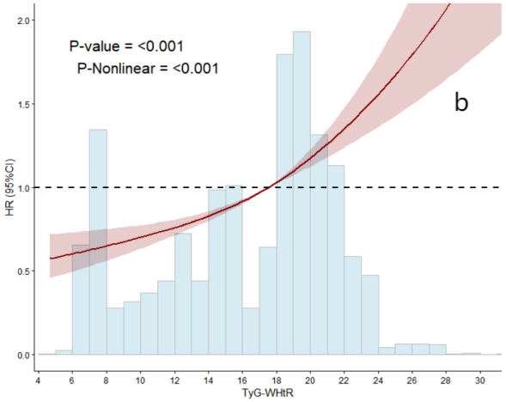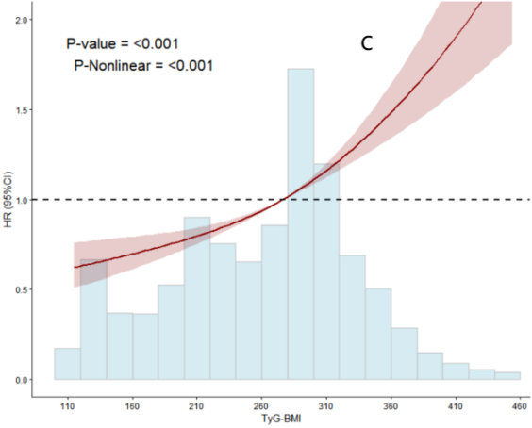gergrg24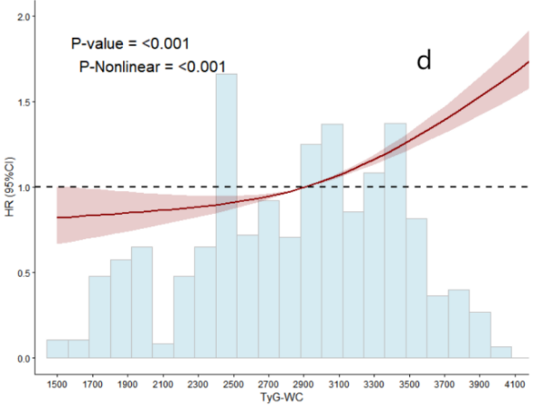
2542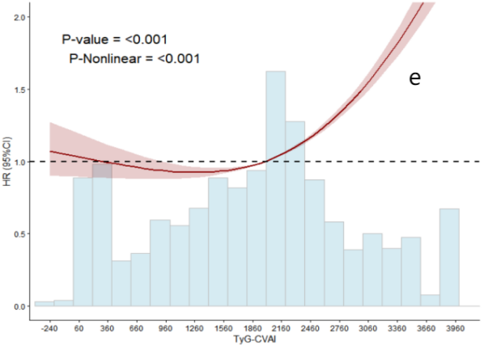
Note. Age, marital status, monthly household income, educational level, smoking status, alcohol Consumption, family history of hypertension, family history of hyperlipidemia, DASH, AIS, high temperatures, noise, dust, and CO were included as model adjustment factors.

Supplementary Figure 2 Dose-response relationship between WSI and hypertension risk
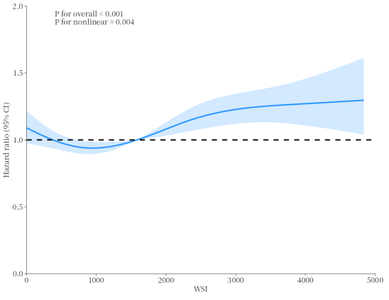
Note. Age, marital status, monthly household income, educational attainment, smoking status, drinking status, family history of hypertension, family history of hyperlipidemia, DASH, AIS, high temperatures, noise, dust, and CO were included as model adjustment factors.

