Additional file 1: Supplementary Tables and Figures
Commuting time and depressive symptoms among employed adults in China: pooled and fixed-effects estimates from the China Family Panel Studies
All results in this file are based on four biennial waves of the China Family Panel Studies (CFPS; 2016, 2018, 2020 and 2022), restricted to respondents aged 16–65 who were coded as currently employed and who had observed one-way commuting-time information. Unless stated otherwise, the main analytic sample comprises 33,322 person-year observations from 18,389 individuals. Pooled ordinary least-squares (OLS) models use heteroscedasticity-consistent (HC1) standard errors clustered by individual; two-way fixed-effects (FE) models use individual-clustered Arellano HC1 standard errors. β denotes the estimated change in the six-item Center for Epidemiologic Studies Depression Scale (CES-D-6) score per additional minute of one-way commuting time. CI, confidence interval; IPW, inverse-probability weighting; SD, standard deviation; SE, standard error.
Contents
Table S1. Sample flow, observability of commuting-time information, and comparison of retained and excluded eligible employed respondents.
Table S2. Missingness by variable in the 2016 wave, and wave-specific measurement checks for the CES-D-6.
Table S3. Weekly working hours: three-model bridge and identifying variation available to the fixed-effects estimator.
Table S4. Full coefficients from the main pooled and fixed-effects models.
Table S5. Fixed-effects sensitivity analyses: sample restrictions, observed time-varying changes, and covariate specification.
Table S6. Pooled robustness, alternative clustering, and selection-weighted analyses.
Table S7. Exploratory analyses: secondary outcomes, non-linearity, effect modification, and the job-satisfaction decomposition.
Table S8. Stratified pooled associations between commuting time and CES-D-6 score.
Table S9. Confirmatory factor analysis of the CES-D: fit indices and standardized loadings, by wave.
Figure S1. Distribution of one-way commuting time among employed respondents.
Figure S2. Exploratory adjusted spline association between one-way commuting time and CES-D-6 score.
Figure S3. Two-way fixed-effects sensitivity analyses.
Table S1. Sample flow, observability of commuting-time information, and comparison of retained and excluded eligible employed respondents
Panel A. Sequential sample flow (person-year observations)
Stage | 2016 | 2018 | 2020 | 2022 | All waves
Person-year observations in source data | 36,892 | 37,123 | 28,530 | 27,001 | 129,546
Aged 16–65 | 31,152 | 28,407 | 21,570 | 20,013 | 101,142
Coded as currently employed | 21,667 | 21,475 | 16,194 | 14,787 | 74,123
Excluded: commuting time missing or negative | −8,973 | −10,017 | −6,654 | −5,414 | −31,058
Excluded: commuting time > 240 minutes | −2 | 0 | 0 | 0 | −2
With observed commuting time 0–240 minutes | 12,692 | 11,458 | 9,540 | 9,373 | 43,063
Excluded: CES-D-6 score missing | −13 | −133 | −146 | −119 | −411
Excluded: any other model covariate missing | −7,318 | −445 | −1,020 | −547 | −9,330
Main analytic sample | 5,361 | 10,880 | 8,374 | 8,707 | 33,322
Note. Covariates required for complete-case inclusion: employment status, age, one-way commuting time, CES-D-6 score, sex, education, marital status, hukou type, community type, weekly working hours, logged annual household income and housing tenure. The main analytic sample comprises 18,389 unique individuals. The large covariate-related loss in 2016 is attributable almost entirely to weekly working hours (see Table S2, Panel A).
Panel B. Observability of commuting-time information among employed working-age respondents
Wave | Employed, aged 16–65 | Commuting time missing or negative | % missing | Commuting time observed
2016 | 21,667 | 8,973 | 41.4 | 12,694
2018 | 21,475 | 10,017 | 46.6 | 11,458
2020 | 16,194 | 6,654 | 41.1 | 9,540
2022 | 14,787 | 5,414 | 36.6 | 9,373
All waves | 74,123 | 31,058 | 41.9 | 43,065
Note. The proportion of employed working-age respondents without observed commuting-time information was broadly similar in every wave. In Panel B, "observed" means a non-negative response and includes the two observations with commuting time greater than 240 minutes; those two observations are excluded under the prespecified upper bound in Panel A. Valid non-negative commuting-time responses were also observed among respondents not classified as currently employed in every wave (2016: 2,000; 2018: 1,827; 2020: 1,577; 2022: 1,396); a non-missing response was therefore not treated as evidence of current employment, and we do not infer the reason for the missingness among employed respondents or assert a specific routing rule for the commuting-time item. Estimates should accordingly be interpreted as applying to employed respondents with observed commuting-time information rather than to all employed adults in China; a selection-weighted sensitivity analysis is reported in Table S6, Panel C.
Panel C. Retained versus excluded eligible employed respondents
Characteristic | Retained (n = 33,322) Mean (SD) | Excluded (n = 40,801) Mean (SD)
Age, years | 38.30 (11.29) | 45.49 (12.05)
Male, proportion | 0.58 (0.49) | 0.53 (0.50)
Education (0–7) | 2.68 (1.43) | 1.54 (1.30)
Urban community, proportion | 0.64 (0.48) | 0.35 (0.48)
Rural hukou, proportion | 0.66 (0.47) | 0.85 (0.35)
Logged annual household income | 11.44 (0.84) | 10.82 (1.02)
CES-D-6 score | 9.27 (2.87) | 9.55 (3.23)
Note. Both groups are restricted to respondents aged 16–65 who were coded as currently employed. Numbers of non-missing observations differ by variable among excluded respondents (education n = 39,708; urban community n = 37,302; rural hukou n = 37,069; household income n = 38,906; CES-D-6 n = 36,189). These differences describe the composition of the analytic sample and constrain the generalisability of the estimates. They do not identify the direction or the magnitude of selection bias in the association between commuting time and depressive symptoms, and they are not interpreted as doing so.
Table S2. Missingness by variable in the 2016 wave, and wave-specific measurement checks for the CES-D-6
Panel A. Missingness by variable among employed working-age respondents in 2016 (n = 21,667)
Variable | Non-missing | Missing | % missing
Weekly working hours | 8,396 | 13,271 | 61.25
Education | 20,633 | 1,034 | 4.77
Housing tenure | 20,953 | 714 | 3.30
Logged annual household income | 21,335 | 332 | 1.53
Community type | 21,494 | 173 | 0.80
CES-D-6 score | 21,640 | 27 | 0.12
Rural hukou | 21,657 | 10 | 0.05
Marital status | 21,666 | 1 | <0.01
Sex | 21,667 | 0 | 0.00
Note. Percentages are calculated among all employed respondents aged 16–65 in 2016. Weekly working hours were missing far more often than any other covariate and account for the majority of the covariate-related sample loss in that wave. Among the 12,692 respondents in 2016 with observed commuting time between 0 and 240 minutes, 13 were excluded because the CES-D-6 score was missing and a further 7,318 were excluded because one or more other model covariates were missing, almost entirely because weekly working hours were unavailable (Table S1, Panel A). This motivated the sensitivity analyses reported in Table S3.
Panel B. Wave-specific measurement checks for the CES-D-6
Wave | n with complete CES-D-6 | Cronbach's α | Mean | SD | Median | Range
2016 | 33,175 | 0.771 | 9.20 | 3.08 | 9 | 6–24
2018 | 32,422 | 0.767 | 9.43 | 3.11 | 9 | 6–24
2020 | 24,531 | 0.777 | 9.52 | 3.22 | 9 | 6–24
2022 | 23,051 | 0.784 | 9.75 | 3.32 | 9 | 6–24
Note. Computed among all CFPS respondents with complete CES-D-6 data in each wave, not only among the analytic sample; the confirmatory factor analyses in Table S9 are instead computed within the analytic sample, so the two sets of checks describe measurement performance in the source population and in the estimation sample respectively. These checks support the internal consistency and comparability of the CES-D-6 across the four waves used here, including the 2016 wave. They do not constitute a formal test of longitudinal measurement invariance.
Table S3. Weekly working hours: three-model bridge and identifying variation available to the fixed-effects estimator
Panel A. Three-model bridge
Model | β | SE | 95% CI | P | Observations | Individuals
A. Main FE: main sample, adjusts for work hours | 0.00154 | 0.00118 | −0.00078 to 0.00386 | 0.192 | 33,322 | 18,389
B. Same-sample FE: omit work-hour adjustment | 0.00161 | 0.00118 | −0.00071 to 0.00393 | 0.174 | 33,322 | 18,389
C. Expanded-sample FE: no work-hour restriction or adjustment | 0.00143 | 0.00100 | −0.00054 to 0.00340 | 0.155 | 39,821 | 20,061
Pooled OLS counterpart of model C | 0.00347 | 0.00074 | 0.00201 to 0.00492 | <0.001 | 39,821 | 20,061
Pooled OLS counterpart of model C, FE covariate set | 0.00272 | 0.00075 | 0.00126 to 0.00418 | <0.001 | 39,821 | 20,061
Note. Comparing models A and B isolates the effect of removing the weekly-work-hours adjustment while holding the sample fixed; comparing models B and C adds the observations that become eligible when weekly working hours are no longer required. Removing the adjustment alone changed neither the point estimate nor its standard error appreciably. The narrower confidence interval in model C coincided with a larger number of individuals contributing repeated observations and within-person variation in commuting time (Panel B); the design does not permit attribution of the change in precision to any single modelling component. In all three fixed-effects models the confidence interval includes the null, and none of these results is described as statistically significant.
Panel B. Identifying variation available to the fixed-effects estimator
Indicator | Main sample | Expanded sample (no work-hours requirement)
Person-year observations | 33,322 | 39,821
Individuals | 18,389 | 20,061
Individuals with ≥ 2 observed waves | 9,674 (52.6%) | 11,478 (57.2%)
Individuals with within-person variation in commuting time | 7,650 (41.6%) | 9,350 (46.6%)
Among individuals with ≥ 2 waves, % with commuting-time variation | 79.1% | 81.5%
Median within-person SD of commuting time, minutes | 5.77 | 5.77
Mean within-person SD of commuting time, minutes | 9.28 | 9.66
Minimum detectable effect, 80% power, two-sided α = 0.05 | 0.00331 | 0.00280
Note. Individuals observed in only one wave contribute no within-person information to the fixed-effects estimator. Percentages are calculated over all individuals in the corresponding sample. Within-person standard deviations are computed among individuals observed in at least two waves. The minimum detectable effect is computed from the realised standard error of the corresponding fixed-effects estimator as (z₀.₉₇₅ + z₀.₈₀) × SE; it is a design-precision quantity and not a retrospective (observed) power calculation. The limited within-person variation in commuting time is the principal reason for the imprecision of the fixed-effects estimates reported throughout.
Table S4. Full coefficients from the main pooled and fixed-effects models
Variable | M1 pooled OLS (basic) | M2 pooled OLS (full) | M3 pooled OLS + tenure | M4 two-way FE
One-way commuting time (min) | 0.00299*** (0.00082) | 0.00387*** (0.00082) | 0.00385*** (0.00082) | 0.00154 (0.00118)
Male | −0.53691*** (0.03917) | −0.56804*** (0.03911) | −0.56801*** (0.03909) | Absorbed
Age | 0.12181*** (0.01312) | 0.09887*** (0.01322) | 0.09876*** (0.01321) | 0.17357 (0.07324)
Age squared | −0.00147*** (0.00016) | −0.00122*** (0.00016) | −0.00121*** (0.00016) | −0.00066 (0.00041)
Education (0–7) | −0.18443*** (0.01570) | −0.15752*** (0.01656) | −0.15890*** (0.01660) | −0.02040 (0.05834)
Married | −0.76055*** (0.05535) | −0.65465*** (0.05534) | −0.63344*** (0.05558) | −0.57597*** (0.10266)
Rural hukou | 0.11171* (0.04502) | 0.01349 (0.04515) | −0.00059 (0.04535) | 0.03467 (0.10002)
Urban community | −0.06744 (0.04151) | −0.01593 (0.04146) | −0.04827 (0.04185) | 0.08410 (0.08392)
Weekly working hours | — | 0.00936*** (0.00101) | 0.00921*** (0.00101) | 0.00573*** (0.00141)
Logged household income | — | −0.22014*** (0.02463) | −0.21098*** (0.02467) | −0.11041** (0.03588)
Owner-occupier (ref. market renter) | — | — | −0.30877*** (0.06486) | —
Social housing (ref. market renter) | — | — | −0.12590 (0.09227) | —
Friends/relatives (ref. market renter) | — | — | 0.01205 (0.11078) | —
Other housing (ref. market renter) | — | — | −0.09874 (0.10078) | —
Wave 2018 (ref. 2016) | — | 0.28356*** (0.04300) | 0.28344*** (0.04296) | Absorbed
Wave 2020 (ref. 2016) | — | 0.47017*** (0.04737) | 0.46682*** (0.04745) | Absorbed
Wave 2022 (ref. 2016) | — | 0.77320*** (0.04928) | 0.75459*** (0.04939) | Absorbed
Intercept | 8.25331*** (0.25488) | 10.22826*** (0.36487) | 10.38973*** (0.36825) | —
Observations | 33,322 | 33,322 | 33,322 | 33,322
Individuals | 18,389 | 18,389 | 18,389 | 18,389
Year fixed effects | No | Yes | Yes | Yes
Individual fixed effects | No | No | No | Yes
Note. Standard errors in parentheses. Pooled models use HC1 standard errors clustered by individual; the two-way fixed-effects model uses individual-clustered Arellano HC1 standard errors. *P < 0.05; **P < 0.01; ***P < 0.001. "Absorbed" denotes covariates subsumed by the individual or year fixed effects. Sex was treated as time-invariant and omitted from the fixed-effects specification; a small number of inconsistent sex reports across waves are noted in Table S8. In the two-way fixed-effects specification, linear age is largely collinear with the combination of individual and survey-year fixed effects and is identified only from residual variation such as unbalanced observation timing; the age coefficients in M4 are therefore reported without significance markers and are not interpretable as substantive parameters, and a specification omitting both age terms is reported in Table S5, Panel C. Education, hukou type and community type are not perfectly time-invariant and are therefore estimated (see Table S5, Panel C). The commuting-time coefficient in M4 is not marked with significance asterisks because it does not reach conventional statistical significance.
Table S5. Fixed-effects sensitivity analyses
Panel A. Sample-restriction sensitivity analyses
Analysis | Methodological concern addressed | β | 95% CI | P | Observations
Main two-way FE model | Reference specification | 0.00154 | −0.00078 to 0.00386 | 0.192 | 33,322
Excluding 2016 | Influence of the 2016 wave | 0.00211 | −0.00071 to 0.00494 | 0.143 | 27,961
Excluding 2020 | Influence of the pandemic-affected wave | 0.00193 | −0.00103 to 0.00488 | 0.201 | 24,948
Excluding 2022 | Influence of the final post-pandemic wave | 0.00131 | −0.00149 to 0.00411 | 0.358 | 24,615
Commuters only (> 0 minutes) | Role of home-based or zero-travel work | 0.00195 | −0.00047 to 0.00436 | 0.114 | 29,807
Balanced four-wave panel | Attrition and panel imbalance | −0.00275 | −0.00769 to 0.00218 | 0.274 | 3,528
Note. The balanced four-wave panel comprises only 882 individuals and 3,528 person-year observations; the corresponding estimate is very imprecise and should not be read as evidence of an association in the opposite direction.
Panel B. Observed time-varying changes
Analysis | Methodological concern addressed | β | 95% CI | P | Observations
Excluding observed inter-provincial movers | Residential mobility across provinces | 0.00157 | −0.00082 to 0.00397 | 0.198 | 31,283
Additionally adjusting for current province | Residential context | 0.00158 | −0.00074 to 0.00390 | 0.182 | 33,322
Additionally adjusting for self-rated health | Time-varying health status | 0.00148 | −0.00083 to 0.00380 | 0.208 | 33,320
2018–2022: additionally adjusting for a recorded new job start | Employment transitions | 0.00196 | −0.00086 to 0.00479 | 0.173 | 27,758
Note. Observed inter-provincial moves were recorded for 803 of 18,389 individuals (4.4%). The employment measure is the CFPS employment-history-calendar (EHC) count of job starts during the recall period, dichotomised as at least one recorded job start. The variable was available for 99.35% of observations in 2018, 98.96% in 2020 and 99.48% in 2022, and approximately 42–43% of observations reported at least one job start during the recall period; the model is estimated on the 27,758 observations of the 2018–2022 panel with a complete record. The measure is described literally and is not interpreted as an employer change or an occupational change. These analyses do not eliminate time-varying confounding, because residential mobility, health and employment transitions may themselves be related to commuting conditions. Employment sector and employer type could not be harmonised consistently across all four waves and were therefore not examined. Current vehicle ownership was considered as a proxy for commuting mode but not adopted, because it may be jointly determined by residential location, employment conditions and commuting requirements and may therefore be post-exposure.
Panel C. Covariate specification checks
Covariate | Individuals with an observed change | % of all individuals
Community type (urban vs rural) | 1,173 | 6.4
Education | 1,720 | 9.4
Hukou type | 804 | 4.4

Sensitivity analysis | β | 95% CI | P | Observations
Two-way FE omitting education, hukou type and community type | 0.00154 | −0.00077 to 0.00386 | 0.192 | 33,322
Two-way FE omitting age and age squared | 0.00148 | −0.00084 to 0.00379 | 0.212 | 33,322
Note. Because some of the observed within-person changes in education, hukou type and community type may reflect reporting or classification changes rather than genuine transitions, these variables are retained in the main specification but are not interpreted as substantive parameters; omitting all three left the commuting-time estimate essentially unchanged. Linear age is largely collinear with the combination of individual and survey-year fixed effects; omitting age and age squared likewise left the commuting-time estimate essentially unchanged, indicating that the main fixed-effects result does not depend on this specification choice.
Table S6. Pooled robustness, alternative clustering, and selection-weighted analyses
Panel A. Robustness of the pooled estimate
Analysis | Methodological concern addressed | β | 95% CI | P | Observations
M2 pooled OLS (reference) | Main pooled specification | 0.00387 | 0.00225 to 0.00548 | <0.001 | 33,322
Exclude 2016 | Influence of the 2016 wave | 0.00401 | 0.00222 to 0.00581 | <0.001 | 27,961
Exclude 2020 | Influence of the pandemic-affected wave | 0.00440 | 0.00254 to 0.00625 | <0.001 | 24,948
Exclude 2022 | Influence of the final post-pandemic wave | 0.00347 | 0.00176 to 0.00518 | <0.001 | 24,615
Commuters only (> 0 minutes) | Role of zero-travel work arrangements | 0.00463 | 0.00294 to 0.00632 | <0.001 | 29,807
Stripped controls (demographics and year only) | Alternative adjustment set | 0.00322 | 0.00161 to 0.00483 | <0.001 | 33,322
Balanced four-wave panel | Attrition and panel imbalance | 0.00364 | −0.00216 to 0.00944 | 0.219 | 3,528
Log-transformed commuting time | Functional form of the exposure | 0.04083 | 0.00969 to 0.07197 | 0.010 | 33,322
Raw reported weekly working hours | Working-hour data quality | 0.00387 | 0.00225 to 0.00548 | <0.001 | 33,322
Exclude weekly hours <1 or >112 | Working-hour data quality | 0.00393 | 0.00232 to 0.00553 | <0.001 | 33,152
Logged income winsorised at 1st/99th percentiles | Income data quality | 0.00387 | 0.00225 to 0.00548 | <0.001 | 33,322
Ordered logit (log-odds) | Distributional assumptions of the outcome | 0.00235 | 0.00131 to 0.00340 | <0.001 | 33,322
Standardized CES-D-6 | Measurement scale of the outcome | 0.00135 | 0.00078 to 0.00191 | <0.001 | 33,322
Quantile 0.25 | Association across the outcome distribution | 0.00247 | 0.00063 to 0.00431 | 0.008 | 33,322
Quantile 0.50 | Association across the outcome distribution | 0.00416 | 0.00217 to 0.00615 | <0.001 | 33,322
Quantile 0.75 | Association across the outcome distribution | 0.00445 | 0.00235 to 0.00654 | <0.001 | 33,322
Weighted pooled sensitivity analysis | CFPS sampling design | 0.00325 | 0.00079 to 0.00572 | 0.010 | 28,809
Note. "Stripped controls" retains sex, age, age squared, education, marital status, hukou type, community type and year indicators and omits weekly working hours and logged household income. Weekly working hours were winsorised to 1–112 hours per week in the main specification; this affected fewer than 0.6% of observations in every wave (2016: 0.45%; 2018: 0.60%; 2020: 0.42%; 2022: 0.53%), so the pooled estimate using the raw reported values is identical to the main estimate to three significant figures rather than duplicated in error. Winsorising logged household income at the 1st and 99th percentiles changed the pooled coefficient only marginally, from 0.0038660 to 0.0038654 (SE 0.00082; 95% CI 0.00225 to 0.00548), because fewer than 1% of observations were affected; the estimate is therefore identical to the main model to three significant figures rather than omitted or duplicated in error. The ordered-logit row reports the log-odds coefficient and its 95% confidence interval; this corresponds to an odds ratio of 1.0024 per additional commuting minute (95% CI 1.0013 to 1.0034). Quantile-regression confidence intervals use bootstrap standard errors (500 replications). The weighted analysis uses CFPS national cross-sectional personal weights normalised within each wave, with individual-clustered standard errors; a positive, non-missing weight was available for 28,809 of 33,322 observations (86.5%; by wave, 2016: 85.6%, 2018: 88.8%, 2020: 85.6%, 2022: 85.0%). It is a weighted pooled sensitivity analysis and not a design-based survey analysis, because sampling strata and primary sampling units were not incorporated; it is not a weighted fixed-effects analysis.
Panel B. Alternative clustering levels for the pooled M2 estimate
Clustering level | Clusters | β | SE | 95% CI | P
Individual (main specification) | 18,389 | 0.00387 | 0.000824 | 0.00225 to 0.00548 | <0.001
Family | 11,608 | 0.00387 | 0.000833 | 0.00223 to 0.00550 | <0.001
Province | 31 | 0.00387 | 0.000803 | 0.00229 to 0.00544 | <0.001
Note. The level of clustering affects only the standard error; the point estimate is identical across the three specifications by construction. Family-level clustering is the more informative comparison here, because depressive symptoms are correlated within households. Province-level clustering is based on a small number of clusters and is reported only as an additional check; it is not used for the main inference. Community-level identifiers were not used because they are not consistently available across all four waves.
Panel C. Selection-weighted (inverse-probability-weighted) pooled analyses
Analysis | β | SE | 95% CI | P | Observations
IPW, untrimmed inverse-probability weights | 0.00522 | 0.00142 | 0.00242 to 0.00801 | <0.001 | 33,322
IPW, weights trimmed at 99th percentile | 0.00449 | 0.00119 | 0.00216 to 0.00681 | <0.001 | 33,322
Note. IPW weights were defined as the inverse of the predicted probability of valid commuting-time information among age-eligible employed person-waves with complete selection-model covariates (age, sex, education, marital status, rural hukou, urban community, logged household income, CES-D-6 score and survey wave); standard errors were clustered by individual. The second row truncates weights at the 99th percentile. The weight distribution had a non-trivial upper tail (median 1.17; 95th percentile 3.70; 99th percentile 7.47; maximum 267.81; 334 observations, 1.00%, trimmed at the 99th percentile). Both estimates are positive and directionally consistent with the main pooled estimate. The IPW analysis addresses selection related to observed commuting information and does not replace the complete-case requirements for the outcome and other regression covariates; it rests on the assumption that missingness is ignorable conditional on the observed variables, which cannot be verified with these data.
Table S7. Exploratory analyses
Panel A. Secondary outcomes (pooled M2 specification)
Outcome | Range | β | 95% CI | P | Observations
CES-D-6 | 6–24 | 0.00387 | 0.00225 to 0.00548 | <0.001 | 33,322
Eight-item CES-D | 8–32 | 0.00437 | 0.00230 to 0.00645 | <0.001 | 33,311
Positive affect | 2–8 | −0.00051 | −0.00138 to 0.00035 | 0.245 | 33,311
Life satisfaction | 1–5 | −0.00076 | −0.00127 to −0.00025 | 0.003 | 33,319
Subjective well-being | 0–10 | −0.00086 | −0.00207 to 0.00035 | 0.164 | 28,199
Note. Higher scores on the CES-D measures indicate more depressive symptoms; higher scores on positive affect, life satisfaction and subjective well-being indicate better states. Subjective well-being was available for nearly all observations in 2018–2022 (10,876 of 10,880; 8,371 of 8,374; and 8,706 of 8,707 respectively) but for only 246 of the 5,361 observations in 2016, giving 28,199 observations in total. These analyses are exploratory and were not corrected for multiple comparisons.
Panel B. Non-linearity (pooled M2 specification)
Model and term | Interpretation | β | 95% CI | P
Quadratic linear term | Linear component | 0.0069448 | 0.0038331 to 0.0100566 | <0.001
Quadratic squared term | Quadratic component | −0.0000278 | −0.0000514 to −0.0000042 | 0.021
Spline baseline slope | Slope from 0 to 30 minutes | 0.0037223 | 0.0000132 to 0.0074315 | 0.049
Spline excess beyond 30 min | Change in slope after 30 minutes | 0.0057318 | −0.0016220 to 0.0130856 | 0.127
Spline excess beyond 60 min | Additional change in slope after 60 minutes | −0.0108529 | −0.0181941 to −0.0035117 | 0.004
Note. All five coefficients are reported so that the spline results are not read selectively. The spline contrasts are centred at a reference value of 0 minutes of commuting; zero-commute observations comprise 10.55% of the analytic sample and may differ from commuters in the nature of their work as well as in travel time. Only 2.65% of observations involved commutes longer than 60 minutes (61–90 minutes: 1.64%; > 90 minutes: 1.01%), so the terms beyond 60 minutes are estimated from sparse data. These results are exploratory and must not be interpreted as establishing a threshold or extrapolated beyond the observed range.
Panel C. Formal tests of effect modification (pooled M2 specification)
Interaction term | β | 95% CI | P | Observations
Commuting time × owner-occupier (ref. market renter) | −0.00236 | −0.00818 to 0.00346 | 0.427 | 29,014
Commuting time × male | −0.00161 | −0.00499 to 0.00177 | 0.350 | 33,322
Commuting time × urban community | −0.00067 | −0.00394 to 0.00260 | 0.690 | 33,322
Commuting time × rural hukou | −0.00117 | −0.00443 to 0.00209 | 0.482 | 33,322
Note. The housing-tenure interaction analysis compares owner-occupiers with market renters and excludes social-housing residents (n = 1,792), friends/relatives housing (n = 1,195), and other tenure categories (n = 1,321), because these categories do not represent owner-occupier versus market-rental tenure. None of the four interaction terms reached conventional statistical significance. These analyses are exploratory and hypothesis-generating; subgroup differences are not interpreted as evidence of effect modification.
Panel D. Exploratory job-satisfaction decomposition (pooled, concurrent-wave)
Component | Estimate | 95% CI | P
Indirect component via job satisfaction | 0.00076 | 0.00052 to 0.00098 | <0.001
Direct component | 0.00315 | 0.00178 to 0.00458 | <0.001
Total | 0.00391 | 0.00252 to 0.00536 | <0.001
Proportion of the total association | About 19% | 12.7% to 31.0% | <0.001
Note. n = 33,317. Estimated using the potential-outcomes framework with quasi-Bayesian Monte Carlo approximation (1,000 simulations). This decomposition is exploratory and non-causal. Exposure, mediator and outcome are measured in the same wave; the sequential-ignorability assumption required for causal mediation cannot be verified in this design; job satisfaction is measured with a single item, which introduces attenuation; and the decomposition does not account for the clustering of repeated observations within individuals, so the reported interval is likely to be too narrow. The proportion is reported to the nearest percentage point because greater precision would not be warranted for a quantity that is not causally identified.
Table S8. Stratified pooled associations between commuting time and CES-D-6 score
Stratum | Observations | Individuals | β | 95% CI | P | Interaction P (Table S7)
All employed respondents | 33,322 | 18,389 | 0.00387 | 0.00225 to 0.00548 | <0.001 | —
Male | 19,275 | 10,541 | 0.00323 | 0.00125 to 0.00520 | 0.001 | 0.350
Female | 14,047 | 7,868 | 0.00543 | 0.00265 to 0.00821 | <0.001 | 0.350
Urban community | 21,380 | 12,015 | 0.00340 | 0.00134 to 0.00546 | 0.001 | 0.690
Rural community | 11,942 | 7,547 | 0.00423 | 0.00164 to 0.00682 | 0.001 | 0.690
Non-rural hukou | 11,330 | 6,370 | 0.00414 | 0.00151 to 0.00676 | 0.002 | 0.482
Rural hukou | 21,992 | 12,823 | 0.00359 | 0.00156 to 0.00562 | <0.001 | 0.482
Owner-occupier | 26,180 | 15,426 | 0.00328 | 0.00151 to 0.00506 | <0.001 | 0.427
Market renter | 2,834 | 2,212 | 0.00573 | 0.00005 to 0.01140 | 0.048 | 0.427
Social housing | 1,792 | 1,452 | 0.00900 | 0.00146 to 0.01655 | 0.019 | —
Friends/relatives housing | 1,195 | 1,021 | 0.00765 | −0.00126 to 0.01655 | 0.093 | —
Other housing | 1,321 | 1,230 | 0.00208 | −0.00563 to 0.00979 | 0.596 | —
Commuters (> 0 minutes) | 29,807 | 16,934 | 0.00463 | 0.00294 to 0.00632 | <0.001 | —
Note. Each row reports a separate pooled M2 regression of CES-D-6 on commuting time within the indicated stratum (full controls, year fixed effects, HC1 standard errors clustered by individual). Stratum-specific coefficients are descriptive associations, not formal tests of heterogeneity. Formal interaction tests are reported in Table S7, Panel C: housing tenure P = 0.427, sex P = 0.350, community type P = 0.690, and hukou status P = 0.482; none reached conventional statistical significance. A difference between two stratum-specific coefficients does not by itself indicate effect modification [33]. Social-housing residents are shown descriptively but were excluded from the housing-tenure interaction analysis because their tenure reflects administrative allocation rather than market rental tenure; the social-housing estimate is imprecise (n = 1,792). Because strata are defined at the observation level, individuals with inconsistent sex reports across waves can appear in both sex-specific rows; this overlap involved 20 individuals. Community type, hukou status and housing tenure are defined at the person-wave level and may change across waves; individuals may therefore appear in more than one row within each grouping, and the stratum-specific individual counts need not sum to 18,389.
Table S9. Confirmatory factor analysis of the CES-D: fit indices and standardized loadings, by wave
Panel A. Model fit indices
Wave | Model | Observations | CFI | TLI | RMSEA | SRMR
All waves | One-factor CES-D-8 | 33,311 | 0.787 | 0.701 | 0.142 | 0.074
All waves | Two-factor negative/positive affect | 33,311 | 0.966 | 0.950 | 0.058 | 0.024
2016 | One-factor CES-D-8 | 5,361 | 0.791 | 0.707 | 0.135 | 0.070
2016 | Two-factor negative/positive affect | 5,361 | 0.960 | 0.942 | 0.060 | 0.026
2018 | One-factor CES-D-8 | 10,878 | 0.781 | 0.693 | 0.141 | 0.074
2018 | Two-factor negative/positive affect | 10,878 | 0.965 | 0.948 | 0.058 | 0.025
2020 | One-factor CES-D-8 | 8,368 | 0.770 | 0.678 | 0.149 | 0.077
2020 | Two-factor negative/positive affect | 8,368 | 0.966 | 0.949 | 0.059 | 0.025
2022 | One-factor CES-D-8 | 8,704 | 0.802 | 0.723 | 0.142 | 0.075
2022 | Two-factor negative/positive affect | 8,704 | 0.969 | 0.954 | 0.058 | 0.024
Note. Estimator: maximum likelihood with robust standard errors and test statistics (MLR). Both the one-factor and two-factor models were fitted to exactly the same eight observed variables: the six negative-affect items (c6, c7, c11, c14, c18 and c20) and the two positive-affect items (c12 and c16), all in their original orientation. In the one-factor model, the loadings of the positive-affect items were free to take the opposite sign; no item was reverse-scored in only one of the compared models. The two-factor model fitted substantially better than the one-factor model in every wave and in the pooled sample, supporting use of the six-item negative-affect subscale as the primary outcome. Analyses included 33,311 person-wave observations from the analytic sample with complete data on all eight items; 11 observations lacked complete data on one or both positive-affect items. The pooled all-waves analysis does not account for repeated observations from the same individuals and is therefore descriptive; the wave-specific models, in which each individual contributes at most one observation, provide the primary evidence concerning structural comparability across waves.
Panel B. Satorra-Bentler scaled chi-square difference tests, one-factor vs two-factor model
Wave | Scaled Δχ² | Δdf | P
All waves | 6199.3 | 1 | <0.001
2016 | 881.3 | 1 | <0.001
2018 | 2047.0 | 1 | <0.001
2020 | 1612.6 | 1 | <0.001
2022 | 1579.4 | 1 | <0.001
Note. The two-factor model fitted significantly better than the one-factor model in every wave (all P < 0.001).
Panel C. Standardized factor loadings, two-factor model, pooled sample
Factor | Item | Standardized loading | SE | P
Negative affect | c6 (low mood) | 0.648 | 0.006 | <0.001
Negative affect | c7 (difficulty getting started) | 0.612 | 0.006 | <0.001
Negative affect | c11 (poor sleep) | 0.463 | 0.006 | <0.001
Negative affect | c14 (loneliness) | 0.635 | 0.006 | <0.001
Negative affect | c18 (sadness) | 0.716 | 0.005 | <0.001
Negative affect | c20 (inability to carry on) | 0.552 | 0.007 | <0.001
Positive affect | c12 | 0.722 | 0.008 | <0.001
Positive affect | c16 | 0.818 | 0.008 | <0.001
Note. All loadings were statistically significant (P < 0.001) and in the expected direction. The loading for item c11 (poor sleep) was somewhat lower (0.43–0.48 across waves) than the other negative-affect items (0.52–0.74), which is consistent with sleep disturbance capturing a somewhat narrower construct; the item was retained because it is part of the validated CES-D-6 subscale.
Supplementary Figures
Figure S1. Distribution of one-way commuting time among employed respondents (N = 33,322).
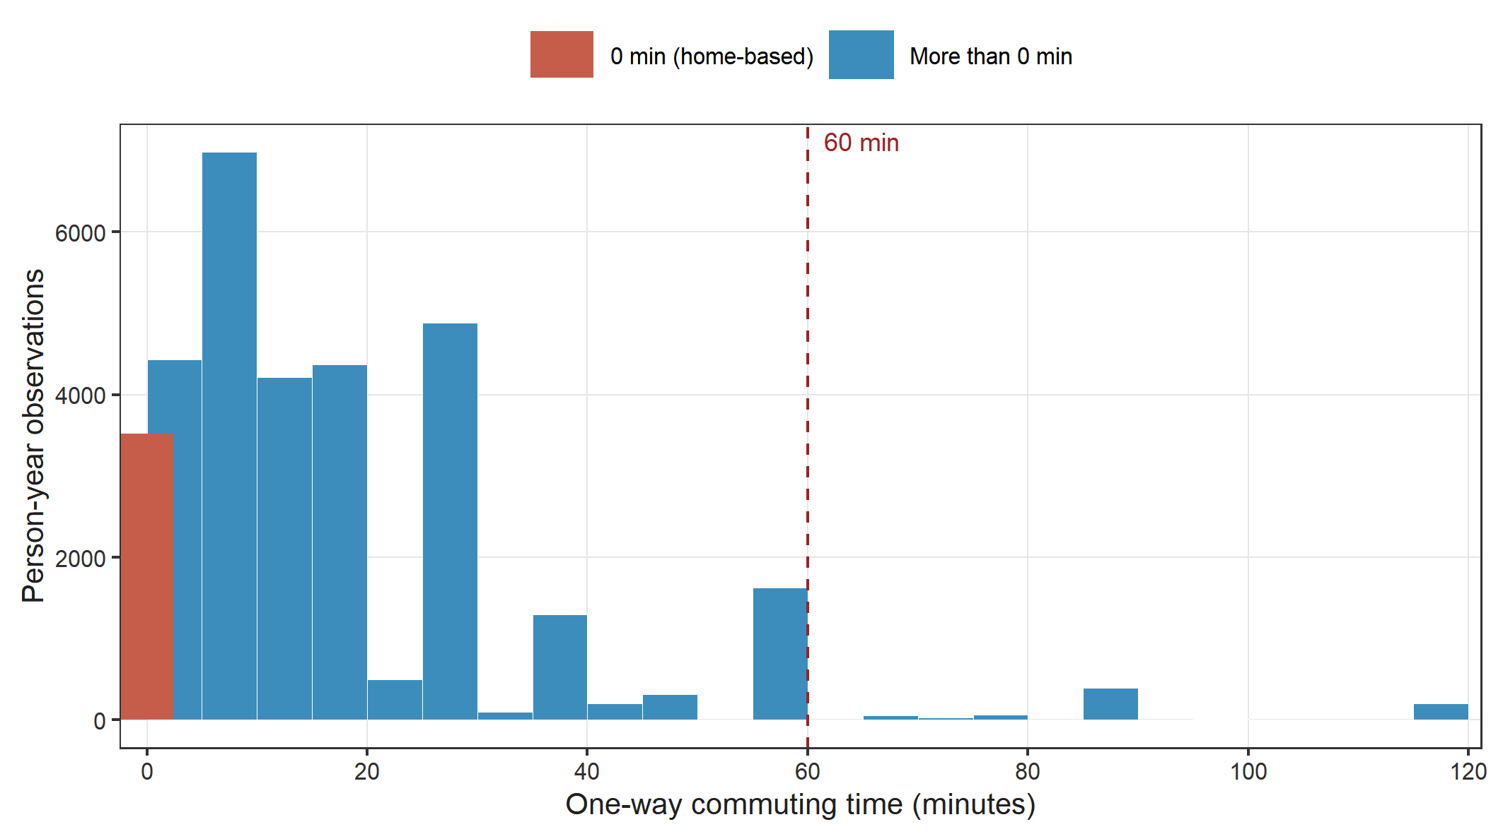
Note. Bins are 5 minutes wide and aligned at multiples of five. Reported commuting times cluster at round values (5, 10, 15, 30, 60 minutes), consistent with rounding in self-reported survey responses; this heaping is relevant to the interpretation of the within-person estimates, because within-person demeaning retains a larger share of measurement error than between-person comparisons. The displayed range is truncated at 120 minutes; values above 120 minutes comprise 0.4% of observations and are included in all analyses. The dashed line marks 60 minutes, referenced in the non-linearity analysis (Table S7, Panel B; Figure S2).
Figure S2. Exploratory adjusted spline association between one-way commuting time and CES-D-6 score.
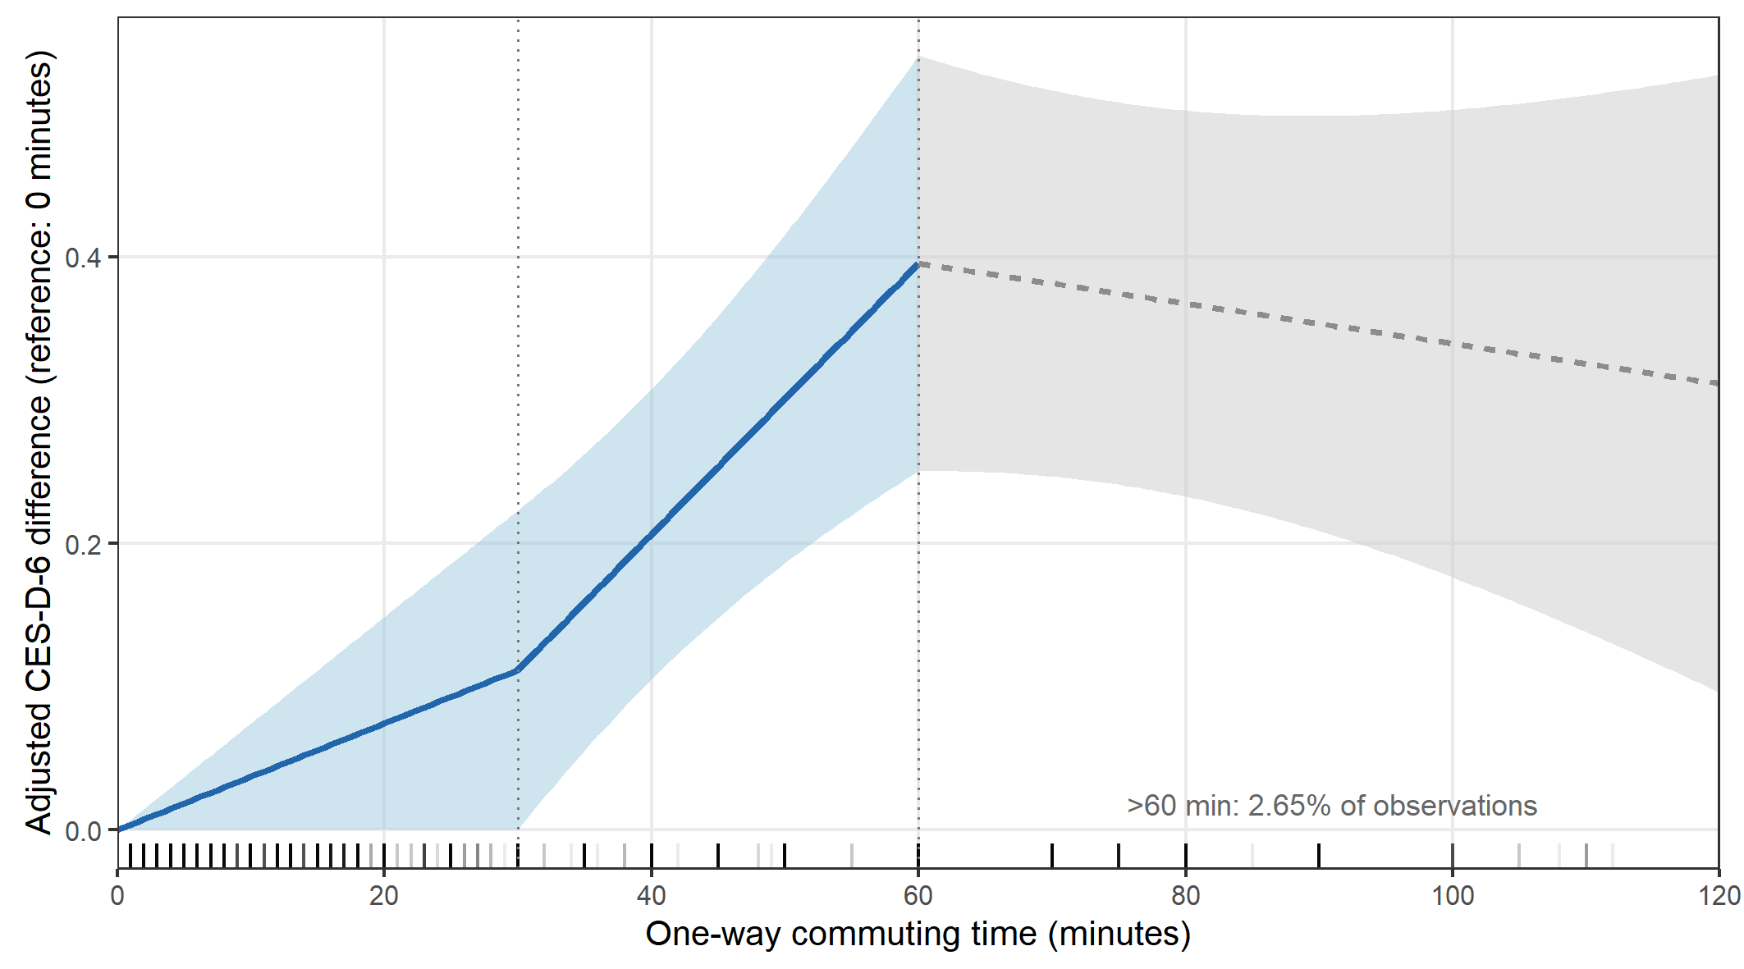
Note. The curve shows adjusted contrasts in predicted CES-D-6 score relative to zero minutes of commuting, derived from the exploratory pooled linear-spline model with knots at 30 and 60 minutes. The contrasts are centred at a reference value of 0 minutes of commuting; zero-commute observations may differ from commuters in the nature of their work. The shaded areas indicate 95% confidence intervals for the corresponding linear contrasts, calculated using individual-clustered HC1 standard errors. Covariates were held at their sample means and survey wave was fixed to 2016. The curve is shown as a solid line from 0 to 60 minutes and as a dashed line beyond 60 minutes. Only 2.65% of observations involved commuting times longer than 60 minutes; estimates in this range are therefore based on sparse data and should not be interpreted as evidence of a threshold or of a protective association at very long commuting times. Rug marks along the horizontal axis show the observed distribution of commuting time. This analysis is exploratory and non-causal.
Figure S3. Two-way fixed-effects sensitivity analyses for the association between commuting time and CES-D-6 score.
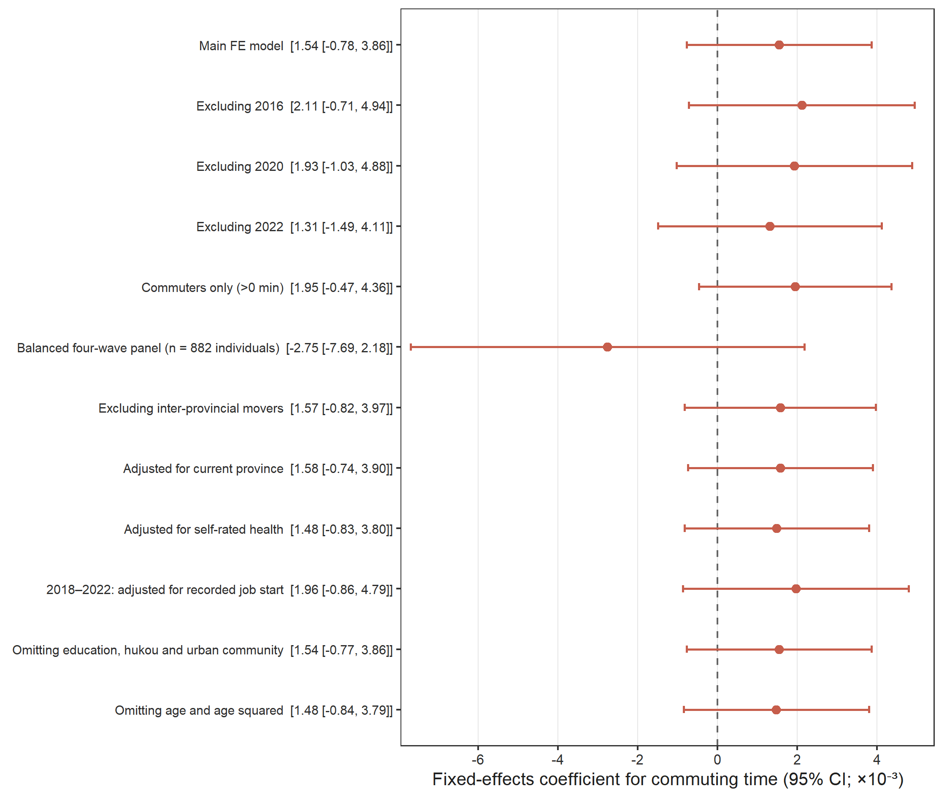
Note. Coefficients and 95% confidence intervals (in brackets) are multiplied by 1,000 for legibility (original units: change in CES-D-6 score per additional minute of one-way commuting time). All models include individual and year fixed effects and individual-clustered Arellano HC1 standard errors. The balanced four-wave panel comprises 882 individuals (3,528 person-year observations) observed in all four waves; its wide confidence interval reflects this small sample and should not be read as evidence of an association in the opposite direction. Full numeric results, including observation counts, are reported in Table S5.

