Additional file 1: Supplementary figures and tables
Cold Dominates the Temperature–Mortality Burden and Defines a Longer Window for Protection: A Seven-Year Time-Series Study of Cold Spells and Heatwaves in Changsha, China

Contents
Fig. S1 Lag-specific and cumulative temperature–mortality associations at extreme cold and extreme heat
Fig. S2 Temperature–lag–mortality surface
Fig. S3 Single-day added lag effects of cold spells on cause-specific mortality
Fig. S4 Single-day added lag effects of heatwaves on cause-specific mortality
Fig. S5 Cumulative added lag effects of cold spells on cause-specific mortality
Fig. S6 Cumulative added lag effects of heatwaves on cause-specific mortality
Table S1 Sensitivity of the added effects of cold spells and heatwaves
Table S2 Sensitivity of the cumulative temperature effect to lag length and pollutant adjustment
Table S3 Attributable fractions under alternative reference temperatures
Table S4 Sensitivity to the placement of the temperature spline knots
Table S5 Temperature-attributable fractions by cause of death

All estimates derive from the same models reported in the main text; no analysis was repeated for this file. Relative risks (RR) for daily mean temperature are cumulative over lags 0–21 days and are referenced to the minimum mortality temperature (MMT, 28.0 °C, 85.7th percentile) unless stated otherwise. Extreme cold and extreme heat denote the 2.5th (2.2 °C) and 97.5th (31.1 °C) percentiles of daily mean temperature. Added effects of cold spells and heatwaves are estimated over lags 0–7 days, over and above the continuous temperature term. CI, confidence interval; AF, attributable fraction; QAIC, quasi-Akaike information criterion.

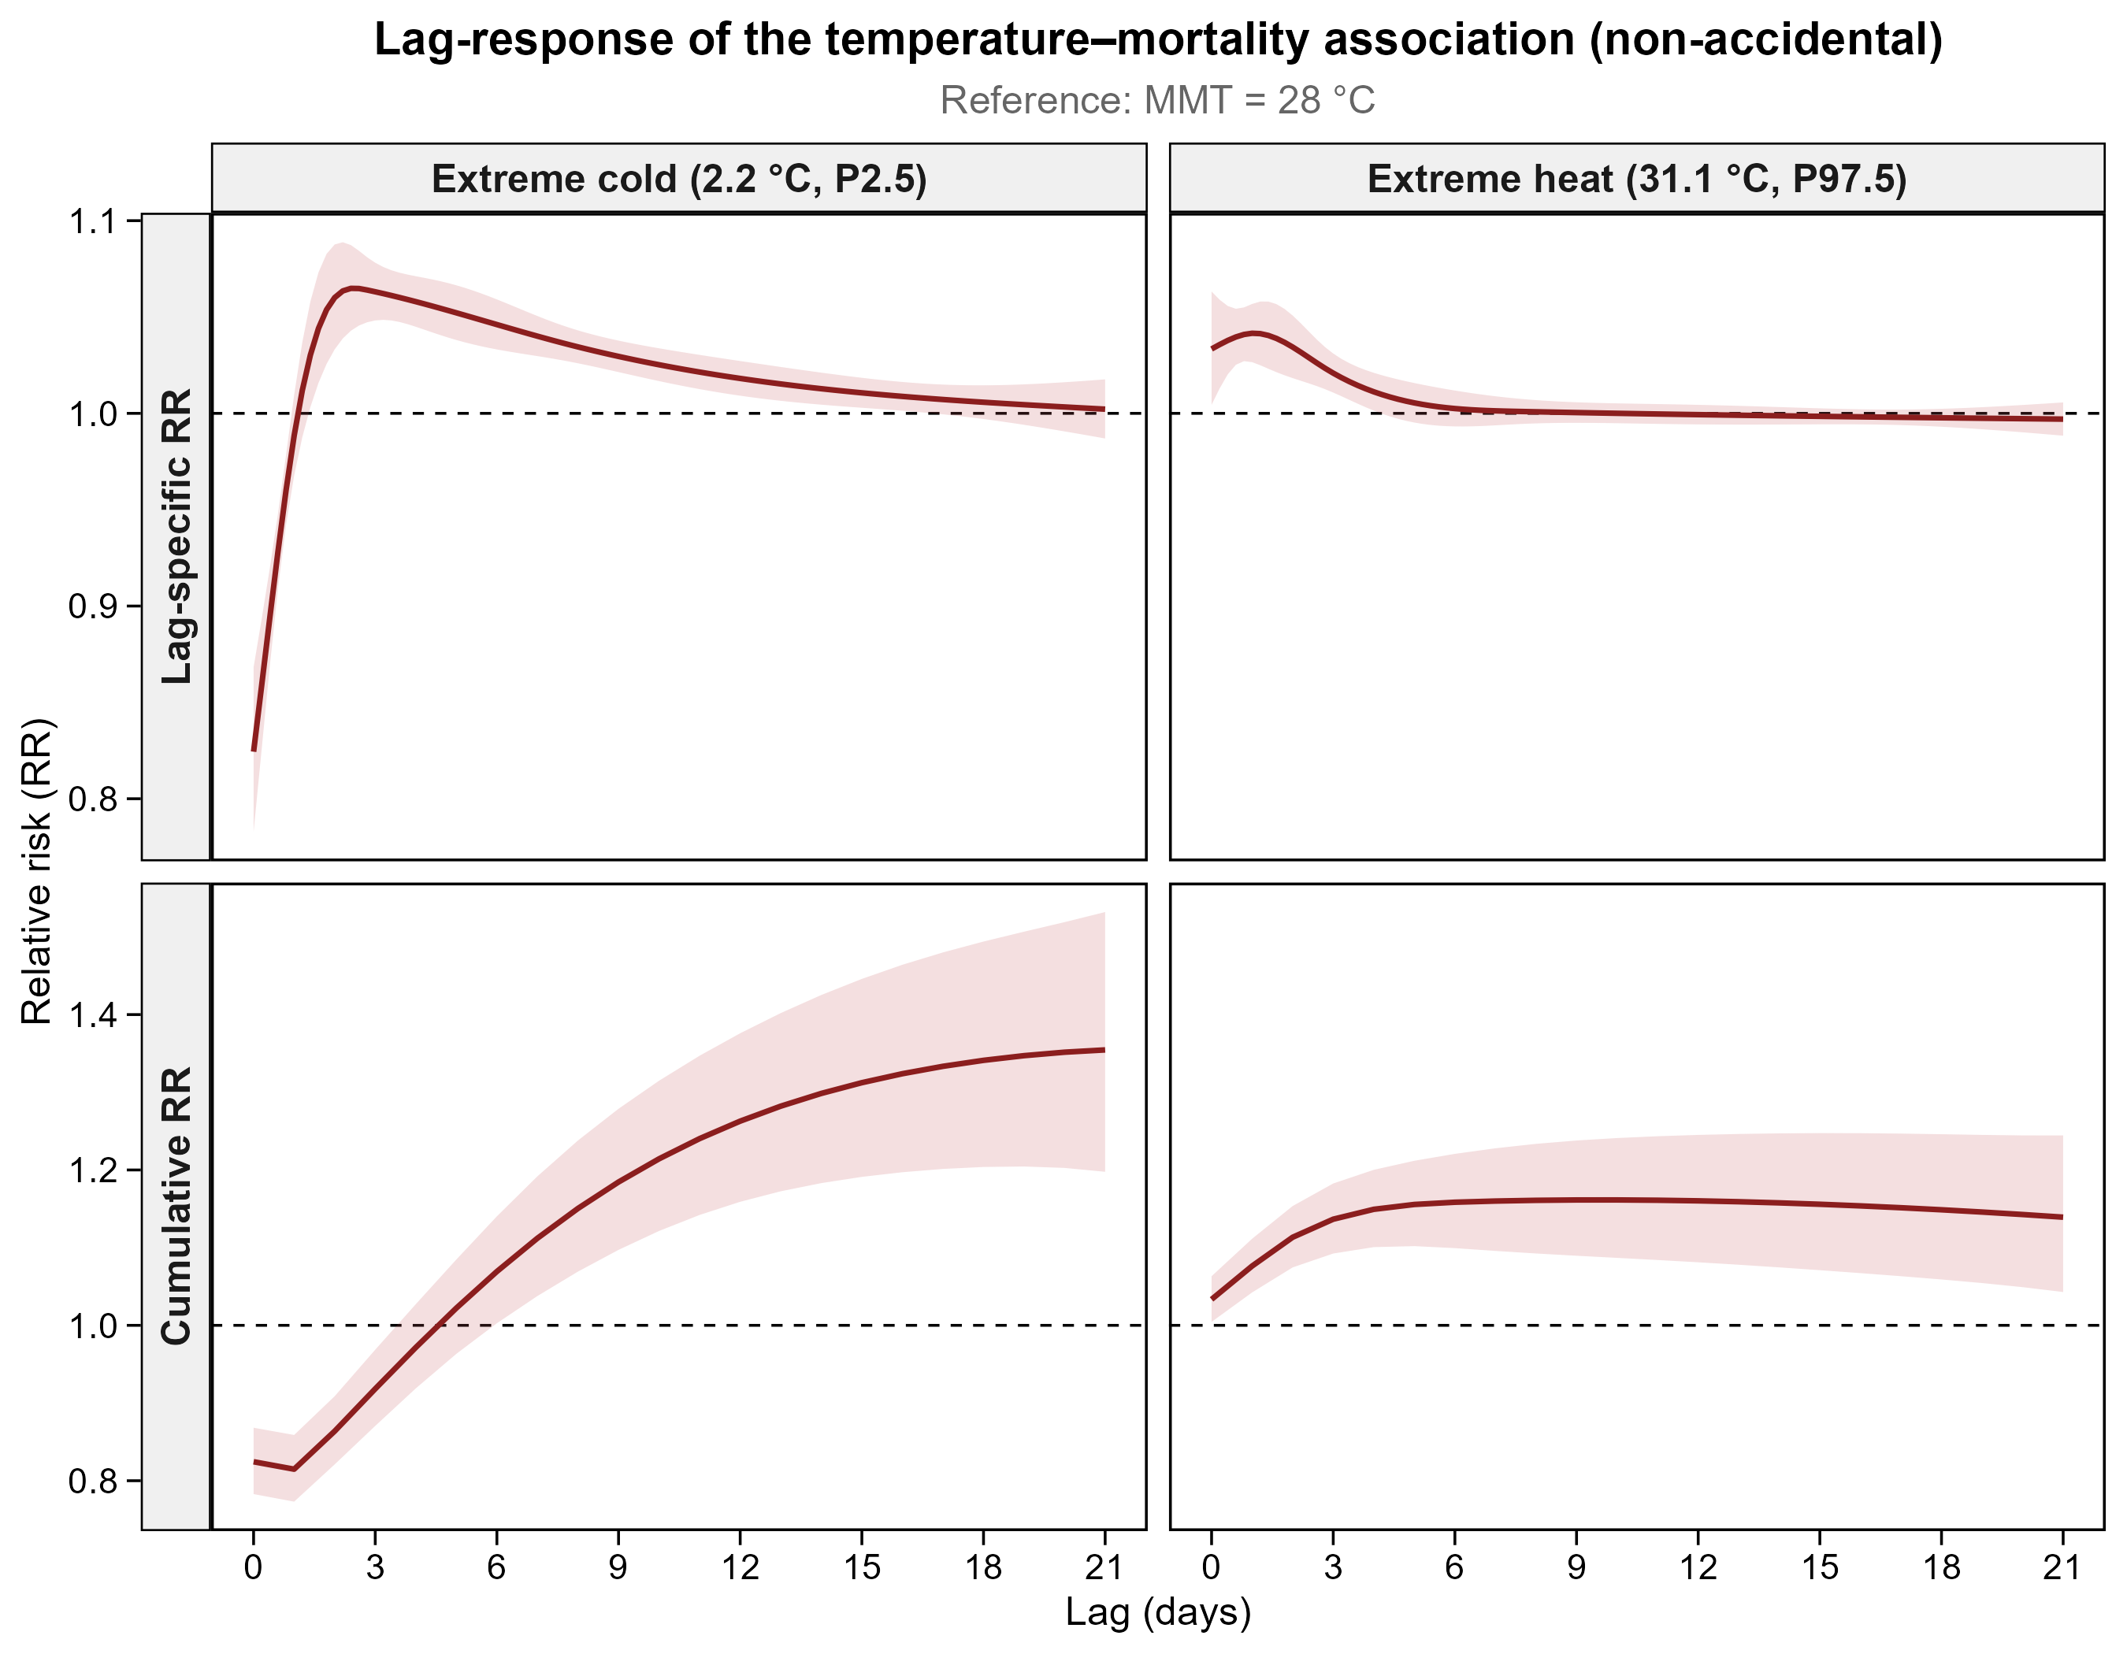
Fig. S1 Lag-specific (upper panels) and cumulative (lower panels) relative risks of non-accidental mortality at extreme cold (2.2 °C, 2.5th percentile) and extreme heat (31.1 °C, 97.5th percentile) of daily mean temperature, relative to the minimum mortality temperature (28.0 °C), over lags 0–21 days. Shaded areas denote 95% CIs. The upper panels are reproduced as Fig. 2b and 2c of the main text.

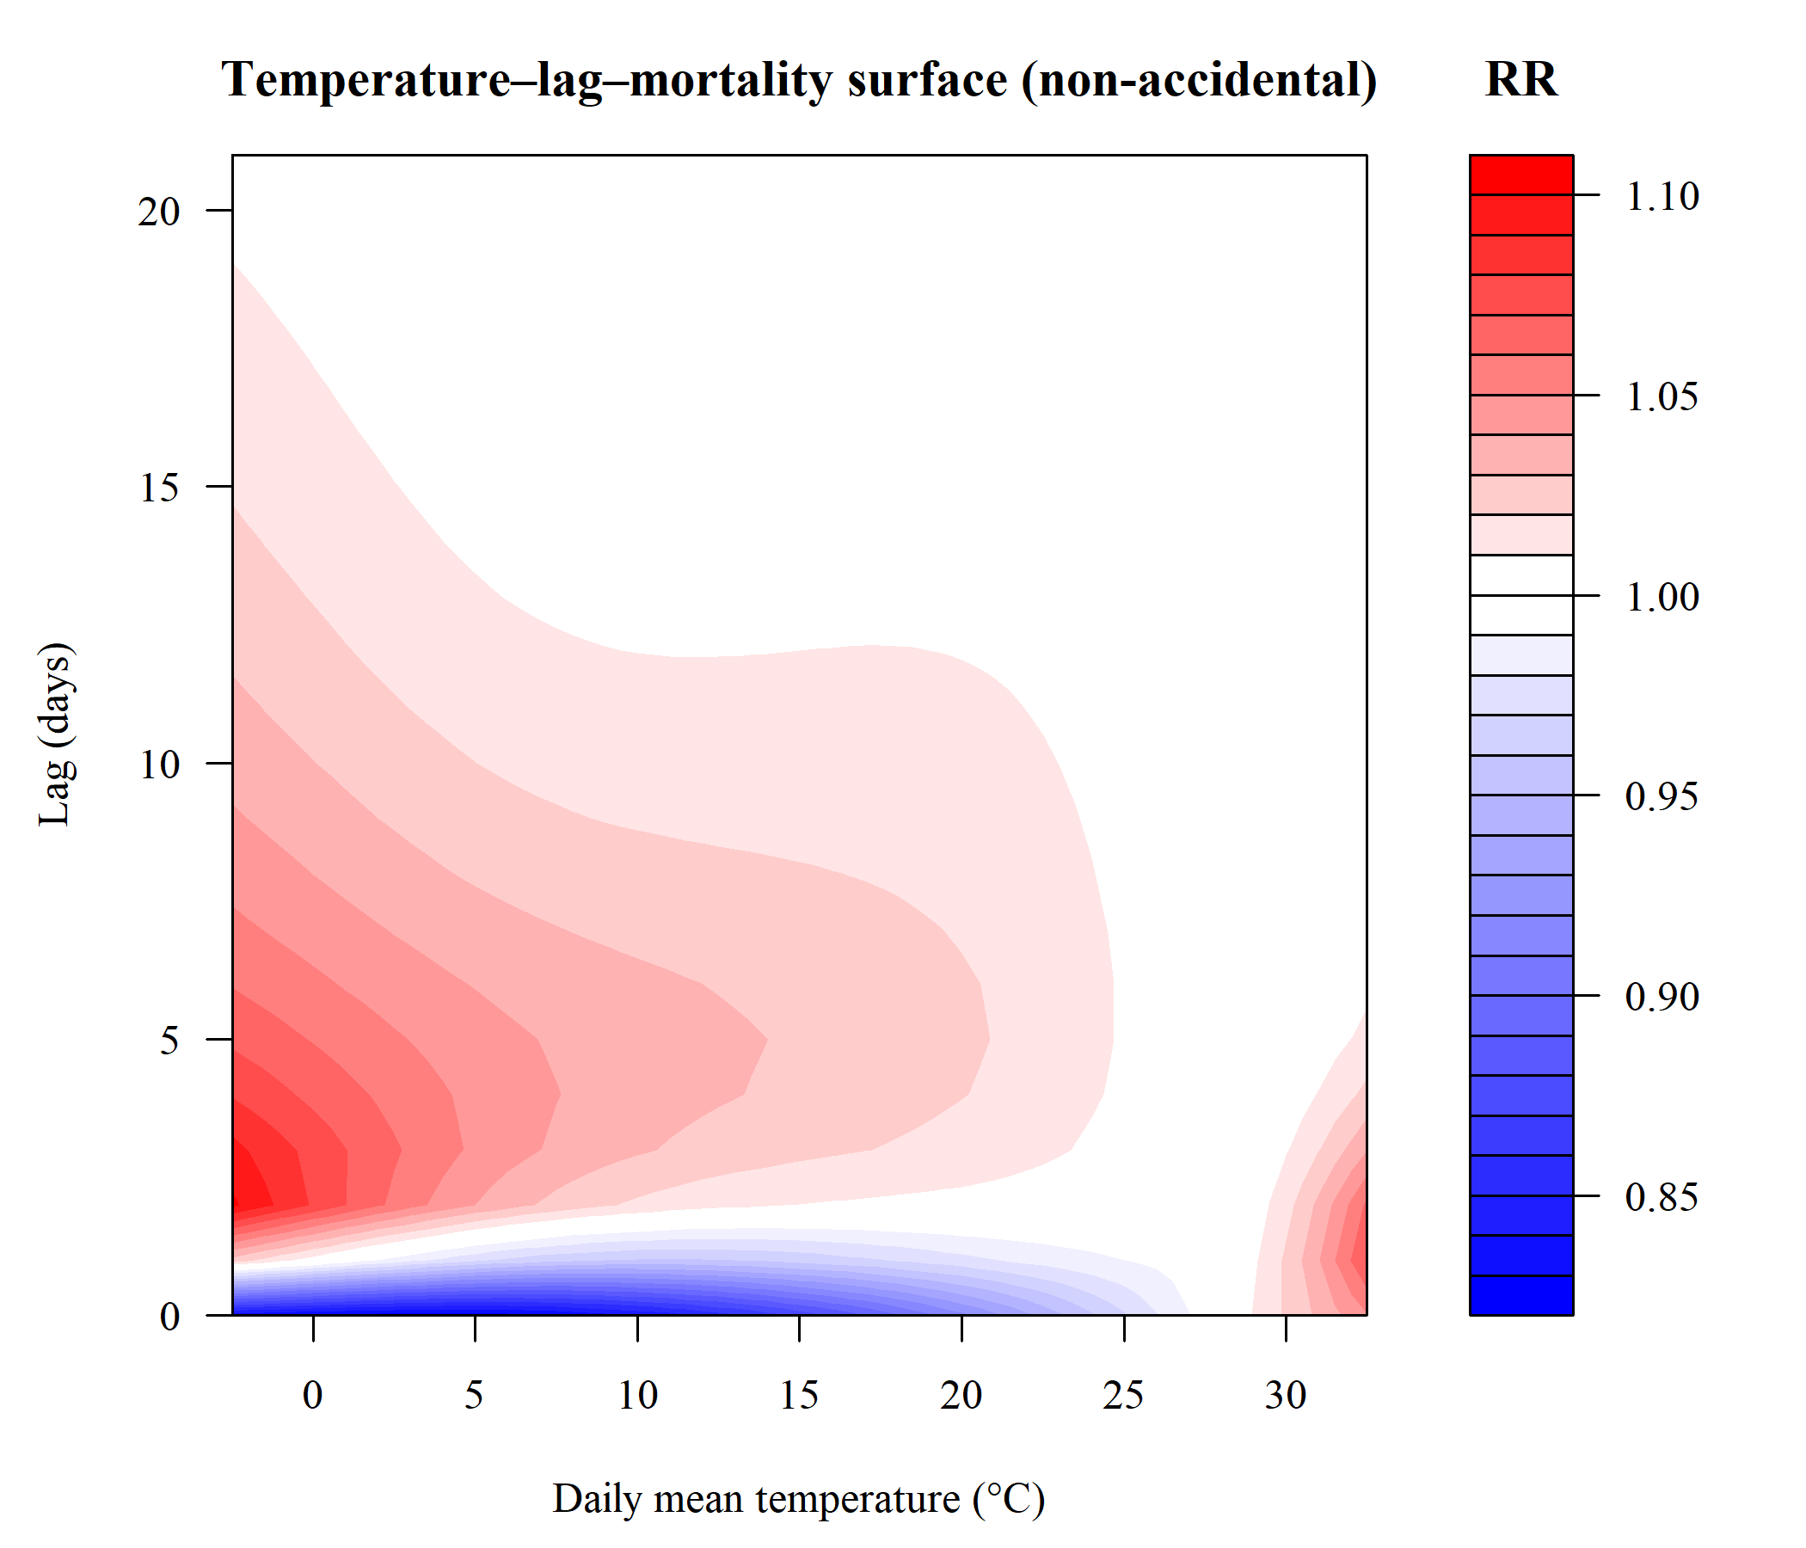
Fig. S2 Temperature–lag–mortality surface for non-accidental mortality, showing the relative risk across the joint space of daily mean temperature and lag (0–21 days), relative to the minimum mortality temperature (28.0 °C).

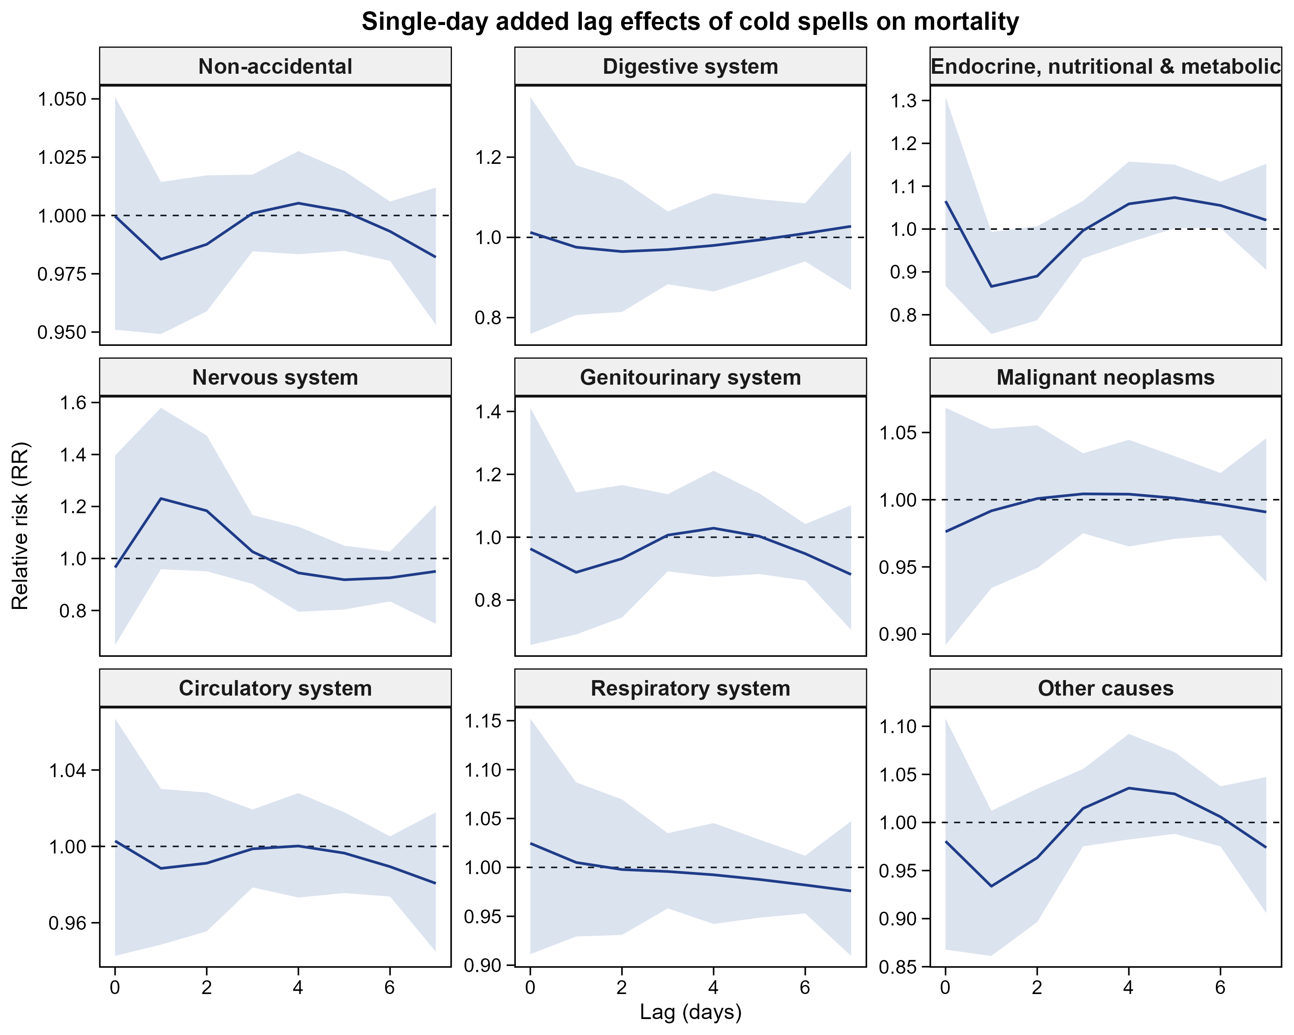
Fig. S3 Single-day added lag effects of cold spells on cause-specific mortality over lags 0–7 days, estimated over and above the continuous daily mean temperature term. Shaded areas denote 95% CIs; the dashed line marks the null. Estimates are relative to non-cold-spell days.

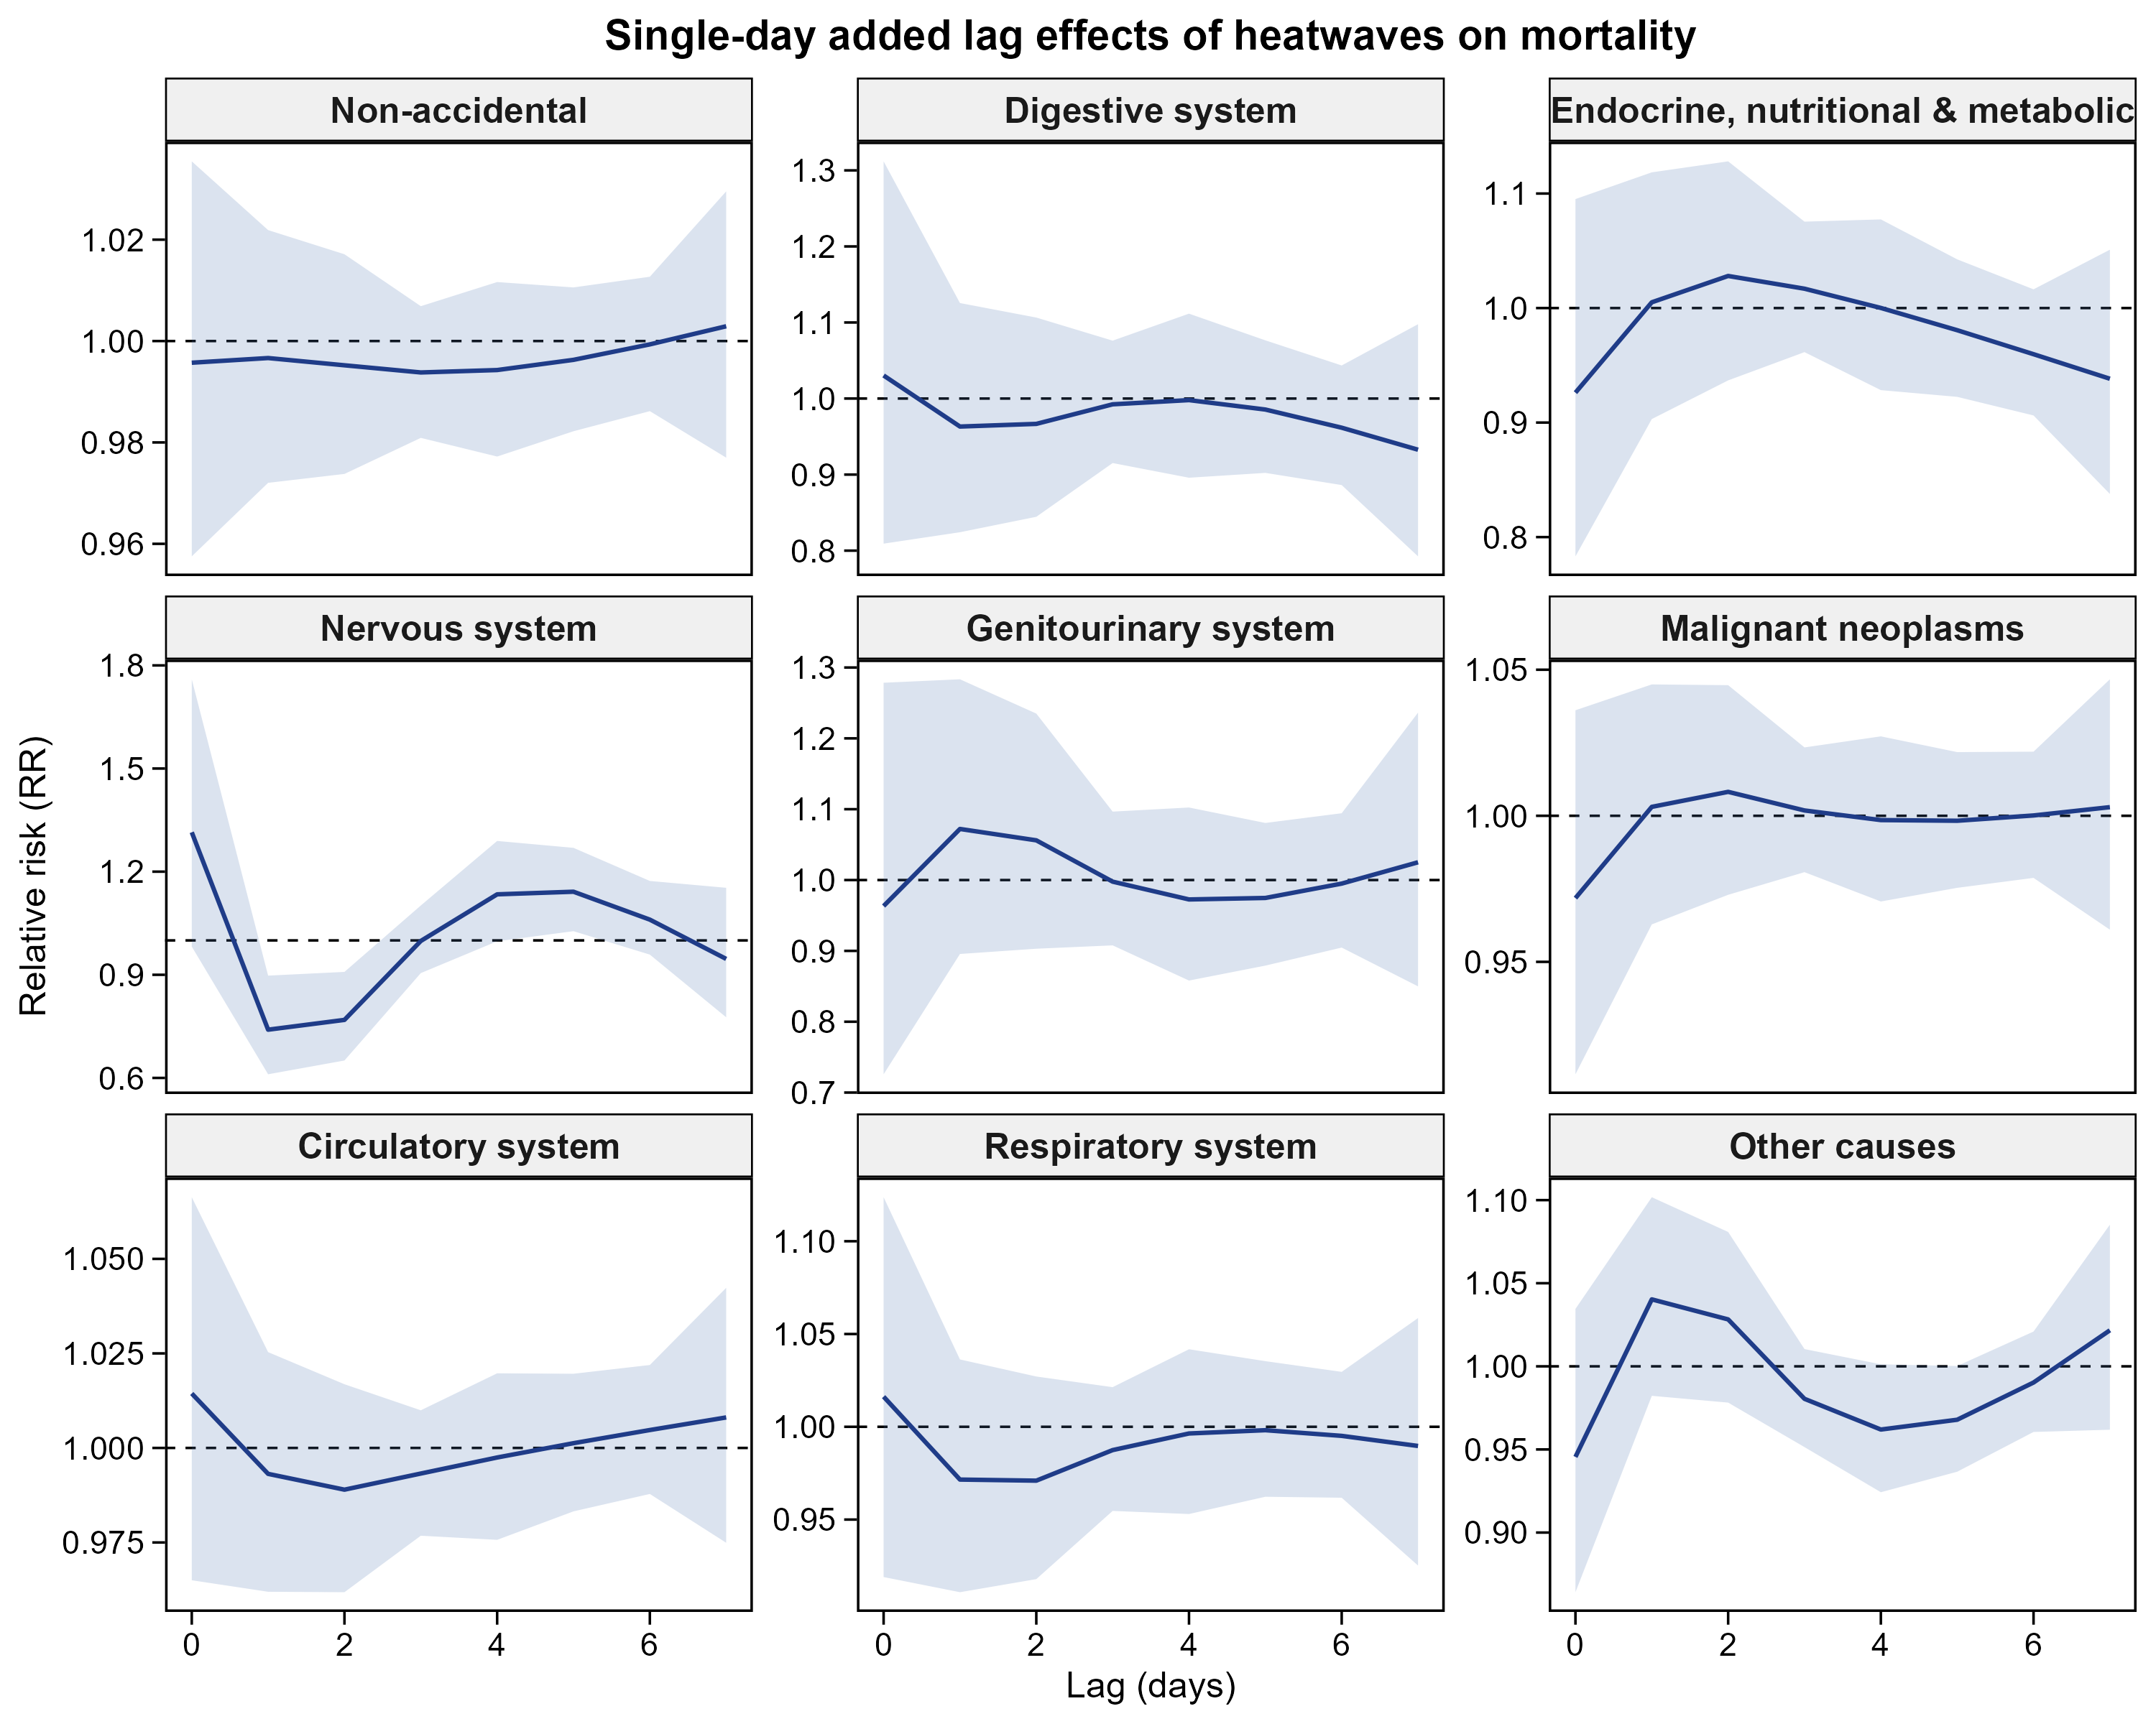
Fig. S4 Single-day added lag effects of heatwaves on cause-specific mortality over lags 0–7 days, estimated over and above the continuous daily mean temperature term. Shaded areas denote 95% CIs; the dashed line marks the null. Estimates are relative to non-heatwave days.

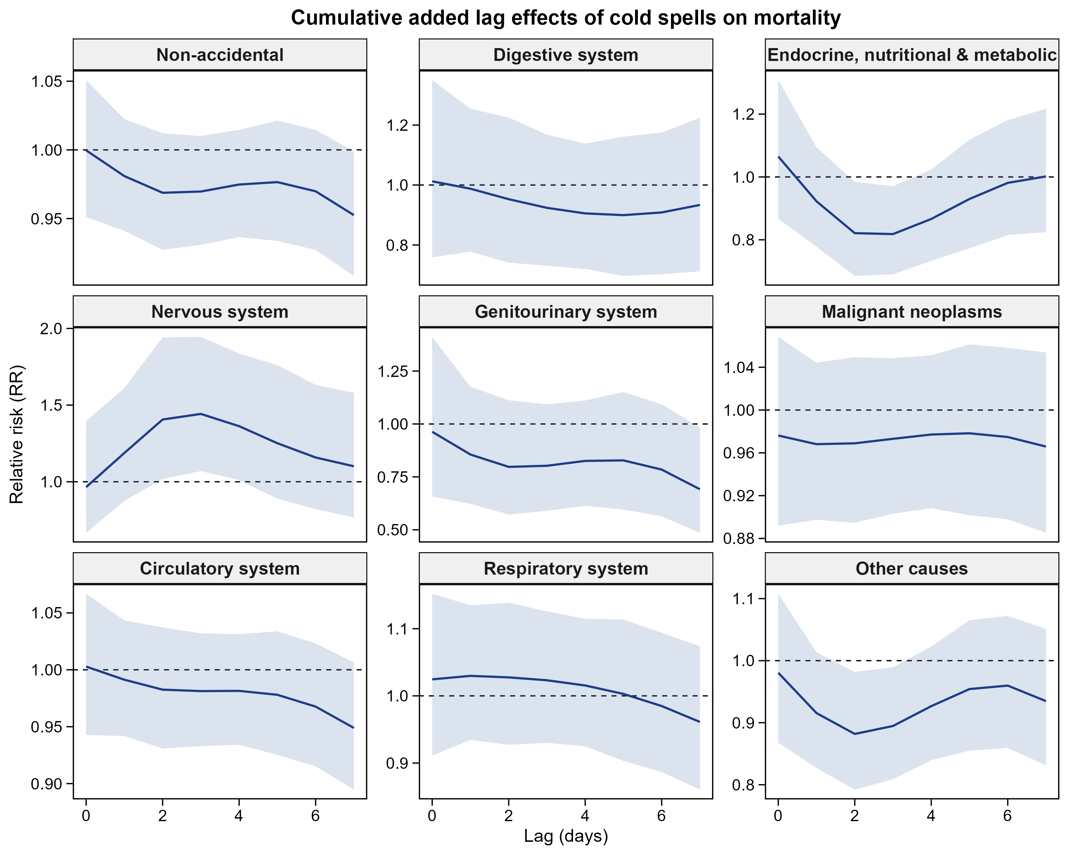
Fig. S5 Cumulative added lag effects of cold spells on cause-specific mortality, accumulated from lag 0 to the lag shown, estimated over and above the continuous daily mean temperature term. Shaded areas denote 95% CIs.

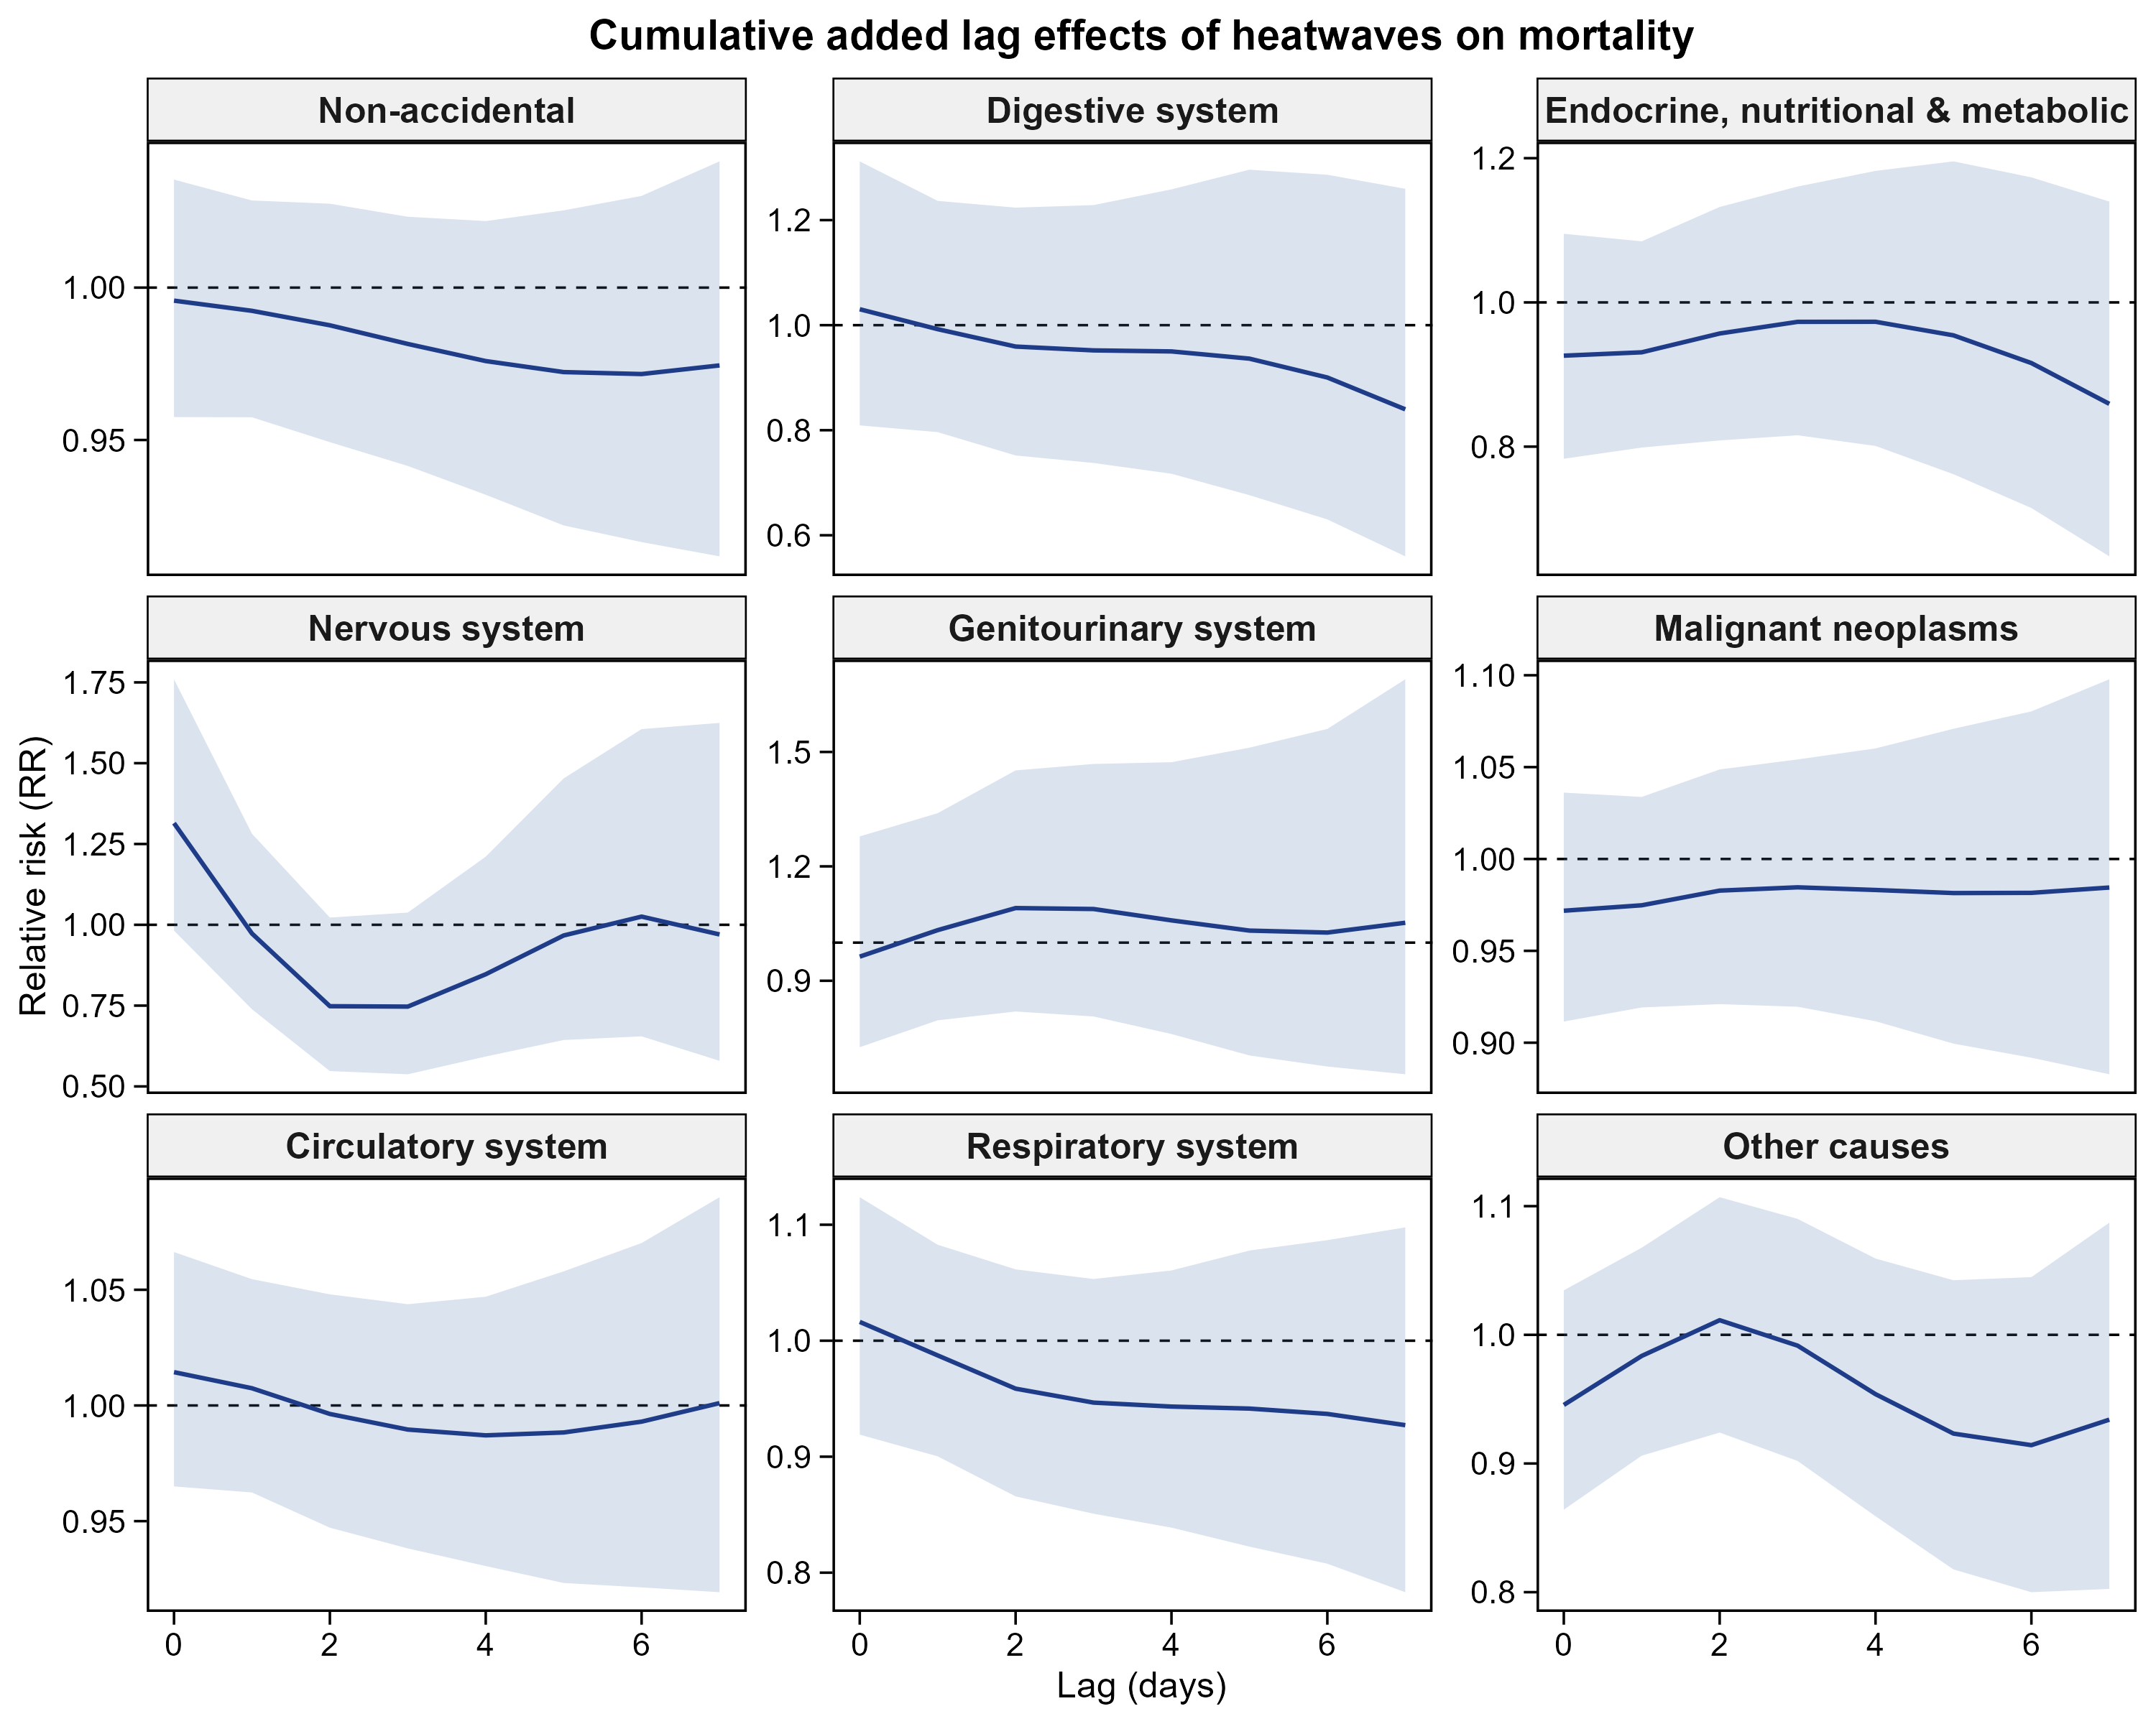
Fig. S6 Cumulative added lag effects of heatwaves on cause-specific mortality, accumulated from lag 0 to the lag shown, estimated over and above the continuous daily mean temperature term. Shaded areas denote 95% CIs.

Table S1 Sensitivity of the added effects of cold spells and heatwaves to model specification (non-accidental mortality).
Specification | Cold spells, added RR (95% CI) | Heatwaves, added RR (95% CI)
Time spline, 6 df per year | 0.976 (0.933, 1.022) | 0.979 (0.917, 1.045)
Time spline, 7 df per year (main model) | 0.953 (0.908, 0.999) | 0.974 (0.912, 1.041)
Time spline, 8 df per year | 0.955 (0.909, 1.003) | 0.997 (0.931, 1.067)
Event lag window 0–3 days | 0.972 (0.935, 1.010) | 0.974 (0.931, 1.018)
Event lag window 0–7 days (main model) | 0.953 (0.908, 0.999) | 0.974 (0.912, 1.041)
Event lag window 0–14 days | 0.917 (0.863, 0.974) | 0.951 (0.867, 1.043)
Without adjustment for relative humidity | 0.956 (0.911, 1.002) | 0.974 (0.911, 1.040)
Alternative heat-wave definition | Not applicable | 0.911 (0.830, 1.000)
Added RRs are cumulative over the event lag window and are estimated over and above the continuous daily mean temperature term; they are relative to non-event days. The main model uses 7 degrees of freedom per year for the time spline and a 0–7 day event lag window, so rows 2 and 5 report the same specification. Of the 15 estimates shown, three intervals excluded unity, all for cold spells and all below unity; the upper limit for the alternative heat-wave definition reached 1.000. These comparisons were not corrected for multiplicity and are reported as exploratory.

Table S2 Sensitivity of the cumulative temperature effect to the maximum lag and to pollutant adjustment (non-accidental mortality).
Specification | Extreme cold, RR (95% CI) | Extreme heat, RR (95% CI)
Main model (maximum lag 21 days, no pollutant) | 1.355 (1.198, 1.532) | 1.139 (1.043, 1.244)
Maximum lag 14 days | 1.291 (1.174, 1.420) | 1.162 (1.078, 1.252)
Maximum lag 21 days | 1.355 (1.198, 1.532) | 1.139 (1.043, 1.244)
Maximum lag 28 days | 1.437 (1.229, 1.680) | 1.162 (1.051, 1.284)
Main model plus PM_{2.5} | 1.368 (1.209, 1.547) | 1.141 (1.045, 1.247)
Main model plus O₃ | 1.363 (1.205, 1.542) | 1.149 (1.051, 1.256)
Main model plus NO₂ | 1.372 (1.212, 1.553) | 1.141 (1.045, 1.247)
RRs are cumulative over the stated maximum lag and are referenced to the minimum mortality temperature. Rows 1 and 3 report the same specification. Pollutants were entered one at a time as a natural cubic spline; O₃ was expressed as the maximum daily 8 h average.

Table S3 Temperature-attributable fractions under alternative reference temperatures (non-accidental mortality).
Reference temperature | °C (percentile) | Cold AF, % (95% CI) | Heat AF, % (95% CI) | Cold : heat
Lower limit of the MMT empirical CI | 10.4 (26.2) | 2.64 (1.92, 3.35) | 0.52 (−4.28, 4.75) | 5.1 : 1
MMT point estimate (main analysis) | 28.0 (85.7) | 7.70 (1.31, 13.36) | 0.85 (0.24, 1.42) | 9.1 : 1
Upper limit of the MMT empirical CI | 28.7 (88.2) | 7.24 (0.65, 13.05) | 0.79 (0.28, 1.27) | 9.2 : 1
The empirical 95% CI for the MMT was obtained by Monte Carlo simulation (5,000 draws) from the reduced overall-cumulative coefficients, searching within the 1st–99th percentiles of daily mean temperature. Attributable fractions were computed by the method of Gasparrini and Leone with 5,000 simulations. The cold burden exceeded the heat burden under all three reference temperatures.

Table S4 Sensitivity of the temperature–mortality association to the placement of the internal knots of the temperature spline (non-accidental mortality).
Internal knot placement | MMT, °C (percentile) | RR at 18 °C | RR at 20 °C | RR at 22 °C | Extreme cold, RR | Extreme heat, RR | Cold AF, % (95% CI) | Heat AF, % (95% CI) | QAIC
10th / 75th / 90th percentiles (main model) | 28.0 (85.7) | 1.088 | 1.097 | 1.094 | 1.355 | 1.139 | 7.70 (1.31, 13.36) | 0.85 (0.24, 1.42) | 21,967.5
10th / 50th / 90th percentiles | 26.9 (81.9) | 1.060 | 1.052 | 1.034 | 1.299 | 1.051 | 4.74 (−1.05, 10.07) | 0.39 (−0.32, 1.06) | 21,983.7
25th / 50th / 75th percentiles | 26.5 (80.6) | 1.053 | 1.048 | 1.030 | 1.300 | 1.024 | 4.28 (−1.53, 9.37) | 0.21 (−0.55, 0.94) | 21,995.9
5th / 50th / 95th percentiles | 26.9 (81.9) | 1.059 | 1.051 | 1.033 | 1.292 | 1.052 | 4.70 (−1.10, 9.99) | 0.39 (−0.35, 1.06) | 21,984.0
RRs at 18, 20 and 22 °C are cumulative over lags 0–21 days and are referenced to the MMT of the corresponding model; they document the mid-range undulation of the exposure–response curve discussed in the main text. The extreme-cold cumulative RR remained significant under all four placements, whereas the attributable-fraction intervals crossed the null under the three alternatives. The main model had the lowest QAIC, by about 16 units. The attributable fractions in the main-model row are those reported in Table 4 of the main text.

Table S5 Temperature-attributable fractions by cause of death, with the moderate and extreme components.
Cause of death | MMT, °C | Cold total, % (95% CI) | Moderate cold, % | Extreme cold, % | Heat total, % (95% CI) | Moderate heat, % | Extreme heat, %
Non-accidental | 28.0 | 7.70 (1.31, 13.36) | 6.60 | 1.10 | 0.85 (0.24, 1.42) | 0.46 | 0.39
Circulatory system | 28.0 | 13.13 (5.56, 19.72) | 11.59 | 1.54 | 1.09 (0.35, 1.78) | 0.60 | 0.49
Respiratory system | 27.5 | 12.49 (−4.06, 25.17) | 11.16 | 1.33 | 2.04 (0.70, 3.17) | 1.19 | 0.85
Malignant neoplasms | 9.8 | 0.87 (−0.26, 1.95) | 0.49 | 0.38 | 4.71 (−4.18, 12.28) | 4.63 | 0.08
Other causes | 11.0 | 1.98 (−0.07, 3.85) | 1.24 | 0.74 | 4.01 (−7.05, 12.85) | 3.75 | 0.26
Digestive system | 8.4 | 1.62 (−1.47, 4.10) | 0.78 | 0.84 | 20.93 (−4.82, 36.51) | 20.11 | 0.82
Endocrine, nutritional and metabolic | 27.6 | 6.89 (−23.33, 27.25) | 6.02 | 0.87 | 1.10 (−1.89, 3.21) | 0.63 | 0.47
Nervous system | 27.5 | 19.14 (−39.82, 46.46) | 16.87 | 2.27 | 3.34 (−1.87, 6.24) | 1.99 | 1.35
Genitourinary system | 28.2 | 15.55 (−39.97, 43.92) | 14.46 | 1.09 | 1.67 (−2.94, 4.45) | 0.86 | 0.81
Each cause was modelled separately and its attributable fractions were computed relative to its own MMT, so the values are not additive across causes. Moderate and extreme components are separated at the 2.5th and 97.5th percentiles of daily mean temperature. The first three rows are those reported in Table 4 of the main text; the remaining six are reported as exploratory. Those cause groups have small daily counts or a weak association with temperature, so their intervals include the null and, for the digestive, endocrine, nervous and genitourinary groups, are wide enough that the point estimates should not be interpreted quantitatively. For causes whose MMT lies in the lower part of the temperature range, the heat component covers a large share of the year and the corresponding fraction is correspondingly unstable.

