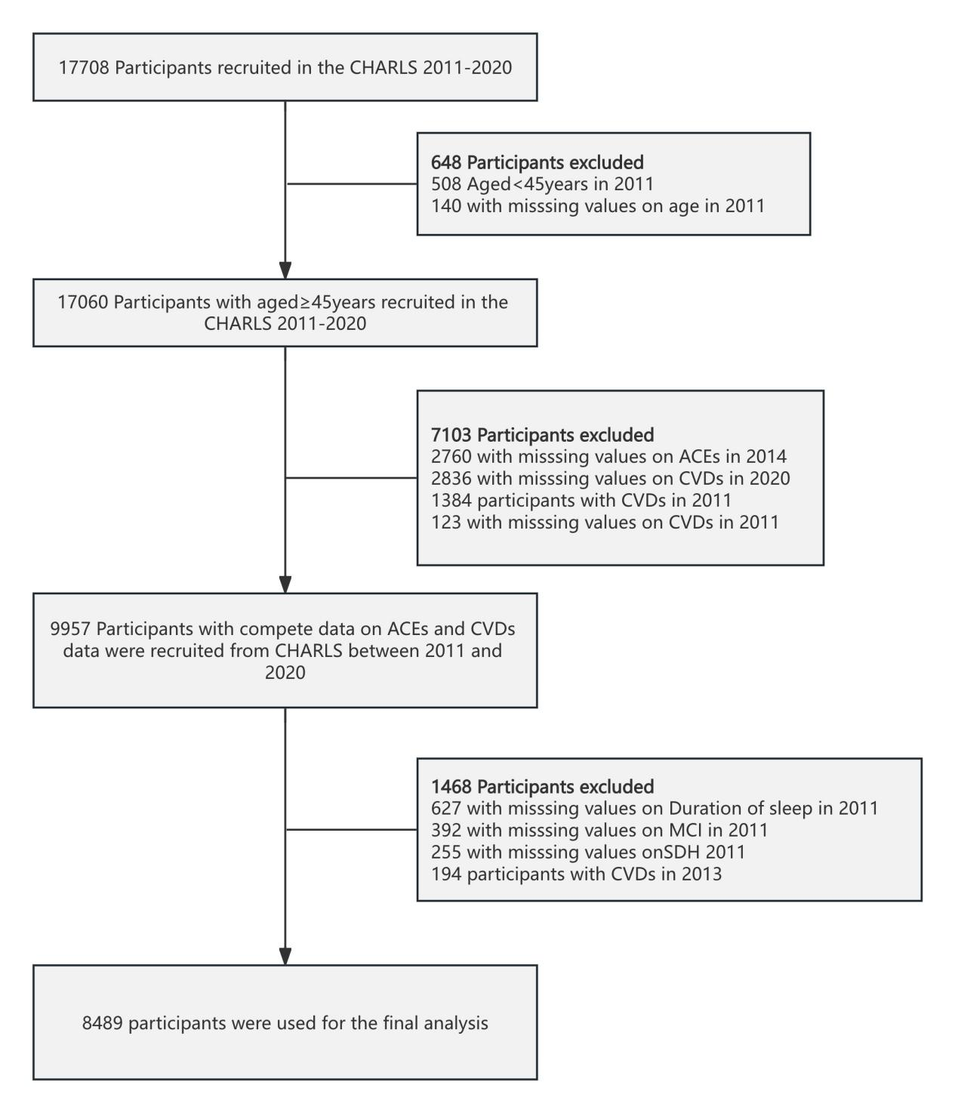

Figure S1. The flow chart of study participants.

Table S1. Definitions of each adverse childhood experiences (ACEs) Indicator
ACE indicators | Questionnaire items in detail
Physical abuse | When you were growing up, did your female/male guardian ever hit you? (oftena , sometimesa , rarely, or never)
Emotional neglect | How much love and affection did your female guardian give you while you were growing up? (often, sometimes, rarelya , or nevera )
Emotional neglect | How much effort did your female guardian put into watching over you? (a lot, some, a littlea , or not at alla )
Household substance abuse | During the years you were growing up, did your female/male guardian ever have alcoholism or drug? (yesa or no)
Household mental illness | Did your female/male guardian have abnormality of mind when you were young? (yesa or no)
Household mental illness | During the years you were growing up, had your female/male guardian often showed continued signs of sadness or depression? (during alla , mosta , some, or only a little of the childhood)
Domestic violence | Have your father/mother ever beat up your mother/father? (oftena , sometimesa , not very often, or never)
Incarcerated household member | During the years you were growing up, have your female/male guardian ever been arrested or sent to prison? (yesa or no)
Parental separation or divorce | Were your biological parents divorced (including long separation due to emotional problems) before you were 17 years? (yesa or no)
Unsafe neighborhood | Was it safe being out alone at night in the neighborhood where you lived as a child? (very safe, somewhat safe, not very safea , or not safe at alla )
Bullying | When you were a child, how often were you picked on or bullied by kids in your neighborhood? (oftena , sometimesa , not very often, or never)
Bullying | When you were a child, how often were you picked on or bullied by kids in your school? (oftena, sometimesa , not very often, or never)
Parental death | Either of the parents was dead before participant was 17 years.
Sibling death | Any of the siblings was dead before participant was 17 years.
Parental disability | Did your female/male guardian have a long time being sick on bed when you were young? (yesa or no)
Parental disability | Did your female/male guardian have a serious deformity when you were young? (yesa or no)

