Additional file 1
Changes in Physical Activity and Transitions Between Functional States Among Adults Aged 50 Years or Older
Supplementary Methods
Data sources and cross-cohort harmonization
The supplementary data documentation reports the cohort-specific files, waves, source items, and operational definitions used in the primary analysis. Harmonized core variables were supplemented where required by the RAND HRS longitudinal physical-activity variables and the original CHARLS physical-activity items. Cohort-specific coding was retained until the common analysis variables were created. The four physical-activity change categories were Stable inactive, Became active, Became inactive, and Stable active.
Functional-state construction
At each observed functional assessment, participants were classified as Independent, IADL disability only, or BADL disability. Independent required no difficulty in either the BADL or IADL summary domain. IADL disability only required IADL difficulty without BADL difficulty. Any BADL difficulty resulted in the BADL disability state. A state was set to missing when either domain could not be determined. Death was not included as an outcome state.
Additional sensitivity analyses
The supplementary analyses included a lagged design, an adjacent-state model that excluded direct Independent–BADL transitions, a model allowing transition-specific age effects, leave-one-cohort-out meta-analyses, a restricted analysis of HRS, ELSA, and SHARE, and an MHAS interval-length sensitivity analysis restricted to intervals of five years or less. The conditional initiation and cessation contrasts were analyzed separately from the primary four-category parameterization: initiation compared Became active with Stable inactive, whereas cessation compared Became inactive with Stable active. A non-linear age sensitivity analysis added the square of centered age to the primary adjustment model.
Extended adjustment model
An extended complete-case adjustment model additionally included smoking status, alcohol consumption, and body-mass index in addition to the primary adjustment covariates. It was fitted separately within each cohort using the same six-transition continuous-time multistate structure as the primary analysis, and cohort-specific estimates were summarized using REML random-effects meta-analysis with Hartung–Knapp adjustment. This model was used as a sensitivity analysis and did not replace the primary estimand.
Missing-data diagnostics
Multiple imputation was performed separately within cohort using chained equations with 30 imputation sets and 20 iterations per chain. PA exposure and functional-state outcome variables were not imputed. The supplementary diagnostics summarize the number of completed imputation sets, logged events, chain endpoint changes, observed-versus-imputed categorical distributions, and invalid imputed categorical values. These diagnostics document computational stability and value validity; they do not establish that missingness was missing at random.
Assessment intervals and observed state changes
Elapsed T1–T2 exposure intervals were calculated from cohort-specific survey years for each interval in the primary complete-case sample. Observed state-to-state counts were tabulated between consecutive functional assessments, including intervals with no observed state change; proportions used all intervals originating in the corresponding state as the denominator. These descriptive proportions are not continuous-time transition probabilities or state-specific person-time rates. For the non-linear age sensitivity analysis, the primary multistate model was refitted with the square of centered age in addition to the linear age term.
Reporting conventions
Hazard ratios are transition-intensity ratios from continuous-time multi-state models. Random-effects meta-analysis used REML with Hartung–Knapp adjustment where applicable. Heterogeneity is reported using I², τ², and 95% prediction intervals. Numbers in the supplementary tables are rounded for presentation.

Supplementary tables

Table S1
Cross-cohort data sources, wave coverage, formal PA definitions, functional-state source items, and primary adjustment covariate domains.
Cohort | HRS | ELSA | SHARE | CHARLS | MHAS
Data waves | RAND HRS longitudinal file, waves 7–16 | Harmonized ELSA file, waves 1–9 | Harmonized SHARE file, waves 1, 2, and 4–8 | Gateway Harmonized CHARLS D.2, waves 1–4, supplemented by original files | Harmonized MHAS file, waves 1–5
PA source items | vgactx; mdactx; ltactx | vgactx_e; mdactx_e; ltactx_e | vgactx; mdactx | DA051–DA055 (vigorous, moderate participation, frequency, and duration) | vigact
Regular activity definition | Frequency- and intensity-weighted vigorous, moderate, and light activity index ≥9 | Frequency- and intensity-weighted vigorous, moderate, and light activity index ≥9 | Frequency- and intensity-weighted vigorous and moderate activity index ≥9 | 4 × moderate minutes/week + 8 × vigorous minutes/week ≥600; duration brackets converted to representative minutes | Vigorous physical activity at least three times per week
Functional-state source items | adl5a; iadl5a | adlfivea; iadlfoura | adlfivea; iadlfoura | adltota_c; iadlfoura | adltot6a; iadlfoura
Functional-state algorithm | Independent if no BADL/IADL difficulty; IADL disability only if IADL difficulty without BADL difficulty; BADL disability if any BADL difficulty | Independent if no BADL/IADL difficulty; IADL disability only if IADL difficulty without BADL difficulty; BADL disability if any BADL difficulty | Independent if no BADL/IADL difficulty; IADL disability only if IADL difficulty without BADL difficulty; BADL disability if any BADL difficulty | Independent if no BADL/IADL difficulty; IADL disability only if IADL difficulty without BADL difficulty; BADL disability if any BADL difficulty | Independent if no BADL/IADL difficulty; IADL disability only if IADL difficulty without BADL difficulty; BADL disability if any BADL difficulty
Adjustment covariate source | Harmonized RAND HRS core variables at T2 | Harmonized ELSA core variables at T2 | Harmonized SHARE core variables at T2 | Gateway Harmonized CHARLS D.2 core variables at T2 | Harmonized MHAS core variables at T2
Data version / file | randhrs1992_2022v1.dta | Project ELSA harmonized file, waves 1–9 | H_SHARE_f2.dta | GH_CHARLS_d2.dta plus original CHARLS files containing DA051–DA055 | H_MHAS_d.dta

Table S2
Scoring of the physical-activity index in HRS, ELSA, and SHARE
Activity intensity | >1 time/week | Once/week | Monthly | Never
Vigorous | 12 | 6 | 2 | 0
Moderate | 6 | 3 | 1 | 0
Light | 3 | 1.5 | 0.5 | 0
Note. For each activity-intensity item, a score was assigned according to reported frequency. In HRS and ELSA, the physical-activity index was calculated as the sum of vigorous-, moderate-, and light-intensity scores, yielding a theoretical range of 0–21. In SHARE, a comparable light-intensity item was not consistently available; the index therefore comprised vigorous- and moderate-intensity scores only, with a theoretical range of 0–18. In all three cohorts, a total score of 9 or higher was classified as active and a score below 9 as inactive. Invalid, special, and non-substantive responses were treated as missing.

Table S3
PA and functional-state construction summary.
Cohort | HRS | ELSA | SHARE | CHARLS | MHAS
PA source items | vgactx; mdactx; ltactx | vgactx_e; mdactx_e; ltactx_e | vgactx; mdactx | DA051–DA055 (vigorous, moderate participation, frequency, and duration) | vigact
PA operational definition | Frequency- and intensity-weighted vigorous, moderate, and light activity index ≥9 | Frequency- and intensity-weighted vigorous, moderate, and light activity index ≥9 | Frequency- and intensity-weighted vigorous and moderate activity index ≥9 | 4 × moderate minutes/week + 8 × vigorous minutes/week ≥600; duration brackets converted to representative minutes | Vigorous physical activity at least three times per week
PA rows | 452340 | 195111 | 1025822 | 102344 | 135795
PA participants | 45234 | 21679 | 146546 | 25586 | 27159
Active observations | 92987 | 54815 | 150896 | 23227 | 25794
Inactive observations | 92687 | 34878 | 174454 | 17072 | 44818
PA missing observations (%) | 59.0 | 54.0 | 68.3 | 60.6 | 48.0
Functional-state source items | adl5a; iadl5a | adlfivea; iadlfoura | adlfivea; iadlfoura | adltota_c; iadlfoura | adltot6a; iadlfoura
Functional-state rows | 452340 | 195111 | 1025822 | 102344 | 135795
Functional-state participants | 45234 | 21679 | 146546 | 25586 | 27159
Independent observations | 141123 | 70627 | 329338 | 54846 | 58203
IADL-only observations | 11356 | 2762 | 13920 | 6728 | 2311
BADL observations | 33878 | 16451 | 45062 | 13670 | 10068
Functional-state missing observations (%) | 58.8 | 54.0 | 62.1 | 26.5 | 48.0

Table S4
Participant flow and analysis-stage counts. The panel-participant column corresponds to the counts shown in Figure 1A.
Cohort | HRS | ELSA | SHARE | CHARLS | MHAS
Age threshold at T2 | 50 | 50 | 50 | 50 | 50
Eligible panel participants | 45234 | 21679 | 146546 | 25586 | 27159
Participants with paired PA–functional records | 26636 | 12985 | 58820 | 3923 | 12776
Paired PA–functional records | 116844 | 53806 | 119742 | 5171 | 24626
Primary complete-case participants | 26626 | 11782 | 57866 | 3853 | 12728

Table S5
Cohort-specific complete-case hazard ratios from the primary six-transition analysis.
Cohort | Physical activity change | Functional-state transition | HR | 95% CI
CHARLS | Became active | Independent → IADL disability only | 0.62 | 0.42–0.90
CHARLS | Became active | Independent → BADL disability | 0.75 | 0.57–1.00
CHARLS | Became active | IADL disability only → Independent | 1.46 | 0.94–2.26
CHARLS | Became active | IADL disability only → BADL disability | 0.70 | 0.39–1.26
CHARLS | Became active | BADL disability → Independent | 1.77 | 1.24–2.53
CHARLS | Became active | BADL disability → IADL disability only | 1.23 | 0.64–2.39
CHARLS | Became inactive | Independent → IADL disability only | 0.75 | 0.53–1.05
CHARLS | Became inactive | Independent → BADL disability | 0.91 | 0.71–1.18
CHARLS | Became inactive | IADL disability only → Independent | 1.26 | 0.83–1.91
CHARLS | Became inactive | IADL disability only → BADL disability | 1.17 | 0.75–1.82
CHARLS | Became inactive | BADL disability → Independent | 1.64 | 1.16–2.32
CHARLS | Became inactive | BADL disability → IADL disability only | 1.35 | 0.73–2.49
CHARLS | Stable active | Independent → IADL disability only | 0.64 | 0.48–0.86
CHARLS | Stable active | Independent → BADL disability | 0.60 | 0.47–0.76
CHARLS | Stable active | IADL disability only → Independent | 1.58 | 1.12–2.24
CHARLS | Stable active | IADL disability only → BADL disability | 0.70 | 0.46–1.08
CHARLS | Stable active | BADL disability → Independent | 1.83 | 1.35–2.49
CHARLS | Stable active | BADL disability → IADL disability only | 1.37 | 0.80–2.34
ELSA | Became active | Independent → IADL disability only | 0.49 | 0.40–0.61
ELSA | Became active | Independent → BADL disability | 0.61 | 0.55–0.68
ELSA | Became active | IADL disability only → Independent | 1.62 | 1.20–2.19
ELSA | Became active | IADL disability only → BADL disability | 0.99 | 0.73–1.33
ELSA | Became active | BADL disability → Independent | 2.43 | 2.14–2.75
ELSA | Became active | BADL disability → IADL disability only | 0.52 | 0.35–0.77
ELSA | Became inactive | Independent → IADL disability only | 0.63 | 0.52–0.77
ELSA | Became inactive | Independent → BADL disability | 0.72 | 0.65–0.79
ELSA | Became inactive | IADL disability only → Independent | 1.35 | 1.05–1.72
ELSA | Became inactive | IADL disability only → BADL disability | 0.95 | 0.76–1.19
ELSA | Became inactive | BADL disability → Independent | 2.00 | 1.78–2.24
ELSA | Became inactive | BADL disability → IADL disability only | 0.80 | 0.61–1.04
ELSA | Stable active | Independent → IADL disability only | 0.26 | 0.22–0.31
ELSA | Stable active | Independent → BADL disability | 0.37 | 0.34–0.40
ELSA | Stable active | IADL disability only → Independent | 2.23 | 1.79–2.79
ELSA | Stable active | IADL disability only → BADL disability | 0.80 | 0.62–1.04
ELSA | Stable active | BADL disability → Independent | 3.03 | 2.74–3.35
ELSA | Stable active | BADL disability → IADL disability only | 0.70 | 0.54–0.92
HRS | Became active | Independent → IADL disability only | 0.80 | 0.73–0.89
HRS | Became active | Independent → BADL disability | 0.66 | 0.61–0.71
HRS | Became active | IADL disability only → Independent | 1.47 | 1.30–1.65
HRS | Became active | IADL disability only → BADL disability | 0.69 | 0.60–0.80
HRS | Became active | BADL disability → Independent | 1.91 | 1.74–2.10
HRS | Became active | BADL disability → IADL disability only | 1.24 | 1.04–1.47
HRS | Became inactive | Independent → IADL disability only | 0.82 | 0.75–0.90
HRS | Became inactive | Independent → BADL disability | 0.75 | 0.70–0.80
HRS | Became inactive | IADL disability only → Independent | 1.22 | 1.09–1.36
HRS | Became inactive | IADL disability only → BADL disability | 0.82 | 0.73–0.92
HRS | Became inactive | BADL disability → Independent | 1.74 | 1.60–1.89
HRS | Became inactive | BADL disability → IADL disability only | 1.25 | 1.08–1.45
HRS | Stable active | Independent → IADL disability only | 0.51 | 0.47–0.55
HRS | Stable active | Independent → BADL disability | 0.41 | 0.38–0.43
HRS | Stable active | IADL disability only → Independent | 1.80 | 1.63–1.98
HRS | Stable active | IADL disability only → BADL disability | 0.57 | 0.50–0.64
HRS | Stable active | BADL disability → Independent | 2.78 | 2.59–2.99
HRS | Stable active | BADL disability → IADL disability only | 1.19 | 1.02–1.38
MHAS | Became active | Independent → IADL disability only | 0.75 | 0.62–0.92
MHAS | Became active | Independent → BADL disability | 0.83 | 0.75–0.91
MHAS | Became active | IADL disability only → Independent | 1.60 | 1.20–2.12
MHAS | Became active | IADL disability only → BADL disability | 0.78 | 0.54–1.12
MHAS | Became active | BADL disability → Independent | 1.54 | 1.33–1.79
MHAS | Became active | BADL disability → IADL disability only | 0.77 | 0.51–1.16
MHAS | Became inactive | Independent → IADL disability only | 0.88 | 0.73–1.06
MHAS | Became inactive | Independent → BADL disability | 0.99 | 0.90–1.08
MHAS | Became inactive | IADL disability only → Independent | 1.18 | 0.89–1.56
MHAS | Became inactive | IADL disability only → BADL disability | 1.10 | 0.84–1.45
MHAS | Became inactive | BADL disability → Independent | 1.30 | 1.13–1.49
MHAS | Became inactive | BADL disability → IADL disability only | 0.96 | 0.69–1.33
MHAS | Stable active | Independent → IADL disability only | 0.73 | 0.59–0.90
MHAS | Stable active | Independent → BADL disability | 0.80 | 0.72–0.89
MHAS | Stable active | IADL disability only → Independent | 1.71 | 1.23–2.36
MHAS | Stable active | IADL disability only → BADL disability | 0.73 | 0.46–1.14
MHAS | Stable active | BADL disability → Independent | 1.90 | 1.64–2.21
MHAS | Stable active | BADL disability → IADL disability only | 0.74 | 0.47–1.17
SHARE | Became active | Independent → IADL disability only | 0.55 | 0.49–0.62
SHARE | Became active | Independent → BADL disability | 0.63 | 0.58–0.67
SHARE | Became active | IADL disability only → Independent | 1.82 | 1.52–2.18
SHARE | Became active | IADL disability only → BADL disability | 0.71 | 0.56–0.91
SHARE | Became active | BADL disability → Independent | 2.19 | 1.98–2.42
SHARE | Became active | BADL disability → IADL disability only | 0.84 | 0.63–1.12
SHARE | Became inactive | Independent → IADL disability only | 0.64 | 0.57–0.71
SHARE | Became inactive | Independent → BADL disability | 0.67 | 0.63–0.72
SHARE | Became inactive | IADL disability only → Independent | 1.51 | 1.32–1.73
SHARE | Became inactive | IADL disability only → BADL disability | 0.66 | 0.56–0.78
SHARE | Became inactive | BADL disability → Independent | 1.88 | 1.74–2.04
SHARE | Became inactive | BADL disability → IADL disability only | 0.87 | 0.71–1.07
SHARE | Stable active | Independent → IADL disability only | 0.35 | 0.31–0.39
SHARE | Stable active | Independent → BADL disability | 0.35 | 0.33–0.38
SHARE | Stable active | IADL disability only → Independent | 2.10 | 1.82–2.42
SHARE | Stable active | IADL disability only → BADL disability | 0.43 | 0.34–0.55
SHARE | Stable active | BADL disability → Independent | 2.76 | 2.53–3.00
SHARE | Stable active | BADL disability → IADL disability only | 0.62 | 0.47–0.83

Table S6
Leave-one-cohort-out random-effects meta-analyses.
Excluded cohort | Physical activity change | Functional-state transition | Pooled HR | 95% CI | I² (%) | τ² | 95% prediction interval | k
HRS | Became active | Independent → IADL disability only | 0.59 | 0.44–0.80 | 70.4 | 0.025 | 0.33–1.06 | 4
HRS | Became active | Independent → BADL disability | 0.69 | 0.54–0.88 | 86.5 | 0.020 | 0.41–1.15 | 4
HRS | Became active | IADL disability only → Independent | 1.70 | 1.48–1.96 | 0.0 | 0.000 | 1.48–1.96 | 4
HRS | Became active | IADL disability only → BADL disability | 0.80 | 0.61–1.04 | 19.5 | 0.007 | 0.55–1.16 | 4
HRS | Became active | BADL disability → Independent | 1.98 | 1.42–2.76 | 87.7 | 0.039 | 0.97–4.03 | 4
HRS | Became active | BADL disability → IADL disability only | 0.76 | 0.46–1.27 | 51.2 | 0.044 | 0.33–1.77 | 4
HRS | Became inactive | Independent → IADL disability only | 0.71 | 0.55–0.92 | 68.9 | 0.019 | 0.43–1.18 | 4
HRS | Became inactive | Independent → BADL disability | 0.80 | 0.59–1.09 | 92.5 | 0.033 | 0.42–1.54 | 4
HRS | Became inactive | IADL disability only → Independent | 1.38 | 1.16–1.66 | 21.9 | 0.004 | 1.05–1.82 | 4
HRS | Became inactive | IADL disability only → BADL disability | 0.92 | 0.60–1.40 | 77.6 | 0.056 | 0.39–2.17 | 4
HRS | Became inactive | BADL disability → Independent | 1.70 | 1.24–2.33 | 89.2 | 0.036 | 0.86–3.35 | 4
HRS | Became inactive | BADL disability → IADL disability only | 0.89 | 0.71–1.10 | 0.0 | 0.000 | 0.71–1.10 | 4
HRS | Stable active | Independent → IADL disability only | 0.45 | 0.20–0.99 | 96.7 | 0.236 | 0.08–2.55 | 4
HRS | Stable active | Independent → BADL disability | 0.50 | 0.26–0.94 | 98.4 | 0.156 | 0.12–2.03 | 4
HRS | Stable active | IADL disability only → Independent | 2.03 | 1.66–2.47 | 0.0 | 0.000 | 1.66–2.47 | 4
HRS | Stable active | IADL disability only → BADL disability | 0.64 | 0.39–1.03 | 72.8 | 0.073 | 0.24–1.70 | 4
HRS | Stable active | BADL disability → Independent | 2.37 | 1.59–3.55 | 93.2 | 0.056 | 1.01–5.58 | 4
HRS | Stable active | BADL disability → IADL disability only | 0.77 | 0.47–1.26 | 55.9 | 0.043 | 0.34–1.75 | 4
ELSA | Became active | Independent → IADL disability only | 0.68 | 0.50–0.91 | 83.3 | 0.031 | 0.36–1.28 | 4
ELSA | Became active | Independent → BADL disability | 0.70 | 0.57–0.87 | 86.2 | 0.015 | 0.45–1.10 | 4
ELSA | Became active | IADL disability only → Independent | 1.59 | 1.33–1.90 | 36.5 | 0.007 | 1.16–2.18 | 4
ELSA | Became active | IADL disability only → BADL disability | 0.70 | 0.66–0.75 | 0.0 | 0.000 | 0.66–0.75 | 4
ELSA | Became active | BADL disability → Independent | 1.86 | 1.46–2.38 | 81.5 | 0.020 | 1.12–3.10 | 4
ELSA | Became active | BADL disability → IADL disability only | 1.00 | 0.68–1.47 | 59.7 | 0.039 | 0.48–2.09 | 4
ELSA | Became inactive | Independent → IADL disability only | 0.76 | 0.60–0.97 | 78.6 | 0.019 | 0.46–1.25 | 4
ELSA | Became inactive | Independent → BADL disability | 0.81 | 0.61–1.08 | 93.7 | 0.030 | 0.44–1.51 | 4
ELSA | Became inactive | IADL disability only → Independent | 1.31 | 1.08–1.59 | 54.6 | 0.010 | 0.90–1.91 | 4
ELSA | Became inactive | IADL disability only → BADL disability | 0.88 | 0.58–1.33 | 83.3 | 0.052 | 0.38–2.02 | 4
ELSA | Became inactive | BADL disability → Independent | 1.64 | 1.25–2.14 | 87.8 | 0.025 | 0.93–2.89 | 4
ELSA | Became inactive | BADL disability → IADL disability only | 1.06 | 0.77–1.46 | 62.3 | 0.027 | 0.58–1.96 | 4
ELSA | Stable active | Independent → IADL disability only | 0.53 | 0.31–0.89 | 95.7 | 0.101 | 0.17–1.66 | 4
ELSA | Stable active | Independent → BADL disability | 0.51 | 0.28–0.93 | 98.6 | 0.138 | 0.14–1.92 | 4
ELSA | Stable active | IADL disability only → Independent | 1.86 | 1.57–2.21 | 37.7 | 0.005 | 1.40–2.47 | 4
ELSA | Stable active | IADL disability only → BADL disability | 0.56 | 0.39–0.82 | 62.0 | 0.030 | 0.29–1.09 | 4
ELSA | Stable active | BADL disability → Independent | 2.33 | 1.63–3.33 | 92.9 | 0.043 | 1.10–4.94 | 4
ELSA | Stable active | BADL disability → IADL disability only | 0.92 | 0.51–1.66 | 80.7 | 0.106 | 0.28–3.03 | 4
SHARE | Became active | Independent → IADL disability only | 0.67 | 0.47–0.96 | 81.5 | 0.042 | 0.32–1.41 | 4
SHARE | Became active | Independent → BADL disability | 0.70 | 0.56–0.88 | 84.7 | 0.017 | 0.44–1.13 | 4
SHARE | Became active | IADL disability only → Independent | 1.50 | 1.39–1.61 | 0.0 | 0.000 | 1.39–1.61 | 4
SHARE | Became active | IADL disability only → BADL disability | 0.77 | 0.59–1.02 | 41.3 | 0.016 | 0.47–1.26 | 4
SHARE | Became active | BADL disability → Independent | 1.90 | 1.39–2.61 | 86.7 | 0.034 | 0.98–3.71 | 4
SHARE | Became active | BADL disability → IADL disability only | 0.88 | 0.45–1.72 | 80.9 | 0.141 | 0.22–3.46 | 4
SHARE | Became inactive | Independent → IADL disability only | 0.78 | 0.62–0.97 | 60.9 | 0.013 | 0.51–1.19 | 4
SHARE | Became inactive | Independent → BADL disability | 0.83 | 0.64–1.06 | 89.1 | 0.022 | 0.49–1.41 | 4
SHARE | Became inactive | IADL disability only → Independent | 1.23 | 1.15–1.32 | 0.0 | 0.000 | 1.15–1.32 | 4
SHARE | Became inactive | IADL disability only → BADL disability | 0.94 | 0.74–1.21 | 50.5 | 0.014 | 0.60–1.48 | 4
SHARE | Became inactive | BADL disability → Independent | 1.66 | 1.23–2.23 | 87.7 | 0.031 | 0.88–3.13 | 4
SHARE | Became inactive | BADL disability → IADL disability only | 1.05 | 0.72–1.52 | 65.0 | 0.037 | 0.51–2.14 | 4
SHARE | Stable active | Independent → IADL disability only | 0.50 | 0.24–1.04 | 96.6 | 0.206 | 0.10–2.52 | 4
SHARE | Stable active | Independent → BADL disability | 0.52 | 0.29–0.92 | 98.2 | 0.128 | 0.14–1.85 | 4
SHARE | Stable active | IADL disability only → Independent | 1.85 | 1.52–2.25 | 24.7 | 0.004 | 1.39–2.45 | 4
SHARE | Stable active | IADL disability only → BADL disability | 0.67 | 0.51–0.88 | 53.5 | 0.022 | 0.39–1.16 | 4
SHARE | Stable active | BADL disability → Independent | 2.38 | 1.58–3.57 | 93.8 | 0.057 | 1.00–5.64 | 4
SHARE | Stable active | BADL disability → IADL disability only | 0.95 | 0.57–1.59 | 76.1 | 0.075 | 0.35–2.61 | 4
CHARLS | Became active | Independent → IADL disability only | 0.64 | 0.44–0.93 | 90.0 | 0.049 | 0.29–1.42 | 4
CHARLS | Became active | Independent → BADL disability | 0.67 | 0.54–0.84 | 89.4 | 0.016 | 0.43–1.07 | 4
CHARLS | Became active | IADL disability only → Independent | 1.60 | 1.36–1.89 | 35.3 | 0.006 | 1.20–2.14 | 4
CHARLS | Became active | IADL disability only → BADL disability | 0.76 | 0.59–0.97 | 38.1 | 0.009 | 0.51–1.13 | 4
CHARLS | Became active | BADL disability → Independent | 1.99 | 1.47–2.71 | 90.6 | 0.032 | 1.04–3.82 | 4
CHARLS | Became active | BADL disability → IADL disability only | 0.83 | 0.47–1.47 | 82.9 | 0.108 | 0.25–2.73 | 4
CHARLS | Became inactive | Independent → IADL disability only | 0.73 | 0.56–0.96 | 83.4 | 0.023 | 0.42–1.27 | 4
CHARLS | Became inactive | Independent → BADL disability | 0.77 | 0.59–1.01 | 94.2 | 0.026 | 0.43–1.38 | 4
CHARLS | Became inactive | IADL disability only → Independent | 1.32 | 1.10–1.59 | 52.9 | 0.008 | 0.94–1.87 | 4
CHARLS | Became inactive | IADL disability only → BADL disability | 0.85 | 0.60–1.20 | 80.5 | 0.035 | 0.43–1.69 | 4
CHARLS | Became inactive | BADL disability → Independent | 1.72 | 1.28–2.31 | 92.2 | 0.030 | 0.91–3.22 | 4
CHARLS | Became inactive | BADL disability → IADL disability only | 0.97 | 0.70–1.35 | 72.3 | 0.033 | 0.50–1.89 | 4
CHARLS | Stable active | Independent → IADL disability only | 0.43 | 0.21–0.88 | 98.0 | 0.195 | 0.09–2.07 | 4
CHARLS | Stable active | Independent → BADL disability | 0.45 | 0.25–0.83 | 99.0 | 0.144 | 0.12–1.75 | 4
CHARLS | Stable active | IADL disability only → Independent | 1.95 | 1.63–2.33 | 46.2 | 0.006 | 1.44–2.65 | 4
CHARLS | Stable active | IADL disability only → BADL disability | 0.60 | 0.38–0.94 | 81.0 | 0.061 | 0.24–1.49 | 4
CHARLS | Stable active | BADL disability → Independent | 2.60 | 1.88–3.58 | 93.9 | 0.036 | 1.31–5.15 | 4
CHARLS | Stable active | BADL disability → IADL disability only | 0.81 | 0.50–1.30 | 81.4 | 0.079 | 0.29–2.22 | 4
MHAS | Became active | Independent → IADL disability only | 0.61 | 0.43–0.87 | 87.3 | 0.044 | 0.29–1.30 | 4
MHAS | Became active | Independent → BADL disability | 0.64 | 0.59–0.69 | 0.1 | 0.000 | 0.59–0.69 | 4
MHAS | Became active | IADL disability only → Independent | 1.59 | 1.33–1.90 | 36.9 | 0.007 | 1.16–2.19 | 4
MHAS | Became active | IADL disability only → BADL disability | 0.75 | 0.58–0.98 | 40.6 | 0.012 | 0.49–1.16 | 4
MHAS | Became active | BADL disability → Independent | 2.11 | 1.73–2.58 | 72.0 | 0.011 | 1.44–3.10 | 4
MHAS | Became active | BADL disability → IADL disability only | 0.90 | 0.47–1.71 | 83.5 | 0.131 | 0.24–3.35 | 4
MHAS | Became inactive | Independent → IADL disability only | 0.71 | 0.57–0.88 | 74.9 | 0.016 | 0.45–1.11 | 4
MHAS | Became inactive | Independent → BADL disability | 0.73 | 0.62–0.84 | 64.2 | 0.004 | 0.57–0.93 | 4
MHAS | Became inactive | IADL disability only → Independent | 1.34 | 1.13–1.59 | 50.7 | 0.008 | 0.96–1.88 | 4
MHAS | Became inactive | IADL disability only → BADL disability | 0.84 | 0.59–1.19 | 76.2 | 0.030 | 0.43–1.61 | 4
MHAS | Became inactive | BADL disability → Independent | 1.85 | 1.66–2.06 | 36.5 | 0.002 | 1.56–2.20 | 4
MHAS | Became inactive | BADL disability → IADL disability only | 1.01 | 0.68–1.49 | 74.7 | 0.043 | 0.47–2.18 | 4
MHAS | Stable active | Independent → IADL disability only | 0.41 | 0.22–0.78 | 97.2 | 0.148 | 0.10–1.64 | 4
MHAS | Stable active | Independent → BADL disability | 0.41 | 0.29–0.59 | 95.9 | 0.041 | 0.20–0.86 | 4
MHAS | Stable active | IADL disability only → Independent | 1.94 | 1.59–2.38 | 49.6 | 0.007 | 1.39–2.71 | 4
MHAS | Stable active | IADL disability only → BADL disability | 0.60 | 0.39–0.93 | 80.6 | 0.059 | 0.25–1.45 | 4
MHAS | Stable active | BADL disability → Independent | 2.70 | 2.06–3.56 | 83.6 | 0.014 | 1.70–4.29 | 4
MHAS | Stable active | BADL disability → IADL disability only | 0.90 | 0.49–1.64 | 85.7 | 0.113 | 0.26–3.06 | 4

Table S7
Restricted analysis of HRS, ELSA, and SHARE, whose PA measures used more comparable frequency-weighted indices.
Physical activity change | Functional-state transition | Pooled HR | 95% CI | I² (%) | τ² | 95% prediction interval | k
Became active | Independent → IADL disability only | 0.61 | 0.32–1.15 | 92.9 | 0.061 | 0.18–2.09 | 3
Became active | Independent → BADL disability | 0.64 | 0.58–0.70 | 0.0 | 0.000 | 0.58–0.70 | 3
Became active | IADL disability only → Independent | 1.61 | 1.20–2.16 | 50.5 | 0.009 | 0.97–2.67 | 3
Became active | IADL disability only → BADL disability | 0.76 | 0.48–1.21 | 58.2 | 0.018 | 0.37–1.59 | 3
Became active | BADL disability → Independent | 2.15 | 1.60–2.90 | 79.7 | 0.011 | 1.25–3.72 | 3
Became active | BADL disability → IADL disability only | 0.83 | 0.29–2.44 | 89.4 | 0.163 | 0.11–6.43 | 3
Became inactive | Independent → IADL disability only | 0.70 | 0.48–1.02 | 84.1 | 0.020 | 0.34–1.43 | 3
Became inactive | Independent → BADL disability | 0.71 | 0.61–0.82 | 61.8 | 0.002 | 0.55–0.92 | 3
Became inactive | IADL disability only → Independent | 1.35 | 1.01–1.81 | 63.3 | 0.010 | 0.80–2.28 | 3
Became inactive | IADL disability only → BADL disability | 0.79 | 0.51–1.24 | 76.8 | 0.023 | 0.36–1.74 | 3
Became inactive | BADL disability → Independent | 1.86 | 1.58–2.19 | 48.8 | 0.002 | 1.44–2.40 | 3
Became inactive | BADL disability → IADL disability only | 0.97 | 0.53–1.76 | 82.3 | 0.049 | 0.32–2.98 | 3
Stable active | Independent → IADL disability only | 0.36 | 0.15–0.85 | 97.3 | 0.114 | 0.07–1.94 | 3
Stable active | Independent → BADL disability | 0.38 | 0.31–0.45 | 78.7 | 0.005 | 0.27–0.53 | 3
Stable active | IADL disability only → Independent | 1.99 | 1.51–2.62 | 59.8 | 0.008 | 1.24–3.19 | 3
Stable active | IADL disability only → BADL disability | 0.58 | 0.27–1.24 | 87.7 | 0.079 | 0.14–2.41 | 3
Stable active | BADL disability → Independent | 2.83 | 2.52–3.18 | 0.1 | 0.000 | 2.52–3.18 | 3
Stable active | BADL disability → IADL disability only | 0.82 | 0.34–1.93 | 88.5 | 0.109 | 0.15–4.31 | 3

Table S8
Conditional initiation and cessation contrasts with pooled heterogeneity statistics and cohort-specific estimates.
Contrast | Functional-state transition | Pooled HR | 95% CI | I² (%) | τ² | 95% prediction interval | k | HRS HR (95% CI) | ELSA HR (95% CI) | SHARE HR (95% CI) | CHARLS HR (95% CI) | MHAS HR (95% CI)
Activity initiation (Became active vs stable inactive) | Independent → IADL disability only | 0.58 | 0.46–0.72 | 74.6 | 0.021 | 0.37–0.91 | 5 | 0.64 (0.58–0.70) | 0.44 (0.35–0.54) | 0.54 (0.48–0.61) | 0.68 (0.46–1.00) | 0.67 (0.54–0.82)
Activity initiation (Became active vs stable inactive) | Independent → BADL disability | 0.64 | 0.53–0.79 | 90.2 | 0.023 | 0.40–1.03 | 5 | 0.54 (0.50–0.58) | 0.60 (0.54–0.67) | 0.61 (0.57–0.66) | 0.78 (0.58–1.05) | 0.79 (0.71–0.87)
Activity initiation (Became active vs stable inactive) | IADL disability only → Independent | 1.38 | 1.12–1.69 | 55.9 | 0.017 | 0.91–2.09 | 5 | 1.22 (1.09–1.38) | 1.38 (1.04–1.83) | 1.69 (1.40–2.04) | 1.62 (1.03–2.55) | 1.16 (0.85–1.58)
Activity initiation (Became active vs stable inactive) | IADL disability only → BADL disability | 0.73 | 0.59–0.89 | 44.8 | 0.015 | 0.49–1.08 | 5 | 0.62 (0.54–0.72) | 0.87 (0.66–1.15) | 0.69 (0.53–0.89) | 0.75 (0.40–1.39) | 0.87 (0.61–1.24)
Activity initiation (Became active vs stable inactive) | BADL disability → Independent | 1.73 | 1.40–2.13 | 84.7 | 0.024 | 1.07–2.79 | 5 | 1.65 (1.51–1.80) | 1.91 (1.69–2.16) | 2.03 (1.83–2.25) | 1.82 (1.26–2.63) | 1.33 (1.14–1.56)
Activity initiation (Became active vs stable inactive) | BADL disability → IADL disability only | 0.85 | 0.61–1.17 | 64.6 | 0.048 | 0.42–1.68 | 5 | 1.08 (0.91–1.27) | 0.58 (0.42–0.82) | 0.91 (0.69–1.21) | 1.01 (0.49–2.09) | 0.71 (0.46–1.11)
Activity cessation (Became inactive vs stable active) | Independent → IADL disability only | 1.28 | 1.03–1.58 | 70.7 | 0.018 | 0.83–1.96 | 5 | 1.22 (1.10–1.34) | 1.59 (1.28–1.97) | 1.39 (1.22–1.58) | 1.23 (0.88–1.71) | 0.98 (0.77–1.24)
Activity cessation (Became inactive vs stable active) | Independent → BADL disability | 1.35 | 1.06–1.73 | 92.9 | 0.036 | 0.76–2.42 | 5 | 1.28 (1.19–1.37) | 1.46 (1.32–1.62) | 1.62 (1.50–1.76) | 1.55 (1.21–1.99) | 0.99 (0.88–1.12)
Activity cessation (Became inactive vs stable active) | IADL disability only → Independent | 0.70 | 0.63–0.78 | 0.0 | 0.000 | 0.63–0.78 | 5 | 0.72 (0.64–0.81) | 0.73 (0.55–0.95) | 0.65 (0.55–0.77) | 0.92 (0.62–1.34) | 0.63 (0.43–0.91)
Activity cessation (Became inactive vs stable active) | IADL disability only → BADL disability | 1.14 | 0.92–1.42 | 26.5 | 0.007 | 0.83–1.57 | 5 | 1.13 (0.98–1.31) | 0.91 (0.68–1.23) | 1.38 (1.06–1.78) | 1.47 (0.92–2.36) | 0.98 (0.65–1.47)
Activity cessation (Became inactive vs stable active) | BADL disability → Independent | 0.66 | 0.61–0.72 | 0.0 | 0.000 | 0.61–0.72 | 5 | 0.64 (0.58–0.70) | 0.65 (0.58–0.73) | 0.68 (0.62–0.76) | 0.91 (0.66–1.27) | 0.66 (0.56–0.78)
Activity cessation (Became inactive vs stable active) | BADL disability → IADL disability only | 1.01 | 0.76–1.35 | 53.8 | 0.033 | 0.57–1.81 | 5 | 0.81 (0.67–0.97) | 0.88 (0.63–1.23) | 1.31 (0.96–1.80) | 1.14 (0.63–2.07) | 1.24 (0.78–1.99)

Table S9
Primary versus lagged analysis summary. The lagged analysis starts outcome follow-up at the first functional assessment after T2.
Analysis set | Overall | CHARLS | ELSA | HRS | MHAS | SHARE
Primary effects | 90 | 18 | 18 | 18 | 18 | 18
Lagged effects | 90 | 18 | 18 | 18 | 18 | 18
Common effects | 90 | 18 | 18 | 18 | 18 | 18
Mean absolute log-HR difference | 0.163 | 0.241 | 0.151 | 0.087 | 0.203 | 0.131
Median absolute log-HR difference | 0.118 | 0.167 | 0.117 | 0.088 | 0.228 | 0.132
Mean HR ratio (lagged / primary) | 1.043 | 1.068 | 1.086 | 0.999 | 0.962 | 1.101

Table S10
Structural sensitivity analyses: adjacent-state model and transition-specific age-effect model. Estimates for becoming inactive in the adjacent-state rows use the primary four-category parameterization and are not the conditional cessation contrast.
Analysis | Physical activity change | Functional-state transition | Pooled HR | 95% CI | I² (%) | τ² | k
Adjacent-state model | Became active | Independent → IADL disability only | 0.61 | 0.49–0.77 | 73.2 | 0.022 | 5
Adjacent-state model | Became active | IADL disability only → Independent | 1.74 | 1.42–2.14 | 47.6 | 0.015 | 5
Adjacent-state model | Became active | IADL disability only → BADL disability | 0.74 | 0.63–0.86 | 0.0 | 0.000 | 5
Adjacent-state model | Became active | BADL disability → IADL disability only | 1.30 | 0.94–1.80 | 0.0 | 0.000 | 5
Adjacent-state model | Became inactive | Independent → IADL disability only | 0.74 | 0.64–0.85 | 55.7 | 0.008 | 5
Adjacent-state model | Became inactive | IADL disability only → Independent | 1.41 | 1.16–1.71 | 57.0 | 0.016 | 5
Adjacent-state model | Became inactive | IADL disability only → BADL disability | 0.88 | 0.65–1.20 | 75.3 | 0.041 | 5
Adjacent-state model | Became inactive | BADL disability → IADL disability only | 1.35 | 1.09–1.67 | 25.2 | 0.011 | 5
Adjacent-state model | Stable active | Independent → IADL disability only | 0.44 | 0.27–0.72 | 96.1 | 0.145 | 5
Adjacent-state model | Stable active | IADL disability only → Independent | 2.23 | 1.70–2.92 | 73.3 | 0.029 | 5
Adjacent-state model | Stable active | IADL disability only → BADL disability | 0.57 | 0.41–0.79 | 67.2 | 0.048 | 5
Adjacent-state model | Stable active | BADL disability → IADL disability only | 1.87 | 1.27–2.75 | 54.9 | 0.048 | 5
Transition-specific age sensitivity | Became active | Independent → IADL disability only | 0.70 | 0.58–0.86 | 74.0 | 0.019 | 5
Transition-specific age sensitivity | Became active | Independent → BADL disability | 0.72 | 0.62–0.83 | 81.5 | 0.011 | 5
Transition-specific age sensitivity | Became active | IADL disability only → Independent | 1.36 | 1.27–1.45 | 0.0 | 0.000 | 5
Transition-specific age sensitivity | Became active | IADL disability only → BADL disability | 0.76 | 0.65–0.89 | 15.4 | 0.003 | 5
Transition-specific age sensitivity | Became active | BADL disability → Independent | 1.67 | 1.33–2.11 | 87.2 | 0.029 | 5
Transition-specific age sensitivity | Became active | BADL disability → IADL disability only | 0.86 | 0.56–1.35 | 76.4 | 0.089 | 5
Transition-specific age sensitivity | Became inactive | Independent → IADL disability only | 0.78 | 0.68–0.90 | 54.5 | 0.007 | 5
Transition-specific age sensitivity | Became inactive | Independent → BADL disability | 0.81 | 0.67–0.98 | 90.9 | 0.020 | 5
Transition-specific age sensitivity | Became inactive | IADL disability only → Independent | 1.25 | 1.17–1.33 | 0.0 | 0.000 | 5
Transition-specific age sensitivity | Became inactive | IADL disability only → BADL disability | 0.90 | 0.67–1.21 | 79.0 | 0.039 | 5
Transition-specific age sensitivity | Became inactive | BADL disability → Independent | 1.54 | 1.27–1.88 | 85.9 | 0.020 | 5
Transition-specific age sensitivity | Became inactive | BADL disability → IADL disability only | 1.00 | 0.78–1.27 | 58.2 | 0.022 | 5
Transition-specific age sensitivity | Stable active | Independent → IADL disability only | 0.54 | 0.34–0.84 | 96.0 | 0.119 | 5
Transition-specific age sensitivity | Stable active | Independent → BADL disability | 0.52 | 0.34–0.80 | 98.4 | 0.115 | 5
Transition-specific age sensitivity | Stable active | IADL disability only → Independent | 1.55 | 1.41–1.69 | 0.0 | 0.000 | 5
Transition-specific age sensitivity | Stable active | IADL disability only → BADL disability | 0.63 | 0.46–0.85 | 68.9 | 0.038 | 5
Transition-specific age sensitivity | Stable active | BADL disability → Independent | 1.98 | 1.42–2.74 | 95.3 | 0.062 | 5
Transition-specific age sensitivity | Stable active | BADL disability → IADL disability only | 0.85 | 0.58–1.26 | 75.5 | 0.068 | 5

Table S11
MHAS interval-length sensitivity analysis comparing all eligible MHAS intervals with intervals of five years or less.
Physical activity change | Functional-state transition | Primary MHAS HR (95% CI) | Interval length ≤5-year HR (95% CI) | Primary MHAS analysis | Interval-length sensitivity analysis
Became active | Independent → IADL disability only | 0.75 (0.62–0.92) | 0.66 (0.40–1.06) | All eligible MHAS intervals | Interval length ≤5 years; 5,553 eligible person-intervals contributed by 5,553 participants
Became active | Independent → BADL disability | 0.83 (0.75–0.91) | 0.95 (0.77–1.19) | All eligible MHAS intervals | Interval length ≤5 years; 5,553 eligible person-intervals contributed by 5,553 participants
Became active | IADL disability only → Independent | 1.60 (1.20–2.12) | 0.73 (0.38–1.37) | All eligible MHAS intervals | Interval length ≤5 years; 5,553 eligible person-intervals contributed by 5,553 participants
Became active | IADL disability only → BADL disability | 0.78 (0.54–1.12) | 0.93 (0.48–1.78) | All eligible MHAS intervals | Interval length ≤5 years; 5,553 eligible person-intervals contributed by 5,553 participants
Became active | BADL disability → Independent | 1.54 (1.33–1.79) | 1.17 (0.90–1.53) | All eligible MHAS intervals | Interval length ≤5 years; 5,553 eligible person-intervals contributed by 5,553 participants
Became active | BADL disability → IADL disability only | 0.77 (0.51–1.16) | 1.00 (0.47–2.11) | All eligible MHAS intervals | Interval length ≤5 years; 5,553 eligible person-intervals contributed by 5,553 participants
Became inactive | Independent → IADL disability only | 0.88 (0.73–1.06) | 0.81 (0.53–1.24) | All eligible MHAS intervals | Interval length ≤5 years; 5,553 eligible person-intervals contributed by 5,553 participants
Became inactive | Independent → BADL disability | 0.99 (0.90–1.08) | 0.95 (0.77–1.17) | All eligible MHAS intervals | Interval length ≤5 years; 5,553 eligible person-intervals contributed by 5,553 participants
Became inactive | IADL disability only → Independent | 1.18 (0.89–1.56) | 0.66 (0.40–1.08) | All eligible MHAS intervals | Interval length ≤5 years; 5,553 eligible person-intervals contributed by 5,553 participants
Became inactive | IADL disability only → BADL disability | 1.10 (0.84–1.45) | 1.39 (0.90–2.14) | All eligible MHAS intervals | Interval length ≤5 years; 5,553 eligible person-intervals contributed by 5,553 participants
Became inactive | BADL disability → Independent | 1.30 (1.13–1.49) | 0.99 (0.78–1.25) | All eligible MHAS intervals | Interval length ≤5 years; 5,553 eligible person-intervals contributed by 5,553 participants
Became inactive | BADL disability → IADL disability only | 0.96 (0.69–1.33) | 1.37 (0.78–2.41) | All eligible MHAS intervals | Interval length ≤5 years; 5,553 eligible person-intervals contributed by 5,553 participants
Stable active | Independent → IADL disability only | 0.73 (0.59–0.90) | 0.66 (0.41–1.07) | All eligible MHAS intervals | Interval length ≤5 years; 5,553 eligible person-intervals contributed by 5,553 participants
Stable active | Independent → BADL disability | 0.80 (0.72–0.89) | 0.86 (0.69–1.08) | All eligible MHAS intervals | Interval length ≤5 years; 5,553 eligible person-intervals contributed by 5,553 participants
Stable active | IADL disability only → Independent | 1.71 (1.23–2.36) | 1.15 (0.69–1.92) | All eligible MHAS intervals | Interval length ≤5 years; 5,553 eligible person-intervals contributed by 5,553 participants
Stable active | IADL disability only → BADL disability | 0.73 (0.46–1.14) | 1.09 (0.60–1.96) | All eligible MHAS intervals | Interval length ≤5 years; 5,553 eligible person-intervals contributed by 5,553 participants
Stable active | BADL disability → Independent | 1.90 (1.64–2.21) | 1.53 (1.17–2.00) | All eligible MHAS intervals | Interval length ≤5 years; 5,553 eligible person-intervals contributed by 5,553 participants
Stable active | BADL disability → IADL disability only | 0.74 (0.47–1.17) | 0.72 (0.28–1.88) | All eligible MHAS intervals | Interval length ≤5 years; 5,553 eligible person-intervals contributed by 5,553 participants

Table S12
Extended complete-case adjustment analysis. The extended model included the primary adjustment covariates plus smoking status, alcohol consumption, and body-mass index. Hazard ratios compare each physical-activity change category with Stable inactive as the reference group. Cohort-specific complete-case participant counts were HRS 26,336, ELSA 8,935, SHARE 33,222, CHARLS 3,277, and MHAS 11,522.
Physical activity change | Functional-state transition | Pooled HR | 95% CI | 95% prediction interval | I² (%) | τ² | k
Became active | Independent-to-IADL disability only | 0.67 | 0.51–0.89 | 0.37–1.22 | 76.7 | 0.036 | 5
Became active | Independent-to-BADL disability | 0.72 | 0.64–0.81 | 0.56–0.92 | 61.6 | 0.006 | 5
Became active | IADL disability only-to-Independent | 1.62 | 1.38–1.90 | 1.23–2.14 | 25.2 | 0.007 | 5
Became active | IADL disability only-to-BADL disability | 0.72 | 0.61–0.85 | 0.61–0.85 | 0.0 | 0.000 | 5
Became active | BADL disability-to-Independent | 1.84 | 1.58–2.14 | 1.35–2.51 | 60.1 | 0.009 | 5
Became active | BADL disability-to-IADL disability only | 0.93 | 0.65–1.35 | 0.44–1.98 | 58.4 | 0.056 | 5
Became inactive | Independent-to-IADL disability only | 0.74 | 0.56–0.97 | 0.41–1.32 | 78.4 | 0.034 | 5
Became inactive | Independent-to-BADL disability | 0.81 | 0.67–0.98 | 0.53–1.25 | 86.0 | 0.019 | 5
Became inactive | IADL disability only-to-Independent | 1.24 | 1.12–1.37 | 1.12–1.37 | 0.0 | 0.000 | 5
Became inactive | IADL disability only-to-BADL disability | 0.89 | 0.74–1.08 | 0.67–1.19 | 24.5 | 0.006 | 5
Became inactive | BADL disability-to-Independent | 1.64 | 1.33–2.01 | 1.03–2.59 | 80.9 | 0.022 | 5
Became inactive | BADL disability-to-IADL disability only | 1.01 | 0.65–1.54 | 0.42–2.42 | 72.9 | 0.076 | 5
Stable active | Independent-to-IADL disability only | 0.49 | 0.28–0.85 | 0.13–1.80 | 95.8 | 0.180 | 5
Stable active | Independent-to-BADL disability | 0.51 | 0.35–0.74 | 0.20–1.25 | 96.9 | 0.088 | 5
Stable active | IADL disability only-to-Independent | 1.93 | 1.62–2.30 | 1.45–2.59 | 34.3 | 0.007 | 5
Stable active | IADL disability only-to-BADL disability | 0.57 | 0.39–0.81 | 0.30–1.07 | 54.0 | 0.036 | 5
Stable active | BADL disability-to-Independent | 2.34 | 1.84–2.98 | 1.38–3.99 | 86.6 | 0.029 | 5
Stable active | BADL disability-to-IADL disability only | 0.77 | 0.45–1.31 | 0.23–2.54 | 80.0 | 0.148 | 5

Table S13
MICE quality-control summary for m=30 and maxit=20. Chain endpoint stability, observed-versus-imputed distributions, and categorical-value validity are summarized by cohort.
Cohort | HRS | ELSA | SHARE | CHARLS | MHAS
m | 30 | 30 | 30 | 30 | 30
maxit | 20 | 20 | 20 | 20 | 20
Imputation sets | 30 | 30 | 30 | 30 | 30
Logged events | 0 | 0 | 0 | 0 | 0
Variables with categorical-validity checks | 4 | 4 | 4 | 4 | 4
Invalid imputed categorical values | 0 | 0 | 0 | 0 | 0
Chain endpoint mean-change range | 0.000–0.545 | 0.000–0.444 | 0.000–0.150 | 0.000–0.524 | 0.000–3.000
Max observed–imputed percentage-point difference | 12.9 | 12.0 | 11.5 | 11.6 | 9.6

Table S14
Cohort-specific intervals between the T1 and T2 physical-activity assessments in the primary complete-case sample
Cohort | Participants | PA-change intervals | Median T1–T2 years (IQR) | Range, years
HRS | 26,626 | 116,721 | 2.0 (2.0–2.0) | 2.0–16.0
ELSA | 11,782 | 48,360 | 2.0 (2.0–2.0) | 2.0–14.0
SHARE | 57,866 | 116,466 | 2.0 (2.0–2.0) | 2.0–13.0
CHARLS | 3,853 | 5,053 | 2.0 (2.0–2.0) | 2.0–4.0
MHAS | 12,728 | 24,540 | 3.0 (2.0–9.0) | 2.0–14.0
Note. Intervals were calculated from the survey years of the two physical-activity assessments used to define PA change in the primary complete-case sample. IQR, interquartile range; PA, physical activity.

Table S15
Cohort-specific observed functional-state pairs and crude transition proportions in the primary complete-case sample
Cohort | Origin state | Destination state | Origin-state intervals | Observed pairs | Observed %
HRS | Independent | Independent | 90,984 | 79,902 | 87.8
HRS | Independent | IADL disability only | 90,984 | 3,829 | 4.2
HRS | Independent | BADL disability | 90,984 | 7,253 | 8.0
HRS | IADL disability only | Independent | 6,781 | 2,520 | 37.2
HRS | IADL disability only | IADL disability only | 6,781 | 2,088 | 30.8
HRS | IADL disability only | BADL disability | 6,781 | 2,173 | 32.0
HRS | BADL disability | Independent | 18,956 | 4,443 | 23.4
HRS | BADL disability | IADL disability only | 18,956 | 1,404 | 7.4
HRS | BADL disability | BADL disability | 18,956 | 13,109 | 69.2
ELSA | Independent | Independent | 38,789 | 34,733 | 89.5
ELSA | Independent | IADL disability only | 38,789 | 794 | 2.0
ELSA | Independent | BADL disability | 38,789 | 3,262 | 8.4
ELSA | IADL disability only | Independent | 1,344 | 476 | 35.4
ELSA | IADL disability only | IADL disability only | 1,344 | 323 | 24.0
ELSA | IADL disability only | BADL disability | 1,344 | 545 | 40.6
ELSA | BADL disability | Independent | 8,227 | 2,421 | 29.4
ELSA | BADL disability | IADL disability only | 8,227 | 446 | 5.4
ELSA | BADL disability | BADL disability | 8,227 | 5,360 | 65.2
SHARE | Independent | Independent | 101,200 | 91,551 | 90.5
SHARE | Independent | IADL disability only | 101,200 | 2,762 | 2.7
SHARE | Independent | BADL disability | 101,200 | 6,887 | 6.8
SHARE | IADL disability only | Independent | 3,575 | 1,419 | 39.7
SHARE | IADL disability only | IADL disability only | 3,575 | 974 | 27.2
SHARE | IADL disability only | BADL disability | 3,575 | 1,182 | 33.1
SHARE | BADL disability | Independent | 11,691 | 4,201 | 35.9
SHARE | BADL disability | IADL disability only | 11,691 | 816 | 7.0
SHARE | BADL disability | BADL disability | 11,691 | 6,674 | 57.1
CHARLS | Independent | Independent | 3,667 | 2,881 | 78.6
CHARLS | Independent | IADL disability only | 3,667 | 293 | 8.0
CHARLS | Independent | BADL disability | 3,667 | 493 | 13.4
CHARLS | IADL disability only | Independent | 448 | 225 | 50.2
CHARLS | IADL disability only | IADL disability only | 448 | 86 | 19.2
CHARLS | IADL disability only | BADL disability | 448 | 137 | 30.6
CHARLS | BADL disability | Independent | 938 | 308 | 32.8
CHARLS | BADL disability | IADL disability only | 938 | 88 | 9.4
CHARLS | BADL disability | BADL disability | 938 | 542 | 57.8
MHAS | Independent | Independent | 20,178 | 16,331 | 80.9
MHAS | Independent | IADL disability only | 20,178 | 778 | 3.9
MHAS | Independent | BADL disability | 20,178 | 3,069 | 15.2
MHAS | IADL disability only | Independent | 822 | 365 | 44.4
MHAS | IADL disability only | IADL disability only | 822 | 135 | 16.4
MHAS | IADL disability only | BADL disability | 822 | 322 | 39.2
MHAS | BADL disability | Independent | 3,540 | 1,432 | 40.5
MHAS | BADL disability | IADL disability only | 3,540 | 237 | 6.7
MHAS | BADL disability | BADL disability | 3,540 | 1,871 | 52.9
Note. Counts describe states recorded at consecutive functional assessments in the primary complete-case sample. They include intervals with no observed state change. Percentages use all intervals beginning in the corresponding origin state as the denominator. An observed Independent-to-BADL change does not establish that an intermediate IADL state was absent between assessments. These percentages are descriptive and are not continuous-time transition probabilities. IADL, instrumental activities of daily living; BADL, basic activities of daily living.

Table S16
Sensitivity analysis adding a quadratic age term to the primary complete-case analysis
Diagnostic | Result
Cohort-specific models completed | 5 of 5
Models with convergence code 0 | 5 of 5
Pooled PA comparisons evaluated | 18
Association directions concordant | 18 of 18
Median absolute change in log-HR | 0.004
Maximum absolute change in log-HR | 0.011
Note. The primary complete-case analysis was refitted separately in each cohort after adding the square of centered age to the linear age term. Comparisons refer to the 18 pooled physical-activity change-by-transition estimates from paired linear-age and quadratic-age refits. HR, hazard ratio; PA, physical activity.
Supplementary figures
Figure S1
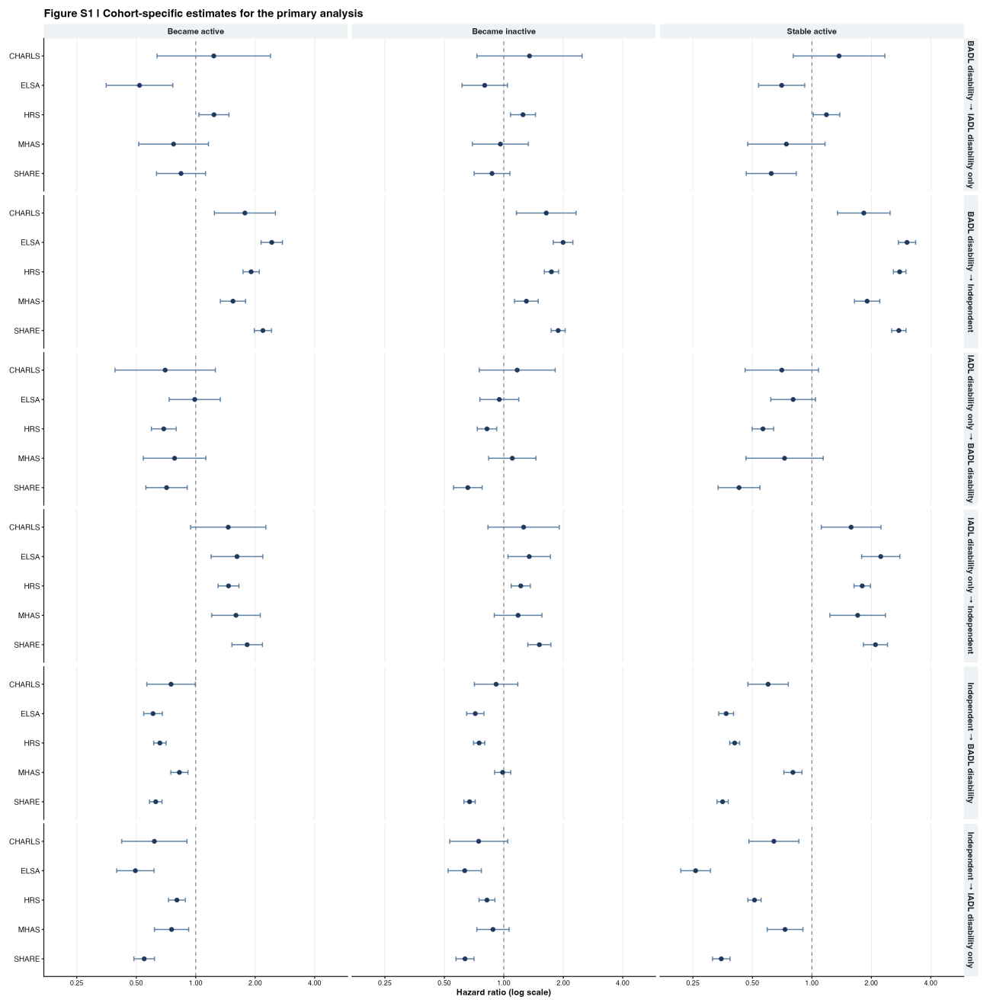
Cohort-specific estimates for all primary PA-change contrasts and functional-state transitions.

Figure S2
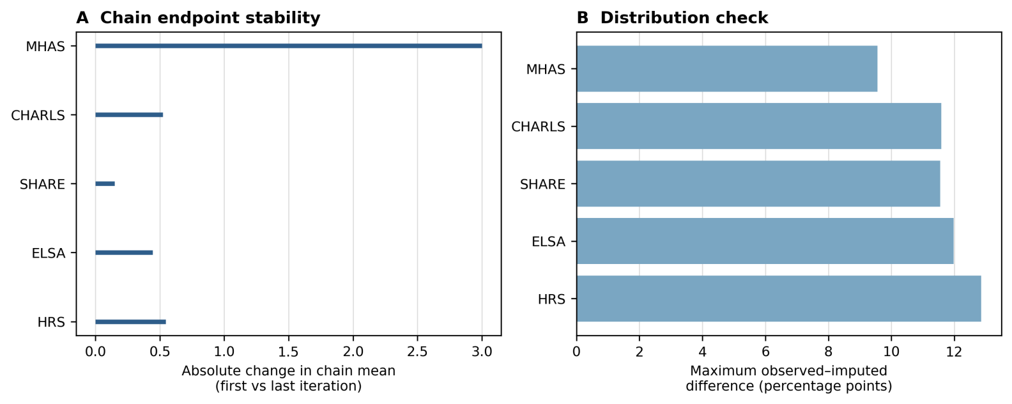
MICE diagnostics. In Panel A, horizontal segments show the minimum-to-maximum absolute change in chain means between the first and last iteration across variables and chains; no summary point estimate is implied. Panel B shows the maximum observed-versus-imputed category percentage-point difference by cohort.
Figure S3
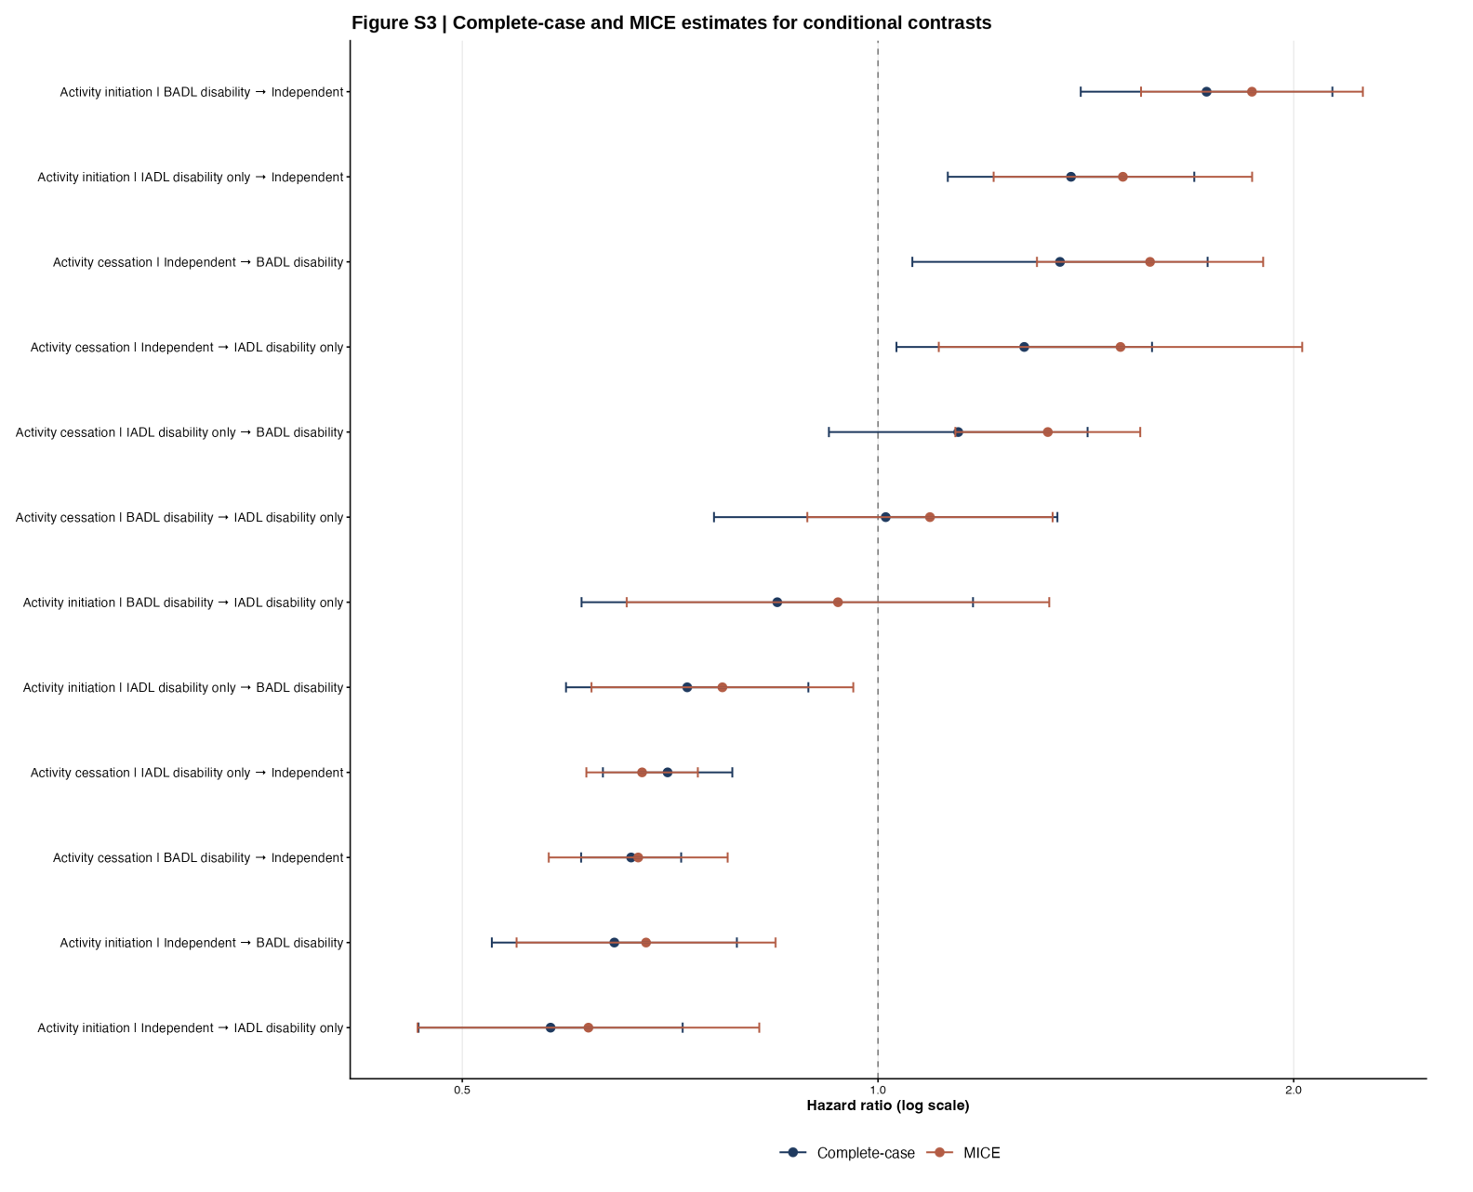
Complete-case and multiple-imputation estimates for the 12 conditional activity-initiation and activity-cessation contrasts. Activity initiation compares Became active with Stable inactive among participants inactive at T1, whereas activity cessation compares Became inactive with Stable active among participants active at T1. Points indicate hazard-ratio estimates, and horizontal intervals indicate 95% confidence intervals. Blue and orange symbols represent complete-case and multiple-imputation by chained equations (MICE) estimates, respectively. Gray segments connect the two estimates for each contrast and indicate the change in point estimates between the two approaches; they do not represent uncertainty intervals. The horizontal axis is shown on a logarithmic scale, and the vertical dashed line at HR = 1 indicates the null value. No prediction intervals are shown.

