Figure S1. Relationship of change from baseline in 6MWD and sildenafil average steady-state concentration.
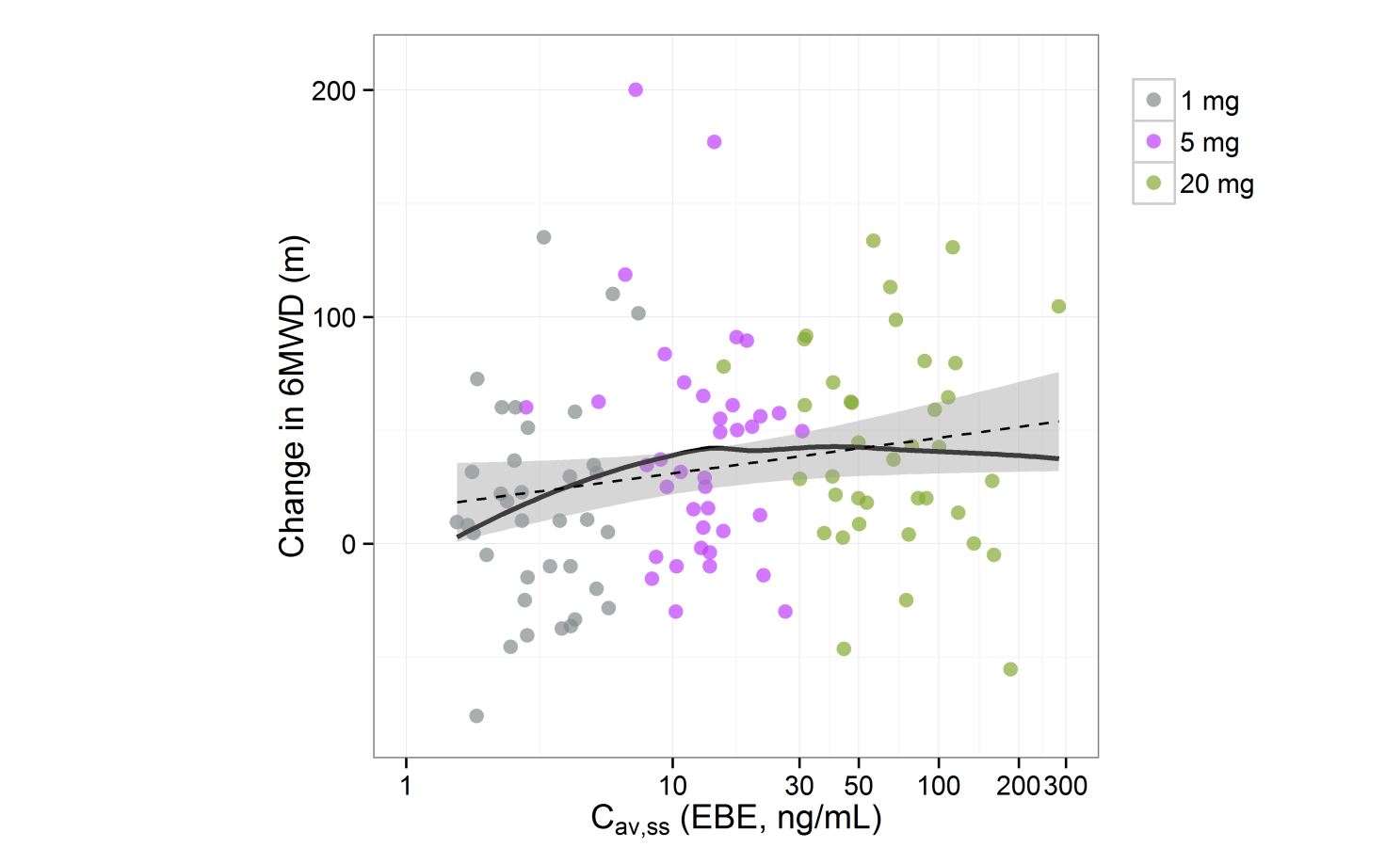
Symbols correspond to dose groups, the linear model and its 95% confidence interval is indicated by a straight dashed line and a shaded area, respectively, and the solid black line corresponds to a smoother curve.

