Additional file 1. Study questionnaires used in the JSHS study
Alcohol Intake Questions consisted of simple questions about drinking in the present time and in the past:
- Have you ever drunk alcohol at least once a month?
- Yes
- Does not take at all

The original Korean questionnaire
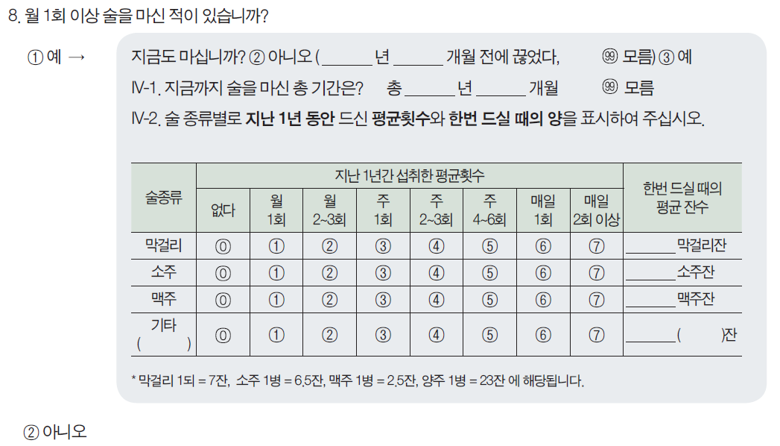
Tobacco Smoking Questions consisted of simple questions about smoking cigarettes in the present time and in the past:
- Have you ever smoked cigarettes? (No means less than 5 packs of cigarettes or 100 cigarettes of tobacco in a lifetime)
- How old were you when you first started regular cigarette smoking?
- If you have stopped smoking cigarettes completely, how old were you when you stopped?
- How many cigarettes do you smoke per day now?

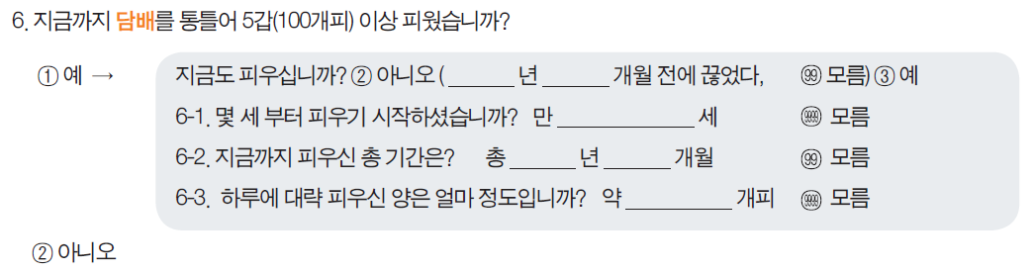
The original Korean questionnaire
Physical Activity Questionnaire consisted of simple questions about regular exercise:
- Do you exercise regularly at least once a week?
- Yes
- No

The original Korean questionnaire
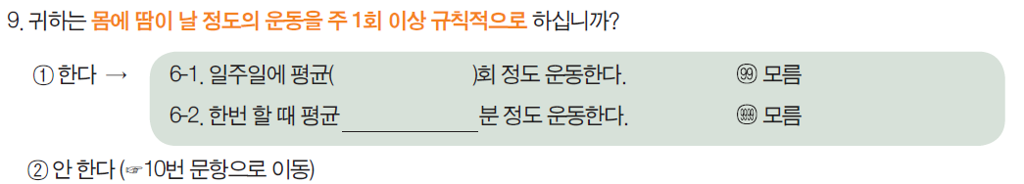
Monthly household income consisted of simple questions about parents' income:
- What is your average monthly income for your household?
- Less than 1,000,000 Korean won
- 1,000,000 – 1,990,000 Korean won
- 2,000,000 – 2,990,000 Korean won
- 3,000,000 – 3,990,000 Korean won
- 4,000,000 – 4,990,000 Korean won
- 5,000,000 – 5,990,000 Korean won
- More than 6,000,000 Korean won
99) Do not wish to answer

The original Korean questionnaire
