On-line Data Supplement

Effects of Endogenous Sex Hormones on Symptom Control and Lung Function in Adolescents with Asthma

Mark D. DeBoer, MD ¹, Brenda R. Phillips, MS ², David T. Mauger, PhD ², Joe Zein, MD ³, Serpil C. Erzurum, MD ³, Anne M. Fitzpatrick, PhD ⁴, Benjamin M. Gaston, MD ⁵, Ross Myers, MD ⁵, Kristie R. Ross, MD ⁵, James Chmiel, MD, MPH ⁵, Min Jie Lee, MD ⁵, John V. Fahy, MD, MSc ⁶, Michael Peters, MD ⁶, Ngoc P. Ly, MD, MPH ⁶, Sally E. Wenzel, MD ⁷, Merritt L. Fajt, MD ⁷, Fernando Holguin, MD ⁷, Allyson Larkin, MD ⁷, Wendy C. Moore, MD ⁸, Stephen P. Peters, MD, PhD ⁸, Mario Castro, MD ⁹, MPH, Andrea M. Coverstone, MD ⁹, Leonard B. Bacharier MD ⁹, Nizar N. Jarjour, MD ¹⁰, Ronald L. Sorkness, PhD ¹⁰, Sima Ramratnam, MD ¹⁰, Anne-Marie Irani, MD ¹¹, Elliot Israel, MD ¹², Bruce Levy, MD ¹², Wanda Phipatanakul MD, MS ¹², Jonathan M. Gaffin, MD, MMSc ¹², and W. Gerald Teague, MD ¹
Affiliations
¹ University of Virginia School of Medicine; ² Pennsylvania State University School of Medicine; ³ Lerner Research Institute, Cleveland Clinic Foundation; ⁴ Rainbow Babies and Children’s Hospital; ⁵ University of California, San Francisco School of Medicine; ⁶ University of Pittsburgh School of Medicine; ⁷ Emory University School of Medicine; ⁸ Wake Forest University School of Medicine; ⁹ Washington University School of Medicine; ¹⁰ University of Wisconsin School of Medicine; ¹¹ Virginia Commonwealth University School of Medicine; ¹² Harvard University School of Medicine.
Corresponding Author
W. Gerald Teague, MD
Ivy Foundation Distinguished Professor of Pediatrics
University of Virginia School of Medicine
Charlottesville, VA 22908
Email: wgt2p@virginia.edu/Phone: 434-243-06

On-line Supplement Tables

Table S1
Characteristics of Females Discordant for Breast and Pubic Hair Stages of Pubertal Development

 | Breast development > pubic hair  (n=1) | Pubic hair > breast development (n=6) | No Discrepancy
Age, mean ± sd | 9.3 | 12.1 ± 0.8 | 11.9 ± 3.23
Race/ethnicity, n (%)
White non-Hispanic | 0 (0) | 2 (33) | 24 (38)
African American non-Hispanic | 1 (100) | 3 (50) | 22 (34)
Hispanic | 0 (0) | 1 (17) | 10 (16)
Other | 0 (0) | 0 (0) | 8 (13)
Asthma severity, n (%)
Severe | 1 (100) | 3 (50) | 23 (36)
Not severe | 0 (0) | 3 (50) | 41 (64)

Table S2-A-1
Lung Function by Sex and Pubertal Stage in Children 6-18 Years with Asthma
BMI ≥ 85%

 | Males |  |  |  |  | Females |  |  |  |  | Females
 | Tanner stages of pubic hair† |  |  |  |  | Tanner stages of breast development† |  |  |  |  | Tanner stages of pubic hair†
 | 1-2  n=49 | 3-5  n=18 | Ratio  3-5:  1-2 | ∆  3-5:  1-2 |  | 1-2  n=16 | 3-5  n=21 | Ratio  3-5:  1-2 | ∆  3-5:  1-2 |  | 1-2  n=17 | 3-5  n=20 | Ratio  3-5:  1-2 | ∆  3-5:  1-2
Pre-BD FEV1  (%) | 91.6 (20.5) | 89.0 (19.7) | 0.97 | -2.6 |  | 92.6 (12.1) | 90.0 (13.0) | 0.97 | -2.6 |  | 92.5 (11.8) | 89.9 (13.4) | 0.97 | -2.5
Max Post-BD FEV1  (%) | 106.5 (21.4) | 106.7 (10.5) | 1.00 | 0.3 |  | 110.7 (11.7) | 102.8 (12.5) | 0.93 | -7.9* |  | 110.2 (11.5) | 102.9 (12.8) | 0.93 | -7.4*
BD Resp.  (% FEV₁ change) | 17.9 (16.9) | 24.2 (23.4) | 1.36 | 6.4 |  | 20.3 (9.4) | 14.9 (8.7) | 0.74 | -5.4 |  | 19.9 (9.3) | 15.1 (8.9) | 0.76 | -4.8
Absolute BD Resp.  (net FEV₁ change) | 14.9 (10.7) | 17.7 (11.7) | 1.19 | 2.9 |  | 18.1 (6.9) | 12.9 (6.4) | 0.71 | -5.3 |  | 17.7 (6.9) | 12.9 (6.6) | 0.73 | -4.8
Pre-BD FVC  (%) | 104.2 (17.3) | 108.2 (18.3) | 1.04 | 4.0 |  | 106.4 (12.2) | 103.8 (11.9) | 0.98 | -2.6 |  | 105.8 (12.1) | 104.2 (12.1) | 0.99 | -1.6
Max Post-BD FVC (% ) | 112.4 (19.1) | 114.8 (13.7) | 1.02 | 2.4 |  | 116.6 (13.4) | 108.4 (13.0) | 0.93 | -8.2 |  | 115.6 (13.6) | 108.8 (13.2) | 0.94 | -6.8
Pre-BD FEV1/  FVC (%) | 86.6 (11.2) | 81.7 (11.5) | 0.94 | -5.0 |  | 86.6 (8.5) | 86.3 (8.3) | 1.00 | -0.3 |  | 87.1 (8.5) | 85.9 (8.3) | 0.99 | -1.2
Max Post-BD FEV1/FVC (%) | 94.3 (8.9) | 93.6 (6.8) | 0.99 | -0.7 |  | 96.1 (7.3) | 95.2 (7.0) | 0.99 | -0.9 |  | 96.4 (7.2) | 94.9 (7.0) | 0.98 | -1.5
PC20 (log 2) | 0.7 (1.6), n=18 | 1.2 (3.3), n=7 | 1.70 | 0.5 |  | 1.6 (0.9) , n=2 | -0.5 (2.8) , n=7 | -.32 | -2.1 |  | 1.6 (0.9) , n=2 | -0.5 (2.8) , n=7 | -.32 | -2.1
Ϯ Cross sectional, based on enrollment examination; * p < 0.05 Tanner Stage 1-2 versus Tanner Stage 3-5.

Table S2-A-2
Lung Function by Sex and Pubertal Stage in Children 6-18 Years with Asthma
BMI < 85%

 | Males |  |  |  |  | Females |  |  |  |  | Females
 | Tanner stages of pubic hair† |  |  |  |  | Tanner stages of breast development† |  |  |  |  | Tanner stages of pubic hair†
 | 1-2  n=35 | 3-5  n=14 | Ratio  3-5:  1-2 | ∆  3-5:  1-2 |  | 1-2  n=16 | 3-5  n=18 | Ratio  3-5:  1-2 | ∆  3-5:  1-2 |  | 1-2  n=37 | 3-5  n=34 | Ratio  3-5:  1-2 | ∆  3-5:  1-2
Pre-BD FEV1  (%) | 86.3 (15.1) | 89.2 (11.7) | 1.03 | 2.9 |  | 95.3 (14.2) | 83.9 (16.7) | 0.88 | -11.4* |  | 88.6 (17.8) | 90.2 (14.8) | 1.02 | 1.7
Max Post-BD FEV1  (%) | 99.3 (15.5) | 104.4 (10.1) | 1.05 | 5.1 |  | 108.1 (14.7) | 97.8 (13.7) | 0.90 | -10.3* |  | 102.5 (15.9) | 103.0 (13.9) | 1.01 | 0.5
BD Resp.  (% FEV₁ change) | 16.5 (16.3) | 18.6 (17.1) | 1.13 | 2.2 |  | 14.1 (11.3) | 19.9 (24.1) | 1.41 | 5.8 |  | 18.5 (21.9) | 15.4 (14.9) | 0.83 | -3.1
Absolute BD Resp.  (net FEV₁ change) | 13.0 (9.8) | 15.3 (12.0) | 1.17 | 2.2 |  | 12.8 (8.9) | 14.0 (11.8) | 1.09 | 1.2 |  | 13.9 (11.5) | 12.7 (9.1) | 0.92 | -1.2
Pre-BD FVC  (%) | 97.4 (12.9) | 104.2 (12.9) | 1.07 | 6.8 |  | 106.2 (11.3) | 96.6 (13.3) | 0.91 | -9.7* |  | 100.5 (14.4) | 102.1 (11.6) | 1.02 | 1.6
Max Post-BD FVC (% ) | 104.8 (14.4) | 109.6 (14.0) | 1.05 | 4.8 |  | 111.1 (12.2) | 100.7 (13.6) | 0.91 | -10.4* |  | 106.0 (14.8) | 105.0 (12.8) | 0.99 | -1.0
Pre-BD FEV1/  FVC (%) | 88.2 (10.2) | 85.9 (11.8) | 0.97 | -2.4 |  | 89.1 (8.4) | 86.4 (13.7) | 0.97 | -2.7 |  | 87.4 (11.2) | 88.1 (12.2) | 1.01 | 0.7
Max Post-BD FEV1/FVC (%) | 95.9 (8.6) | 96.6 (8.1) | 1.01 | 0.8 |  | 98.3 (8.0) | 97.8 (9.4) | 1.00 | -0.4 |  | 97.6 (8.4) | 98.7 (9.3) | 1.01 | 1.0
PC20 (log 2) | -0.2 (2.0) , n=17 | 0.5 (3.0) , n=3 | -3.2 | 0.7 |  | -1.6 (4.0) , n=5 | 0.5 (2.0) , n=8 | -.31 | 2.2 |  | -0.8 (3.6) , n=8 | 0.4 (1.9) , n=5 | -.53 | 1.2
Ϯ Cross sectional, based on enrollment examination; * p < 0.05 Tanner Stage 1-2 versus Tanner Stage 3-5.

Table S2-B-1
ACQ6 by Sex, Pubertal Stage, and
Asthma Severity in Children 6-18 Years of Age
BMI ≥ 85%

 | Males |  |  |  |  | Females |  |  |  |  | Females
 | Tanner stages of pubic hair† |  |  |  |  | Tanner stages of breast development† |  |  |  |  | Tanner stages of pubic hair†
 | 1-2  n=49 | 3-5  n=18 | Ratio  3-5:  1-2 | ∆  3-5:  1-2 |  | 1-2  n=16 | 3-5  n=21 | Ratio  3-5:  1-2 | ∆  3-5:  1-2 |  | 1-2  n=17 | 3-5  n=20 | Ratio  3-5:  1-2 | ∆  3-5:  1-2
ACQ6 | 1.2 (0.9) | 1.0 (0.9) | 0.84 | -0.2 |  | 1.3 (1.0) | 1.6 (1.1) | 1.27 | 0.3 |  | 1.3 (1.0) | 1.6 (1.1) | 1.25 | 0.3
Severe
ACQ6 | 1.3 (1.0) , n=32 | 0.9 (0.6) , n=10 | 0.69 | -0.4 |  | 1.5 (1.1) , n=11 | 1.7 (1.1) , n=14 | 1.13 | 0.2 |  | 1.5 (1.1) , n=11 | 1.7 (1.1) , n=14 | 1.13 | 0.2
Non-severe
ACQ6 | 0.8 (0.6) , n=17 | 1.0 (1.2) , n=8 | 1.27 | 0.2 |  | 0.8 (0.6) , n=5 | 1.5 (1.3) , n=7 | 1.87 | 0.7 |  | 0.9 (0.7) , n=6 | 1.5 (1.4) , n=6 | 1.56 | 0.5
*p < 0.05, Tanner Stage I-II compared to Tanner Stage III-V.

Table S2-B-2
ACQ6 by Sex, Pubertal Stage, and
Asthma Severity in Children 6-18 Years of Age
BMI < 85%

 | Males |  |  |  |  | Females |  |  |  |  | Females
 | Tanner stages of pubic hair† |  |  |  |  | Tanner stages of breast development† |  |  |  |  | Tanner stages of pubic hair†
 | 1-2  n=35 | 3-5  n=14 | Ratio  3-5:  1-2 | ∆  3-5:  1-2 |  | 1-2  n=16 | 3-5  n=18 | Ratio  3-5:  1-2 | ∆  3-5:  1-2 |  | 1-2  n=20 | 3-5  n=14 | Ratio  3-5:  1-2 | ∆  3-5:  1-2
ACQ6 | 1.2 (1.0) | 0.7 (0.5) | 0.54 | -0.6* |  | 0.8 (0.6) | 1.0 (0.8) | 1.29 | 0.2 |  | 0.9 (0.8) | 1.0 (0.7) | 1.07 | 0.1
Severe
ACQ6 | 1.7 (0.8) , n=17 | 0.9 (0.6) , n=7 | 0.53 | -0.8* |  | 0.7 (0.6) , n=8 | 1.0 (0.8) , n=11 | 1.50 | 0.3 |  | 0.8 (0.7) , n=11 | 1.0 (0.8) , n=8 | 1.30 | 0.2
Non-severe
ACQ6 | 0.8 (0.9) , n=18 | 0.4 (0.3) , n=7 | 0.53 | -0.4 |  | 0.9 (0.6) , n=8 | 1.0 (0.8) , n=7 | 1.14 | 0.1 |  | 1.0 (0.9) , n=9 | 0.9 (0.4) , n=6 | 0.86 | -0.1
*p < 0.05, Tanner Stage I-II compared to Tanner Stage III-V.

Table S3-A-1
Linear Regression Analysis of Lung Function and ACQ6 by Sex Hormone Levels in Males 6-18 Years with Asthma and BMI >85 percentile
(n=23)

Outcome variable | Covariate remaining in the model* | Beta coefficient | Covariate p value | R squared | P value of the model
Pre-BD FEV₁  (%) | Log (DHEA-S) | 11.721 | 0.029 | 0.207 | 0.029
Post-BD FEV₁ (%) | Log (DHEA-S) | 12.285 | 0.0258 | 0.215 | 0.0258
Pre-BD FVC  (%) | log (DHEA-S) | 12.44 | 0.022 | 0.225 | 0.022
ACQ6 | Log (DHEA-S) | -0.674 | 0.003 | 0.35 | 0.003
*Results reflect final results of a model that started with testosterone and DHEA-S. Covariates that were not significantly associated with the outcome in this model were then removed by backward selection and model was re-run with remaining variables.

Table S3-A-2
Linear Regression Analysis of Lung Function and ACQ6 by Sex Hormone Levels in Males 6-18 Years with Asthma and BMI <85 percentile
(n=22)

Outcome variable | Covariate remaining in the model* | Beta coefficient | Covariate p value | R squared | P value of the model
Pre-BD FEV₁  (%) | Log (DHEA-S) | 4.114 | 0.33 | 0.048 | 0.33
Post-BD FEV₁ (%) | Log (DHEA-S) | 5.55 | 0.197 | 0.081 | 0.197
Pre-BD FVC  (%) | log (DHEA-S) | 4.083 | 0.284 | 0.057 | 0.284
ACQ6 | Log (DHEA-S) | -0.272 | 0.356 | 0.043 | 0.356
*Results reflect final results of a model that started with testosterone and DHEA-S. Covariates that were not significantly associated with the outcome in this model were then removed by backward selection and model was re-run with remaining variables.

Table S3-B-1
Multi-Variable Regression Analysis of Lung Function and ACQ6 by Sex Hormone Levels in Females 6-18 Years with Asthma and BMI >85 percentile
(n=13)

Outcome variable | Covariate remaining in the model* | Beta coefficient | Covariate p value | R squared | P value of the model
Pre-BD FEV₁  (%) | Estradiol | -0.065 | 0.637 | 0.021 | 0.637
Post-BD FEV₁ (%) | Estradiol | 0.0347 | 0.749 | 0.01 | 0.749
Pre-BD FVC  (%) | Estradiol | -0.146 | 0.228 | 0.129 | 0.146
Post-BD FVC (%) | log (DHEA-S) | -5.907 | 0.055 | 0.295 | 0.055
ACQ6 | log (DHEA-S) | 0.541 | 0.228 | 0.129 | 0.228
*Results reflect final results of a model that started with log (DHEA-S), estradiol, progesterone, and free testosterone as covariates. Covariates that were not significantly associated with the outcome in this model were then removed by backward selection and model was re-run with remaining variables.

Table S3-B-2
Multi-Variable Regression Analysis of Lung Function and ACQ6 by Sex Hormone Levels in Females 6-18 Years with Asthma and BMI <85 percentile
(n=12)

Outcome variable | Covariate remaining in the model* | Beta coefficient | Covariate p value | R squared | P value of the model
Pre-BD FEV₁  (%) | Estradiol | -0.479 | 0.12 | 0.2247 | 0.12
Post-BD FEV₁ (%) | Estradiol | -0.4184 | 0.134 | 0.209 | 0.135
Pre-BD FVC  (%) | Estradiol | -0.291 | 0.276 | 0.117 | 0.276
Post-BD FVC (%) | Estradiol | -0.151 | 0.555 | 0.036 | 0.555
ACQ6 | log (DHEA-S) | 0.388 | 0.124 | 0.220 | 0.388
*Results reflect final results of a model that started with log (DHEA-S), estradiol, progesterone, and free testosterone as covariates. Covariates that were not significantly associated with the outcome in this model were then removed by backward selection and model was re-run with remaining variables.

Table S2
Univariable Regression Analysis of ACQ6 by Age in children 6-18 Years with Asthma
Outcome variable | Covariate remaining in the model* | Beta coefficient | Covariate p value | R squared | P value of the model
Girls
ACQ6 | Age | 0.055 | 0.447 | 0.025 | 0.447
ACQ6 | Age <12 vs. Age >12 (assuming age 12 defines puberty) | 0.397 | 0.394 | 0.032 | 0.394
ACQ6 | Are you still menstruating (yes vs. No) | 0.939 | 0.031 | 0.186 | 0.031
Boys
ACQ6 | Age | -0.09 | 0.099 | 0.061 | 0.099

Online Supplement Figures
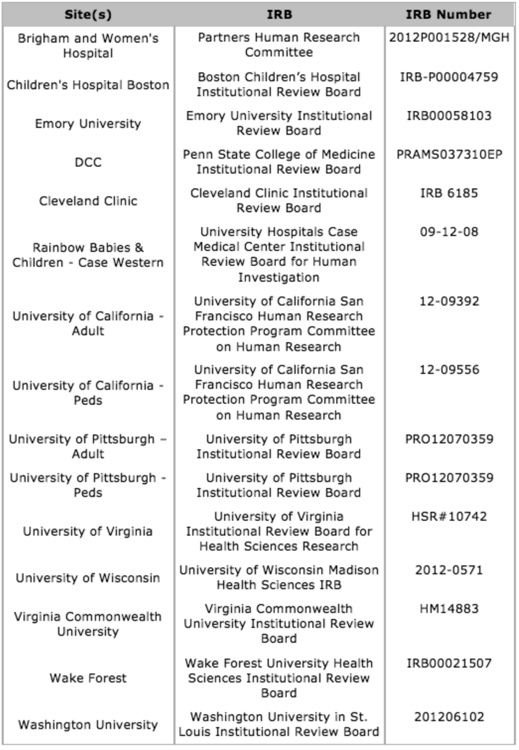
Supplementary Figure S1: Participating institutions, involved Institutional Review Boards (IRB) and IRB numbers.

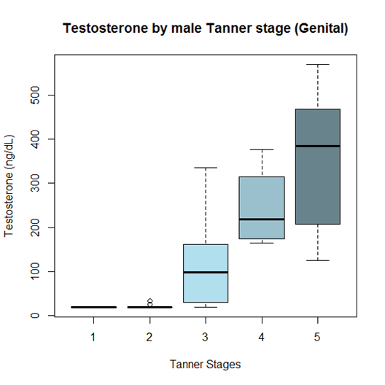

A.

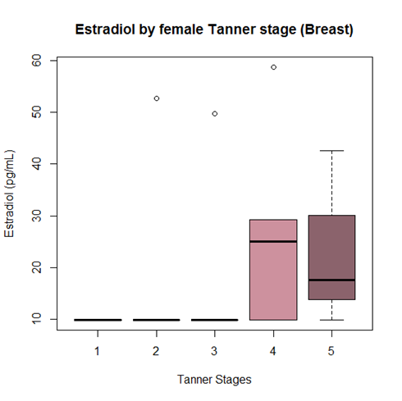

B.

Supplementary Figure S2: Sex hormone levels by Tanner stage for testosterone in males (A) and estradiol in females (B). Box plots are median and confidence intervals.

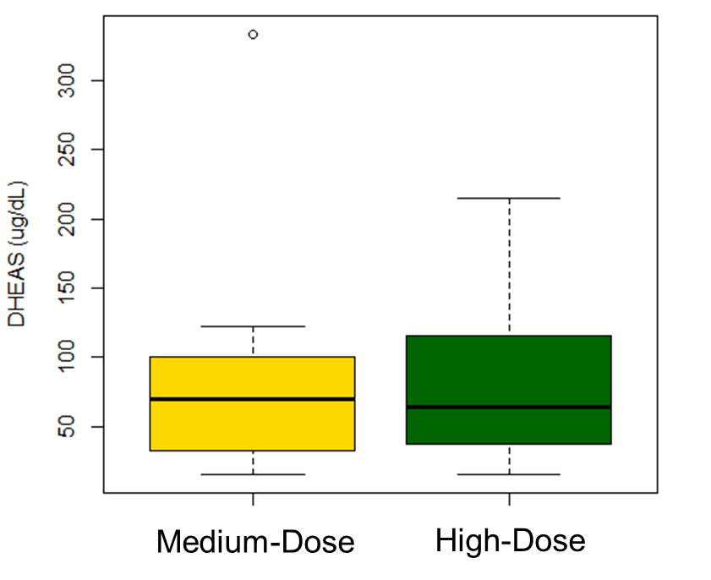

Supplementary Figure S3. DHEA-S levels in boys with asthma treated with medium-dose and high-dose inhaled corticosteroids. Box plots are median and confidence intervals.

