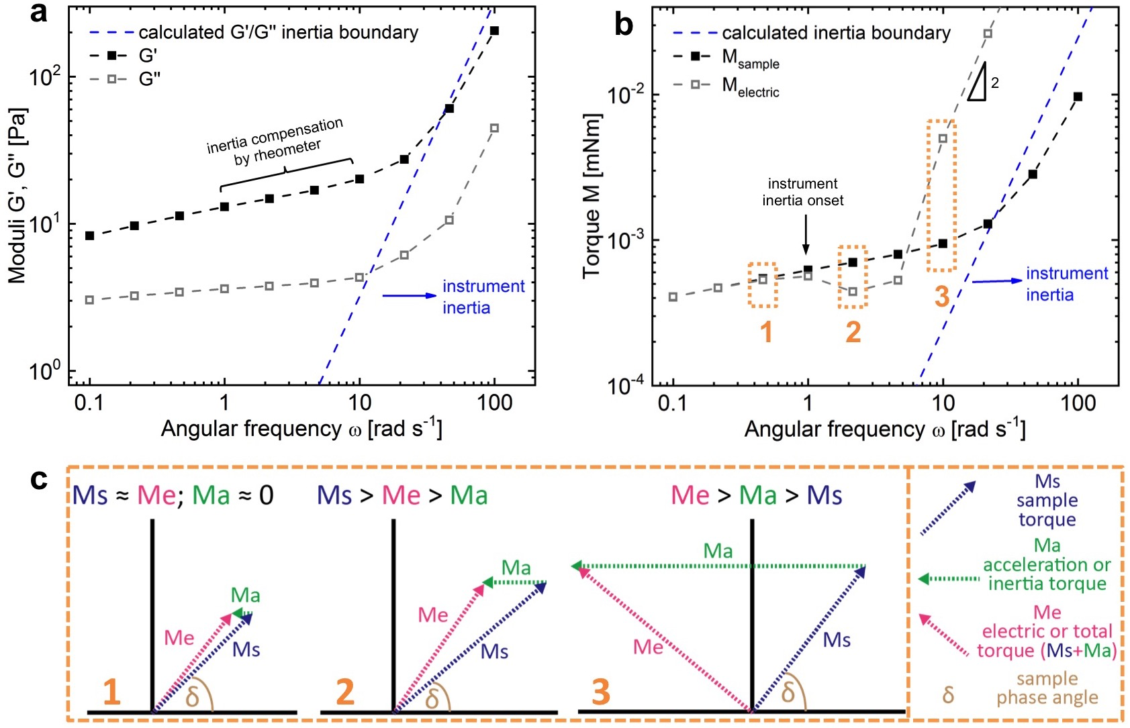

Figure S5. Instrument inertia in cystic fibrosis sputum shear rheology measurements. (a) Frequency sweeps a representative sputum sample depicting the storage modulus (G’) and the loss modulus (G’’). (b) Corresponding raw data to (a) depicting the sample torque (M_{sample}) and the electrical torque (M_{electric}) – corresponding to the total torque measured by the rheometer - as a function of angular frequency. Note that at frequencies ω > 10 rad s⁻¹ the electrical torque starts to scale with a slope of 2 with frequency in the log-log plot, a hallmark for inertia. The blue dashed lines show the calculated inertia limit for an Anton Paar MCR (302, 502, 702) rheometer using a plate-plate 25 mm diameter (PP25) measuring geometry, which agrees well with the observed onset of instrument inertia. The calculations are based on a formula provided by Ewoldt et al. [1]. (c) Schematic drawing of torque vector diagrams. Torque vectors are shown for three distinct angular frequencies corresponding to boxes in (b). 1 depicts the almost complete absence of inertia, whereas 2 and 3 show different scenarios of instrument inertia affecting the total torque.

Reference

[1] Ewoldt RH, Johnston MT, Caretta LM. Experimental Challenges of Shear Rheology: How to Avoid Bad Data. Biol Med Phys Biomed. 2015:207-41.

