Figure S1. Three sets of endobronchial ultrasound images.
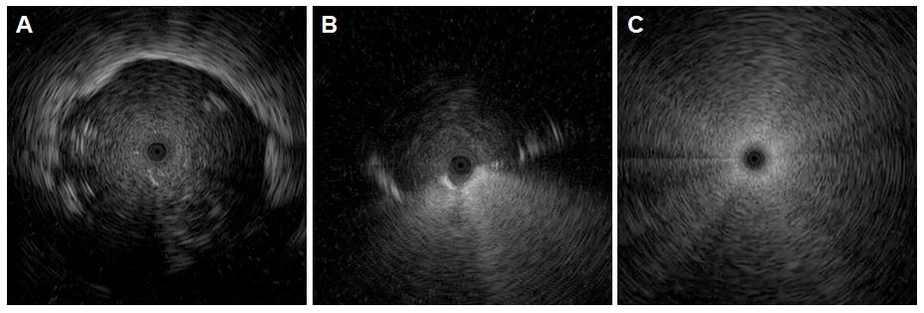The radial probe endobronchial ultrasound was positioned inside the lesion (A, within), in the bronchus adjacent to the lesion (B, adjacent to), and outside the lesion (C, outside).

