Online data supplement

Table S1 GRADE profile for quality assessment of evidence
Quality assessment |  |  |  |  |  |  | No of patients |  | Effect |  | Quality | Importance
No of studies | Design | Risk of bias | Inconsistency | Indirectness | Imprecision | Other considerations | Surfactant | Placebo | Relative  (95% CI) | Absolute | Quality | Importance
mortality (follow-up 0.5-5 days; assessed with: follow up)
11 | randomized trials | serious¹ | no serious inconsistency | no serious indirectness | serious² | none | 604/1938 (31.2%) | 572/1877 (30.5%) | OR 1.02 (0.93 to 1.12) | 6 more per 1000 (from 21 fewer to 37 more) | ⊕⊕ΟΟ  LOW | CRITICAL
 |  |  |  |  |  |  |  | 32.4% | OR 1.02 (0.93 to 1.12) | 6 more per 1000 (from 23 fewer to 39 more) | ⊕⊕ΟΟ  LOW | CRITICAL
PaO2/FiO2 ratio (follow-up 24-72 hours)
3 | randomized trials | very serious³ | no serious inconsistency | no serious indirectness | serious⁴ | none | 232 | 231 | - | SMD 0.06 higher (0.12 to 0.24higher) | ⊕ΟΟΟ  VERY LOW | IMPORTANT
¹ Allocation concealment were not reported totally.
^{2, 4} The sample sizes were all small.
³ Allocation concealment was not reported totally, and two trials did not have unequivocal blinding method.

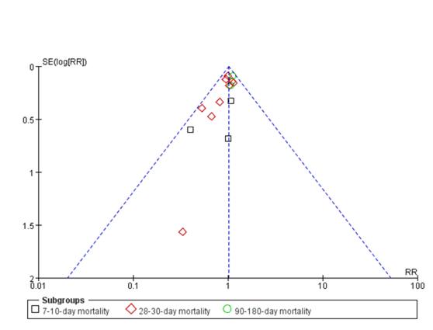

Fig S1 Analysis of funnel plot for mortality outcomes in adult ARDS patients after surfactant therapy.

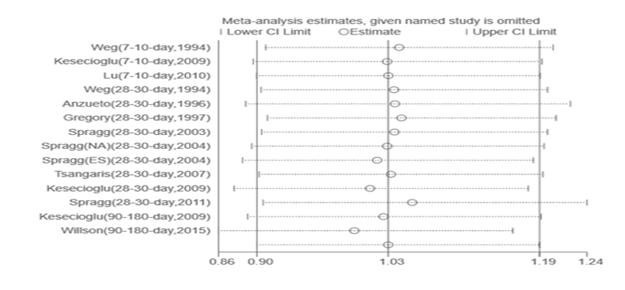
Fig S2 Sensitive analysis for mortality outcomes of adult ARDS patients with surfactant therapy.

