Additional file Figure S1. Trial sequential analysis for lung cancer mortality

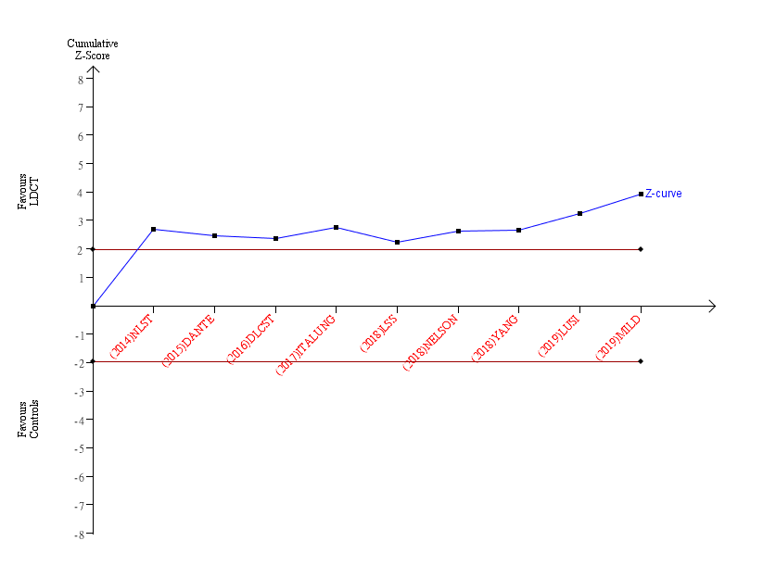

The required information size (RIS) was not renderable because the first information fraction exceeded 100% of the RIS. The Z curve has crossed the conventional boundary for benefit and RIS, indicating that the conclusion is sufficient and no more trials are needed.

