Additional File 1. Demographic and clinical characteristics before and after weighting for patients with index date prior to 10/1/2017
Variable | Pirfenidone | Nintedanib | SMD¹ | Pirfenidone | Nintedanib | SMD¹
n | 697 | 551 |  | 1269.2 | 1225.3
Age (%) |  |  | 0.111 |  |  | 0.027
65-74 | 222 (31.9) | 156 (28.3) |  | 30.7 | 29.7
40-54 | 34 ( 4.9) | 28 ( 5.1) |  | 5.1 | 5.0
55-64 | 186 (26.7) | 137 (24.9) |  | 26.1 | 25.9
75-79 | 121 (17.4) | 108 (19.6) |  | 18.1 | 18.4
80+ | 134 (19.2) | 122 (22.1) |  | 20.0 | 20.9
Sex = Female (%) | 220 (31.6) | 171 (31.0) | 0.011 | 30.9 | 32.4 | 0.032
Region (%) |  |  | 0.154 |  |  | 0.041
South/Unknown | 255 (36.6) | 223 (40.5) |  | 38.0 | 38.6
Northeast | 141 (20.2) | 99 (18.0) |  | 19.2 | 19.0
North Central | 205 (29.4) | 176 (31.9) |  | 31.3 | 29.8
West | 96 (13.8) | 53 ( 9.6) |  | 11.5 | 12.6
Deyo CCI excluding COPD (median [IQR]) | 1.0 [0.0, 3.0] | 1.0 [0.0, 3.0] | 0.049 | 1.0 [0.0, 3.0] | 1.0 [0.0, 3.0] | 0.024
COPD = Yes (%) | 313 (44.9) | 281 (51.0) | 0.122 | 47.4 | 47.8 | 0.007
Stroke = Yes (%) | 18 ( 2.6) | 11 ( 2.0) | 0.039 | 2.3 | 2.5 | 0.013
Pneumonia² = Yes (%) | 67 ( 9.6) | 58 (10.5) | 0.030 | 10.1 | 9.6 | 0.016
ILD Center of Excellence³ = Yes (%) | 52 ( 7.5) | 46 ( 8.3) | 0.033 | 8.0 | 8.1 | 0.004
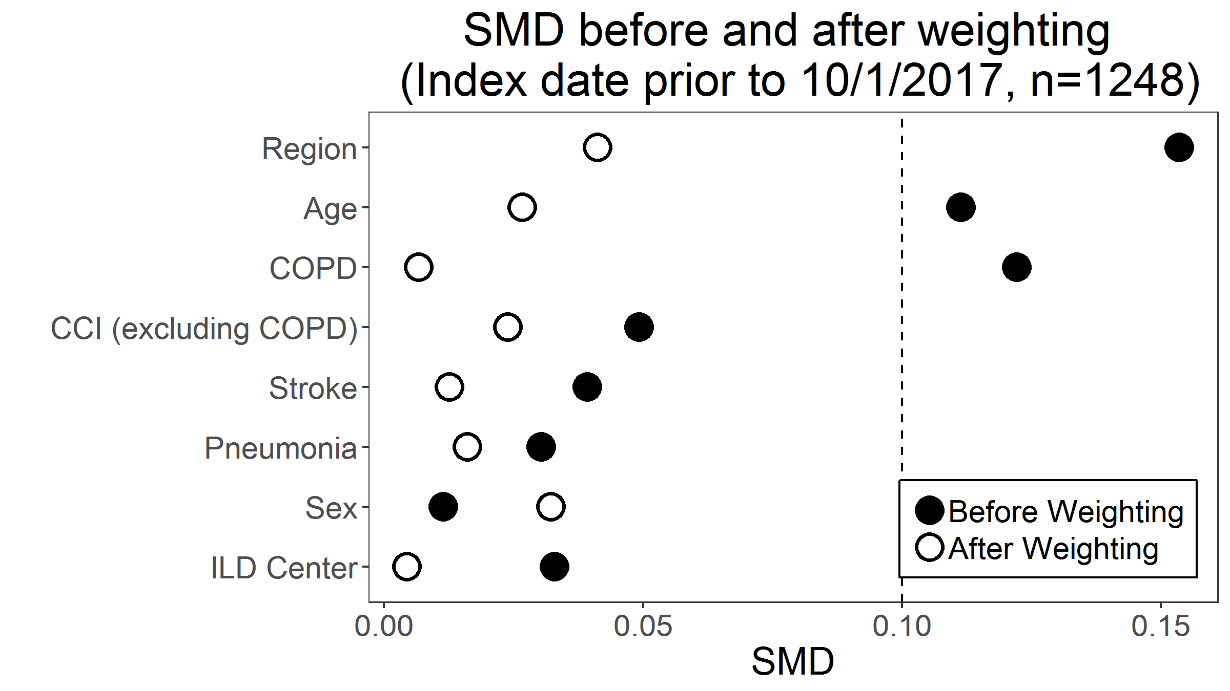
¹Pirfenidone vs. nintedanib
²Pnemonia diagnosis in the three months immediately preceding the index date
³Interstitial Lung Disease (ILD) centers of excellence were defined as medical centers with specific expertise in the treatment of pulmonary fibrosis, as recognized by the Pulmonary Fibrosis Foundation.
CCI, Carlson Comorbidity Index; COPD, chronic obstructive pulmonary disease; SMD, standardized mean difference

