Additional file
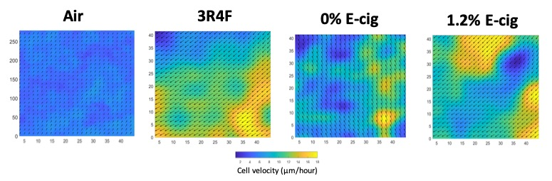Additional file 2 Showed is the heat map analysis of a single image taken during recording time-lapse video of HBECs exposed to (left to right) control air, CS, EC (0%) nicotine and EC (1.2%) nicotine.

