SUPPLEMENTARY INFORMATION

Title
The impact of high-flow nasal cannula oxygen therapy on exercise capacity in fibrotic interstitial lung disease: a proof-of-concept randomized controlled crossover trial

Authors
Atsushi Suzuki^{1,2}, Masahiko Ando³, Tomoki Kimura¹, Kensuke Kataoka¹, Toshiki Yokoyama¹, Eiichi Shiroshita⁴ and Yasuhiro Kondoh¹

Affiliations
¹Department of Respiratory Medicine and Allergy, Tosei General Hospital, Seto, Aichi, Japan
²Department of Respiratory Medicine, Nagoya University Graduate School of Medicine, Nagoya, Aichi, Japan
³Center for Advanced Medicine and Clinical Research, Nagoya University
Hospital, Nagoya, Aichi, Japan
⁴Pacific Medico Co., Ltd., Chiyoda-ku, Tokyo, Japan

Table S1. Comparison of baseline characteristics between IPF and non-IPF
 | IPF | Non-IPF-FILD | P value
Number | 12 | 8
Age, years | 69.4 ± 5.4 | 72.8 ± 10.1 | 0.349
Sex, M/F | 11/1 | 8/0 | 0.402
BMI, Kg/m² | 21.6 ± 2.8 | 23.4 ± 7.4 | 0.449
Smoking status
Ever/Never | 11/1 | 8/0 | 0.402
Pack-years | 51.9 ± 47.9 | 56.3 ± 28.7 | 0.822
mMRC | 2.8 ± 1.1 | 2.5 ± 0.9 | 0.494
FVC, %pred. | 56.4 ± 13.4 | 65.2 ± 15.9 | 0.198
FEV₁/FVC, % | 88.0 ± 7.9 | 88.1 ± 7.9 | 0.981
DLco, %pred.* | 28.0 ± 11.6 | 37.5 ± 17.9 | 0.209
RV, %pred.** | 51.5 ± 23.1 | 68.9 ± 23.1 | 0.173
Oxygen therapy, Yes
Flow at rest, L/min | 0.9 ± 1.2 | 0.8 ± 1.7 | 0.877
PaCO₂, torr | 44.3 ± 4.9 | 41.6 ± 6.0 | 0.286
Pulmonary hypertension | 6 | 6 | 0.264
Baseline CWRET
Endurance time, min | 3.1 ± 1.3 | 5.3 ± 4.9 | 0.145
Min SpO₂, % | 77.2 ± 5.6 | 78.5 ± 8.2 | 0.669
Max HR, bpm | 120.2 ± 18.5 | 122.6 ± 18.0 | 0.772
Final Borg scale
Dyspnea | 6.8 ± 2.3 | 7.0 ± 1.9 | 0.801
Leg fatigue | 5.3 ± 2.9 | 7.5 ± 2.0 | 0.079
Data are presented as number (%) or mean ± standard deviation (SD).
P-value from chi-squared test or Student’s t-test.
* n = 17 (A: n = 9, B: n = 8), ** n = 16 (A: n = 8, B: n = 8)

Table S2. Subgroup analysis of endpoints in VM good responders

N = 15 | VM | HFNC | Difference (95% CI) | P-value**
Primary endpoint
Endurance time, min | 8.1 (5.0-11.1) | 6.6 (3.6-9.7) | -1.4 (-5.8-2.9) | 0.499
Secondary endpoint
Min SpO₂, % | 90.2 (85.6-94.8) | 90.5 (85.9-95.3) | 0.3 (-6.3-6.9) | 0.918
Max HR, bpm | 120.0 (110.8-129.2) | 118.3 (109.0-127.3) | -1.8 (-14.8-11.1) | 0.775
Isotime Borg scale (dyspnea) | 5.6 (4.1-7.0) | 5.9 (4.4-7.3) | 0.3 (-1.8-2.4) | 0.774
Isotime Borg scale (leg fatigue) | 4.9 (3.1-6.6) | 4.9 (3.1-6.6) | 0.0 (-2.4-2.5) | 0.997
Final Borg scale (dyspnea) | 6.9 (5.5-8.2) | 6.5 (5.2-7.9) | -0.3 (-2.2-1.6) | 0.710
Final Borg scale (leg fatigue) | 5.6 (3.8-7.3) | 5.5 (3.8-7.3) | -0.0 (-2.5-2.5) | 0.988
Patient comfort of device | 8.0 (6.5-9.4) | 6.3 (4.9-7.8) | -1.6 (-3.6-0.4) | 0.109

Data are presented as number (%) or mean (95% CI).
HFNC, high-flow nasal cannula; HR, heart rate; SpO₂, saturation of peripheral oxygen; VM, venturi mask.

* Good responder was defined as a patient with > 100 seconds or 33 % improvement in endurance time from baseline CWRET.
**Calculated by generalized linear mixed-effects model with fixed factors for each device, sequence, and period,
and a random factor for subject within sequence.

Table S3. Comparison of baseline characteristics between HFNC good responders and non-responders
 | HFNC  Responders | HFNC  Non-responders | P value
Number | 13 | 7
Age, years | 71.5 ± 7.7 | 69.3 ± 7.7 | 0.541
Sex, M/F | 13/0 | 6/1 | 0.162
BMI, Kg/m² | 22.0 ± 5.8 | 22.9 ± 3.7 | 0.725
Smoking status
Ever/Never | 12/1 | 7/0 | 0.452
Pack-years | 59.8 ± 45.1 | 42.2 ± 29.7 | 0.371
mMRC | 2.8 ± 0.9 | 2.6 ± 1.3 | 0.694
FVC, %pred. | 58.8 ± 16.4 | 62.1 ± 11.7 | 0.650
FEV₁/FVC, % | 89.5 ± 7.7 | 85.2 ± 10.1 | 0.295
DLco, %pred.* | 34.0 ± 18.5 | 30.4 ± 9.5 | 0.645
RV, %pred.** | 57.9 ± 25.9 | 62.2 ± 22.9 | 0.739
Oxygen therapy, Yes
Flow at rest, L/min | 0.7 ± 1.0 | 1.2 ± 2.0 | 0.536
PaCO₂, torr | 42.7 ± 6.1 | 44.2 ± 3.7 | 0.576
FILD classification, n
IPF | 9 | 3
NSIP | 0 | 1
CTD-ILD | 0 | 1
Unclassifiable IIP | 4 | 1
Baseline CWRET
Endurance time, min | 3.3 ± 1.4 | 5.1 ± 5.3 | 0.247
Min SpO₂, % | 78.5 ± 5.1 | 76.3 ± 9.1 | 0.573
Max HR, bpm | 118.1 ± 16.1 | 126.9 ± 20.9 | 0.307
Final Borg scale
Dyspnea | 6.9 ± 2.3 | 6.9 ± 1.8 | 0.991
Leg fatigue | 6.6 ± 2.3 | 5.4 ± 3.5 | 0.344
Data are presented as number (%) or mean ± standard deviation (SD).
P-value from chi-squared test or Student’s t-test.
* n = 17 (A: n = 9, B: n = 8), ** n = 16 (A: n = 8, B: n = 8)

Figure S1. Trend graph of SpO₂ during endurance exercise tolerance test in each subject
Dotted line = baseline test; Dashed line = VM; Solid line = HFNC

Figure S2. Trend graph of heart rate (HR) during endurance exercise tolerance test in each subject
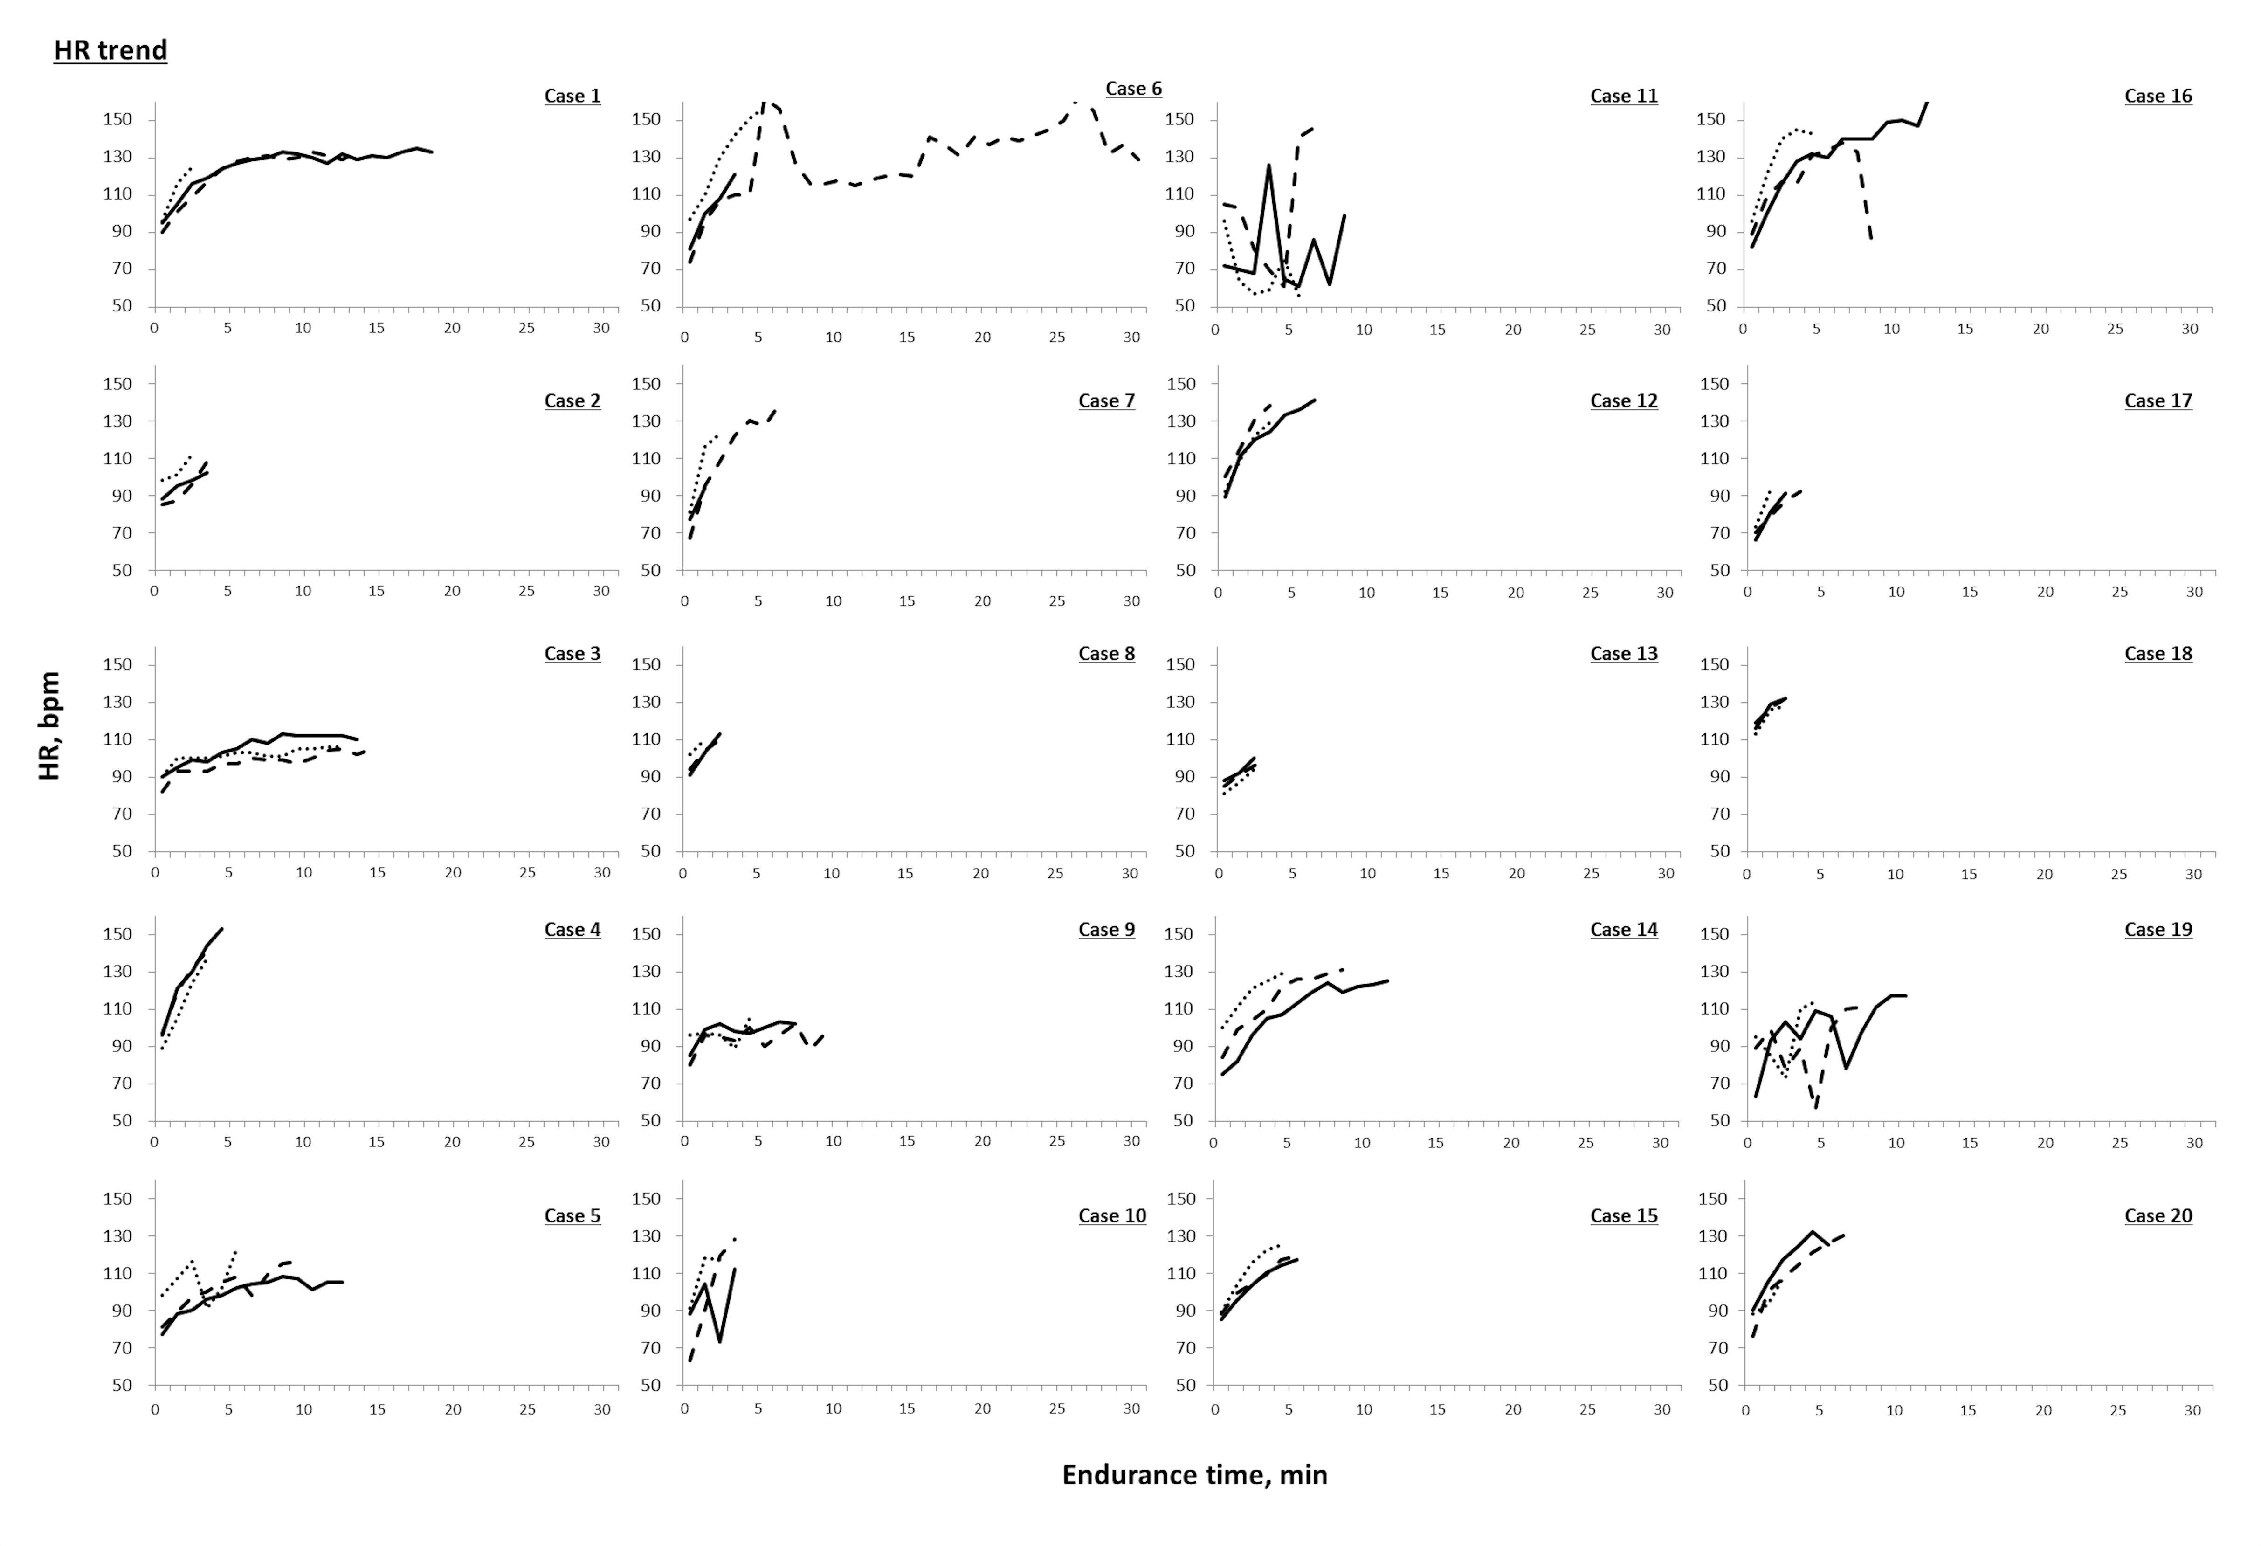

Figure S3. Trend graph of Borg scale (dyspnea) during endurance exercise tolerance test in each subject
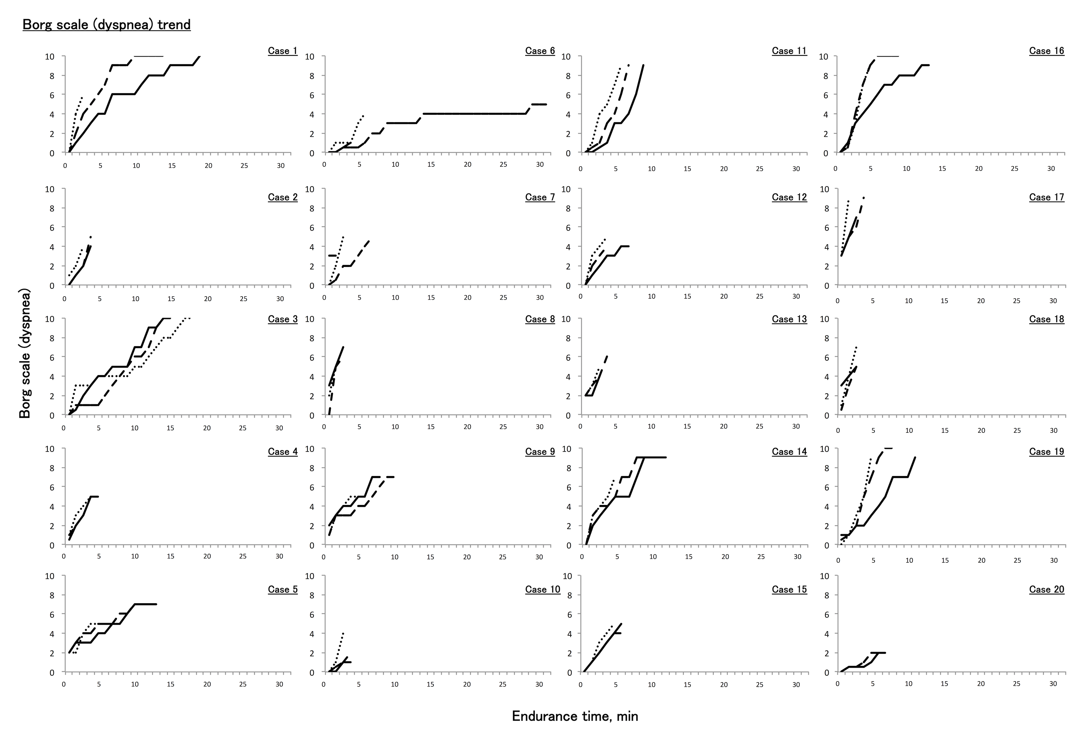

Figure S4. Trend graph of Borg scale (leg fatigue) during endurance exercise tolerance test in each subject
