Appendix A. Respiratory characteristics of COVID-19 patients treated with prone positioning (n = 29)
 | pre-prone | post-prone | pre-supine | post-supine
PF ratio
Mean (SEM) | 107.5 (5.6) | 155.7 (11.2) | 142.0 (10.8) | 131.5 (9.1)
Range | 64.0, 179 | 72.0, 295 | 72.0, 290 | 66.7, 233
t-statistic (p-value) ª | NA | 4.62 (0.000*) | 3.31 (0.001*) | 2.30 (0.02)
ANOVA F-statistic (p-value) ^{b} | 7.6144 (0.000*)
PaCO2 (mmHg)
Mean (SEM) | 60.0 (2.5) | 67.2 (3.1) | 66.3 (3.0) | 60.4 (3.4)
Range | 39.5, 87.0 | 41.3, 103 | 37.0, 100 | 33.1, 124
t-statistic (p-value) | NA | 2.33 (0.02) | 2.05 (0.04) | 0.13 (0.90)
p-value | NA
ANOVA F-statistic (p-value) | 3.0321 (0.03)
SaF ratio
Mean (SEM) | 121.3 (4.2) | 131.5 (5.1) | 139.9 (5.1) | 139.7 (5.9)
Range | 90.0, 182 | 86.3, 197 | 86.3, 197 | 92.0, 234
t-statistic (p-value) | NA | 2.28 (0.025) | 4.16 (0.000*) | 4.10 (0.000*)
p-value | NA
ANOVA F-statistic (p-value) ^{b} | 7.6841 (0.000*)
Notes:
Pre-prone = 1 hr before proning; Post-prone = 1 hr after proning; Pre-supine = 15 hr after proning; Post-supine = 1 hr after return to supine position.
ª t-statistic is derived from a simple linear mixed model and tests for difference in mean of each characteristic compared to baseline (pre-prone).
^{b} F-statistic is from repeated measures ANOVA and tests the null hypothesis that the four measurements are all equal (e.g., PFr H₀: PFr _{pre-prone} = PFr _{post-prone} = PFr _{pre-supine} = PFr _{post-supine}).
* Bonferroni corrected: p<0.017.

APPENDIX B
Protocol for Positional Therapy in COVID-19 in a Resource Limited Setting

Patient Selection
Inclusion criteria:
Age between 18 and 75 years of age
PaO₂ to FiO₂ ratio (PFr) ≤ 150 with:
≤ 72 hours of PFr ≤ 150
Total days of ventilation ≤ 14
Peep of ≥ 5 cm H₂O and FiO₂ ≥ 0.60

Exclusion criteria:
BMI > 35
Family or patient decision for no escalation of care
(DNR patients are eligible if clinically appropriate)
Unmanaged abdominal compartment syndrome
CXR with total opacification not due to effusion verified with ultrasound
New (≤ 48 hours) pacemaker insertion

Materials
Four standard bed sheets
Three pillows, folded blankets, or folded sheets
8 - 12” for chest
It is essential that this pad is placed only between sternal notch and xyphoid
3 - 6” for pelvis
2 - 4” for face
3 - 4” under ankles
Two large absorbent pads
Tape and ointment for eyes
Pads for exposed boney prominences
Pulse oximeter
New set of EKG leads if appropriate
Intubation equipment available

Bedside Preparation
Monitor and EKG leads
Place pulse oximeter on modulated audible setting
Remove all anterior EKG leads and pads
Ventilator
Document current settings with attention to minute volume and pressures
Pre-oxygenate with FiO₂ of 100%
Airway
Inspect ETT depth at teeth and stabilization
Suction ETT to assure patency and clear any secretions
Skin care
Assure ETT is secure and not threatening skin, lips, or eyes
Carefully pad all boney prominences on body and face
Assure nasogastric (NG) tube does not threaten nasal alae or lip
Inspect tongue for edema or injury potential
Lines and tubes
Discontinue all non-essential lines if possible
Move all lines to midline (or tight to flank) of rotation (to head or feet)
Assure that lines will not end up under the patient
Pad and protect femoral and subclavian lines
Assure that chest tubes are padded, and connections are secure
Communication
Primary care team and bedside RN are informed of plan and timing
Team leader conducts the time out check list
Airway person calls the commands for movement
No other conversations or activities during time out or movement

Movement Sequence
The pulse oximeter always remains connected and on audible
Assure the ventral surface of the patient is clear of devices or foreign bodies
Assure all padding is in place
Absorbent pads (sternal notch to knees, top over bottom)
Sheet with cephalad edge rolled towards patient down to the shoulders
This facilitates coverage of the bed once the patient is prone
Two lifting sheets folded in half and lengthwise to 12” width placed perpendicular
One across nipple lines
One across iliac crests
Pillows or folded linen
8 - 12” for chest
3 – 6” for pelvis
adjust to individual habitus to allow belly to hang free of pressure
Second sheet with cephalad edge rolled towards patient to the shoulders
This will become the new bottom sheet
Roll the lateral edges of all linen towards patient until tight
At least two team members on each side
Airway manager counts, maintains airway, never lifts except to stabilize the head
Always roll towards the ventilator
Move efficiently and assume the patient will become volatile but improve when prone
Avoid a lengthy pause in the lateral position
The adjustment of the chest pillows is an immediate priority

Specific roles and actions
Airway person
assures all personnel ready
reinforces direction and sequence of movements
demonstrates cadence (i.e., move on three - 1, 2, 3…)
2 persons (or 3 persons) on each side
Move the patient in the sheet package horizontally away from ventilator
Roll the patient back towards ventilator
Center the patient on bed
Clear sheets and absorbent pads from back
Lift chest sling and adjust chest pillows/pads
Center between the sternal notch and the xyphoid
Mild curvature of back, symmetrical, and stable, arms are neutral
Assure belly hangs free
Lift pelvic sling and adjust pads
Flat and symmetrical
Assure belly hangs free
Gentleman’s check to assure genitals are appropriately positioned and padded
Place pad (4” – 8”) under face
Pass suction catheter to assure airway patency of ETT
Inspect for tongue security
Assure ears are flat
Assure the ETT is positioned without compromise
Reattach lines and EKG pads and leads
Reposition foley and chest tubes as necessary
Assure bedside is secure and to the satisfaction of the primary RN
Checklists are read before and after each movement
Immediate debriefing is held, and opportunities identified are recorded

APPENDIX C
Pre-prone check list

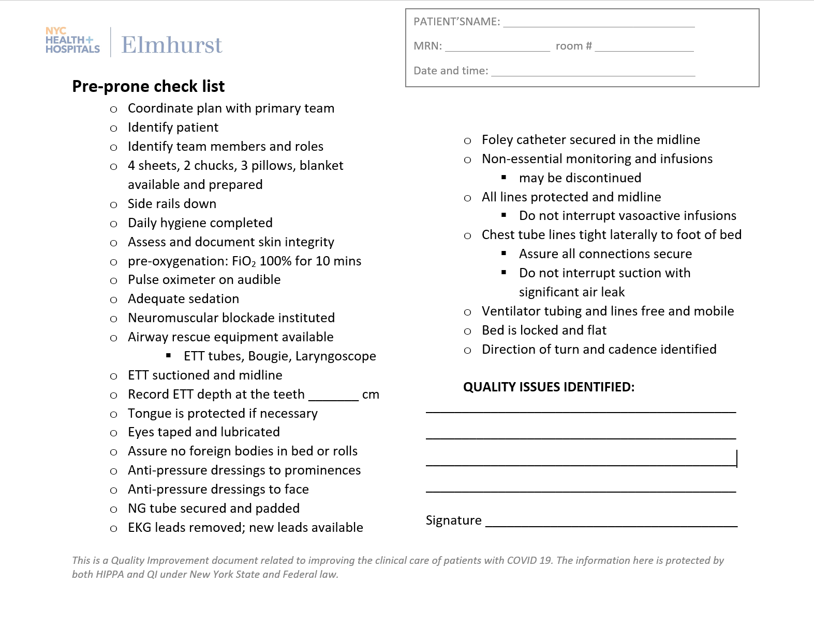

APPENDIX D
Post – prone check list

