Supplementary Materials

- Table S1. Demographics of physician survey-takers
- Table S2. Frequency with which physicians assessed the risk of malignancy to be less than 60%
- Table S3. Frequency of physicians estimating a risk of malignancy ≤ 60% without and with a Percepta GSC very high risk result.
- Table S4. Demographics of physicians reporting an increase in confidence in the treatment plan compared to those reporting a decrease in confidence following a Percepta GSC result.
- Figure S1. Allocation of cases to physician survey takers
- Figure S2. Percepta GSC risk re-stratification algorithm
- Figure S3. Percepta GSC result report for risk re-stratification high risk to very high risk
- Figure S4. Confidence scale

Table S1. Demographics of survey takers.
Survey Taker Characteristics | N=101¹
Use of Percepta in medical practice
Yes | 57 (56%)
No | 44 (44%)
Medical Specialty
Interventional Pulmonology | 29 (29%)
Pulmonary Critical Care | 29 (29%)
Pulmonology | 43 (43%)
Length of time in medical practice (years) | 13 (8, 23)
Region of medical practice (within the US)
Midwest | 29 (29%)
Northeast | 29 (29%)
South | 29 (29%)
West | 14 (14%)
Medical practice setting
Academic or Teaching Hospital | 50 (50%)
Community-Based | 51 (50%)
Bronchoscopies performed for suspect lung cancer (monthly) | 15 (10, 25)
¹n (%); Median (IQR, interquartile range)

Table S2. Demographics of survey takers, Percepta GSC Users vs. Non-Users.
Characteristic | Non-User, N = 44¹ | User, N = 57¹ | p-value²
Specialty |  |  | 0.001
Interventional Pulmonology | 6 (14%) | 23 (40%)
Pulmonary Critical Care | 11 (25%) | 18 (32%)
Pulmonology | 27 (61%) | 16 (28%)
Years of Practice | 16 (11, 24) | 11 (5, 21) | 0.03
Region |  |  | 0.2
Midwest | 14 (32%) | 15 (26%)
Northeast | 15 (34%) | 14 (25%)
South | 8 (18%) | 21 (37%)
West | 7 (16%) | 7 (12%)
Type of Practice |  |  | 0.055
Academic or Teaching Hospital | 17 (39%) | 33 (58%)
Community-Based | 27 (61%) | 24 (42%)
Bronchscopies Per Month | 15 (12, 31) | 15 (10, 25) | 0.069
¹n (%); Median (IQR) ²Pearson's Chi-squared test; Wilcoxon rank sum test

Table S3. Frequency of physicians estimating a risk of malignancy ≤ 60% without and with a Percepta GSC very high risk result.

<=60% ROM | Without | With
 | Percepta | Percepta
Independent | 33% | 12.50%
Pre/post | 32.80% | 8.80%

ROM = risk of malignancy

Table S4. Demographics of physicians reporting an increase in confidence in the treatment plan compared to those reporting a decrease in confidence following a Percepta GSC result.

 | Same/More Confident after | Less Confident after | P-value²
 | Percepta GSC | Percepta GSC
 | (N=297)¹ | (N = 44)¹
Percepta User |  |  | 0.2
Non-User | 133 (45%) | 24 (55%)
User | 164 (55%) | 20 (45%)
Specialty |  |  | 0.6
Interventional Pulmonology | 83 (28%) | 15 (34%)
Pulmonary Critical Care | 83 (28%) | 13 (30%)
Pulmonology | 131 (44%) | 16 (36%)
Years of Practice | 13 (9, 23) | 12 (8, 20) | 0.5
Type of Practice |  |  | 0.7
Academic or Teaching Hospital | 137 (46%) | 19 (43%)
Community-Based | 160 (54%) | 25 (57%)
Bronchoscopies Per Month | 15 (10, 25) | 15 (10, 30) | 0.5
¹ n (%); Median (IQR)
² Pearson's Chi-squared test; Wilcoxon rank sum test

Figure S1. Allocation of cases to physician survey takers. (Not all physicians received cases in all three formats.)

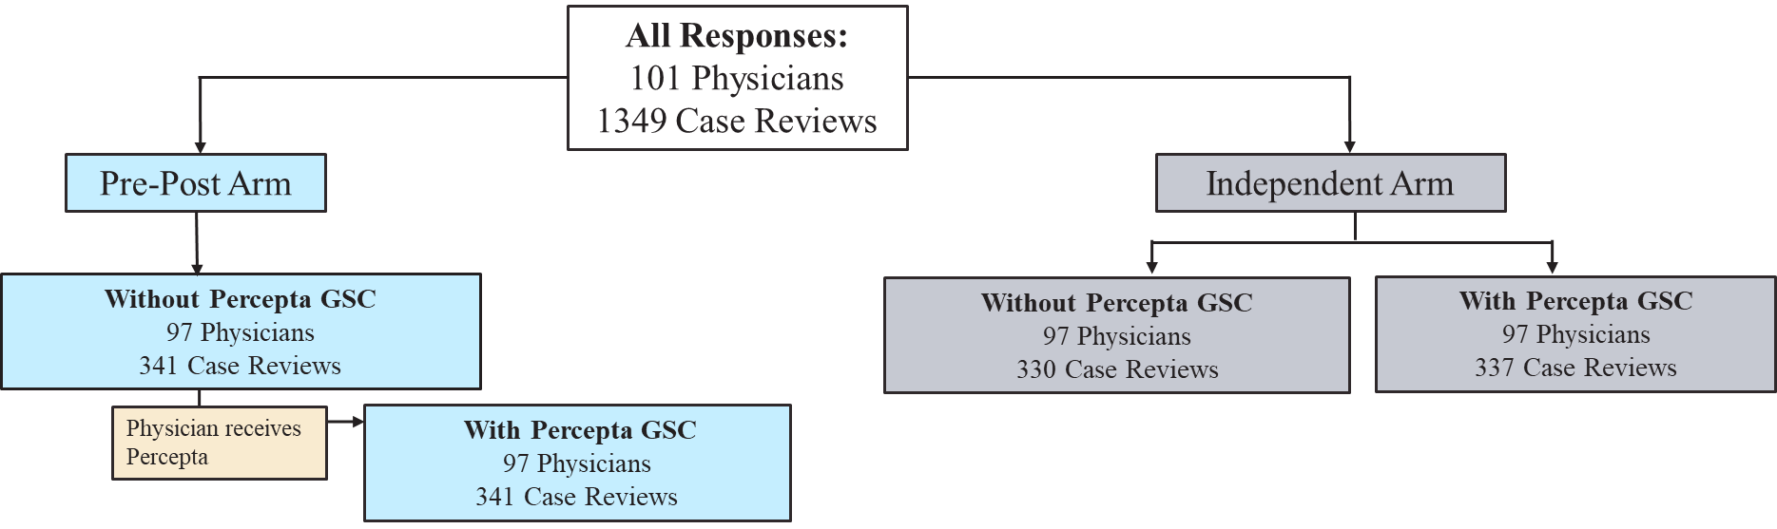

Figure S2. Percepta GSC result report for risk re-stratification high risk to very high risk.
Figure S3. Confidence scale for assessment of physician confidence.

Not at all Confident |  |  | Neutral |  |  | Extremely Confident
1 | 2 | 3 | 4 | 5 | 6 | 7

Figure S4. Potential risk re-stratification algorithm for Percepta GSC.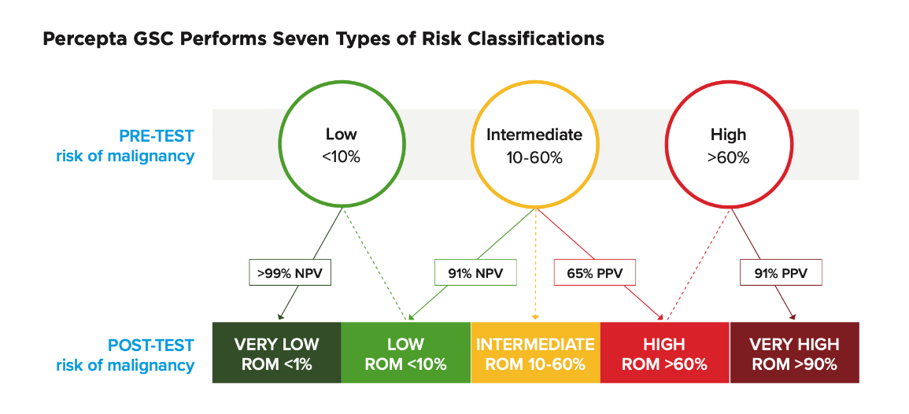
PPV=positive predictive value; NPV=negative predictive value; ROM=risk of malignancy

