Supplementary material

Title: Identification of the molecular subgroups in asthma by gene expression profiles: airway inflammation implications

Authors: Min Li^{1,2†}, Wenye Zhu^{3†}, Ummair Saeed ⁴, Shibo Sun², Yan Fang², Chu Wang² and Zhuang Luo^{2*}

¹Department of Respiratory and Critical Care Medicine, West China Hospital, Sichuan University, Chengdu, China
²Department of Respiratory and Critical Care Medicine, First Affiliated Hospital of Kunming Medical University, Kunming, China
³Department of Pharmacy, First Affiliated Hospital of Kunming Medical University, Kunming, China
⁴Department of Dermatology, National Orthopedic and General Hospital, Bahawalpur, Pakistan

Supplementary Table legends

Supplementary Table S1. The definition of immune terms used for ssGSEA.
Supplementary Table S2. The details of the genes in each of the WGCNA modules.
Supplementary Table S3. Demographic and clinical characteristics of the patients with asthma grouped by cluster analysis in validation dataset (GSE41863)

Supplementary Table S3. Demographic and clinical characteristics of the patients with asthma grouped by cluster analysis in validation cohort (GSE41863)
Variables | Total | Cluster I | Cluster II | χ2/z | p-valueª
Number | 47 | 28 | 19
Age, year, median (Q1,Q3) | 57 (21, 82) | 58 (33, 82) | 57 (21,78) | 0.553 | 0.580
Gender,n(%) |  |  |  | 0.004 | 0.950
Female | 22 | 11 (52.3) | 19 (57.5)
Male | 25 | 10 (47.7) | 14 (42.5)
Airway inflammation n(%)
Eosinophilic | 15 | 14(50.0) | 1(4.2) | 10.204 | 0.001
Neutrophilic | 17 | 8 (28.6) | 9 (47.4) | 1.695 | 0.187
Paucigranulocytic | 10 | 3(10.7) | 7 (36.8) | 4.515 | 0.034
Mixed Granulocytic | 5 | 3 (10.7) | 2 (10.5) | 0.0004 | 0.984
ª Compare between Cluster I and Cluster II.

Supplementary Figures

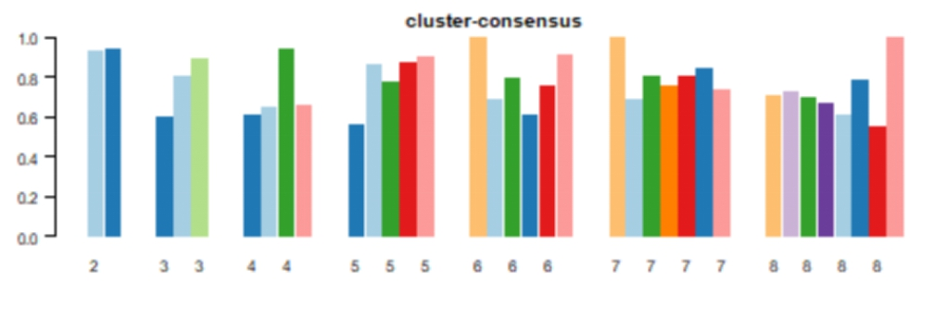
Supplementary Figure S1. Cluster-consensus score bar-plot of the validation dataset. The bar-plot represents the consensus scores for subgroups with cluster count (k) ranging from 2 to 8.

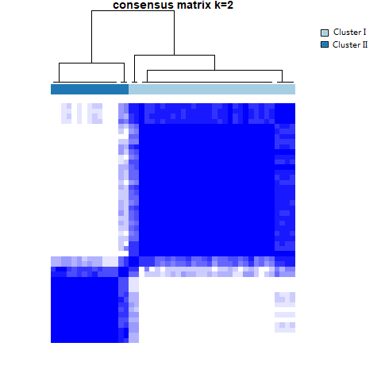
Supplementary Figure S2. Consensus matrix heatmap of the validation dataset (GSE41863). The color-coded heatmap represents the consensus matrix with consensus k=2, which was determined by the minimal consensus scores for subgroups (>0.8). Color gradients represent consensus values from zero to1. White corresponds to 0 and dark blue to 1.

