PREPARE Analysis Results for SAU
Contents
1 SUBJECT POPULATION 2
Table 1.1 Patient Disposition (Saudi patients) 2
Table 1.2 Patient Recruitment by Site (All Enrolled) 3
2 DEMOGRAPHIC AND LIFESTYLE CHARACTERIZATION 4
Table 2.1 Demographic and Lifestyle Characteristics 4
3 DISEASE CHARACTERIZATION 6
Table 3.1 Disease Characteristics 6
Table 3.2 Asthma Treatments in the Last 12 Months 8
Table 3.3 Spirometry Assessment 10
Table 3.4 Blood Test at Visit (in visit window) 13
Table 3.5 Phenotype 14
4 ASTHMA SYMPTOM CONTROL 15
Table 4.1 Asthma Symptom Control 15
5 EOSINOPHILIC ASTHMA PATIENTS SUB-GROUP ANALYSIS 16
Table 5.1 Demographic and Lifestyle Characteristics by Phenotype in SAU 16
Table 5.2 Disease Characteristics by Phenotype in SAU 18
Table 5.3 Pattern of CS Use by Phenotype in SAU 20
Table 5.4 Chi-square Test of Association between Asthma Control Levels and Phenotype in SAU 21
Chi-square Test of Association between Asthma Control Levels and Phenotype in SAU (atopic phenotype as total serum IgE > 100 IU/ml) 22
Chi-square Test of Association between Asthma Control Levels and Phenotype in SAU (atopic phenotype as total serum IgE > 150 IU/ml) 23
Figure 5.6 ANOVA Test of Differences in Number of Severe Exacerbations across Phenotype in SAU (atopic phenotype as total serum IgE > 100 IU/ml) 25
ANOVA Test of Differences in Number of Severe Exacerbations across Phenotype in SAU (atopic phenotype as total serum IgE > 150 IU/ml) 25

1 SUBJECT POPULATION

Table 1.1 Patient Disposition (Saudi patients)

 | SAU
Patients enrolled^{[a]} | 101
Full Analysis Set^{[b]} | 101 (100)

[a] Informed consent received.
[b] Percentages are calculated from number of patients who are enrolled.
No subjects excluded from the analysis.

Table 1.2 Patient Recruitment by Site (All Enrolled)
 | Overall
SAU | 101
Location
SAU-01 | 30 (29.7)
SAU-02 | 25 (24.8)
SAU-04 | 11 (10.9)
SAU-06 | 18 (17.8)
SAU-07 | 17 (16.8)

For category variables, n (%) was used for statistics.

2 DEMOGRAPHIC AND LIFESTYLE CHARACTERIZATION

Table 2.1 Demographic and Lifestyle Characteristics
Demographic and Lifestyle Characteristics | SAU (N = 101)
Age
minimum | 17.1
median (IQR) | 49.0 (38.0, 57.4)
mean (sd) | 48.7 ± 13.2
maximum | 77.8
Age group
<=18 | 1 (1)
18-54 | 68 (67)
>=55 | 32 (32)
Gender
Female | 84 (83)
Male | 17 (17)
Height (cm)
minimum | 120.0
median (IQR) | 156.0 (151.0, 163.0)
mean (sd) | 157.1 ± 8.8
maximum | 175.0
Weight (kg)
minimum | 30.0
median (IQR) | 80.0 (67.1, 88.9)
mean (sd) | 79.1 ± 19.2
maximum | 150.0
BMI (kg/m²)
minimum | 15.9
median (IQR) | 31.7 (26.2, 36.8)
mean (sd) | 32.0 ± 7.2
maximum | 58.6
BMI group
<18.5 | 1 (1)
18.5-24.9 | 17 (17)
≥25-29.9 | 25 (25)
≥30 | 58 (57)
Educational level
Elementary school | 12 (12)
Secondary school | 12 (12)
High-school | 10 (10)
University and post-university education | 27 (27)
Unknown | 40 (40)
Insurance status
Fully Reimbursed | 69 (68)
Partially Reimbursed | 7 (7)
Not reimbursed | 24 (24)
Unknown | 1 (1)
Smoking status history
Active smoker | 0 (0)
Former smoker | 9 (9)
Never smoker | 92 (91)

SD=Standard deviation; IQR=Interquartile range (25th Percentile to 75th Percentile);
for category variables, n (%) was used for statistics.

3 DISEASE CHARACTERIZATION

Table 3.1 Disease Characteristics
Disease Characteristics | SAU (N = 101)
Asthma duration, year
minimum | 1.0
median (IQR) | 15.9 (8.3, 24.7)
mean (sd) | 17.6 ± 12.1
maximum | 57.8
Number of severe asthma exacerbations in the last year
minimum | 0.0
median (IQR) | 2.0 (1.0, 3.0)
mean (sd) | 2.7 ± 4.2
maximum | 30.0
Number of severe asthma exacerbations
0 | 24 (24)
1 | 21 (21)
2 | 24 (24)
3 | 9 (9)
>3 | 23 (23)
Asthma classification
Early-onset asthma | 14 (14)
Late-onset asthma | 87 (86)
History of atopy
NO | 83 (82)
YES | 18 (18)
Missing | 0/101 (0)
Skin prick test history
NO | 39 (98)
YES | 1 (2)
Missing | 61/101 (60)
If yes skin prick test
Negative | 0 (0)
Positive | 1 (100)
Aeroallergens positive
N/A | 1 (100)
No | 0 (0)
Yes | 0 (0)
Missing | 100/101 (99)
Specific IgE available in the medical records
NO | 3 (7)
YES | 38 (93)
Missing | 60/101 (59)
If yes specific IgE
Negative | 20 (53)
Positive | 18 (47)
Comorbidities
NO | 35 (35)
YES | 65 (65)
Missing | 1/101 (1)
Co-morbidity type* | 65
Rhinitis | 42 (64.6)
Nasal polyps | 17 (26.2)
Atopic dermatitis | 2 (3.1)
Asthma associated with NSAIDs | 0 (0.0)
Sinusitis | 14 (21.5)
Aspergillosis | 0 (0.0)
Eczema | 1 (1.5)
Urticaria | 0 (0.0)

SD=Standard deviation; IQR=Interquartile range (25th Percentile to 75th Percentile);
for category variables, n (%) was used for statistics.
* Co-morbidity type: we only list interested co-morbidities, and other types of co-morbidity were not shown in the table. Percentages are calculated based on number of patients who had comorbidities.

Table 3.2 Asthma Treatments in the Last 12 Months
Asthma Treatments in the Last  12 Months | SAU (N = 101)
Chronic OCS
No | 94 (93)
Yes | 7 (7)
Chronic OCS: Active substances*
Deflazacort | 0 (0)
Dexamethasone | 0 (0)
Methyl-prednisolone | 0 (0)
Prednisolone | 0 (0)
Prednisone | 7 (100)
Chronic OCS: TOTAL DAILY DOSE
Minimum | 5.0
median (IQR) | 10.0 (7.5, 10.0)
mean (sd) | 10.7 ± 6.7
Maximum | 25.0
Chronic OCS: TOTAL EXPOSURE OVER 12 MONTH
Minimum | 405.0
median (IQR) | 3,600.0 (2,712.5, 3,600.0)
mean (sd) | 3,679.3 ± 2,703.1
Maximum | 9,125.0
Missing | 0/7 (0)
CS burst treatment/short course
No | 40 (40)
Yes | 60 (60)
Missing | 1/101 (1)
CS burst treatment/short course: Active substances*
Betametasone | 0 (0)
Deflazacort | 0 (0)
Dexamethasone | 0 (0)
Dexamethasone/Meprednisone | 0 (0)
Hydrocortisone | 1 (2)
Meprednisone | 0 (0)
Methyl-prednisolone | 3 (5)
Prednisolone | 0 (0)
Prednisone | 55 (93)
Missing | 1/60 (2)
TOTAL NUMBER OF BURSTS/COURSES Corticosteroids OVER 12 MONTHS*
1 | 13 (22)
2 | 20 (33)
3 | 10 (17)
>3 | 17 (28)
Missing | 0/60 (0)
ICS/LABA (fixed dose combination)
NO | 2 (2)
YES | 99 (98)
ICS/LABA: Active substances*
Beclomethasone/Formoterol | 1 (1)
Budesonida | 0 (0)
Budesonide/Formoterol | 52 (53)
Fluticasone/Salmeterol | 44 (44)
Fluticasone/ Vilanterol | 2 (2)
Fluticasone/Formoterol | 0 (0)
Fluticasone/Umeclidinium/Vilanterol | 0 (0)
Mometasone/Formoterol | 0 (0)
ICS/LABA: TOTAL DAILY ICS DOSE*
Low dose | 2 (2)
Medium dose | 50 (51)
High dose | 47 (47)
Other maintenance therapies
NO | 12(12)
YES | 89(88)
Other drug class*
LTRA | 58(65)
SABA | 31(35)
LAMA | 36(40)
ICS | 2(2)
LABA | 0(0)
SAMA | 1(1)
Antihistamine | 0(0)
Xanthine | 5(6)
SABA/SAMA | 0(0)
Nasal steroid | 3(3)
Anti IgE Antibody | 0(0)
Other drug dosage form*
Inhalation | 59(66)
Tablet | 58(65)
Nasal | 3(3)
Capsulas | 0(0)
Injection | 0(0)

CS=Corticosteroids; ICS=Inhaled Corticosteroid; OCS=Oral Corticosteroid; LTRA: Leukotriene Receptor Antagonists; LABA=Long Acting Beta2 Agonists;
SABA: Short Acting Beta2 Agonists; SAMA: Short Acting Muscarinic Antagonists; LAMA: Long Acting Muscarinic Antagonists;
SD=Standard deviation; IQR=Interquartile range (25th Percentile to 75th Percentile).
For category variables, n (%) was used for statistics.
* Percentages are calculated from number of patients who answered “YES” to the corresponding question about treatment.

Table 3.3 Spirometry Assessment
Spirometry Assessment | SAU (N = 101)
MOST RECENT SPIROMETRY ASSESSMENT available | 75
Pre-bronchodilator FVC
Minimum | 0.9
median (IQR) | 2.5 (2.0, 3.1)
mean (sd) | 2.6 ± 0.8
Maximum | 4.6
Missing | 0/75 (0)
Post-bronchodilator FVC
Minimum | 1.1
median (IQR) | 2.6 (2.0, 3.2)
mean (sd) | 2.7 ± 0.8
Maximum | 4.3
Missing | 23/75 (31)
Pre-BD % of the predicted FVC value
Minimum | 33.0
median (IQR) | 84.5 (72.0, 96.0)
mean (sd) | 83.4 ± 17.6
Maximum | 122.5
Missing | 0/75 (0)
Post-BD % of the predicted FVC value
Minimum | 45.0
median (IQR) | 83.0 (70.0, 94.4)
mean (sd) | 82.9 ± 16.9
Maximum | 118.8
Missing | 34/75 (45)
Pre-bronchodilator FEV1
Minimum | 0.5
median (IQR) | 2.0 (1.5, 2.4)
mean (sd) | 2.0 ± 0.7
Maximum | 4.0
Missing | 0/75 (0)
Post-bronchodilator FEV1
Minimum | 0.6
median (IQR) | 2.0 (1.5, 2.5)
mean (sd) | 2.0 ± 0.7
Maximum | 3.6
Missing | 24/75 (32)
Pre-BD % of the predicted FEV1 value
Minimum | 27.0
median (IQR) | 78.4 (67.6, 91.4)
mean (sd) | 77.9 ± 20.7
Maximum | 118.0
Missing | 1/75 (1)
Post-BD % of the predicted FEV1 value
Minimum | 32.0
median (IQR) | 80.0 (72.0, 94.0)
mean (sd) | 80.8 ± 18.9
Maximum | 118.0
Missing | 34/75 (45)
Pre-bronchodilator FEV1 / FVC
Minimum | 39.7
median (IQR) | 77.0 (70.4, 83.3)
mean (sd) | 76.3 ± 11.2
Maximum | 111.3
Missing | 0/75 (0)
Post-bronchodilator FEV1 / FVC
Minimum | 41.1
median (IQR) | 78.5 (74.1, 84.1)
mean (sd) | 76.7 ± 10.9
Maximum | 91.7
Missing | 24/75 (32)
SD=Standard deviation; IQR=Interquartile range (25th Percentile to 75th Percentile);
for category variables, n (%) was used for statistics.

Table 3.4 Blood Test at Visit (in visit window)
Blood Test | SAU (N = 101)
White blood cell count, cells/mm³
minimum | 3,820.0
median (IQR) | 7,300.0 (6,100.0, 8,910.0)
mean (sd) | 7,837.8 ± 2,573.7
maximum | 17,730.0
Eosinophils%
minimum | 0.0
median (IQR) | 3.3 (1.7, 6.3)
mean (sd) | 4.7 ± 4.0
maximum | 15.0
Absolute Eosinophils, cells/mm³
minimum | 0.0
median (IQR) | 250.0 (110.0, 500.0)
mean (sd) | 361.0 ± 344.2
maximum | 1,500.0
Total serum IgE, IU/ml
minimum | 0.0
median (IQR) | 99.5 (38.0, 289.0)
mean (sd) | 255.4 ± 430.7
maximum | 2,876.0

SD=Standard deviation; IQR=Interquartile range (25th Percentile to 75th Percentile);
for category variables, n (%) was used for statistics.

Table 3.5 Phenotype
Phenotype | SAU (N = 101)
Eosinophilic phenotype
blood eosinophil count ≥300 cells/mm³ | 45 (45)
Atopic phenotype
total serum IgE > 100 IU/ml | 50 (50)
Overlap of atopic and eosinophilic phenotype
total serum IgE > 100 IU/ml & blood eosinophil count ≥ 300 cells/mm³ | 25 (25)
Atopic phenotype
total serum IgE > 150 IU/ml | 41 (41)
Overlap of atopic and eosinophilic phenotype
total serum IgE > 150 IU/ml & blood eosinophil count ≥ 300 cells/mm3 | 23 (23)

For category variables, n (%) was used for statistics.

Eosinophil group
Eosinophil group | SAU (N = 101)
Eosinophilic group
>=300 cells/mm³ | 45 (45)
150-299 cells/ mm³ | 21 (21)
<150 cells/ mm³ | 35 (35)

4 ASTHMA SYMPTOM CONTROL

Table 4.1 Asthma Symptom Control
Asthma Symptom Control | SAU (N = 101)
Level of Asthma Symptom Control
Well-controlled | 9 (9)
Partly controlled | 22 (22)
Uncontrolled | 70 (69)

For category variables, n (%) was used for statistics.

5 EOSINOPHILIC ASTHMA PATIENTS SUB-GROUP ANALYSIS

Table 5.1 Demographic and Lifestyle Characteristics by Phenotype in SAU
Demographic and Lifestyle Characteristics | SAU (N = 101) | Eosinophilic phenotype (N = 45) | Atopic phenotype1 (N = 50) | Overlap of atopic and eosinophilic phenotype1 (N = 25) | Atopic phenotype2 (N = 41) | Overlap of atopic and eosinophilic phenotype2 (N = 23)
Age
minimum | 17.1 | 23.1 | 17.1 | 23.1 | 17.1 | 23.1
median (IQR) | 49.0 (38.0, 57.4) | 49.0 (44.1, 58.9) | 48.0 (37.8, 57.1) | 49.0 (45.2, 56.4) | 46.3 (37.8, 56.9) | 49.0 (45.5, 56.6)
mean (sd) | 48.7 ± 13.2 | 50.3 ± 13.6 | 47.7 ± 12.8 | 48.7 ± 10.5 | 47.3 ± 12.9 | 49.0 ± 10.8
maximum | 77.8 | 77.8 | 74.9 | 66.9 | 74.9 | 66.9
Age group
<=18 | 1 (1) | 0 (0) | 1 (2) | 0 (0) | 1 (2) | 0 (0)
18-54 | 68 (67) | 28 (62) | 33 (66) | 17 (68) | 27 (66) | 15 (65)
>=55 | 32 (32) | 17 (38) | 16 (32) | 8 (32) | 13 (32) | 8 (35)
Gender
Female | 84 (83) | 35 (78) | 39 (78) | 18 (72) | 30 (73) | 16 (70)
Male | 17 (17) | 10 (22) | 11 (22) | 7 (28) | 11 (27) | 7 (30)
Height
minimum | 120.0 | 120.0 | 120.0 | 120.0 | 120.0 | 120.0
median (IQR) | 156.0 (151.0, 163.0) | 156.0 (151.0, 165.0) | 156.5 (151.2, 165.0) | 157.0 (156.0, 168.0) | 157.0 (154.0, 165.0) | 156.0 (155.5, 166.5)
mean (sd) | 157.1 ± 8.8 | 157.0 ± 10.1 | 157.9 ± 10.0 | 158.7 ± 10.7 | 158.4 ± 10.2 | 158.2 ± 10.8
maximum | 175.0 | 175.0 | 175.0 | 172.0 | 175.0 | 172.0
Weight
minimum | 30.0 | 30.0 | 30.0 | 30.0 | 30.0 | 30.0
median (IQR) | 80.0 (67.1, 88.9) | 75.0 (64.0, 94.6) | 78.5 (68.2, 92.0) | 84.0 (69.0, 98.0) | 72.5 (67.1, 87.0) | 76.0 (68.0, 95.6)
mean (sd) | 79.1 ± 19.2 | 77.6 ± 21.4 | 79.8 ± 19.4 | 82.0 ± 23.6 | 78.1 ± 19.4 | 79.5 ± 22.5
maximum | 150.0 | 125.0 | 125.0 | 125.0 | 125.0 | 125.0
BMI
minimum | 15.9 | 15.9 | 20.0 | 20.0 | 20.0 | 20.0
median (IQR) | 31.7 (26.2, 36.8) | 29.4 (25.6, 36.8) | 31.8 (26.1, 37.0) | 29.6 (25.7, 39.1) | 28.7 (25.2, 34.9) | 29.3 (25.4, 35.8)
mean (sd) | 32.0 ± 7.2 | 31.3 ± 7.7 | 31.9 ± 6.9 | 32.2 ± 7.9 | 31.0 ± 7.0 | 31.4 ± 7.8
maximum | 58.6 | 46.1 | 46.1 | 46.1 | 46.1 | 46.1
BMI group
<18.5 | 1 (1) | 1 (2) | 0 (0) | 0 (0) | 0 (0) | 0 (0)
18.5-24.9 | 17 (17) | 9 (20) | 9 (18) | 5 (20) | 9 (22) | 5 (22)
≥25-29.9 | 25 (25) | 15 (33) | 15 (30) | 8 (32) | 14 (34) | 8 (35)
≥30 | 58 (57) | 20 (44) | 26 (52) | 12 (48) | 18 (44) | 10 (43)
Educational level
Elementary school | 12 (12) | 4 (9) | 7 (14) | 3 (12) | 4 (10) | 3 (13)
Secondary school | 12 (12) | 7 (16) | 6 (12) | 4 (16) | 6 (15) | 4 (17)
High-school | 10 (10) | 5 (11) | 6 (12) | 3 (12) | 4 (10) | 1 (4)
University and post-university education | 27 (27) | 15 (33) | 15 (30) | 10 (40) | 14 (34) | 10 (43)
Unknown | 40 (40) | 14 (31) | 16 (32) | 5 (20) | 13 (32) | 5 (22)
Insurance status
Fully Reimbursed | 69 (68) | 27 (60) | 31 (62) | 12 (48) | 24 (59) | 11 (48)
Partially Reimbursed | 7 (7) | 3 (7) | 5 (10) | 3 (12) | 5 (12) | 3 (13)
Not reimbursed | 24 (24) | 15 (33) | 13 (26) | 10 (40) | 11 (27) | 9 (39)
Unknown | 1 (1) | 0 (0) | 1 (2) | 0 (0) | 1 (2) | 0 (0)
Smoking status history
Former smoker | 9 (9) | 6 (13) | 5 (10) | 4 (16) | 4 (10) | 3 (13)
Never smoker | 92 (91) | 39 (87) | 45 (90) | 21 (84) | 37 (90) | 20 (87)

Atopic phenotype1: total serum IgE > 100 IU/ml,
Overlap of atopic and eosinophilic phenotype1: total serum IgE > 100 IU/ml & blood eosinophil count ≥ 300 cells/mm3,
Atopic phenotype2: total serum IgE > 150 IU/ml,
Overlap of atopic and eosinophilic phenotype2: total serum IgE > 150 IU/ml & blood eosinophil count ≥ 300 cells/mm3,
SD=Standard deviation; IQR=Interquartile range (25th Percentile to 75th Percentile);
for category variables, n (%) was used for statistics.

Table 5.2 Disease Characteristics by Phenotype in SAU
Disease Characteristics | SAU (N = 101) | Eosinophilic phenotype (N = 45) | Atopic phenotype1 (N = 50) | Overlap of atopic and eosinophilic phenotype1 (N = 25) | Atopic phenotype2 (N = 41) | Overlap of atopic and eosinophilic phenotype2 (N = 23)
Asthma_duration
minimum | 1.0 | 1.5 | 1.0 | 1.5 | 1.0 | 2.6
median (IQR) | 15.9 (8.3, 24.7) | 17.8 (7.8, 26.9) | 13.4 (6.6, 22.9) | 15.0 (6.5, 23.0) | 14.0 (7.1, 24.9) | 15.0 (6.8, 24.4)
mean (sd) | 17.6 ± 12.1 | 19.4 ± 12.8 | 15.6 ± 11.5 | 16.5 ± 12.7 | 16.6 ± 12.1 | 17.2 ± 12.9
maximum | 57.8 | 54.9 | 54.9 | 54.9 | 54.9 | 54.9
Number of severe asthma exacerbations in the last year
minimum | 0.0 | 0.0 | 0.0 | 0.0 | 0.0 | 0.0
median (IQR) | 2.0 (1.0, 3.0) | 2.0 (1.0, 3.0) | 2.0 (1.0, 4.0) | 2.0 (1.0, 3.0) | 2.0 (1.0, 4.0) | 2.0 (1.0, 2.5)
mean (sd) | 2.7 ± 4.2 | 2.4 ± 3.4 | 3.2 ± 4.0 | 2.9 ± 3.9 | 3.3 ± 4.3 | 3.0 ± 4.0
maximum | 30.0 | 20.0 | 20.0 | 20.0 | 20.0 | 20.0
Number of severe asthma exacerbations in the last year by groups
0 | 24 (24) | 9 (20) | 7 (14) | 3 (12) | 5 (12) | 2 (9)
1 | 21 (21) | 11 (24) | 10 (20) | 5 (20) | 8 (20) | 5 (22)
2 | 24 (24) | 12 (27) | 15 (30) | 10 (40) | 13 (32) | 10 (43)
3 | 9 (9) | 6 (13) | 2 (4) | 1 (4) | 2 (5) | 1 (4)
>3 | 23 (23) | 7 (16) | 16 (32) | 6 (24) | 13 (32) | 5 (22)
Asthma classification
Early-onset asthma: Asthma diagnosed at <12 years of age. | 14 (14) | 9 (20) | 5 (10) | 4 (16) | 5 (12) | 4 (17)
Late-onset asthma: Asthma diagnosed ≥12 years of age. | 87 (86) | 36 (80) | 45 (90) | 21 (84) | 36 (88) | 19 (83)
History of atopy
NO | 83 (82) | 35 (78) | 38 (76) | 16 (64) | 30 (73) | 15 (65)
YES | 18 (18) | 10 (22) | 12 (24) | 9 (36) | 11 (27) | 8 (35)
Skin prick test history
NO | 39 (98) | 16 (100) | 18 (100) | 11 (100) | 14 (100) | 10 (100)
YES | 1 (2) | 0 (0) | 0 (0) | 0 (0) | 0 (0) | 0 (0)
Missing | 61/101 (60) | 29/45 (64) | 32/50 (64) | 14/25 (56) | 27/41 (66) | 13/23 (57)
If yes skin prick test
Positive | 1 (100) | 0 (NaN) | 0 (NaN) | 0 (NaN) | 0 (NaN) | 0 (NaN)
Aeroallergens positive
N/A | 1 (100) | 0 (NaN) | 0 (NaN) | 0 (NaN) | 0 (NaN) | 0 (NaN)
Missing | 100/101 (99) | 45/45 (100) | 50/50 (100) | 25/25 (100) | 41/41 (100) | 23/23 (100)
Specific IgE available in the medical records
NO | 3 (7) | 2 (12) | 1 (5) | 1 (9) | 1 (7) | 1 (10)
YES | 38 (93) | 14 (88) | 18 (95) | 10 (91) | 14 (93) | 9 (90)
Missing | 60/101 (59) | 29/45 (64) | 31/50 (62) | 14/25 (56) | 26/41 (63) | 13/23 (57)
If yes specific IgE
Negative | 20 (53) | 5 (36) | 4 (22) | 2 (20) | 2 (14) | 1 (11)
Positive | 18 (47) | 9 (64) | 14 (78) | 8 (80) | 12 (86) | 8 (89)
Comorbidities
NO | 35 (35) | 21 (48) | 20 (40) | 14 (56) | 18 (44) | 13 (57)
YES | 65 (65) | 23 (52) | 30 (60) | 11 (44) | 23 (56) | 10 (43)
Missing | 1/101 (1) | 1/45 (2) | 0/50 (0) | 0/25 (0) | 0/41 (0) | 0/23 (0)
Co-morbidity type | 65 | 23 | 30 | 11 | 23 | 10
Rhinitis | 42 (64.6) | 16 (69.6) | 23 (76.7) | 9 (81.8) | 19 (82.6) | 9 (90.0)
Nasal polyps | 17 (26.2) | 7 (30.4) | 11 (36.7) | 5 (45.5) | 9 (39.1) | 5 (50.0)
Atopic dermatitis | 2 (3.1) | 0 (0.0) | 1 (3.3) | 0 (0.0) | 1 (4.3) | 0 (0.0)
Asthma associated with NSAIDs | 0 (0.0) | 0 (0.0) | 0 (0.0) | 0 (0.0) | 0 (0.0) | 0 (0.0)
Sinusitis | 14 (21.5) | 4 (17.4) | 8 (26.7) | 3 (27.3) | 6 (26.1) | 3 (30.0)
Aspergillosis | 0 (0.0) | 0 (0.0) | 0 (0.0) | 0 (0.0) | 0 (0.0) | 0 (0.0)
Eczema | 1 (1.5) | 0 (0.0) | 0 (0.0) | 0 (0.0) | 0 (0.0) | 0 (0.0)
Urticaria | 0 (0.0) | 0 (0.0) | 0 (0.0) | 0 (0.0) | 0 (0.0) | 0 (0.0)

Atopic phenotype1: total serum IgE > 100 IU/ml,
Overlap of atopic and eosinophilic phenotype1: total serum IgE > 100 IU/ml & blood eosinophil count ≥ 300 cells/mm3,
Atopic phenotype2: total serum IgE > 150 IU/ml,
Overlap of atopic and eosinophilic phenotype2: total serum IgE > 150 IU/ml & blood eosinophil count ≥ 300 cells/mm3,
SD=Standard deviation; IQR=Interquartile range (25th Percentile to 75th Percentile);
for category variables, n (%) was used for statistics.

Table 5.3 Pattern of CS Use by Phenotype in SAU
Phenotype | SAU (N = 101) | CS burst treatment/  Short Course (N = 60) | Chronic OCS (N = 7)
Eosinophilic phenotype
blood eosinophil count ≥300 cells/mm3 | 45 (45) | 29 (48) | 3 (43)
Atopic phenotype1
total serum IgE > 100 IU/ml | 50 (50) | 32 (53) | 2 (29)
Overlap of atopic and eosinophilic phenotype1
total serum IgE > 100 IU/ml & blood eosinophil count ≥ 300 cells/mm3 | 25 (25) | 16 (27) | 1 (14)
Atopic phenotype2
total serum IgE > 150 IU/ml | 41 (41) | 28 (47) | 2 (29)
Overlap of atopic and eosinophilic phenotype2
total serum IgE > 150 IU/ml & blood eosinophil count ≥ 300 cells/mm3 | 23 (23) | 16 (27) | 1 (14)

#For category variables, n (%) was used for statistics.

CS Use | SAU (N = 101) | Eosinophilic phenotype (N = 45) | Atopic phenotype1 (N = 50) | Overlap of atopic and eosinophilic phenotype1 (N = 25) | Atopic phenotype2 (N = 41) | Overlap of atopic and eosinophilic phenotype2 (N = 23)
CS burst treatment/short course
Yes | 60 (60) | 29 (64) | 32 (65) | 16 (64) | 28 (70) | 16 (70)
Chronic OCS
Yes | 7 (7) | 3 (7) | 2 (4) | 1 (4) | 2 (5) | 1 (4)

Atopic phenotype1: total serum IgE > 100 IU/ml,
Overlap of atopic and eosinophilic phenotype1: total serum IgE > 100 IU/ml & blood eosinophil count ≥ 300 cells/mm3,
Atopic phenotype2: total serum IgE > 150 IU/ml,
Overlap of atopic and eosinophilic phenotype2: total serum IgE > 150 IU/ml & blood eosinophil count ≥ 300 cells/mm3,

Table 5.4 Chi-square Test of Association between Asthma Control Levels and Phenotype in SAU
Phenotype | SAU (N = 101) | Well-controlled (N = 9) | Partly controlled (N = 22) | Uncontrolled (N = 70) | P value*
Eosinophilic phenotype
blood eosinophil count ≥300 cells/mm3 | 45 (45) | 2 (22) | 11 (50) | 32 (46) | 0.347
Atopic phenotype1
total serum IgE > 100 IU/ml | 50 (50) | 5 (56) | 13 (59) | 32 (46) | 0.511
Overlap of atopic and eosinophilic phenotype1
total serum IgE > 100 IU/ml & blood eosinophil count ≥ 300 cells/mm3 | 25 (25) | 2 (22) | 7 (32) | 16 (23) | 0.685
Atopic phenotype2
total serum IgE > 150 IU/ml | 41 (41) | 3 (33) | 10 (45) | 28 (40) | 0.810
Overlap of atopic and eosinophilic phenotype2
total serum IgE > 150 IU/ml & blood eosinophil count ≥ 300 cells/mm3 | 23 (23) | 2 (22) | 6 (27) | 15 (21) | 0.849

#For category variables, n (%) was used for statistics.
*chi-square test of Each phenotype distribution (Yes/No) cross asthma control levels.
Asthma Control Levels | SAU (N = 101) | Eosinophilic phenotype (N = 45) | Atopic phenotype1 (N = 50) | Overlap of atopic and eosinophilic phenotype1 (N = 25) | Atopic phenotype2 (N = 41) | Overlap of atopic and eosinophilic phenotype2 (N = 23)
Level of Asthma Symptom Control
Well-controlled | 9 (9) | 2 (4) | 5 (10) | 2 (8) | 3 (7) | 2 (9)
Partly controlled | 22 (22) | 11 (24) | 13 (26) | 7 (28) | 10 (24) | 6 (26)
Uncontrolled | 70 (69) | 32 (71) | 32 (64) | 16 (64) | 28 (68) | 15 (65)

Atopic phenotype1: total serum IgE > 100 IU/ml,
Overlap of atopic and eosinophilic phenotype1: total serum IgE > 100 IU/ml & blood eosinophil count ≥ 300 cells/mm3,
Atopic phenotype2: total serum IgE > 150 IU/ml,
Overlap of atopic and eosinophilic phenotype2: total serum IgE > 150 IU/ml & blood eosinophil count ≥ 300 cells/mm3,

Chi-square Test of Association between Asthma Control Levels and Phenotype in SAU (atopic phenotype as total serum IgE > 100 IU/ml)
 | SAU | Well-controlled | Partly controlled | Uncontrolled | p
n | 70 | 5 | 17 | 48
Phenotype (%) |  |  |  |  | 0.540
Only atopic phenotype1 | 25 (35.7) | 3 (60.0) | 6 (35.3) | 16 (33.3)
Only eosinophilic phenotype1 | 20 (28.6) | 0 (0.0) | 4 (23.5) | 16 (33.3)
Overlap of atopic and eosinophilic phenotype1 | 25 (35.7) | 2 (40.0) | 7 (41.2) | 16 (33.3)

Chi-square Test of Association between Asthma Control Levels and Phenotype in SAU (atopic phenotype as total serum IgE > 100 IU/ml)
 | SAU | Only atopic phenotype1 | Only eosinophilic phenotype1 | Overlap of atopic and eosinophilic phenotype1 | p
n | 70 | 25 | 20 | 25
Level of Asthma Symptom Control (%) |  |  |  |  | 0.540
Well-controlled | 5 (7.1) | 3 (12.0) | 0 (0.0) | 2 (8.0)
Partly controlled | 17 (24.3) | 6 (24.0) | 4 (20.0) | 7 (28.0)
Uncontrolled | 48 (68.6) | 16 (64.0) | 16 (80.0) | 16 (64.0)

For category variables, n (%) was used for statistics.
n：blood eosinophil count ≥300 cells/mm3 or total serum IgE > 100 IU/ml.
Only atopic phenotype1: total serum IgE >100 IU/ml and blood eosinophil count <300 cells/mm³.
Only eosinophilic phenotype1: blood eosinophil count ≥300 cells/mm³ and total serum IgE <= 100 IU/ml.
Overlap of atopic and eosinophilic phenotype1: blood eosinophil count ≥300 cells/mm³ and total serum IgE > 100 IU/ml.

Chi-square Test of Association between Asthma Control Levels and Phenotype in SAU (atopic phenotype as total serum IgE > 150 IU/ml)
 | SAU | Well-controlled | Partly controlled | Uncontrolled | p
n | 63 | 3 | 15 | 45
Phenotype (%) |  |  |  |  | 0.712
Only atopic phenotype2 | 18 (28.6) | 1 (33.3) | 4 (26.7) | 13 (28.9)
Only eosinophilic phenotype2 | 22 (34.9) | 0 (0.0) | 5 (33.3) | 17 (37.8)
Overlap of atopic and eosinophilic phenotype2 | 23 (36.5) | 2 (66.7) | 6 (40.0) | 15 (33.3)

Chi-square Test of Association between Asthma Control Levels and Phenotype in SAU (atopic phenotype as total serum IgE > 150 IU/ml)
 | SAU | Only atopic phenotype2 | Only eosinophilic phenotype2 | Overlap of atopic and eosinophilic phenotype2 | p
n | 63 | 18 | 22 | 23
Level of Asthma Symptom Control (%) |  |  |  |  | 0.712
Well-controlled | 3 (4.8) | 1 (5.6) | 0 (0.0) | 2 (8.7)
Partly controlled | 15 (23.8) | 4 (22.2) | 5 (22.7) | 6 (26.1)
Uncontrolled | 45 (71.4) | 13 (72.2) | 17 (77.3) | 15 (65.2)

For category variables, n (%) was used for statistics.
n：blood eosinophil count ≥300 cells/mm3 or total serum IgE > 150 IU/ml.
Only atopic phenotype2: total serum IgE >150 IU/ml and blood eosinophil count <300 cells/mm³.
Only eosinophilic phenotype2: blood eosinophil count ≥300 cells/mm³ and total serum IgE <= 150 IU/ml.
Overlap of atopic and eosinophilic phenotype2: blood eosinophil count ≥300 cells/mm³ and total serum IgE > 150 IU/ml.

Chi-square Test of Association between Asthma Control Levels and Phenotype in SAU (atopic phenotype as total serum IgE > 150 IU/ml)
 | SAU | Well-controlled | Partly controlled | Uncontrolled | p
n | 63 | 3 | 15 | 45
Phenotype (%) |  |  |  |  | 0.712
Only atopic phenotype | 18 (28.6) | 1 (33.3) | 4 (26.7) | 13 (28.9)
Only eosinophilic phenotype | 22 (34.9) | 0 (0.0) | 5 (33.3) | 17 (37.8)
Overlap of atopic and eosinophilic phenotype | 23 (36.5) | 2 (66.7) | 6 (40.0) | 15 (33.3)

Figure 5.6 ANOVA Test of Differences in Number of Severe Exacerbations across Phenotype in SAU (atopic phenotype as total serum IgE > 100 IU/ml)
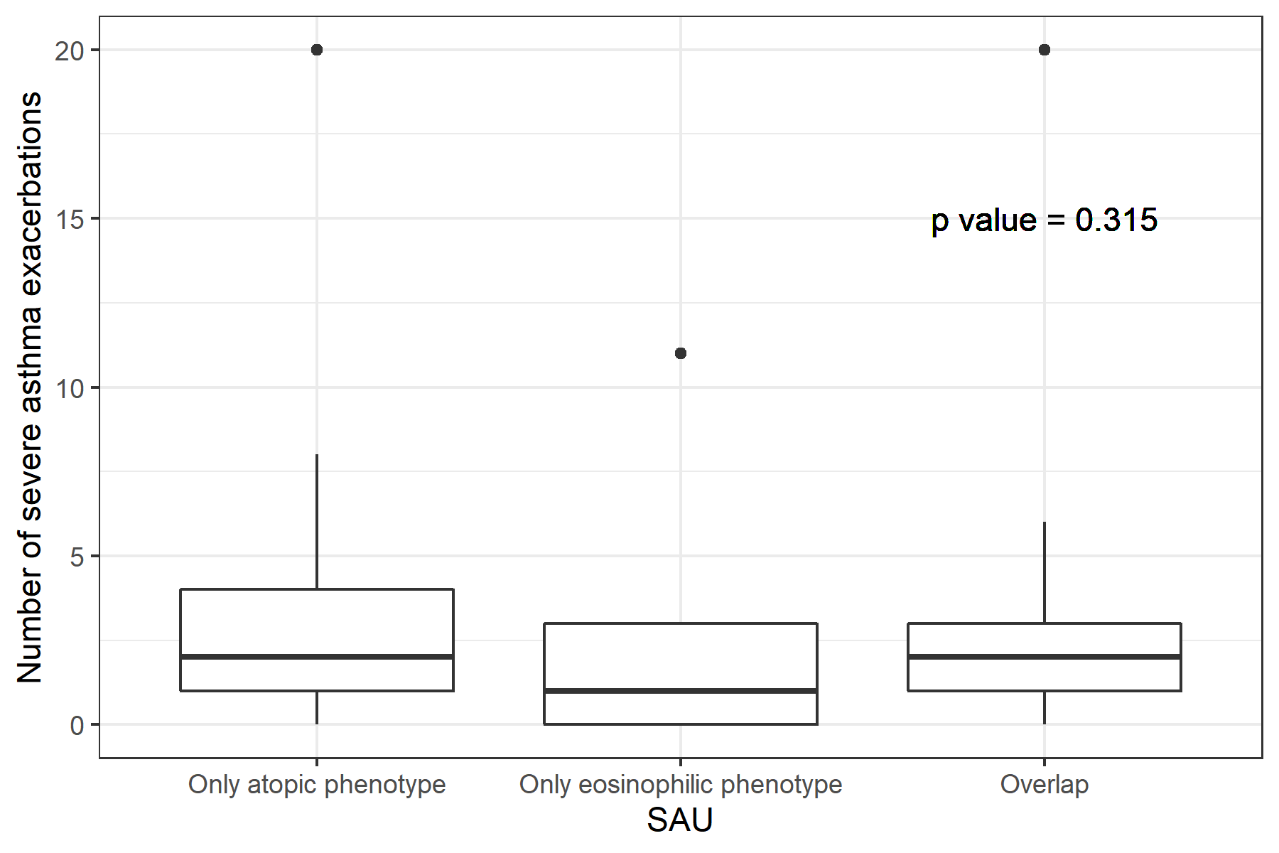
* Only atopic phenotype: total serum IgE >100 IU/ml and blood eosinophil count <300 cells/mm³.
Only eosinophilic phenotype: blood eosinophil count ≥300 cells/mm³ and total serum IgE <= 100 IU/ml.
Overlap: overlap of atopic and eosinophilic phenotype as blood eosinophil count ≥300 cells/mm³ and total serum IgE > 100 IU/ml.

ANOVA Test of Differences in Number of Severe Exacerbations across Phenotype in SAU (atopic phenotype as total serum IgE > 150 IU/ml)
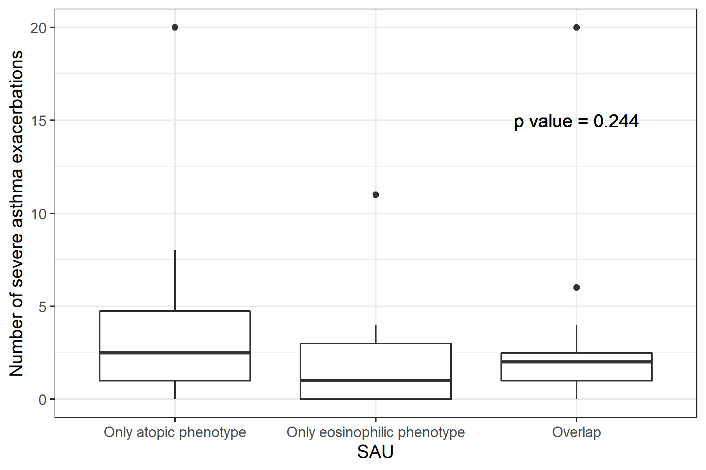
*Only atopic phenotype: total serum IgE >150 IU/ml and blood eosinophil count <300 cells/mm3.
Only eosinophilic phenotype: blood eosinophil count ≥300 cells/mm³ and total serum IgE <= 150 IU/ml.
Overlap: overlap of atopic and eosinophilic phenotype as blood eosinophil count ≥300 cells/mm³ and total serum IgE > 150 IU/ml.

