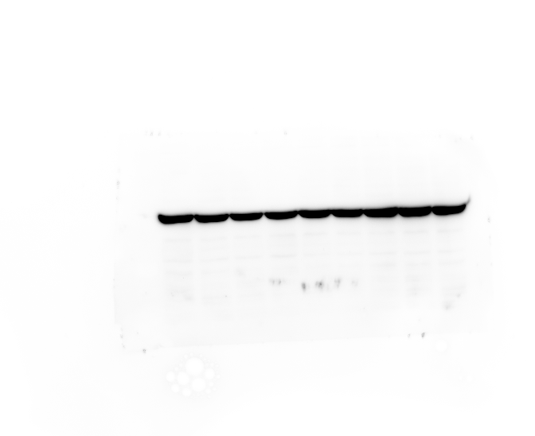
38KD
1-1 2-1 3-1 1-2 2-2 3-2 1-3 2-3 3-3
Figure1. B-Actin

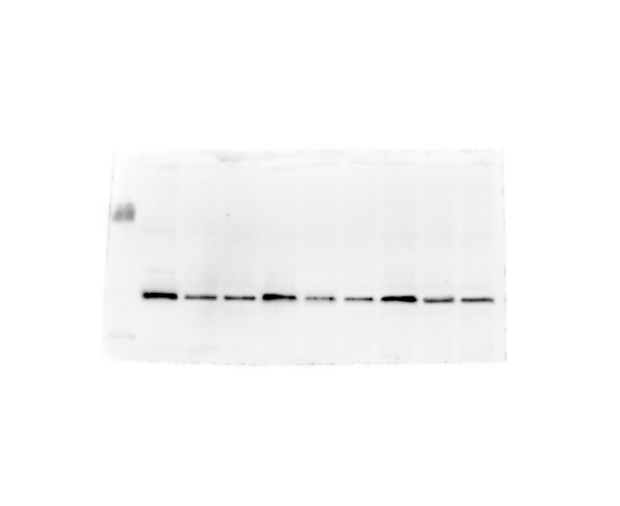
38KD
1-1 2-1 3-1 1-2 2-2 3-2 1-3 2-3 3-3
Figure2. SOSC1

