Supplementary Material

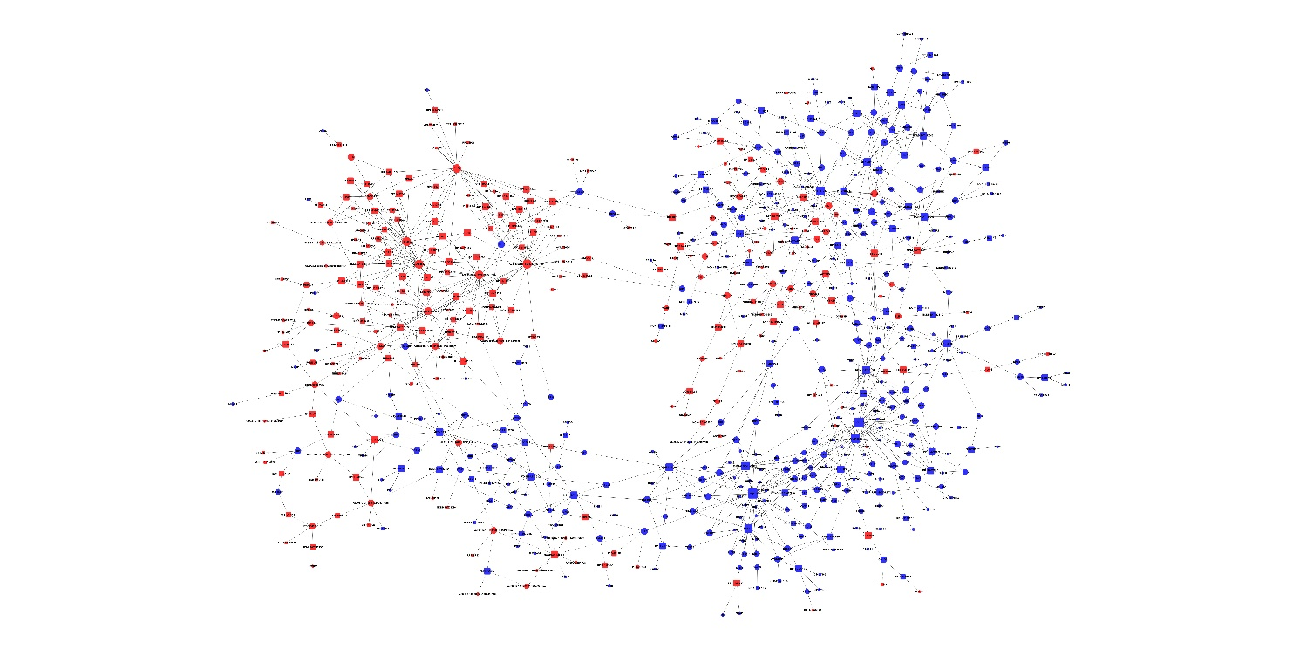
Supplementary Figure 1. LncRNA-mRNA expression network. This network consisted of a coexpression relationship between lncRNAs and mRNAs. Blue represents downregulation and red represents upregulation. Circle nodes represent mRNAs and box nodes represent lncRNAs. The node degree is indicated by the size. An edge represents a coexpression relationship between an mRNA and lncRNA.

Supplementary Table 1. Primers used for real time-polymerase quantitative chain reaction
Gene symbol | Forward primer (5′-3′) | Reverse primer (5′-3′)
CXCL8 | ACTCCAAACCTTTCCACCCC | ATGAATTCTCAGCCCTCTTCAA
FOXO3 | CGGACAAACGGCTCACTCT | GGACCCGCATGAATCGACTAT
G0S2 | CCAAGGAGATGATGGCCCAG | GCTGCACACAGTCTCCATCA
JUN | TCCAAGTGCCGAAAAAGGAAG | CGAGTTCTGAGCTTTCAAGGT
PIK3CA | CCACGACCATCATCAGGTGAA | CCTCACGGAGGCATTCTAAAGT
MTCYBP23 | GCCAACCCCCTCAATACCTC | GGGCCAGTACACCTCCTAGT
NONHSAT115963 | CAATGAGGGGCAGAGAATTATGG | AAAAGAACCTGCTTTTGTTGACTGA
AC019050.1 | ACGGCCAAAACTTCAACACC | GTGGAAGGACCGAGCATACA
HNRNPA1P12 | GGTGCCCACTTAACTGTGAAAAA | TTGCTGTGACGGGGCT
KB-67B5.12 | TTGTTTATGTTTGGCTGGAAGAGTT | AAGTTGAGAAGCTCATCACTGGT

Supplementary Table 2. Ten most up- and down-regulated mRNAs in patients with asthma compared to in normal controls
Gene Symbol | FC | Regulation | P Value | Chromosome
CXCL8 | -54.948 | down | 5.23627E-06 | chr4
G0S2 | -27.665 | down | 2.60256E-08 | chr1
JUN | -17.63 | down | 5.16639E-07 | chr1
FOS | -16.111 | down | 1.24046E-06 | chr14
CD69 | -15.242 | down | 3.73663E-09 | chr12
IL1B | -12.553 | down | 1.14173E-06 | chr2
RGS1 | -10.126 | down | 1.63882E-06 | chr1
DUSP1 | -9.063 | down | 9.77696E-07 | chr5
NAMPT | -8.456 | down | 0.000105139 | chr7
IFIT1 | -7.413 | down | 0.001680308 | chr10
ATP8B2 | 2.621 | up | 7.14415E-05 | chr1
IGLL5 | 2.585 | up | 0.025674158 | chr22
EMD | 2.514 | up | 0.000191305 | chrX
CCR7 | 2.395 | up | 0.015484847 | chr17
CCR4 | 2.378 | up | 0.003516618 | chr3
S1PR1 | 2.362 | up | 0.000949181 | chr1
HBA2 | 2.313 | up | 0.02824217 | chr16
HBA1 | 2.297 | up | 0.028026586 | chr16
RPL27 | 2.282 | up | 0.00480925 | chr17
SYNGAP1 | 2.25 | up | 0.004347276 | chr6
FC: fold-change

Supplementary Table 3. Ten most up- and down-regulated lncRNAs in patients with asthma compared to in normal controls
Gene Symbol | FC | Regulation | P Value | Chromosome
NONHSAT122646 | -13.737 | down | 3.37897E-05 | chr7
RP11-22N19.2 | -6.635 | down | 1.04134E-05 | chr7
MIR222HG | -6.635 | down | 2.6107E-12 | chrX
NONHSAT079756 | -5.205 | down | 2.0095E-05 | chr20
RP6-99M1.3 | -4.993 | down | 3.42689E-07 | chrX
LUCAT1 | -4.595 | down | 0.000628063 | chr5
NONHSAT122608 | -4.408 | down | 0.000230339 | chr7
RP11-300J18.2 | -4.141 | down | 0.000149366 | chr14
NONHSAT122736 | -4.084 | down | 4.14781E-05 | chr7
NONHSAT123408 | -3.784 | down | 5.44169E-06 | chr7
NONHSAT039609 | 4.724 | up | 0.019442522 | chr14
NONHSAT136020 | 3.945 | up | 0.009910918 | chr14
LOC100506159 | 3.681 | up | 0.000663292 | chr12
NONHSAT136018 | 3.34 | up | 0.01141111 | chr22
NONHSAT102434 | 3.16 | up | 0.006133622 | chr5
lnc-EPHA6-1:1 | 2.99 | up | 0.002100903 | chr3
NONHSAT081067 | 2.949 | up | 2.22742E-05 | chr21
NONHSAT136019 | 2.949 | up | 2.22742E-05 | chr22
RP4-539M6.21 | 2.868 | up | 0.000781358 | chr22
NONHSAT136004 | 2.848 | up | 0.008838896 | chr22
FC: fold-change

