Supplementary Files to Research Article
The effect of TGF-β₁ polymorphisms on pulmonary disease progression in patients with cystic fibrosis

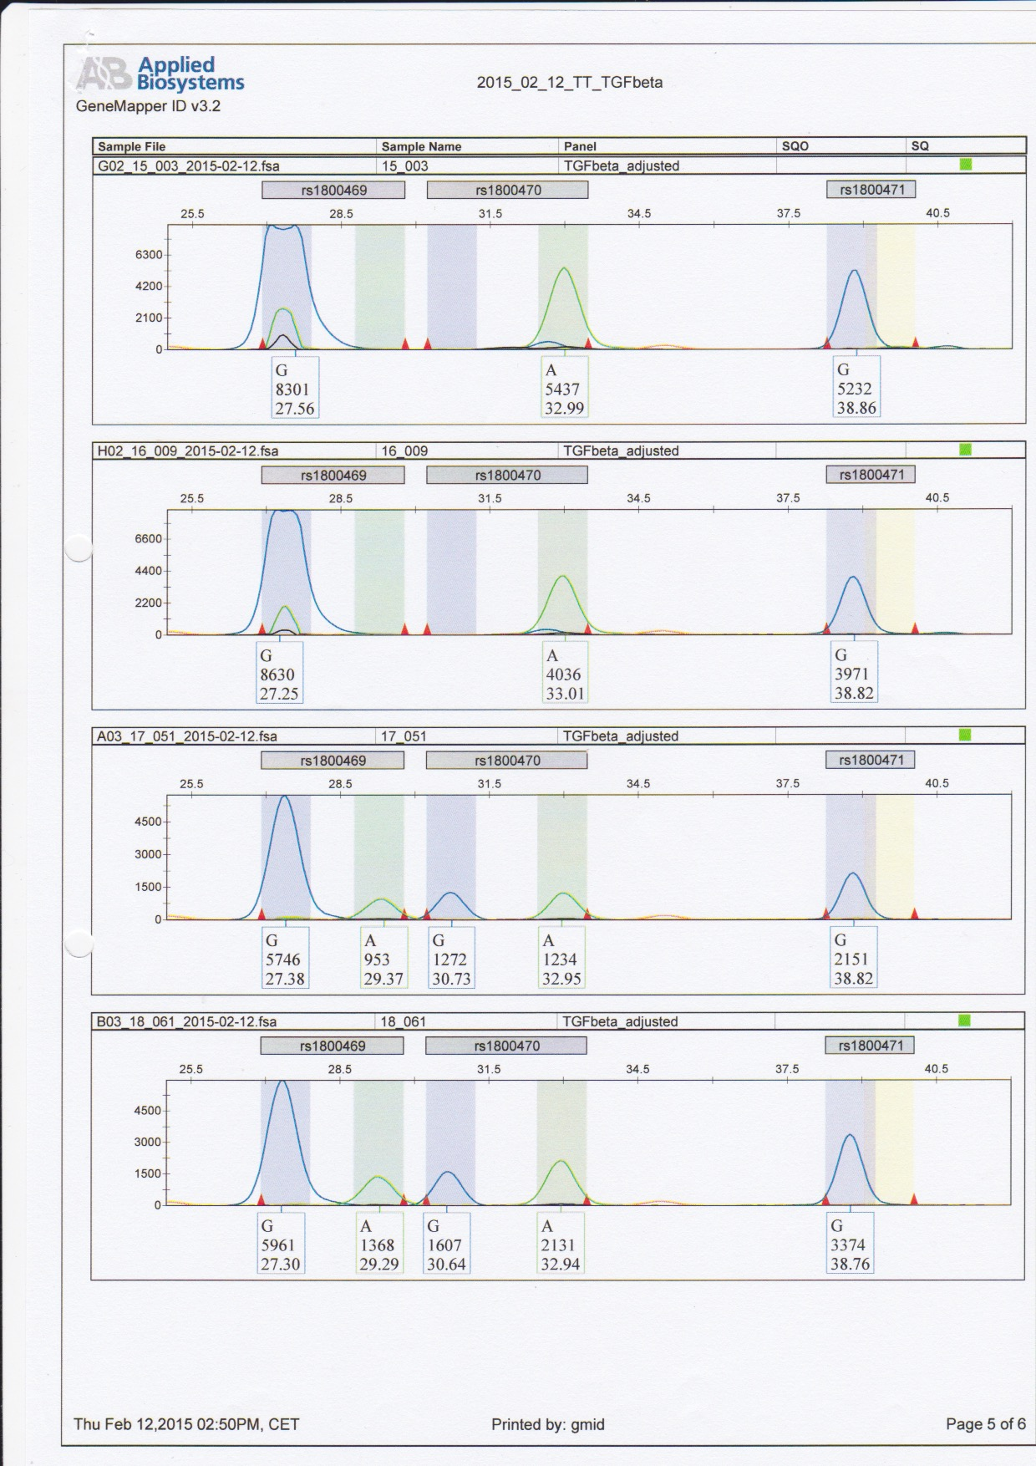
Figure A
Exemplary capillary electrophoresis result of CF-patient showing binding of fluorescent bases to sense DNA strand for promotor and Codon 10 genotyping and binding to antisense DNA strand for Codon 25 genotyping. (Promotor genotype = CT, Codon 10 genotype = CT, Codon 25 genotype = GG).

Figure B
FEV₁ slope Categorization | FEV₁ Slope Sub-Groups in category  [% FEV₁ change/year]
1 | <0
1 | ≥0
2 | < -1
2 | -1 till +1
2 | ≥ +1
3 | < -2
3 | -2 till +2
3 | ≥ +2
Summary of all slope subgroups and categorizations used for more detailed statistical analysis of slope associations with SNPs and TGF-beta1 levels.

Figure C
Lung function rating | Absolute FEV₁ at the end of 5-year period  [% FEV₁ predicted]
Normal | ≥80%
Intermediate | 40-80%
Low | 40%
Summary of FEV1 subgroups, according to best FEV₁ in final year of 5-year observation period.

Figure D
TGF-β₁ SNP locus | SNP Genotype |  | Mean FEV₁ Slope  [% change/year]
TGF-β₁ SNP locus |  | n | Mean FEV₁ Slope  [% change/year]
Promotor | CC | 20 | -2,21
Promotor | CT | 31 | -1,51
Promotor | TT | 5 | -2,05
Codon 10 | CC | 6 | -1,70
Codon 10 | CT | 29 | -1,60
Codon 10 | TT | 18 | -2,20
Codon 25 | GC | 6 | -1,06
Codon 25 | GG | 50 | -1,90
Mean average FEV₁ slope for different SNP genotype groups at all three investigated TGF-beta1 SNP loci.
Figure E

TGF-β₁ SNP locus | Genotype | Inflammatory Markers
TGF-β₁ SNP locus | Genotype | TGF-β₁ in plasma  [pg/ml] | TGF-β₁ in sputum  [pg/ml] | TNF-α in sputum  [pg/ml] | Elastase in sputum  [pg/ml] | Elafin in sputum  [pg/ml] | IL-1β in sputum  [pg/ml] | IL-8 in sputum  [pg/ml] | IL-6 in sputum  [pg/ml]
Promotor | CC | 22.2 x 10³ | 89,73 | 16,83 | 216,45 | 14.477 | 1.412 | 2.988 | 38,4
Promotor | CT | 16.5 x 10³ | 126,48 | 23,93 | 248,42 | 11.317 | 2.004 | 4.320 | 55,5
Promotor | TT | 21.3 x 10³ | 69,50 | 87,57 | 362,40 | 20.175 | 2.245 | 3.649 | 51,38
Codon 10 | CC | 16.9 x 10³ | 95,50 | 61,50 | 340,47 | 19.182 | 2.232 | 4.078 | 47,01
Codon 10 | CT | 18.9 x 10³ | 126,50 | 23,00 | 245,39 | 11.464 | 2.153 | 4.275 | 57,14
Codon 10 | TT | 19.7 x 10³ | 77,0 | 16,52 | 209,88 | 13.941 | 924 | 2.649 | 30,95
Codon 25 | GC | 21.0 x 10³ | 149,17 | 22,23 | 238,65 | 14.445 | 2.760 | 4.349 | 49,13
Codon 25 | GG | 18.7 x 10³ | 103,60 | 30,13 | 251,22 | 13.148 | 1.699 | 3.728 | 49,31

Figure E: Summary of all genotypes and mean average concentrations of investigated inflammatory markers. As inflammatory marker determination was not possible for all patients, the number of patients (n), for which a value was measurable, is reported as follows: TGF-β_{1 Plasma} (n=54), TGF-β_{1 Sputum} (n = 46), Elastase (n=48), Elafin (n=51), IL-1β (n=48), IL-8 (n=48), IL-6 (n = 39).

