Supplementary materials：

Table S1: Vital signs and parameters at the point of HFNC failure in 10 patients from the HFNC failure group
Figure S1：Relationship between FiO2 and the mROX index at PaO2 of 60 mmHg for respiratory rates (RRs) ranging between 20 and 40 bpm.

Table S1 Vital signs and parameters at the point of HFNC failure in 10 patients from the HFNC failure group
Vital signs and parameters | HFNC failure  (n = 10)*
FiO₂ [M(P₂₅，P₇₅),%] | 0.73(0.62–0.83)
Flow on HFNC [M(P₂₅，P₇₅), L/min] | 52.5(50.0–60.0)
HR [M(P₂₅，P₇₅), bpm] | 108.5(76.0–124.0)
RR [M(P₂₅，P₇₅), cpm] | 23.0(17.5–29.8)
SpO₂[mean ± SD, %] | 91.1±8.2
PH [M(P₂₅，P₇₅)] | 7.40(7.36–7.46)
PaO₂ [M(P₂₅，P₇₅), mmHg] | 57.0(48.8–68.0)
PaCO₂ [mean ± SD, mmHg] | 45.8±11.5
Hemodynamic Status [n]  cardiac arrest  arrhythmias  norepinephrine (over 0.1 μg/kg/min) | 0  3  2
Glasgow Coma Scale (GCS) | 3
Automatic Depuration Ability [n] | 3
Annotation: HR, heart rate; RR, respiratory rate; FiO₂, fraction of inspiration O₂; SpO₂, saturation of pulse oxygen; PaO₂, arterial oxygen partial pressure; PaCO₂, arterial carbon dioxide partial pressure; PF ratio, PaO₂/FiO₂; cpm, counts per minute; bpm, beats per minute; P₂₅, 25th percentile; P₇₅, 75th percentile; HFNC, high-flow nasal cannula.*Several patients met multiple criteria which lead to total count was greater than 10.

Figure S1：Relationship between FiO2 and the mROX index at PaO2 of 60 mmHg for respiratory rates (RRs) ranging between 20 and 40 bpm.

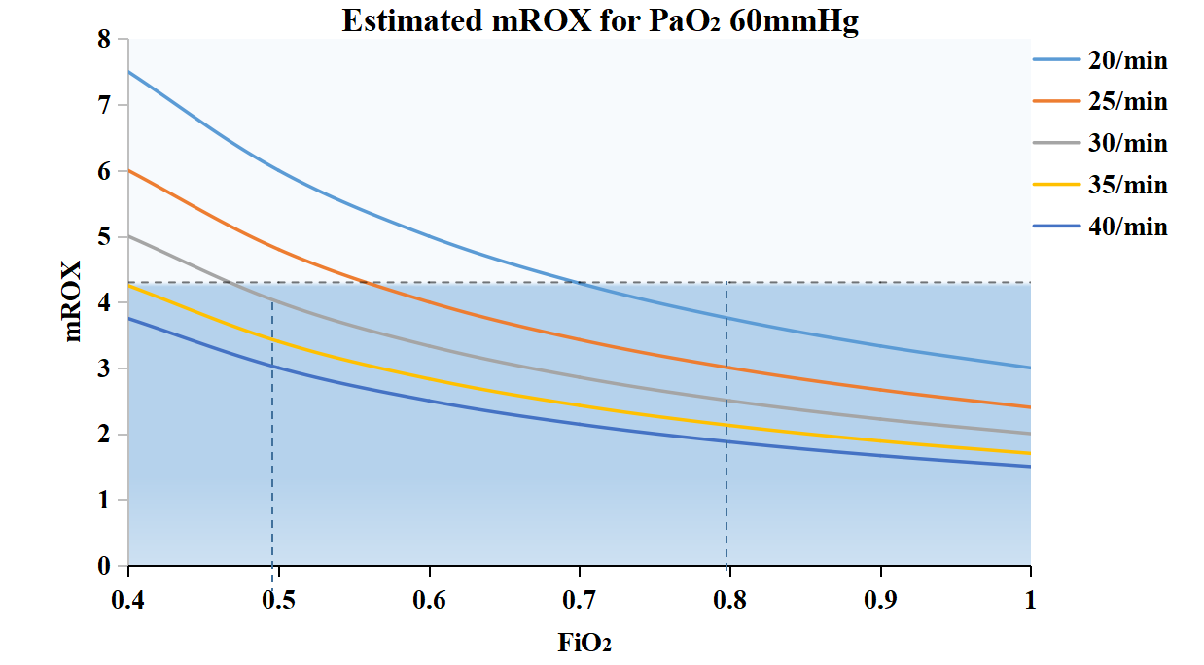
Figure S1. Relationship between FiO₂ and the mROX index at PaO₂ of 60 mmHg for respiratory rates (RRs) ranging between 20 and 40 bpm. The colored lines represent RR. The blue area indicates the mROX value; dashed vertical lines indicate FiO₂ values of 0.5 and 0.8. mROX, ratio of PaO₂/FiO₂(%) to RR(breaths/min).

