Additional file 1

Table S1. Vital signs and Laboratory findings within the first 24 hours of ICU admission among survivors and non-survivors in training cohort
 | Survivor  (n=506) | Non-survivor  (n=246) | P
heartrate_min (times/min, median [IQR]) | 78.00 [66.00, 90.00] | 75.00 [65.00, 90.00] | 0.366
heartrate_max (times/min, median [IQR]) | 117.00 [101.75, 131.25] | 116.00 [103.00, 134.00] | 0.816
heartrate_mean (times/min, median [IQR]) | 94.22 [82.03, 107.20] | 94.28 [81.22, 106.82] | 0.871
sysbp_min (mmHg, median [IQR]) | 84.00 [74.00, 94.00] | 79.00 [72.00, 93.00] | 0.032
sysbp_max (mmHg, median [IQR]) | 149.00 [135.00, 168.00] | 151.00 [134.00, 169.00] | 0.771
sysbp_mean (mmHg, median [IQR]) | 111.78 [103.45, 123.65] | 111.22 [102.39, 122.03] | 0.289
diasbp_min (mmHg, median [IQR]) | 44.00 [37.00, 51.00] | 41.00 [33.00, 48.00] | 0.001
diasbp_max (mmHg, median [IQR]) | 86.00 [77.00, 97.00] | 86.00 [74.00, 102.00] | 0.568
diasbp_mean (mmHg, median [IQR]) | 61.37 [55.97, 67.79] | 59.41 [53.00, 66.16] | 0.013
meanbp_min (mmHg, median [IQR]) | 57.00 [49.00, 64.00] | 54.00 [47.00, 62.83] | 0.015
meanbp_max (mmHg, median [IQR]) | 105.00 [94.00, 122.00] | 106.00 [92.00, 121.00] | 0.658
meanbp_mean (mmHg, median [IQR]) | 76.38 [71.35, 84.27] | 74.88 [68.74, 83.60] | 0.023
resprate_min (times/min, median [IQR]) | 14.00 [11.00, 17.00] | 14.00 [11.00, 18.00] | 0.193
resprate_max (times/min, median [IQR]) | 31.00 [26.00, 37.00] | 33.00 [28.00, 38.00] | 0.055
resprate_mean (times/min, median [IQR]) | 21.43 [18.02, 25.50] | 23.05 [19.19, 26.58] | 0.004
tempc_min (℃,median [IQR]) | 36.50 [35.94, 36.83] | 36.11 [35.50, 36.60] | <0.001
tempc_max (℃,median [IQR]) | 37.90 [37.28, 38.60] | 37.61 [37.00, 38.35] | <0.001
tempc_mean (℃,median [IQR]) | 37.14 [36.76, 37.63] | 36.86 [36.46, 37.38] | <0.001
spo2_min (%,median [IQR]) | 90.00 [85.00, 93.00] | 89.00 [84.00, 92.00] | 0.210
spo2_max (%,median [IQR]) | 100.00 [100.00, 100.00] | 100.00 [100.00, 100.00] | 0.902
spo2_mean (%,median [IQR]) | 96.55 [94.97, 98.00] | 96.23 [94.80, 97.90] | 0.346
bicarbonate_min (mmol/L, median [IQR]) | 21.00 [18.00, 25.00] | 20.00 [16.00, 23.00] | <0.001
bicarbonate_max (mmol/L, median [IQR]) | 24.00 [22.00, 28.00] | 23.00 [21.00, 27.00] | 0.008
bilirubin_min (mg/dL, median [IQR]) | 0.65 [0.40, 1.00] | 0.70 [0.40, 2.00] | 0.005
bilirubin_max (mg/dL, median [IQR]) | 0.70 [0.50, 1.30] | 0.90 [0.50, 2.75] | 0.001
creatinine_min (mg/dL, median [IQR]) | 0.91 [0.67, 1.40] | 1.20 [0.80, 1.94] | <0.001
creatinine_max (mg/dL, median [IQR]) | 1.20 [0.80, 2.00] | 1.50 [0.98, 2.36] | <0.001
chloride_min (mmol/L, median [IQR]) | 103.00 [99.00, 107.00] | 102.00 [98.00, 107.00] | 0.395
chloride_max (mmol/L, median [IQR]) | 107.00 [103.00, 112.00] | 107.00 [102.00, 111.00] | 0.671
glucose_min (mg/dL, median [IQR]) | 106.00 [89.00, 132.00] | 107.00 [83.25, 135.00] | 0.837
glucose_max (mg/dL, median [IQR]) | 177.00 [137.00, 236.75] | 187.50 [147.25, 248.00] | 0.028
hematocrit_min (%,median [IQR]) | 30.85 [26.30, 36.08] | 29.80 [25.00, 34.60] | 0.017
hematocrit_max (%,median [IQR]) | 35.90 [31.35, 41.00] | 34.20 [30.40, 39.50] | 0.019
hemoglobin_min (g/dL,mean(SD)) | 10.47±2.23 | 9.85±2.41 | 0.001
hemoglobin_max (g/dL, median [IQR]) | 12.00 [10.40, 13.57] | 11.20 [10.00, 13.00] | 0.006
lactate_min (mmol/L,median [IQR]) | 1.40 [1.00, 2.10] | 1.80 [1.20, 2.80] | <0.001
lactate_max (mmol/L,median [IQR]) | 2.40 [1.40, 4.30] | 3.15 [1.80, 6.70] | <0.001
platelet_min (10^9/L,median [IQR]) | 183.00 [116.75, 247.25] | 148.00 [77.00, 228.00] | 0.001
platelet_max (10^9/L,median [IQR]) | 220.50 [158.00, 294.25] | 192.00 [120.00, 281.00] | 0.002
potassium_min (mmol/L,median [IQR]) | 3.70 [3.30, 4.00] | 3.70 [3.30, 4.20] | 0.406
potassium_max (mmol/L,median [IQR]) | 4.40 [3.90, 4.90] | 4.50 [4.00, 5.30] | 0.018
inr_min (median [IQR]) | 1.20 [1.10, 1.40] | 1.30 [1.11, 1.70] | <0.001
inr_max (median [IQR]) | 1.30 [1.20, 1.70] | 1.60 [1.20, 2.30] | <0.001
pt_min (sec, median [IQR]) | 13.90 [12.80, 15.40] | 14.60 [13.30, 17.65] | <0.001
pt_max (sec, median [IQR]) | 14.90 [13.50, 17.10] | 16.70 [13.90, 22.95] | <0.001
sodium_min (mmol/L, median [IQR]) | 137.00 [134.00, 140.00] | 137.00 [134.00, 140.00] | 0.468
sodium_max (mmol/L, median [IQR]) | 141.00 [138.00, 144.00] | 140.00 [137.00, 144.00] | 0.912
bun_min (mg/dL, median [IQR]) | 18.00 [12.00, 30.00] | 27.00 [17.00, 42.00] | <0.001
bun_max (mg/dL, median [IQR]) | 23.00 [16.00, 36.25] | 33.00 [21.00, 48.00] | <0.001
wbc_min (10^9/L, median [IQR]) | 10.40 [6.65, 14.72] | 11.70 [6.70, 15.40] | 0.142
wbc_max (10^9/L, median [IQR]) | 13.85 [9.70, 19.22] | 15.37 [10.20, 19.80] | 0.149
ca_t_min (mmol/L, median [IQR]) | 7.80 [7.20, 8.40] | 7.70 [7.10, 8.20] | 0.318
ca_t_max (mmol/L, median [IQR]) | 8.40 [7.80, 8.90] | 8.30 [7.80, 8.90] | 0.815
rbc_min (10^12/L, median [IQR]) | 3.45 [2.97, 4.03] | 3.32 [2.77, 3.87] | 0.002
rbc_max (10^12/L, median [IQR]) | 3.97 [3.46, 4.54] | 3.76 [3.25, 4.33] | 0.001
mch_min (pg, median [IQR]) | 29.90 [28.45, 31.10] | 30.20 [28.50, 31.60] | 0.149
mch_max (pg, median [IQR]) | 30.50 [29.00, 31.80] | 30.90 [29.00, 32.20] | 0.096
mchc_min (%, median [IQR]) | 33.00 [31.90, 33.90] | 32.70 [31.60, 33.70] | 0.023
mchc_max (%, median [IQR]) | 33.80 [32.70, 34.90] | 33.50 [32.20, 34.70] | 0.101
mcv_min (fL, median [IQR]) | 89.00 [85.00, 93.00] | 90.00 [86.00, 95.00] | 0.02
mcv_max (fL, median [IQR]) | 91.00 [87.00, 95.00] | 93.00 [88.00, 98.00] | 0.002
rdw_min (%, median [IQR]) | 14.30 [13.40, 15.70] | 15.20 [14.00, 17.10] | <0.001
rdw_max (%, median [IQR]) | 14.70 [13.75, 16.00] | 15.50 [14.30, 17.98] | <0.001
po2_min (mmHg, median [IQR]) | 66.00 [55.00, 80.00] | 65.00 [54.00, 76.95] | 0.255
po2_max (mmHg, median [IQR]) | 163.00 [106.00, 242.00] | 166.00 [106.50, 253.50] | 0.805
pco2_min (mmHg, median [IQR]) | 36.00 [31.00, 42.00] | 34.00 [28.00, 40.00] | <0.001
pco2_max (mmHg, median [IQR]) | 49.10 [41.80, 59.00] | 48.00 [40.00, 60.00] | 0.218
aado2_min (mmHg, median [IQR]) | 238.48 [146.31, 420.46] | 309.55 [172.10, 464.00] | 0.004
aado2_max (mmHg, median [IQR]) | 427.00 [243.70, 570.25] | 495.00 [312.49, 593.64] | 0.001
ph_min (median [IQR]) | 7.28 [7.20, 7.35] | 7.25 [7.16, 7.36] | 0.061
ph_max (median [IQR]) | 7.41 [7.37, 7.46] | 7.41 [7.34, 7.47] | 0.594
baseexcess_min (mmol/L, median [IQR]) | -4.00 [-9.00, 0.10] | -5.25 [-11.00, 0.00] | 0.011
baseexcess_max (mmol/L, median [IQR]) | 0.00 [-2.00, 3.50] | 0.00 [-3.00, 2.60] | 0.031
albumin_min, g/dL (median [IQR]) | 2.70 [2.30, 3.10] | 2.50 [1.90, 2.90] | <0.001
albumin_max, g/dL (median [IQR]) | 2.90 [2.40, 3.30] | 2.70 [2.30, 3.20] | 0.02
bilirubin_min, g/dL (median [IQR]) | 0.65 [0.40, 1.00] | 0.70 [0.40, 2.00] | 0.005
bilirubin_max, g/dL (median [IQR]) | 0.70 [0.50, 1.30] | 0.90 [0.50, 2.75] | 0.001
ALT_min, IU/L (median [IQR]) | 30.0 [19.0, 57.0] | 34.0 [19.0, 78.5] | 0.155
ALT_max, IU/L (median [IQR]) | 35.0 [22.0, 71.0] | 44.0 [21.5, 121] | 0.043
AST_min, IU/L (median [IQR]) | 43.0 [24.0, 76.8] | 61.0 [29.5, 124] | 0.001
AST_max, IU/L (median [IQR]) | 51.0 [27.0, 116] | 74.0 [36.0, 229] | <0.001
ALP_min, IU/L (median [IQR]) | 78.0 [57.0, 107] | 88.0 [65.0, 128] | 0.004
ALP_max, IU/L (median [IQR]) | 83.0 [62.0, 115] | 99.0 [74.0, 141] | <0.001
urine output (mL, median [IQR]) | 1716.50 [922.25, 2691.50] | 1198.00 [653.00, 2050.00] | <0.001

sysbp systolic blood pressure, diasbp diastolic blood pressure, meanbp mean blood pressure, resprate respiratary rate, tempc temperature, bun blood urea nitrogen, wbc white blood cell, INR international normalized ratio, Spo2 oxyhemoglobin saturation, pt prothrombin time, rbc red blood cell, mch mean hemoglobin content of red blood cells, mchc mean corpuscular hemoglobin concentration, mcv mean corpuscular volume, rdw red blood cell distribution width, aado2 alveolar-arterial oxygen gradient, po2 oxygen partial pressure, pco2 partial pressure of carbon dioxide, ca_t total calcium, ALT Alanine Aminotransferase, AST Asparate Aminotransferase, ALP Alkaline Phosphatase, max maximum, min minimum
Note: Variable name with the prefix of vent means the data was collected at the beginning of invasive ventilation.

Table S2. Vital signs, laboratory findings and ventilator settings within the first 24 hours of ventilation among survivors and non-survivors in training cohort
 | Survivor  (n=506) | Non-survivor  (n=246) | P
vent_heartrate_min (times/min, median [IQR]) | 76.00 [64.00, 89.00] | 73.00 [63.25, 87.00] | 0.264
vent_heartrate_max (times/min, median [IQR]) | 116.00 [101.00, 131.00] | 117.50 [101.25, 134.00] | 0.462
vent_heartrate_mean (times/min, median [IQR]) | 92.92 [80.40, 105.85] | 92.35 [80.21, 105.80] | 0.901
vent_sysbp_min (mmHg, median [IQR]) | 82.00 [73.00, 92.00] | 78.00 [69.00, 89.00] | 0.003
vent_sysbp_max (mmHg, median [IQR]) | 148.50 [134.00, 167.00] | 150.00 [133.00, 169.00] | 0.585
vent_sysbp_mean (mmHg, median [IQR]) | 110.15 [102.60, 119.39] | 109.10 [101.66, 119.58] | 0.389
vent_diasbp_min (mmHg, median [IQR]) | 44.00 [37.00, 50.00] | 41.00 [34.00, 47.00] | <0.001
vent_diasbp_max (mmHg, median [IQR]) | 85.00 [75.25, 96.00] | 83.00 [72.00, 98.00] | 0.414
vent_diasbp_mean (mmHg, median [IQR]) | 60.75 [55.76, 66.66] | 58.10 [52.39, 64.34] | 0.001
vent_meanbp_min (mmHg, median [IQR]) | 56.50 [49.00, 63.00] | 54.00 [46.00, 60.00] | 0.001
vent_meanbp_max (mmHg, median [IQR]) | 104.83 [93.00, 120.92] | 104.00 [92.00, 121.00] | 0.593
vent_meanbp_mean (mmHg, median [IQR]) | 75.74 [71.07, 82.55] | 73.89 [68.89, 81.86] | 0.023
vent_resprate_min (times/min, median [IQR]) | 13.00 [10.00, 16.00] | 14.00 [10.00, 17.00] | 0.559
vent_resprate_max (times/min, median [IQR]) | 30.00 [25.00, 35.00] | 31.00 [26.00, 36.00] | 0.041
vent_resprate_mean (times/min, median [IQR]) | 20.70 [17.41, 24.84] | 21.85 [18.56, 25.81] | 0.009
vent_tempc_min (℃, median [IQR]) | 36.50 [35.94, 36.90] | 36.20 [35.54, 36.62] | <0.001
vent_tempc_max (℃, median [IQR]) | 38.00 [37.40, 38.60] | 37.70 [37.17, 38.39] | 0.001
vent_tempc_mean (℃, median [IQR]) | 37.21 [36.82, 37.64] | 36.99 [36.52, 37.42] | <0.001
vent_spo2_min (%, median [IQR]) | 91.00 [86.00, 93.00] | 90.00 [84.75, 93.00] | 0.32
vent_spo2_max (%, median [IQR]) | 100.00 [100.00, 100.00] | 100.00 [100.00, 100.00] | 0.743
vent_spo2_mean (%, median [IQR]) | 96.96 [95.57, 98.20] | 96.62 [95.05, 98.21] | 0.324
vent_po2_min (mmHg, median [IQR]) | 67.00 [56.00, 82.00] | 65.00 [54.00, 79.62] | 0.280
vent_po2_max (mmHg, median [IQR]) | 174.00 [116.00, 247.00] | 162.50 [110.85, 255.25] | 0.666
vent_pco2_min (mmHg, median [IQR]) | 36.00 [31.95, 42.00] | 34.00 [29.00, 39.27] | <0.001
vent_pco2_max (mmHg, median [IQR]) | 50.00 [42.00, 60.00] | 49.35 [41.15, 61.50] | 0.598
vent_aado2_min_firstvent (mmHg, median [IQR]) | 249.94 [160.20, 420.24] | 314.40 [186.11, 464.00] | 0.001
vent_aado2_max_firstvent (mmHg, median [IQR]) | 435.96 [269.90, 574.57] | 497.51 [321.08, 586.99] | 0.002
vent_ph_min (median [IQR]) | 7.27 [7.20, 7.35] | 7.24 [7.15, 7.33] | 0.009
vent_ph_max (median [IQR]) | 7.41 [7.36, 7.46] | 7.41 [7.34, 7.47] | 0.676
vent_baseexcess_min(mmol/L, median [IQR]) | -4.00 [-8.70, 0.40] | -5.00 [-11.00, 0.00] | 0.004
vent_baseexcess_max(mmol/L, median [IQR]) | 0.30 [-2.00, 4.00] | 0.00 [-3.00, 3.00] | 0.018
vent_tidal_volume_min (mL, median [IQR]) | 440.00 [375.00, 500.00] | 443.00 [369.25, 500.00] | 0.924
vent_tidal_volume_max (mL, median [IQR]) | 600.00 [520.00, 700.00] | 600.00 [519.25, 697.50] | 0.572
vent_peep_min (cmH₂O, median [IQR]) | 5.00 [5.00, 8.00] | 5.00 [5.00, 8.00] | 0.774
vent_peep_max (cmH₂O, median [IQR]) | 10.00 [5.00, 12.75] | 10.00 [5.00, 14.00] | 0.281
vent_plateau_pressure_min (cmH₂O, median [IQR]) | 20.00 [16.00, 24.00] | 20.00 [17.00, 25.00] | 0.261
vent_plateau_pressure_max (cmH₂O, median [IQR]) | 27.00 [22.00, 32.00] | 27.50 [23.00, 33.00] | 0.278
vent_peak_insp_pressure_min (cmH₂O, median [IQR]) | 22.00 [17.00, 26.00] | 21.00 [16.00, 26.00] | 0.451
vent_peak_insp_pressure_max (cmH₂O, median [IQR]) | 33.00 [28.00, 38.00] | 34.00 [28.00, 39.00] | 0.342
vent_resp_rate_set_min (times/min, median [IQR]) | 15.00 [12.00, 19.00] | 14.00 [12.00, 20.00] | 0.773
vent_resp_rate_set_max (times/min, median [IQR]) | 24.00 [18.00, 30.00] | 25.00 [20.00, 30.00] | 0.040
vent_fio2_min (%, median [IQR]) | 50.00 [40.00, 50.00] | 50.00 [40.00, 60.00] | 0.004
vent_fio2_max (%, median [IQR]) | 80.00 [60.00, 100.00] | 100.00 [60.00, 100.00] | 0.015
vent_bicarbonate_min(mmol/L, median [IQR]) | 21.00 [18.00, 25.00] | 20.00 [16.00, 24.00] | <0.001
vent_bicarbonate_max(mmol/L, median [IQR]) | 24.00 [21.25, 28.00] | 23.00 [21.00, 27.00] | 0.002
vent_creatinine_min(mg/dL, median [IQR]) | 0.90 [0.64, 1.46] | 1.30 [0.80, 2.00] | <0.001
vent_creatinine_max(mg/dL, median [IQR]) | 1.19 [0.80, 2.00] | 1.60 [1.00, 2.36] | <0.001
vent_chloride_min(mmol/L, median [IQR]) | 103.50 [99.00, 108.00] | 103.00 [99.00, 107.00] | 0.575
vent_chloride_max(mmol/L, median [IQR]) | 108.00 [103.00, 112.00] | 107.00 [104.00, 111.00] | 0.739
vent_glucose_min(mg/dL, median [IQR]) | 106.00 [87.00, 132.00] | 108.00 [85.25, 135.00] | 0.715
vent_glucose_max(mg/dL, median [IQR]) | 177.00 [137.00, 238.25] | 192.00 [152.25, 248.00] | 0.009
vent_hematocrit_min(%,median [IQR]) | 30.25 [25.80, 35.40] | 29.50 [24.60, 34.00] | 0.035
vent_hematocrit_max(%,median [IQR]) | 35.00 [30.98, 41.00] | 33.50 [29.60, 39.00] | 0.010
vent_hemoglobin_min(g/dL, median [IQR]) | 10.10 [8.70, 11.72] | 9.70 [8.10, 11.30] | 0.005
vent_hemoglobin_max(g/dL, median [IQR]) | 11.70 [10.10, 13.40] | 11.00 [9.50, 12.90] | 0.004
vent_lactate_min(mmol/L, median [IQR]) | 1.40 [1.00, 2.00] | 1.80 [1.20, 2.90] | <0.001
vent_lactate_max(mmol/L, median [IQR]) | 2.20 [1.40, 4.18] | 3.40 [1.80, 7.10] | <0.001
vent_platelet_min(10^9/L, median [IQR]) | 180.00 [117.00, 247.00] | 143.00 [75.00, 224.00] | <0.001
vent_platelet_max(10^9/L, median [IQR]) | 218.00 [158.00, 295.00] | 188.00 [114.00, 279.00] | <0.001
vent_potassium_min(mmol/L, median [IQR]) | 3.70 [3.30, 4.00] | 3.70 [3.30, 4.10] | 0.525
vent_potassium_max(mmol/L, median [IQR]) | 4.30 [3.95, 4.90] | 4.50 [4.00, 5.10] | 0.042
vent_inr_min (median [IQR]) | 1.20 [1.10, 1.44] | 1.30 [1.10, 1.70] | 0.002
vent_inr_max (median [IQR]) | 1.40 [1.20, 1.70] | 1.60 [1.20, 2.25] | 0.001
vent_pt_min (sec, median [IQR]) | 14.00 [12.90, 15.60] | 14.60 [13.20, 18.02] | 0.002
vent_pt_max (sec, median [IQR]) | 15.00 [13.60, 17.50] | 16.95 [13.90, 21.35] | <0.001
vent_sodium_min (mmol/L, median [IQR]) | 138.00 [135.00, 140.00] | 137.00 [134.00, 141.00] | 0.64
vent_sodium_max (mmol/L, median [IQR]) | 141.00 [138.00, 144.00] | 141.00 [137.00, 144.00] | 0.887
vent_bun_min (mg/dL, median [IQR]) | 18.00 [12.00, 30.00] | 29.00 [17.00, 45.00] | <0.001
vent_bun_max (mg/dL, median [IQR]) | 23.00 [15.00, 37.00] | 34.00 [21.00, 55.00] | <0.001
vent_wbc_min (10^9/L, median [IQR]) | 10.30 [6.60, 14.75] | 11.30 [6.80, 16.10] | 0.052
vent_wbc_max (10^9/L, median [IQR]) | 13.80 [9.70, 19.20] | 15.30 [10.22, 20.70] | 0.091
vent_ca_t_min (mmol/L, median [IQR]) | 7.80 [7.10, 8.30] | 7.60 [7.10, 8.20] | 0.068
vent_ca_t_max (mmol/L, median [IQR]) | 8.30 [7.80, 8.80] | 8.20 [7.70, 8.80] | 0.614
vent_rbc_min (10^12/L, median [IQR]) | 3.42 [2.93, 3.92] | 3.32 [2.76, 3.84] | 0.006
vent_rbc_max (10^12/L, median [IQR]) | 3.83 [3.40, 4.44] | 3.70 [3.12, 4.28] | 0.002
vent_mch_min(pg, median [IQR]) | 29.90 [28.40, 31.10] | 30.15 [28.50, 31.60] | 0.129
vent_mch_max(pg, median [IQR]) | 30.60 [29.00, 31.80] | 30.70 [29.00, 32.18] | 0.116
vent_mchc_min(%, median [IQR]) | 33.00 [32.00, 33.80] | 32.70 [31.70, 33.70] | 0.076
vent_mchc_max(%, median [IQR]) | 33.80 [32.58, 34.90] | 33.50 [32.20, 34.80] | 0.191
vent_mcv_min(fL, median [IQR]) | 89.00 [85.00, 93.53] | 90.00 [86.00, 95.00] | 0.029
vent_mcv_max(fL, median [IQR]) | 91.00 [87.00, 95.00] | 92.50 [88.00, 97.00] | 0.004
vent_rdw_min(%, median [IQR]) | 14.40 [13.50, 15.70] | 15.25 [14.00, 17.28] | <0.001
vent_rdw_max(%, median [IQR]) | 14.80 [13.80, 16.00] | 15.50 [14.30, 17.88] | <0.001
vent_albumin_min, g/dL (median [IQR]) | 2.60 [2.20, 3.10] | 2.50 [1.90, 2.90] | 0.003
vent_albumin_max, g/dL (median [IQR]) | 2.80 [2.30, 3.30] | 2.80 [2.15, 3.20] | 0.112
vent_bilirubin_min, g/dL (median [IQR]) | 0.65 [0.40, 1.00] | 0.80 [0.40, 2.00] | 0.003
vent_bilirubin_max, g/dL (median [IQR]) | 0.70 [0.50, 1.28] | 0.90 [0.50, 3.10] | 0.001
vent_ALT_min, IU/L (median [IQR]) | 32.0 [19.0, 58.8] | 34.0 [19.2, 88.8] | 0.223
vent_ALT_max, IU/L (median [IQR]) | 36.0 [22.0, 73.0] | 41.0 [22.0, 128] | 0.076
vent_AST_min, IU/L (median [IQR]) | 44.0 [25.0, 84.0] | 62.0 [27.2, 145] | 0.003
vent_AST_max, IU/L (median [IQR]) | 52.0 [27.5, 118] | 75.5 [33.2, 232] | 0.001
vent_ALP_min, IU/L (median [IQR]) | 77.0 [55.0, 104] | 88.0 [65.0, 130] | 0.001
vent_ALP_max, IU/L (median [IQR]) | 82.0 [61.0, 113] | 99.0 [71.0, 141] | <0.001
vent_urineoutput(mL, median [IQR]) | 1655.00 [930.00, 2504.00] | 1050.00 [549.00, 1880.00] | <0.001
sysbp systolic blood pressure, diasbp diastolic blood pressure, meanbp mean blood pressure, resprate respiratary rate, tempc temperature, bun blood urea nitrogen, wbc white blood cell, INR international normalized ratio, Spo2 oxyhemoglobin saturation，pt prothrombin time，rbc red blood cell,mch mean hemoglobin content of red blood cells, mchc mean corpuscular hemoglobin concentration, mcv mean corpuscular volume, rdw red blood corpuscular volume distribution width,aado2 alveolar-arterial oxygen gradient ,po2 oxygen partial pressure, pco2 partial pressure of carbon dioxide, ca_t calcium, peak_insp_pressure peak inspiratory pressure, resp_rate_set setting respiratory rate , ALT Alanine Aminotransferase, AST Asparate Aminotransferase, ALP Alkaline Phosphatase, vent ventilation, max maximum, min minimum
Note: Variable name with the prefix of vent means the data was collected within the first 24 hours of invasive ventilation.

TableS3. Characteristics of the internal validation cohort comparing survived vs non-survived patients.
 | Survivor  (n=225) | Non-Survivor  (n=98) | P
Age, yr (median [IQR]) | 58.00 [46.39, 69.80] | 64.75 [54.72, 78.92] | <0.001
Respiratory rate_mean, breaths/min (mean±SD) | 21.58 [18.64, 25.97] | 22.89 [20.09, 25.92] | 0.058
INR_max (median [IQR]) | 1.40 [1.20, 1.70] | 1.40 [1.16, 1.70] | 0.941
RDW_min, % (median [IQR]) | 14.30 [13.40, 16.00] | 15.15 [14.00, 17.02] | 0.001
AaDO₂_max, mmHg (median [IQR]) | 412.45 [228.65, 575.25] | 549.00 [326.44, 598.74] | <0.001
Albumin_min, g/dL (mean ± SD) | 2.74 ±0.64 | 2.46±0.70 | 0.005
Albumin_max, g/dL (mean ± SD) | 2.88 ±0.64 | 2.68±0.73 | 0.053
Bilirubin_min, g/dL (median [IQR]) | 0.50 [0.30, 1.17] | 0.75 [0.50, 1.80] | 0.013
Bilirubin_max, g/dL (median [IQR]) | 0.60 [0.40, 1.30] | 0.80 [0.50, 1.95] | 0.013
ALT_min, IU/L (median [IQR]) | 32.0 [19.8, 58.5] | 30.5 [21.0, 69.5] | 0.595
ALT_max, IU/L (median [IQR]) | 33.5 [20.0, 63.2] | 35.0 [23.2, 83.0] | 0.256
AST_min, IU/L (median [IQR]) | 39.0 [25.0, 89.8] | 44.0 [24.0, 124] | 0.392
AST_max, IU/L (median [IQR]) | 43.5 [26.0, 96.0] | 51.0 [31.0, 175] | 0.164
ALP_min, IU/L (median [IQR]) | 84.5 [64.0, 114] | 90.0 [62.0, 128] | 0.501
ALP_max, IU/L (median [IQR]) | 90.0 [65.2, 126] | 97.0 [63.0, 159] | 0.304
vent_Tempc_mean, ℃ (median [IQR]) | 37.17 [36.77, 37.68] | 36.85 [36.35, 37.38] | <0.001
vent_Lactate_max, mmol/L (median [IQR]) | 2.20 [1.30, 4.50] | 2.50 [1.55, 5.15] | 0.048
vent_BUN_min, mg/dL (median [IQR]) | 18.00 [13.00, 29.00] | 27.00 [18.75, 42.50] | <0.001
vent_WBC_min, 10^9/L (median [IQR]) | 10.40 [7.70, 15.20] | 11.85 [8.03, 16.73] | 0.190
vent_Albumin_min, g/dL (mean ± SD) | 2.67 ±0.62 | 2.43 ±0.74 | 0.027
vent_Albumin_max, g/dL (mean ± SD) | 2.80 ±0.63 | 2.62 ±0.79 | 0.114
vent_Bilirubin_min, g/dL (median [IQR]) | 0.60 [0.30, 1.20] | 0.80 [0.50, 1.80] | 0.013
vent_Bilirubin_max, g/dL (median [IQR]) | 0.60 [0.40, 1.30] | 1.00 [0.50, 2.10] | 0.008
vent_ALT_min, IU/L (median [IQR]) | 32.0 [19.0, 66.0] | 32.0 [21.0, 68.0] | 0.463
vent_ALT_max, IU/L (median [IQR]) | 34.0 [19.8, 67.5] | 37.0 [23.0, 86.0] | 0.279
vent_AST_min, IU/L (median [IQR]) | 38.5 [23.0, 91.8] | 51.5 [26.2, 132] | 0.134
vent_AST_max, IU/L (median [IQR]) | 44.0 [25.0, 96.0] | 55.5 [27.5, 192] | 0.115
vent_ALP_min, IU/L (median [IQR]) | 80.0 [60.5, 110] | 87.5 [61.2, 131] | 0.3
vent_ALP_max, IU/L (median [IQR]) | 83.0 [64.0, 122] | 95.5 [62.2, 150] | 0.23
Subgroup of ARDS, n (%) |  |  | 0.123
Direct (pulmonary) ARDS | 139 (61.8) | 70 (71.4)
Indirect (extrapulmonary) ARDS | 86 (38.2) | 28 (28.6)
Severity score
SAPS II (median [IQR]) | 39.00 [32.00, 51.50] | 55.00 [44.50, 66.50] | <0.001
OASIS (mean (SD)) | 35.96 (8.38) | 39.70 (9.81) | 0.001
SOFA (median [IQR]) | 6.00 [4.00, 9.00] | 8.00 [5.00, 12.00] | 0.001
APACHE IV (median [IQR]) | 71.50 [56.00, 91.75] | 88.00 [67.50, 110.50] | 0.003
APPS (median [IQR]) | 5.00 [5.00, 7.00] | 6.00 [5.00, 7.00] | 0.002
INR international normalized ratio, RDW red blood cell distribution width, AaDO₂ alveolo-arterial oxygen difference, Tempc temperature, BUN blood urea nitrogen, WBC white blood cell, ALT Alanine Aminotransferase, AST Asparate Aminotransferase, ALP Alkaline Phosphatase, SAPS II simplified acute physiology score II, SOFA sequential organ failure assessment, OASIS oxford acute severity of illness score, APACHE IV acute physiology and chronic health evaluation IV, APPS Age, PaO₂/FiO₂, and Plateau Pressure Score, vent ventilation, max maximum, min minimum
Note: Variable name with the prefix of vent means the data was collected within the first 24 hours of invasive ventilation.

Table S4. Characteristics of the external validation cohort comparing survived vs non-survived patients.
 | Survivor  (n=355) | Non-Survivor  (n=166) | P
Age, yr (median [IQR]) | 60.00 [47.00, 70.00] | 64.00 [54.25, 75.00] | 0.001
Gender (male) | 217 (61.1%) | 101 (60.8%) | >0.999
Respiratory rate_mean, breaths/min (mean ± SD) | 22.45±4.38 | 22.35±4.32 | 0.806
INR_max (median [IQR]) | 1.40 [1.20, 1.80] | 1.60 [1.30, 2.48] | <0.001
RDW_min, % (median [IQR]) | 14.70 [13.55, 16.00] | 15.35 [14.00, 17.50] | 0.001
AaDO₂_max, mmHg (median [IQR]) | 395.25 [243.62, 561.00] | 438.45 [270.26, 578.56] | 0.055
Albumin_min, g/dL (median [IQR]) | 2.80 [2.40, 3.20] | 2.70 [2.20, 3.30] | 0.464
Albumin_max, g/dL (median [IQR]) | 2.90 [2.50, 3.30] | 2.85 [2.40, 3.50] | 0.821
Bilirubin_min, g/dL (median [IQR]) | 0.80 [0.40, 1.60] | 1.00 [0.50, 3.65] | 0.001
Bilirubin_max, g/dL (median [IQR]) | 0.90 [0.50, 2.30] | 1.30 [0.60, 4.98] | 0.001
ALT_min, IU/L (median [IQR]) | 34.0 [19.0, 72.0] | 37.0 [23.0, 108] | 0.299
ALT_max, IU/L (median [IQR]) | 42.5 [21.0, 121] | 44.0 [26.0, 194] | 0.175
AST_min, IU/L (median [IQR]) | 58.0 [29.2, 127] | 69.5 [37.8, 230] | 0.02
AST_max, IU/L (median [IQR]) | 72.0 [34.0, 204] | 110 [44.8, 447] | 0.012
ALP_min, IU/L (median [IQR]) | 72.0 [55.0, 102] | 90.0 [64.2, 133] | <0.001
ALP_max, IU/L (median [IQR]) | 82.5 [60.8, 115] | 104 [74.0, 156] | <0.001
vent_Tempc_mean, ℃ (median [IQR]) | 37.22 [36.87, 37.62] | 36.96 [36.63, 37.49] | <0.001
vent_Lactate_max, mmol/L (median [IQR]) | 2.40 [1.60, 4.45] | 3.45 [2.20, 6.60] | <0.001
vent_BUN_min, mg/dL (median [IQR]) | 22.00 [13.00, 37.00] | 29.00 [18.00, 44.00] | <0.001
vent_WBC_min, 10^9/L (median [IQR]) | 11.30 [7.30, 16.05] | 11.55 [7.10, 18.10] | 0.505
vent_Albumin_min, g/dL (median [IQR]) | 2.70 [2.30, 3.20] | 2.70 [2.20, 3.20] | 0.471
vent_Albumin_max, g/dL (median [IQR]) | 2.90 [2.50, 3.30] | 2.80 [2.40, 3.40] | 0.938
vent_Bilirubin_min, g/dL (median [IQR]) | 0.70 [0.40, 1.70] | 1.00 [0.55, 3.55] | <0.001
vent_Bilirubin_max, g/dL (median [IQR]) | 0.90 [0.50, 2.30] | 1.30 [0.60, 5.30] | 0.001
vent_ALT_min, IU/L (median [IQR]) | 33.0 [19.0, 75.0] | 37.0 [23.0, 112] | 0.215
vent_ALT_max, IU/L (median [IQR]) | 43.0 [22.0, 120] | 47.0 [26.0, 183] | 0.142
vent_AST_min, IU/L (median [IQR]) | 58.0 [29.0, 128] | 70.5 [38.0, 215] | 0.017
vent_AST_max, IU/L (median [IQR]) | 74.0 [33.5, 206] | 109 [45.2, 442] | 0.011
vent_ALP_min, IU/L (median [IQR]) | 72.0 [55.0, 102] | 89.0 [63.5, 131] | 0.001
vent_ALP_max, IU/L (median [IQR]) | 81.0 [61.0, 113] | 102 [71.5, 154] | <0.001
Subgroup of ARDS, n (%) |  |  | 0.365
Direct (pulmonary) ARDS | 230 (64.8) | 100 (60.2)
Indirect (extrapulmonary) ARDS | 86 (38.2) | 28 (28.6)
Severity score
SAPS II (median [IQR]) | 46.00 [37.00, 57.00] | 55.00 [47.00, 67.00] | <0.001
SOFA (median [IQR]) | 9.00 [6.00, 11.00] | 11.00 [8.00, 14.00] | <0.001
OASIS (median [IQR]) | 42.00 [37.00, 48.00] | 48.00 [42.00, 53.75] | <0.001
APPS (median [IQR]) | 5.00 [5.00, 6.00] | 6.00 [5.00, 7.00] | <0.001

INR international normalized ratio, RDW red blood cell distribution width, AaDO₂ alveolo-arterial oxygen difference, Tempc temperature, BUN blood urea nitrogen, WBC white blood cell, ALT Alanine Aminotransferase, AST Asparate Aminotransferase, ALP Alkaline Phosphatase, SAPS II simplified acute physiology score II, OASIS oxford acute severity of illness score, APPS Age, PaO₂/FiO₂, and Plateau Pressure Score, vent ventilation, max maximum, min minimum
Note: Variable name with the prefix of vent means the data was collected within the first 24 hours of invasive ventilation.

Figure S1. The detailed process of data extraction. (A) MIMIC-III; (B)eICU; (C) MIMIC-IV.
# Patients in external validation cohort with any missing data ascertained at ICU admission including age, mean of respiratory rate, the maximum of INR and alveolo-arterial oxygen difference, and the minimum of RDW, and data collected at the beginning of invasive ventilation including mean of temperature, the maximum of lactate, the minimum of blood urea nitrogen and white blood cell counts were excluded.

(A) LASSO coefficient profiles of the 176 features.
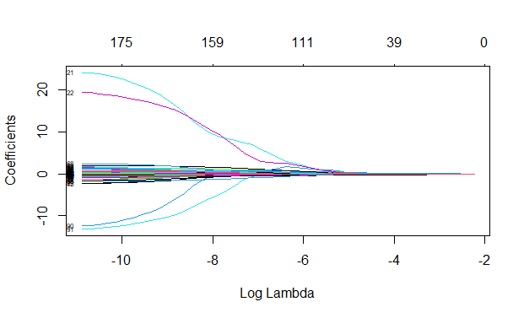

(B) Tuning parameter (λ) selection in the LASSO model used 10-fold cross-validation via minimum criteria.
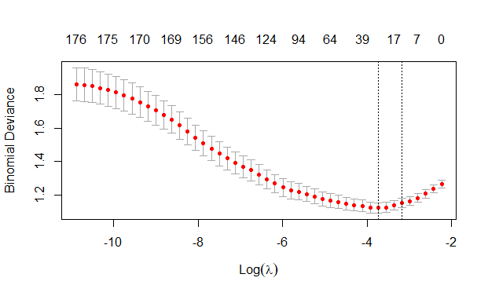
Figure S2. Feature selection using the least absolute shrinkage and selection operator (LASSO) binary logistic regression model. (A) LASSO coefficient profiles of the 176 features. (B) Tuning parameter (λ) selection in the LASSO model used 10-fold cross-validation via minimum criteria
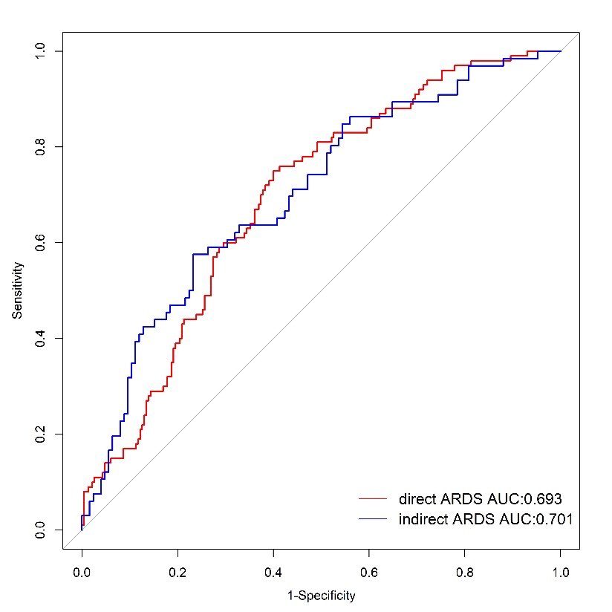
Figure S3. The ROC curves of our model validated in cohort of direct ARDS and indirect ARDS.
De Long method, direct ARDS vs. indirect ARDS P=0.858

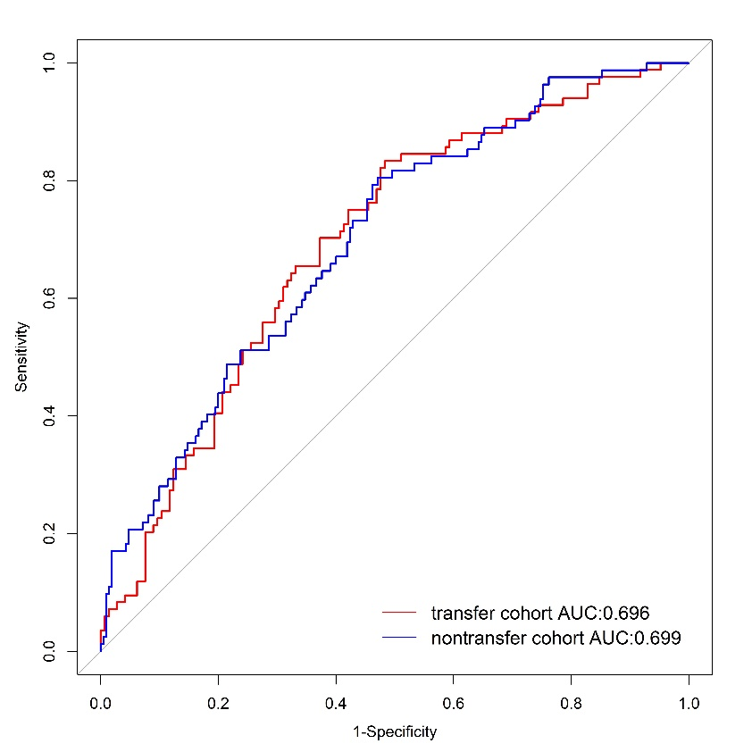
Figure S4. The ROC curves of our model validated in cohort of transferred and non-transferred.
De Long method, transferred vs. non-transferred P=0.858

