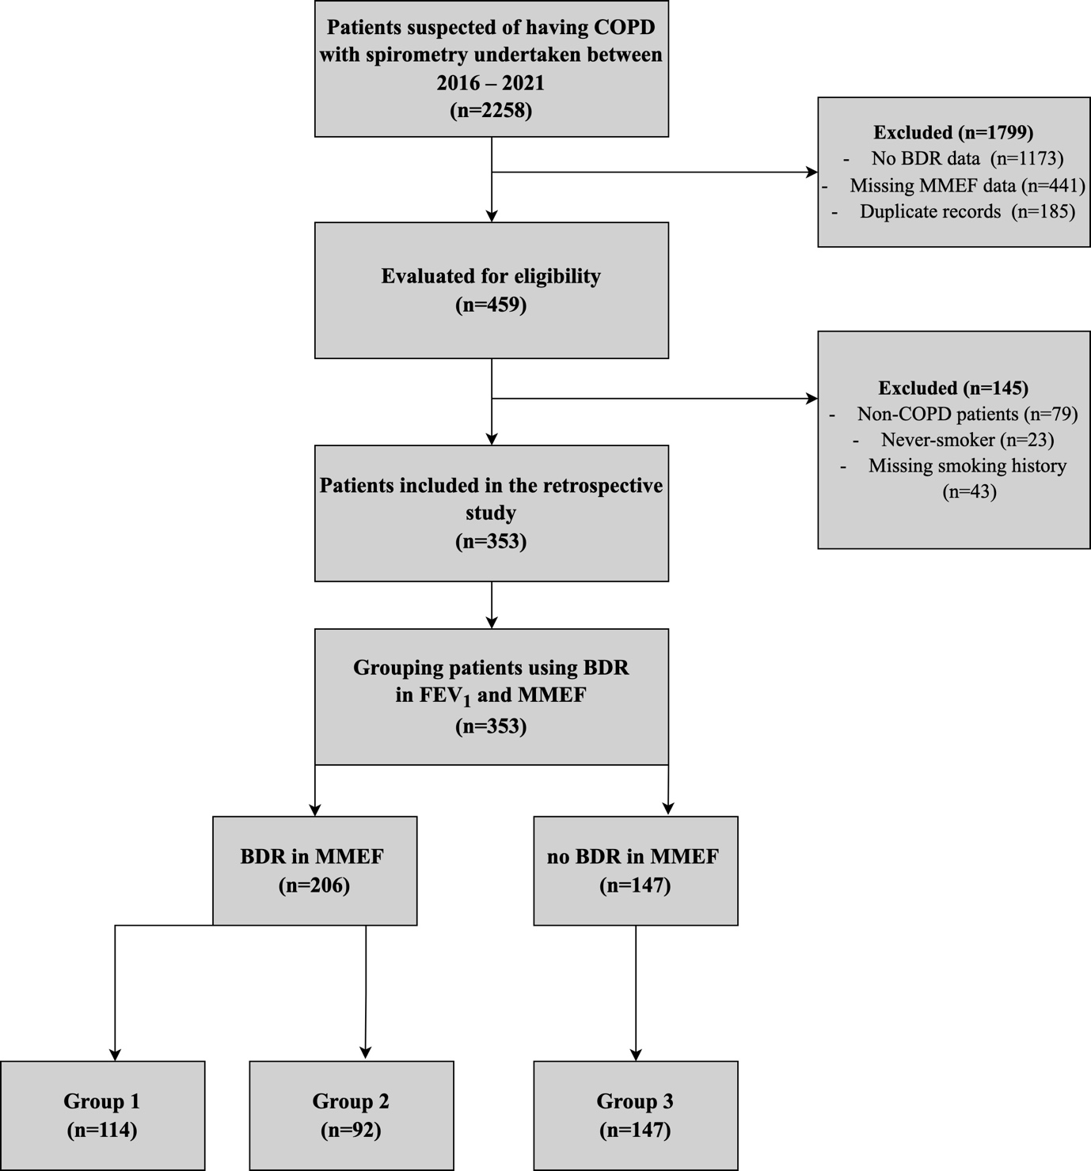

Flowchart of the participants in study using the 0.70 criteria.
Legend: This figure demonstrates the selection process for patients according to eligibility criteria. Group 1, those with BDR in FEV₁ and MMEF; Group 2, those with BDR in MMEF alone; Group 3, those with no BDR in either FEV₁ or MMEF.
Abbreviations: COPD, chronic obstructive pulmonary disease; MMEF, maximal mid-expiratory flow; FEV₁, forced expiratory volume in 1 second; BDR, bronchodilator response.

