SUPPLEMENTARY FIGURES

Association between psoriasis and lung cancer: two-sample Mendelian randomization analyses

Figure S1. Leave-one-out analysis for lung cancer, based on Tsoi LC.
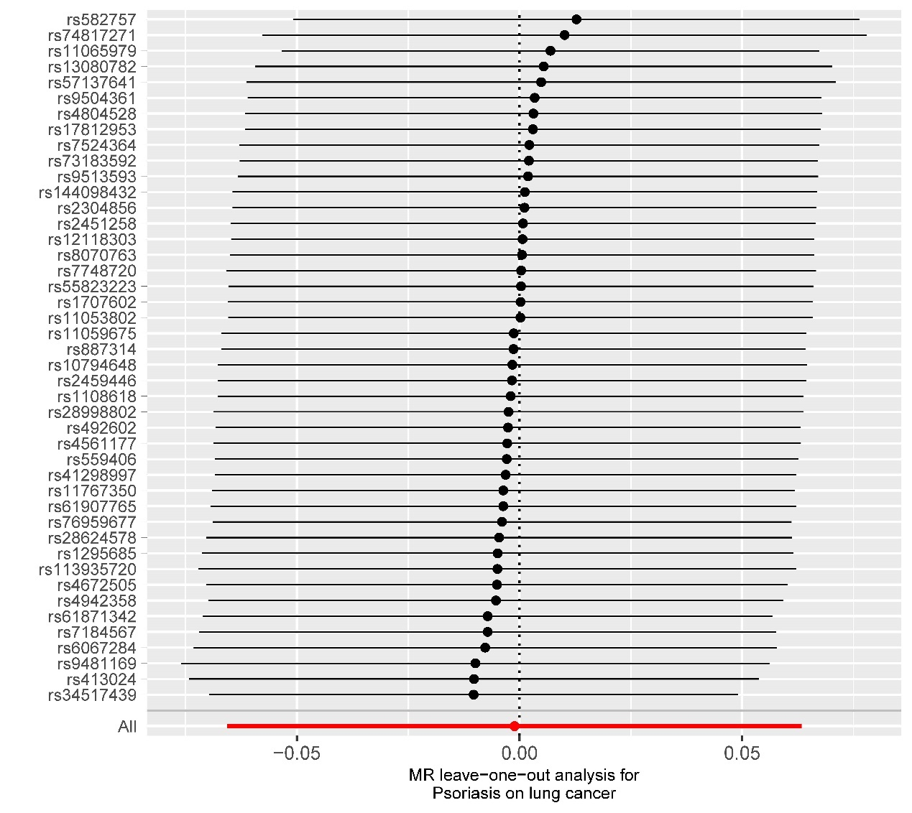

Figure S2. Leave-one-out analysis for squamous cell lung cancer, based on Tsoi LC.
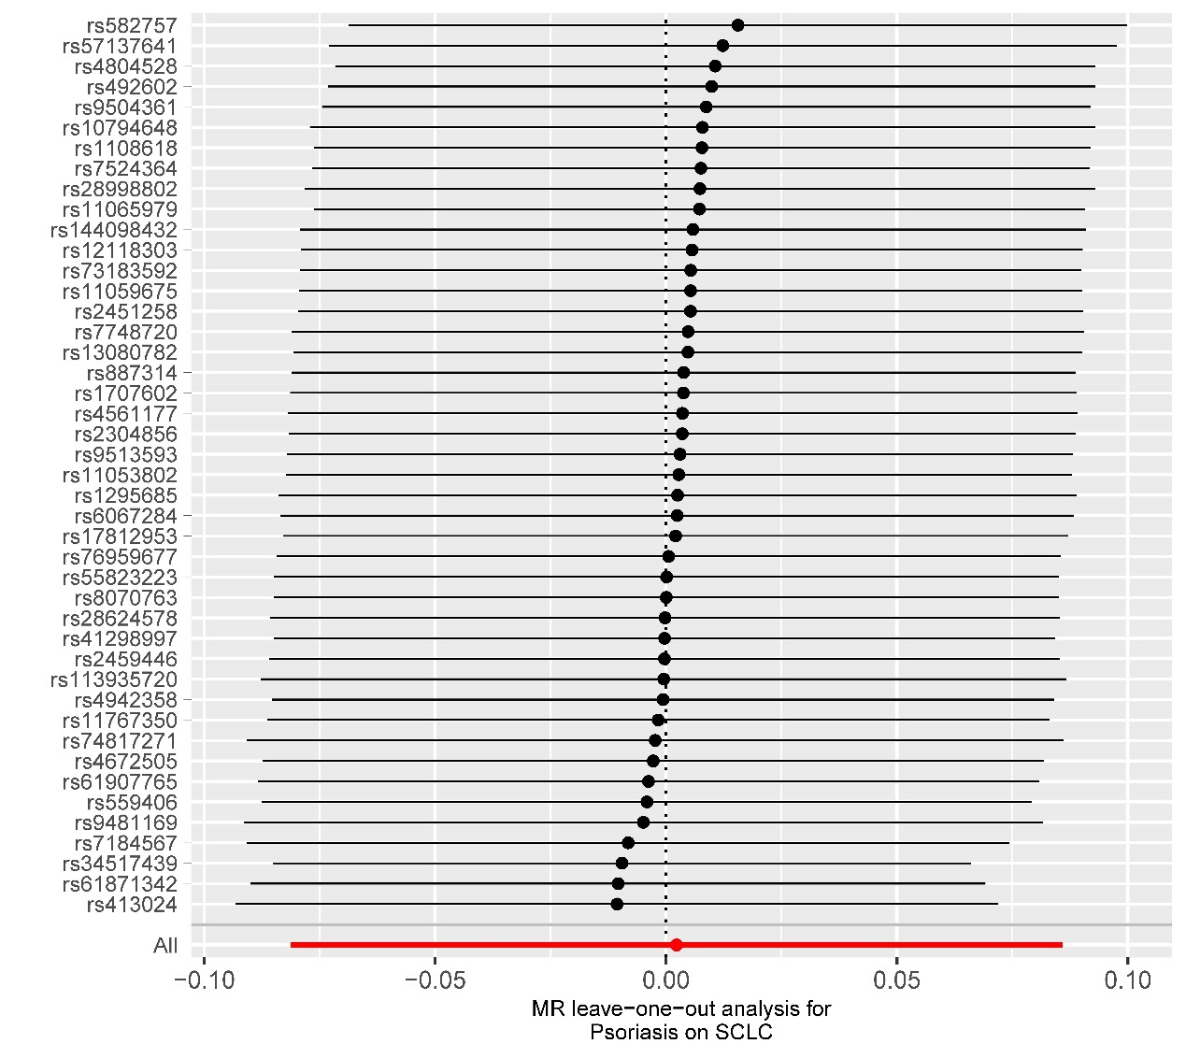

Figure S3. Leave-one-out analysis for lung adenocarcinoma, based on Tsoi LC.
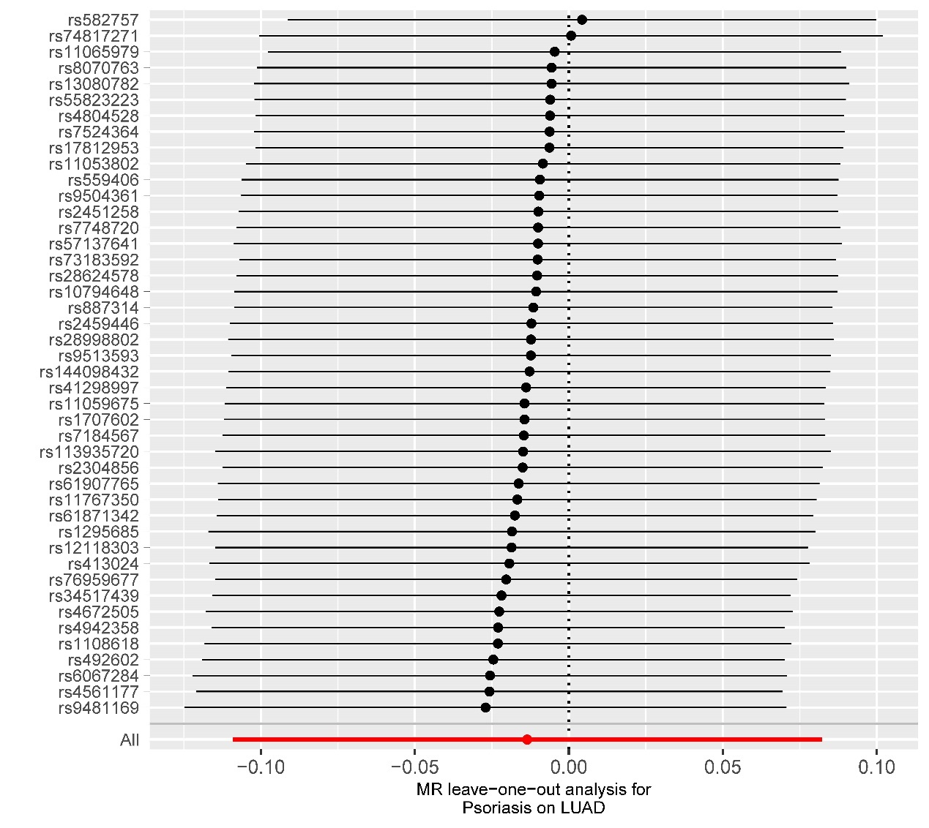

Figure S4. Leave-one-out analysis for lung cancer, based on FinnGen.
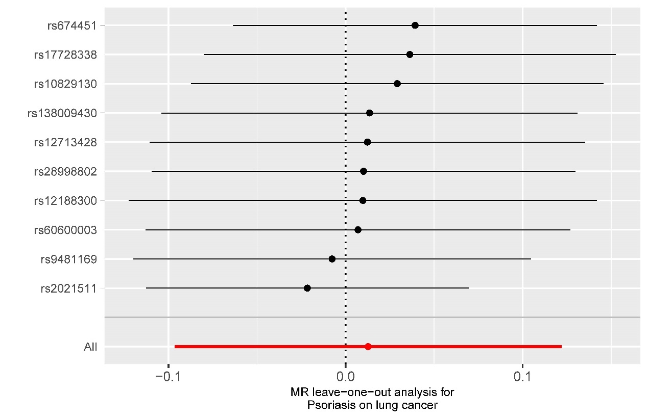

Figure S5. Leave-one-out analysis for squamous cell lung cancer, based on FinnGen.
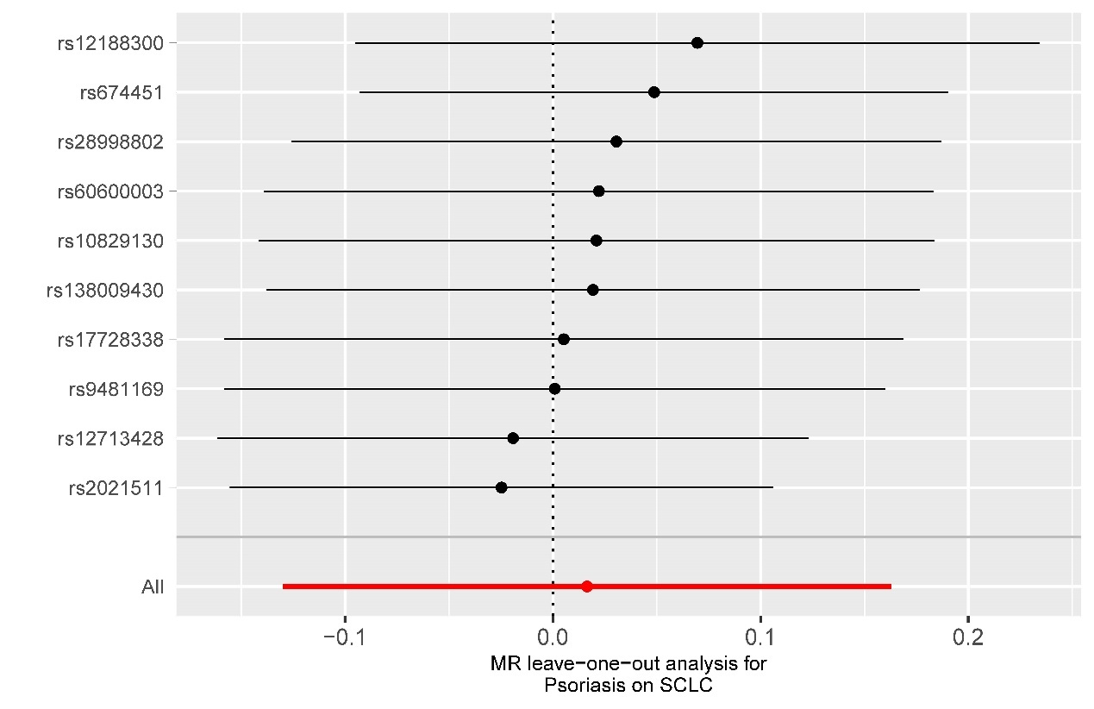

Figure S6. Leave-one-out analysis for lung adenocarcinoma, based on FinnGen.
