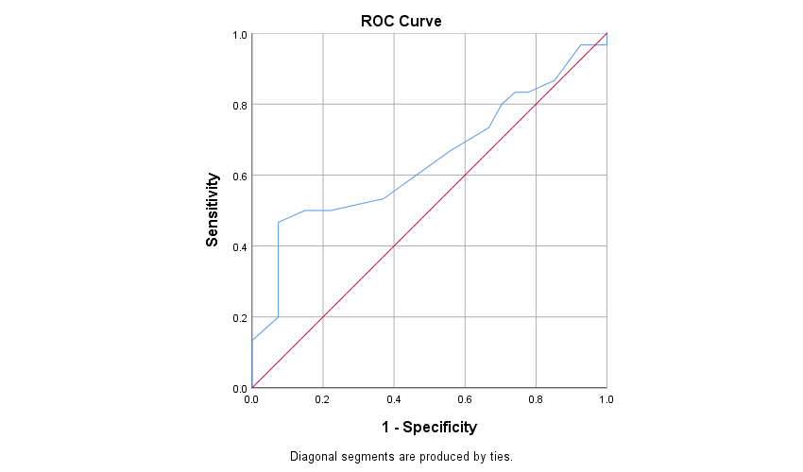
AUC = 0.643
95% CI: 0.497 − 0.788
Supplementary Fig. 1. Receiver operating characteristic curve analysis of the Montreal Cognitive Assessment scores in patients with and without incorrect technique at 1 month after training. The optimal cut-off value was 16.

