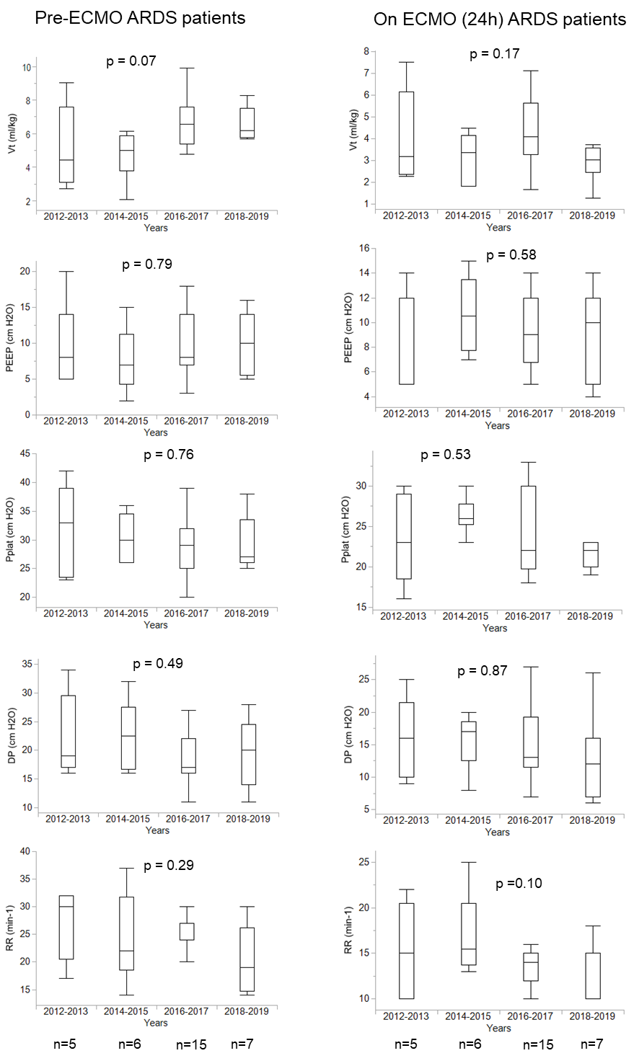
Additional File 8. Ventilatory strategies during the 8 years of the study in the ARDS population. Patients were grouped in 4 periods of 2 y each. Differences across years were analyzed by ANOVA

