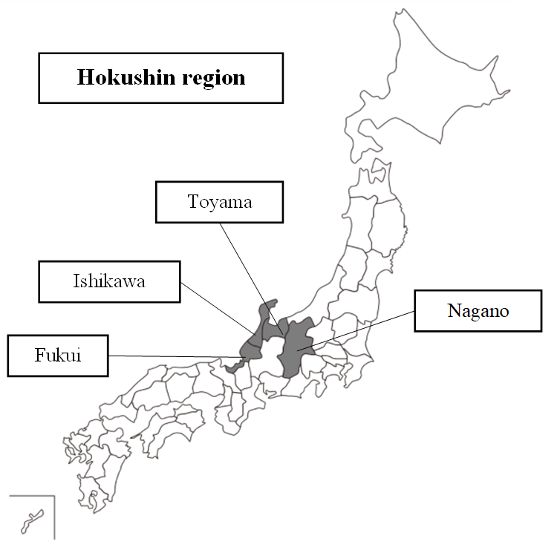

Supplementary Fig. 1 The Hokushin region is composed of the Fukui, Ishikawa, Toyama, and Nagano prefectures, which have commonalities, such as the population’s age distribution and snowy climates during the winter.

