Supplementary
Contribution of Small Airway Inflammation to COPD Development
Li Li#, M.D.; Ying Gong#, M.D.; Dongni Hou# M.D., Ph.D.; Yijun Song# M.D., Ph.D.; Jing Bi#, M.D., Ph.D.; Miao Li#, M.D., Ph.D.; Junjie Han#, M.D.; Yuanlin Song*, M.D., Ph.D.; Jun She*, M.D., Ph.D.
Department of Pulmonary and Critical Care Medicine, Zhongshan Hospital, Fudan University, Shanghai, China
*Correspondance:
Jun She, M.D., Ph.D.; Department of Pulmonary Medicine, Zhongshan Hospital, Fudan University, 180 Feng Lin Road, Shanghai, China, 200032; E-mail: she.jun@zs-hospital.sh.cn
Yuanlin Song, M.D., Ph.D.; Department of Pulmonary Medicine, Zhongshan Hospital, Fudan University, 180 Feng Lin Road, Shanghai, China, 200032; E-mail: song.yuanlin@zs-hospital.sh.cn
# Li Li, Ying Gong, Dongni Hou, Yijun Song, Jing Bi, Miao Li, Junjie Han contributed equally.

Table S1 Characteristics of COPD subjects according to FEV₁ in the study
COPD subjects | FEV₁ > 80 | 70 < FEV₁ < 80 | 60 < FEV₁ < 70 | 50 < FEV₁ < 60 | 40 < FEV₁ < 50 | 30 < FEV₁ < 40 | 20 <FEV₁ < 30
 | N = 28 | N = 44 | N = 32 | N = 37 | N = 34 | N = 23 | N = 19
Mean age (SD), years | 65.7 (6.8) | 67.5 (5.7) | 69.3 (7.8) | 65.1 (4.8) | 65.8 (5.5) | 66.8 (6.5) | 70.8 (7.4)
Mean height (SD), cm  Mean weight (SD), kg  BMI (SD)  Pulmonary function test  Mean FVC (SD), L  Mean FVC (SD), % predicted  Mean FEV₁ (SD), L  Mean FEV₁ (SD), % predicted  Mean FEV₁/FVC (SD), ratio  Mean FEV₁/FVC (SD), % predicted  Mean IC (SD), L  Mean IC (SD), % predicted  Mean FEF25 (SD), % predicted | 165.6 (7.4)  63.9 (11.5)  23.7 (3.8)  3.6 (0.8)  102.1 (13.3)  2.4 (0.6)  90.4 (9.2)  68.1 (5.9)  84.3 (7.5)  2.3 (0.8)  90.0 (18.7)  64.8 (19.5) | 168.0 (8.2)  65.3 (10.5)  23.5 (3.1)  3.4 (0.8)  95.2 (12.8)  2.0 (0.4)  74.6 (2.9)  61.0 (6.6)  79.1 (8.9)  2.3 (0.5)  89.2 (11.5)  40.4 (8.8) | 167.2 (5.4)  66.0 (7.0)  23.6 (2.4)  3.0 (0.4)  82.5 (9.3)  1.9 (0.2)  64.9 (3.3)  61.5 (5.7)  80.3 (7.9)  2.1 (0.4)  77.8 (7.4)  36.0 (8.7) | 166.1 (8.2)  68.7 (9.7)  24.9 (3.3)  3.0 (0.7)  82.3 (9.2)  1.6 (0.3)  55.3 (2.2)  52.1 (4.4)  67.5 (6.0)  2.2 (0.6)  79.6 (15.1)  25.0 (3.2) | 167.6 (6.8)  67.2 (8.1)  23.7 (2.9)  2.5 (0.4)  66.9 (9.5)  1.3 (0.2)  44.3 (2.4)  52.1 (8.7)  67.6 (11.4)  1.8 (0.3)  64.6 (6.5)  19.5 (7.9) | 167.6 (6.8)  67.2 (8.1)  23.7 (2.9)  2.5 (0.4)  69.1 (9.7)  1.0 (0.1)  35.3 (3.2)  39.3 (4.9)  51.1 (6.9)  1.8 (0.5)  70.6 (18.7)  11.3 (2.3) | 167.6 (6.8)  67.2 (8.1)  23.7 (2.9)  1.8 (0.4)  51.3 (11.0)  0.7 (0.1)  26.4 (2.2)  40.3 (8.7)  52.6 (12.0)  1.2 (0.4)  49.1 (19.9)  7.9 (2.2)
Mean FEF50 (SD), % predicted | 45.1 (17.4) | 33.1 (7.5) | 28.0 (8.5) | 19.2 (2.8) | 17.3 (4.5) | 9.7 (1.3) | 7.9 (1.9)
Mean FEF75 (SD), % predicted | 41.6 (18.5) | 36.4 (12.5) | 35.2 (10.8) | 21.8 (4.9) | 21.7 (4.5) | 17.4 (5.6) | 17.9 (8.8)
Data shown were means (SD) or as percentages. BMI body mass index; COPD chronic obstructive pulmonary disease; SD standard deviation.

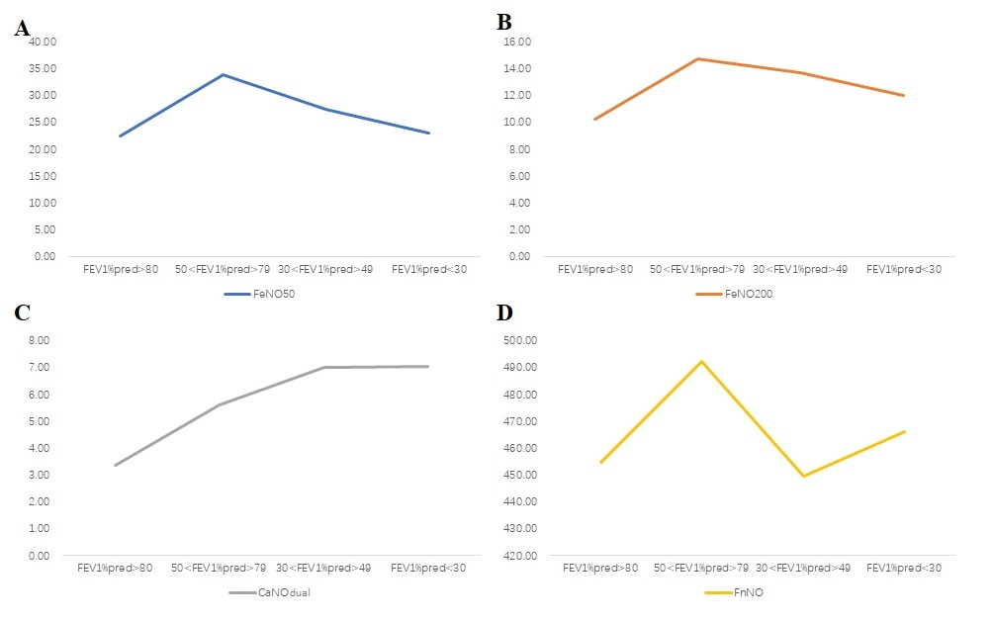
Fig. S1 The tendency of exhaled NO in the COPD group according to the GOLD grade. A FeNO₅₀, B FeNO₂₀₀, C CaNO_{dual}, and D FnNO

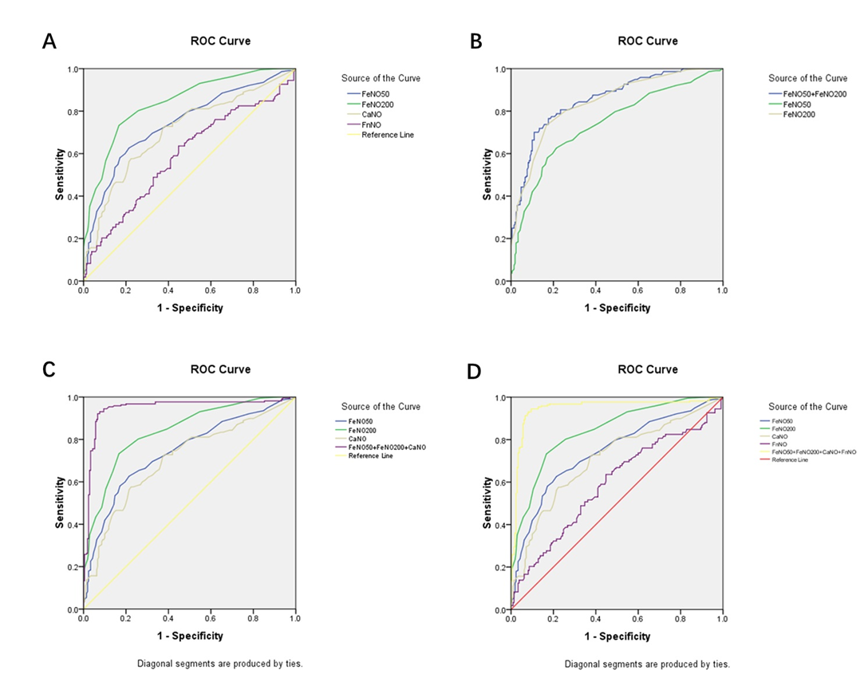
Fig. S2. A Area under the curve of exhaled NO in COPD. B Area under the ROC curve is 0.855 when combining FeNO₅₀ and FeNO₂₀₀. C Area under the ROC curve is 0.947 when combining FeNO₅₀, FeNO₂₀₀, and CaNO_{dual}. D Area under the ROC curve is 0.947 when combining FeNO₅₀, FeNO₂₀₀, CaNO_{dual}, and FnNO.

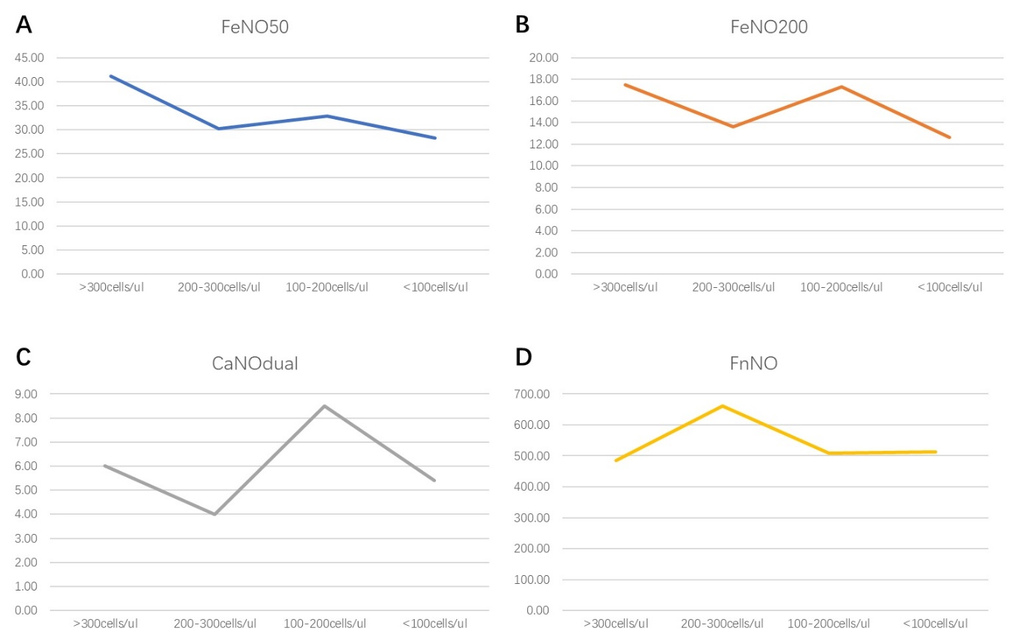
Fig. S3. The tendency of exhaled NO in the COPD group according to eosinophils. A FeNO₅₀, B FeNO₂₀₀, C CaNO_{dual}, and D FnNO

