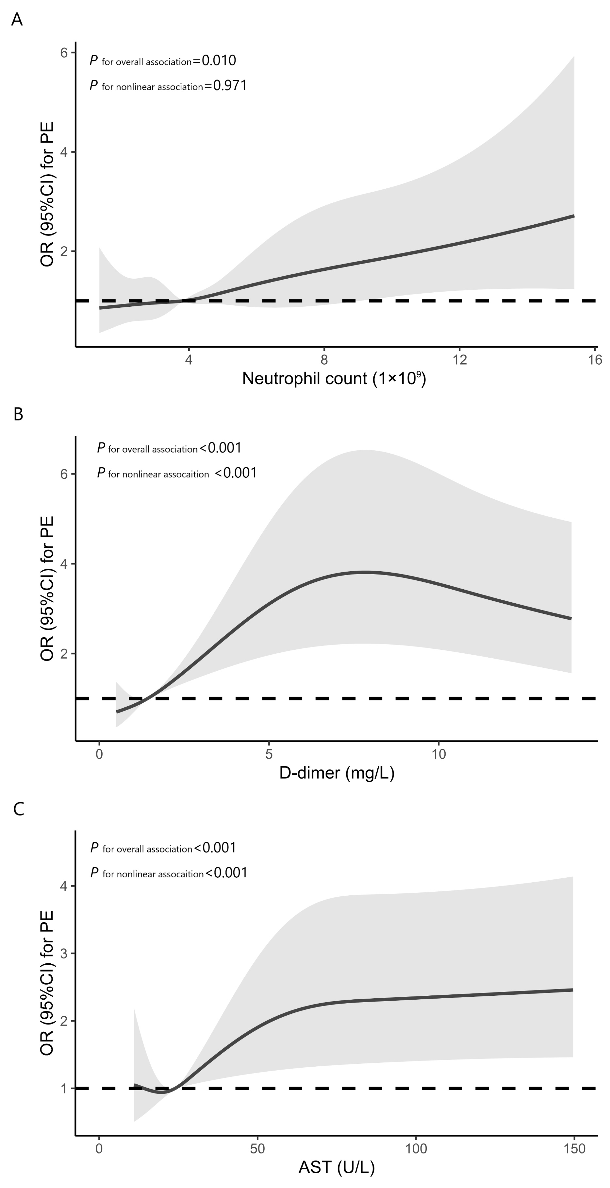
Supplementary Materials
Figure S1 Restrictive cubic spline plot of the association between neutrophil count, D-dimer, AST, and PE (A neutrophil count, B D-dimer, C AST)
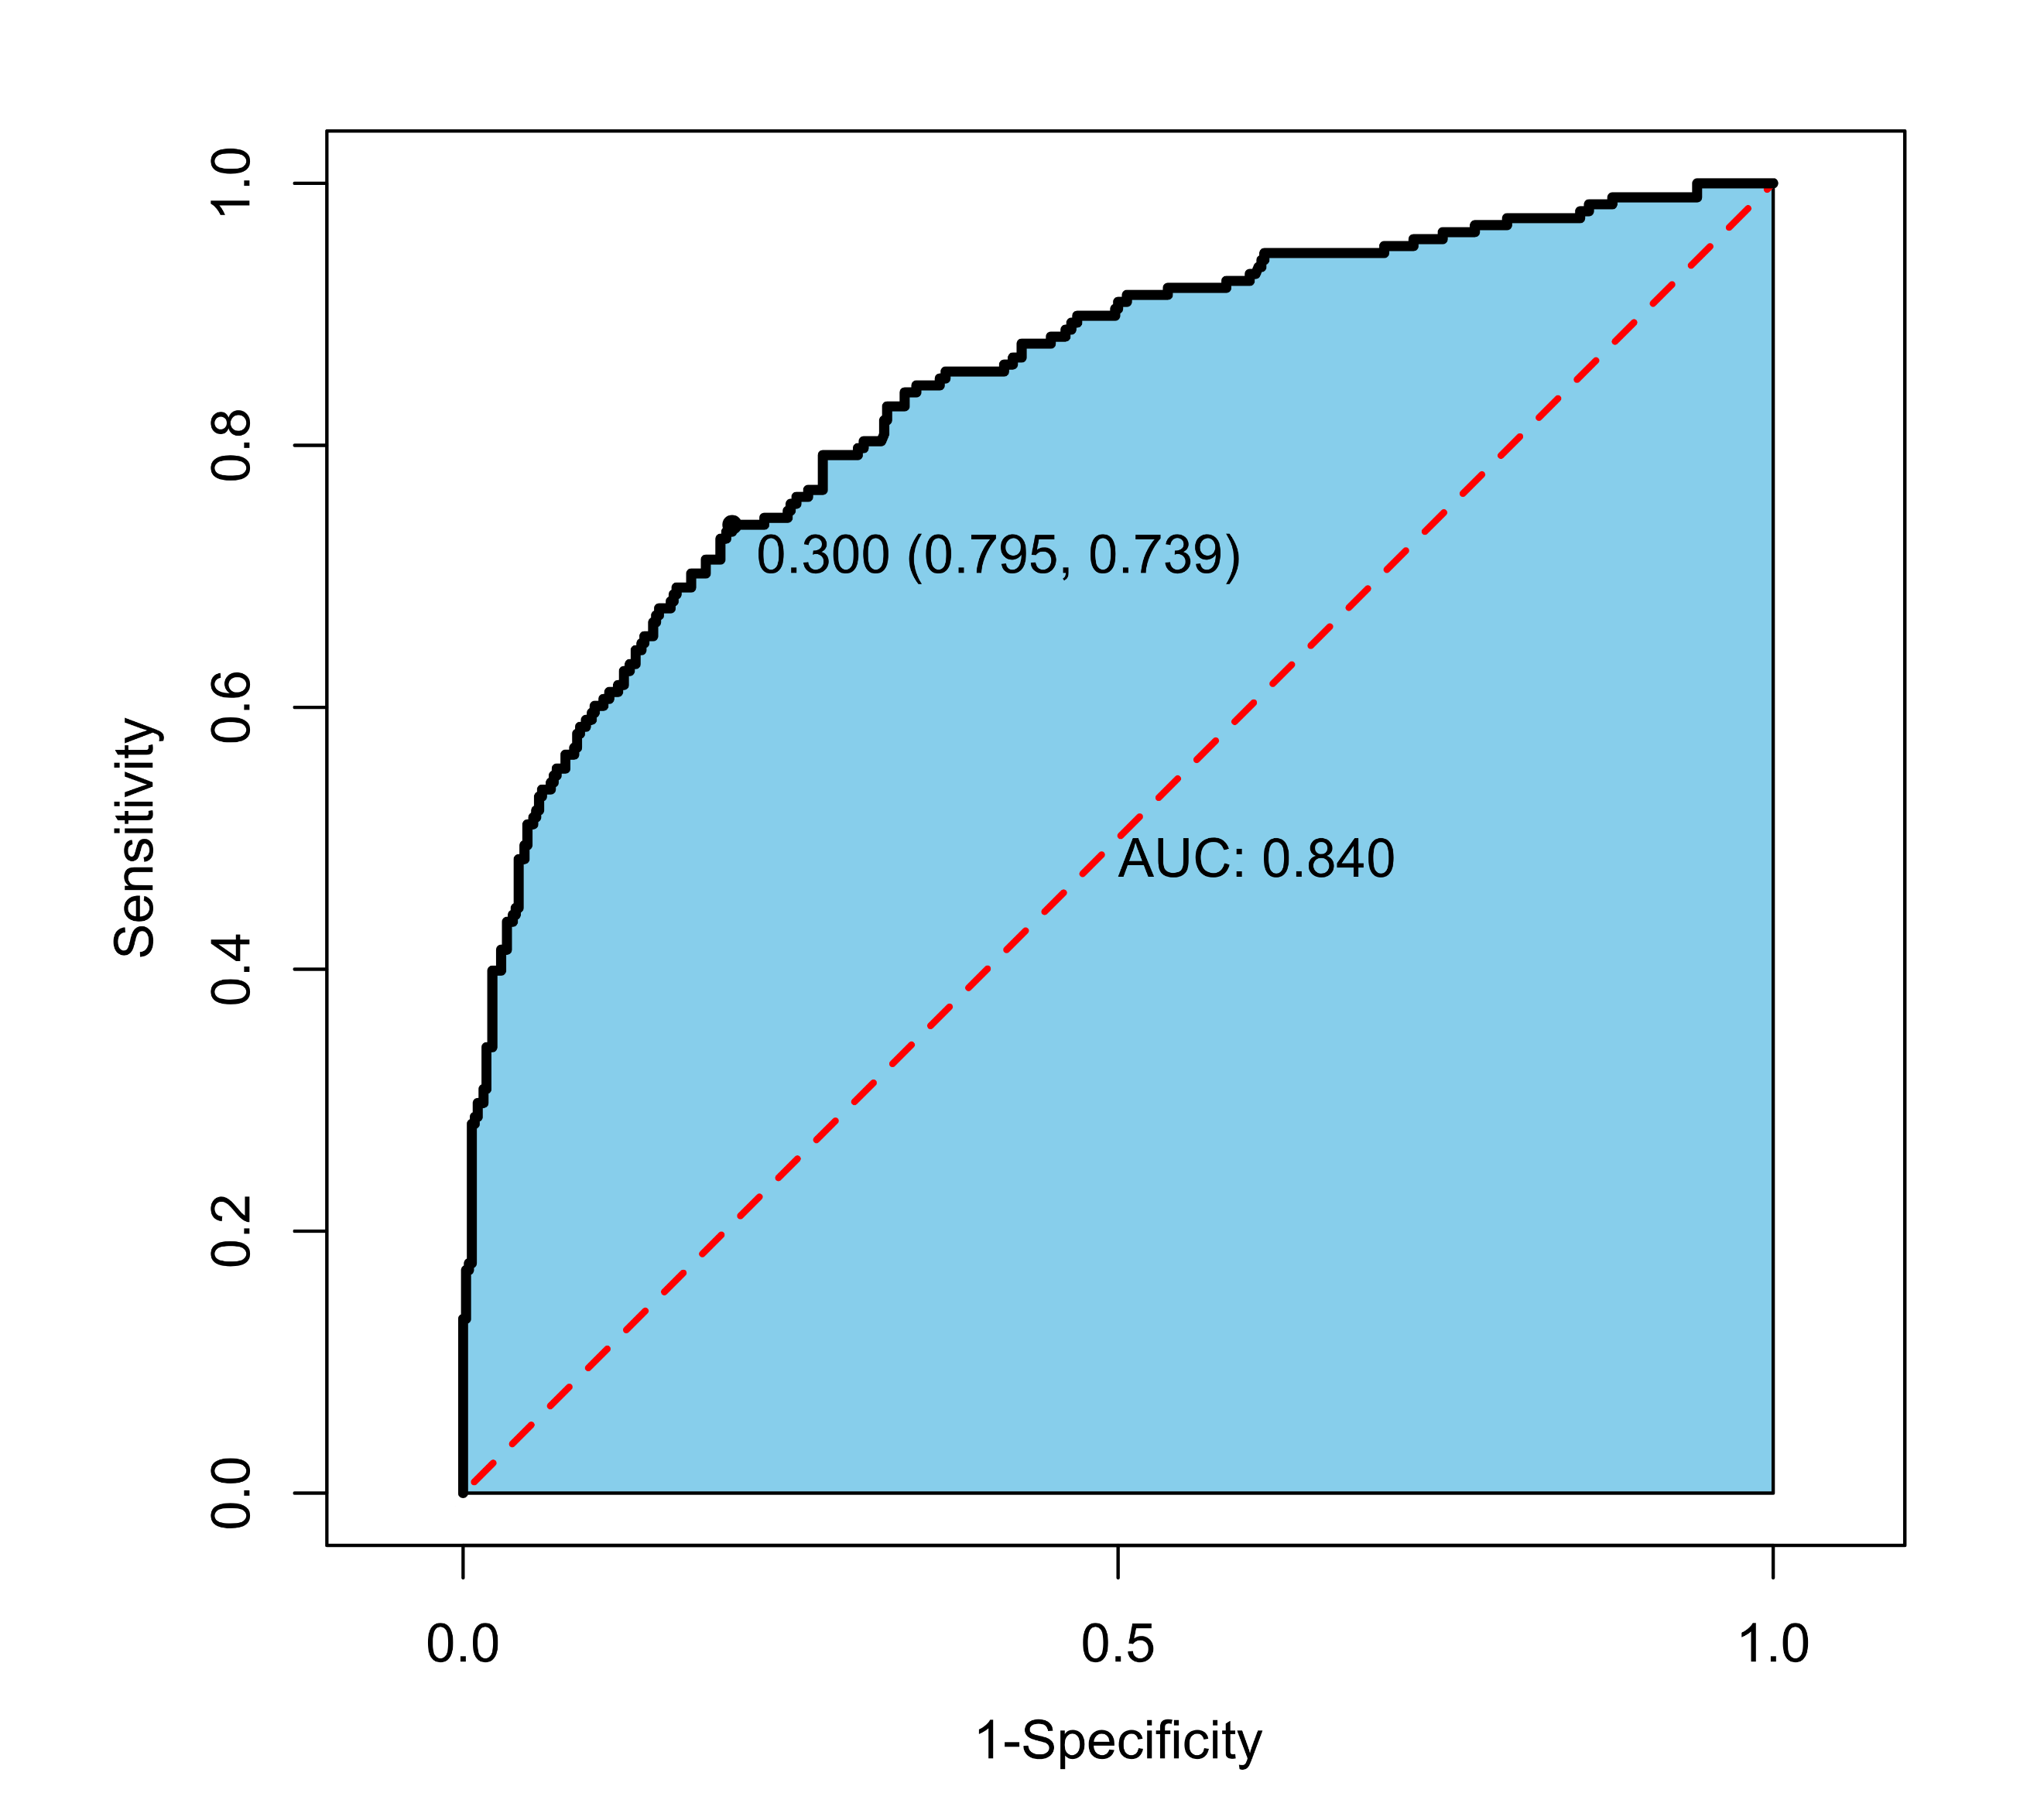
Figure S2 Receiver operating characteristic curve of multivariable logistic regression

