eTable 1. GOLD stage prediction performance of the Ensemble model.
eFigure 1. Feature extraction visualization using Heatmaps of Grad-CAM for COPD detection based on CXR images. The chest x-ray image of COPD patient (A); The Grad-CAM of the same COPD patient (B).

eTable 1. GOLD Stage Prediction Performance of the Ensemble Model
Classification | AUC | ACC | sensitivity | F1
Three classification | 0.894 | 0.79 | 0.78 | 0.78
Five classification | 0.852 | 0.52 | 0.59 | 0.55
Abbreviations: GOLD, the global initiative for chronic obstructive lung disease; AUC, area under the curve; ACC, accuracy; F1, false positive rate.

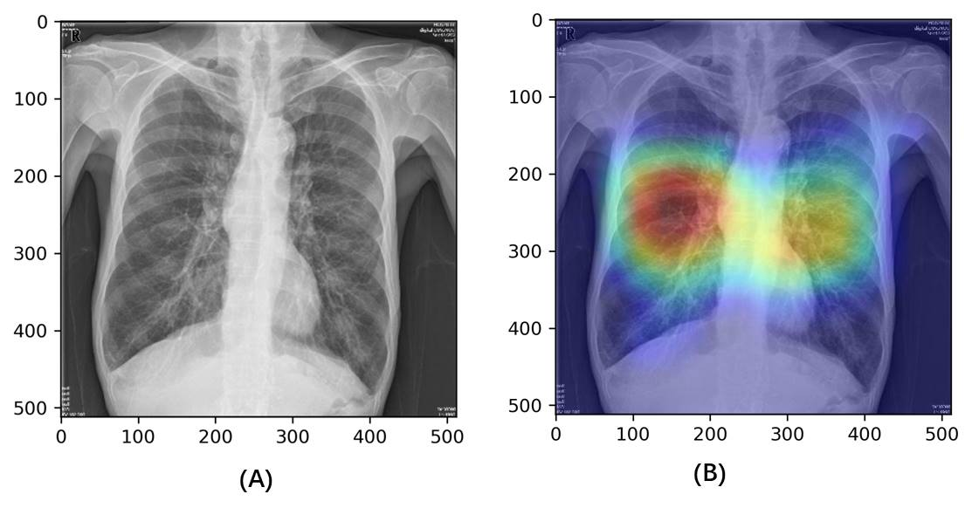
eFigure 1. Feature extraction visualization using Heatmaps of Grad-CAM for COPD detection based on CXR images. The highlighted areas with increased values are discriminative features for identification of COPD. The chest x-ray image of COPD patient (A); The Grad-CAM of the same COPD patient (B). COPD, chronic obstructive pulmonary disease; Grad-CAM, Gradient Class Activation Map.

