Supplementary Figure 1. Number of cases from each hospital included in this study
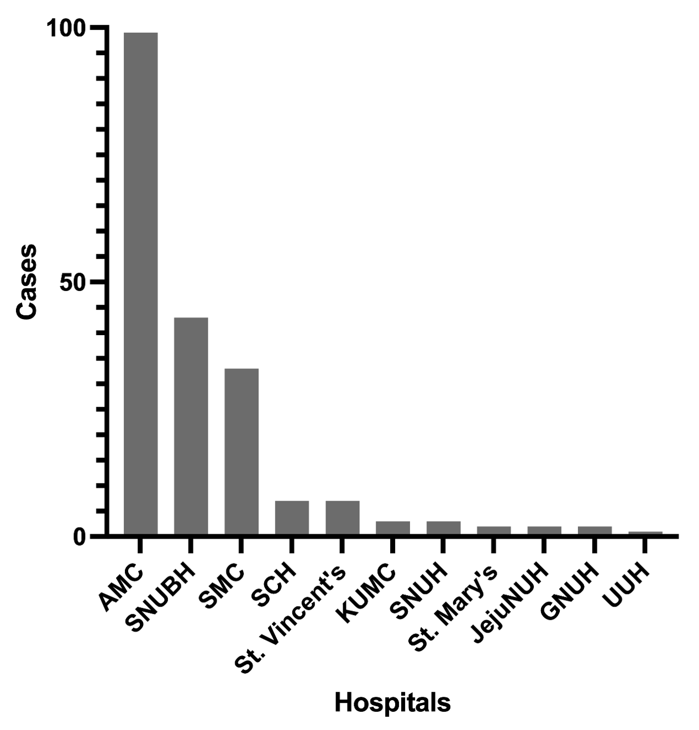
Abbreviations: AMC, Asan Medical Center; SNUBH, Seoul National University Bundang Hospital; SMC, Samsung Medical Center; SCH, Soonchunhyang University Cheonan Hospital; KUMC, Korea University Ansan Hospital; SNUH, Seoul National University Hospital; St Mary’s, Eunpyeong St. Mary’s Hospital; Jeju NUH, Jeju National University Hospital; GNUH, Gyeongsang National University Hospital; UUH, Ulsan University Hospital

