Supplementary Figure 2. Kaplan–Meier survival analysis of the overall survival among patients with severe emphysema following treatment with EBV
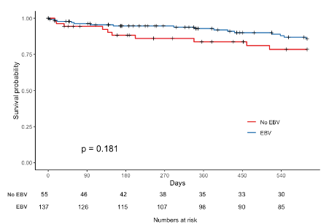
Abbreviations: EBV, endobronchial valve

