Supplementary Fig. 1 Change of trigger delay time from baseline to A) I-sync, B) C-sync, and C) I/C sync. C-sync – cycle synchronization, I-sync – inspiratory synchronization, I/C-sync – inspiratory and cycle synchronization.

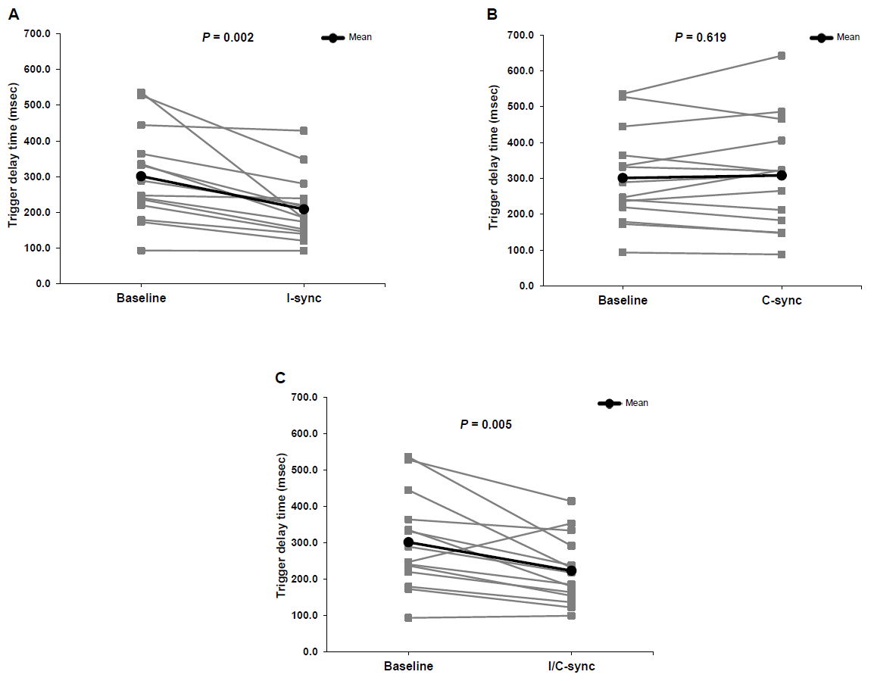

Supplementary Fig. 2 Change of cycle delay time to A) I-sync, B) C-sync, and C) I/C sync. C-sync – cycle synchronization, I-sync – inspiratory synchronization, I/C-sync – inspiratory and cycle synchronization.

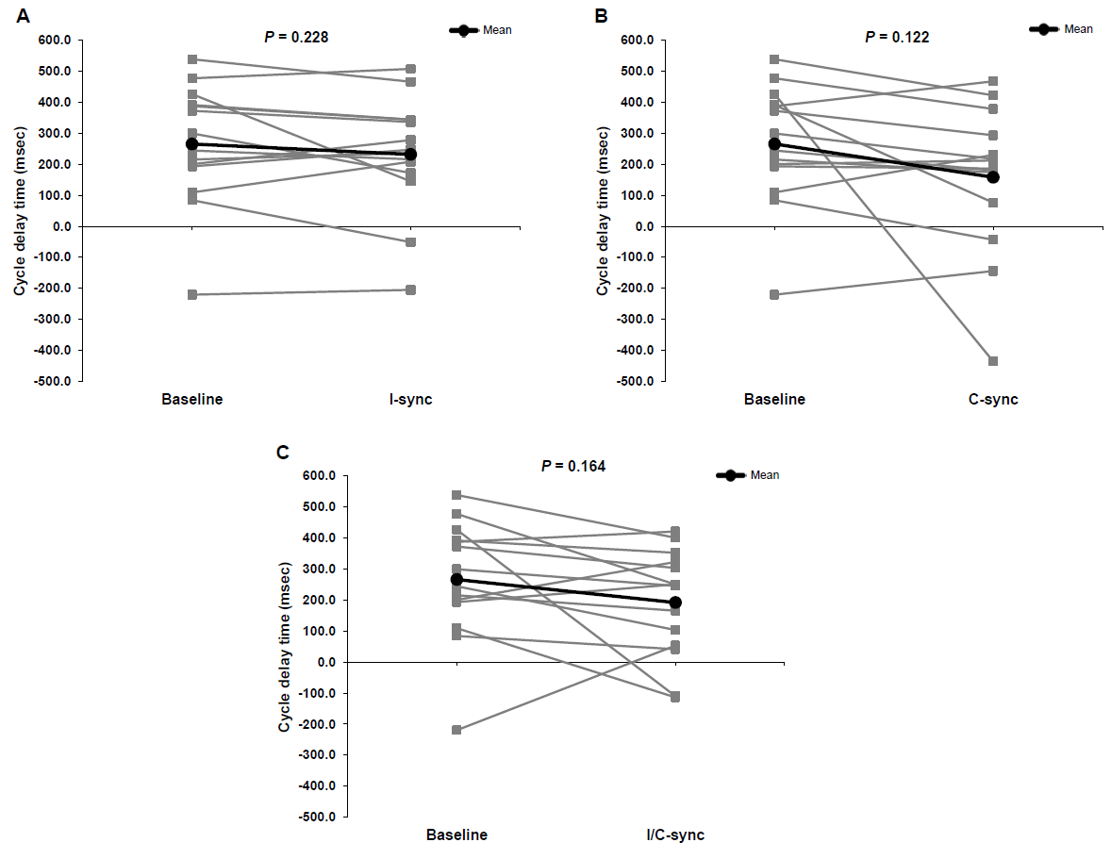

Supplementary Fig. 3 Change of delta Paw drop from baseline to A) I-sync, B) C-sync, and C) I/C sync. C-sync – cycle synchronization, I-sync – inspiratory synchronization, I/C-sync – inspiratory and cycle synchronization.

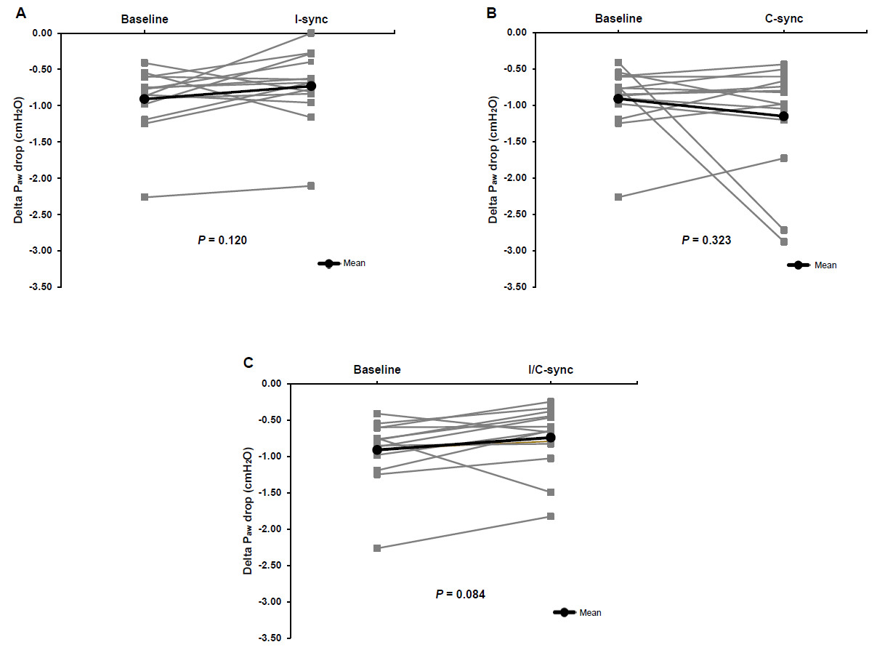

Supplementary Fig. 4 Change of delta Pes drop from baseline to to A) I-sync, B) C-sync, and C) I/C sync. C-sync – cycle synchronization, I-sync – inspiratory synchronization, I/C-sync – inspiratory and cycle synchronization.

