ADDITIONAL FILE
Supplementary Table S1: Mortality across the 4-year study period
Follow-up year | Total Patients (n) | Mortality  (n) | % of Overall Cohort
Year 1 | 238,158 | 9,903 | 4.16
Year 2 | 228,255 | 7,661 | 3.22
Year 3 | 220,594 | 5,960 | 2.50
Year 4 | 214,634 | 4,356 | 1.83

Supplementary Table S2: Subgroup analysis - exacerbation rate across place of diagnosis, censored by mortality and treatment
 |  | Total  Person-Years in 12-Month Blocks - Censored by Mortality and Treatment | Exacerbation Rates
 |  |  | Moderate |  | Severe |  | Severe (Prior Definition) |  | Any
 |  |  | N | Rates | N | Rates | N | Rates | N | Rates
Inpatient Diagnosis  (n=90,678) | Year 1 | 65,705.9 | 4,486 | 0.07 | 4,744 | 0.07 | 13,127 | 0.20 | 9,230 | 0.14
Inpatient Diagnosis  (n=90,678) | Year 2 | 53,353.7 | 2,555 | 0.05 | 2,159 | 0.04 | 5,957 | 0.11 | 4,714 | 0.09
Inpatient Diagnosis  (n=90,678) | Year 3 | 45,900.7 | 1,427 | 0.03 | 1,203 | 0.03 | 3,446 | 0.08 | 2,630 | 0.06
Inpatient Diagnosis  (n=90,678) | Year 4 | 38,428.8 | 482 | 0.01 | 464 | 0.01 | 3,446 | 0.09 | 946 | 0.02
Non-Inpatient Diagnosis  (n=147,480) | Year 1 | 119,439.1 | 4,300 | 0.04 | 690 | 0.01 | 1,454 | 0.01 | 4,990 | 0.04
Non-Inpatient Diagnosis  (n=147,480) | Year 2 | 106,941.6 | 2,332 | 0.02 | 374 | 0.00 | 775 | 0.01 | 2,706 | 0.03
Non-Inpatient Diagnosis  (n=147,480) | Year 3 | 99,700.8 | 1,397 | 0.01 | 190 | 0.00 | 411 | 0.00 | 1,587 | 0.02
Non-Inpatient Diagnosis  (n=147,480) | Year 4 | 89,076.3 | 540 | 0.01 | 64 | 0.00 | 411 | 0.00 | 604 | 0.01

Supplementary Figure S1: Study design

COPD: chronic obstructive pulmonary disease; ICD-10: International Statistical Classification of Diseases, 10th revision.

Supplementary Figure S2: Patient disposition

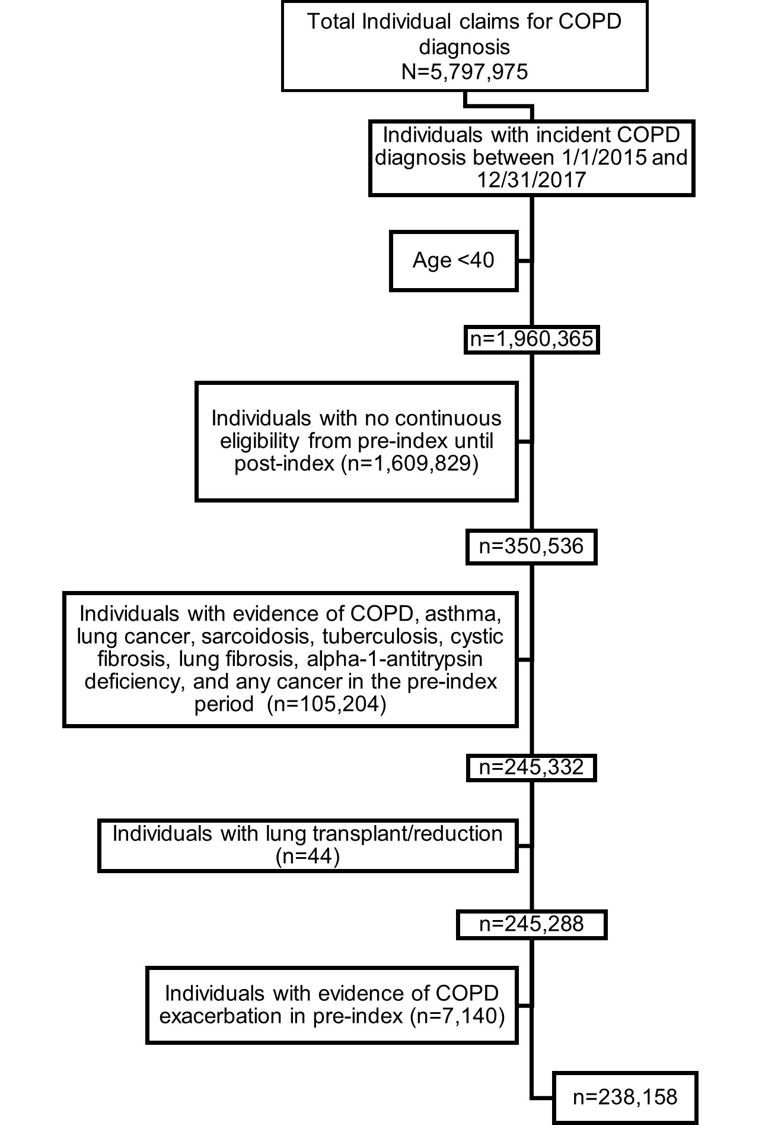
COPD: chronic obstructive pulmonary disease.

Supplementary Figure S3: Subgroup analysis - exacerbation rate across diagnosis place of service, censored by mortality and treatment. A) Rate of moderate exacerbations; B) Rate of severe exacerbations; C) Rate of any exacerbations (moderate or severe).

