Supplementary information

Supplementary table 1. Analysis of relationship between ILA and cancer treatment.

 | Treatment§ | With ILA | Without ILA | P value
Lung cancer | with treatment (n=20)§ | 2 | 18 | 0.688
Lung cancer | without treatment (n=198) | 17 | 181 | 0.688
Other cancers than lung cancer | with treatment (n=35) | 10 | 25 | 0.999
Other cancers than lung cancer | without treatment (n=13) | 3 | 10 | 0.999
§ lung cancer treatment before the diagnosis of ILA

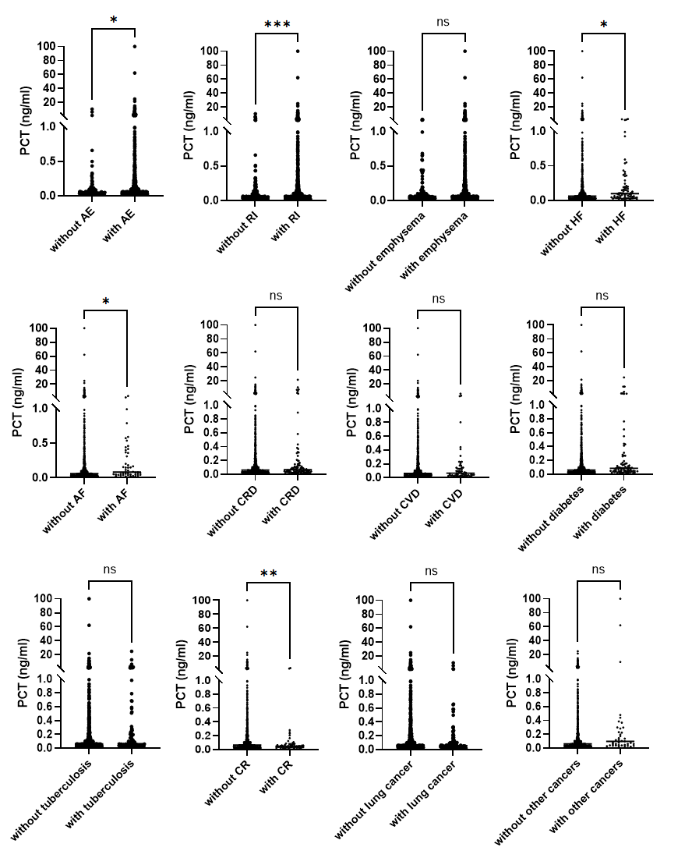
Figure S1. Association between Procalcitonin (PCT) and Clinical Features or Co-morbidities of COPD This figure illustrates the association between procalcitonin (PCT) levels and various clinical features or co-morbidities of chronic obstructive pulmonary disease (COPD), including acute exacerbations (AE), respiratory infections (RI), heart failure (HF), atrial fibrillation (AF), coronary artery disease (CRD), cardiac valve disease (CVD), and chronic rhinitis (CR). Statistical significance was assessed using the Mann–Whitney U test, with significance levels indicated as follows: *p < 0.05, **p < 0.01, and ***p < 0.001.

