BMC Pulmonary Medicine – Dondi et al.
Supplementary material
Figure S1 - Percentage distribution of the Italian population in 2015 in the Fondazione Ricerca e Salute (ReS) database and according to the Italian Institute of Statistics (ISTAT), by age group
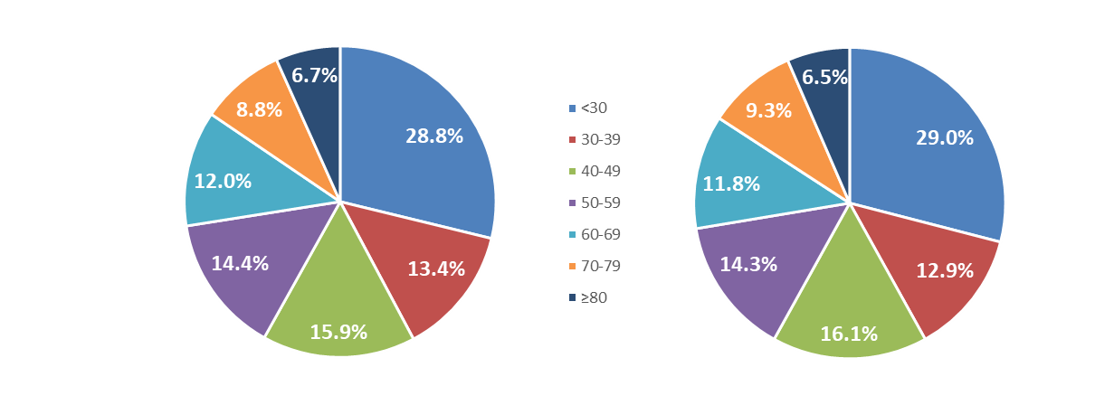
ReS database population 2015
ISTAT population 2015

Box S1 – Description of the administrative healthcare data source
Fondazione ReS is a non-profit foundation working on Italian healthcare real-world data with the aim of planning and monitoring healthcare policy issues, for different stakeholders and in various clinical fields since its establishment in 2018 [1-3]. Through the collaboration with Cineca (Interuniversity Consortium [4]), which guarantees quality and security of the data management (international standard certifications), the ReS database, after further quality and accuracy data checks, collects and integrates the administrative healthcare data that Italian Local and Regional Healthcare Authorities (HAs) annually convey to the Italian Ministry of Health. Data from some HAs, owners of these data, are made available to Fondazione ReS under specific agreements, to be analyzed in aggregated form, after anonymization. Demographics (age, sex, local HA of residency and disease waiver claim for co-payment) of each patient are completely anonymized at the source according to European privacy rules [5]. The pharmaceuticals’ database contains drugs reimbursed by the SSN and supplied from local and hospital pharmacies (Italian marketing code, ATC code, dose, number of packages and dispensing date). The hospitalizations’ database contains in-hospital diagnoses and procedures, according to the Italian version of the 2007 ICD-9-CM (International Classification of Diseases- 9th version – Clinical modification [6]), accessible through the hospital discharge forms of overnight and daily in-hospital stay. The outpatient specialist care database (visits, diagnostic and invasive/non-invasive procedures charged to the SSN) is analyzed based on the current national classification system, 2017 version [7]. Administrative healthcare databases also provide direct costs incurred by the SSN, due to reimbursement purposes.

REFERENCES

1. Maggioni AP, Dondi L, Pedrini A, Ronconi G, Calabria S, Cimminiello C, Martini N: The use of antiplatelet agents after an acute coronary syndrome in a large community Italian setting of more than 12 million subjects. Eur Heart J Acute Cardiovasc Care 2019, 8(6):527-535.
2. Ronconi G, Dondi L, Calabria S, Piccinni C, Pedrini A, Esposito I, Martini N: Real-world Prescription Pattern, Discontinuation and Costs of Ibrutinib-Naïve Patients with Chronic Lymphocytic Leukemia: An Italian Healthcare Administrative Database Analysis. Clin Drug Investig 2021.
3. Piccinni C, Cevoli S, Ronconi G, Dondi L, Calabria S, Pedrini A, Maggioni AP, Esposito I, Addesi A, Favoni V et al: Insights into real-world treatment of cluster headache through a large Italian database: prevalence, prescription patterns, and costs. Expert Rev Clin Pharmacol 2021:1-7.
4. CINECA - Interuniversity Consortium [https://www.cineca.it/]
5. European Parliament and Council of the European Union: Regulation (EU) 2016/679 of 27 April 2016 on the protection of natural persons with regard to the processing of personal data and on the free movement of such data, and repealing Directive 95/46/EC (General Data Protection Regulation). In.; 2016.
6. Ministero del Lavoro, della Salute e delle Politiche Sociali: Classificazione delle malattie, dei traumatismi, degli interventi chirurgici e delle procedure dagnostiche e terapeutiche. Versione italiana della ICD9-CM. In.; 2007.
7. Ministero del Lavoro della Salute e delle Politiche Sociali: Nomenclatore prestazioni di assistenza specialistica ambulatoriale. Allegato 4. DPCM 12 gennaio 2017. In.; 2017.

Table S1 – Criteria identifying the study population of patients with chronic obstructive pulmonary disease (COPD)

Administrative flow | Codes and descriptions
- Chronic obstructive pulmonary disease (patients aged ≥45 years old)
Hospitalizations | At least one hospital discharge form with one of the following primary/secondary diagnoses (ICD-9-CM code) in 2019/2020:  491.x - Chronic bronchitis  492.x - Emphysema  496 - Chronic airway obstruction, not elsewhere classified
Disease waiver claim | The following disease waivers claim codes active in the register “exemption of pathology” for 2019/2020:  057 - Chronic obstructive pulmonary disease
Pharmaceuticals | At least 4 supplies of the following drugs (ATC codes) in 2019/2020:  R03 - Drugs for obstructive airway diseases
- Patients potentially affected by asthma were identified by at least one of the following criteria and excluded
Hospitalizations | At least one hospital discharge form with the following primary/secondary diagnosis (ICD-9-CM code) in 2019/2020:  493.x - Asthma
Disease waiver claim | The following disease waivers claim codes active in the register “exemption of pathology” in 2019/2020:  007 - Asthma
Pharmaceuticals | At least 1 supply of one of the following drugs (ATC codes) in 2019/2020:  R03BA - Inhaled Glucocorticoids alone (in the absence of other R03 codes)  R03DX05 - Omalizumab  R03DX09 - Mepolizumab  R03DX10 - Benralizumab  R03DC - Leukotriene receptor antagonists  Among patients meeting the pharmaceutical criterion for COPD identification, at least one supply of inhaled corticosteroids as monotherapy (ATC code: R03DC) during the accrual period (i.e., 2019/2020)
Local outpatient specialist care | Among patients meeting the pharmaceutical criterion for COPD identification, at least one of the following performances (national classification) in 2019/2020:  89.37.5-89.37.6: bronchial challenge tests

Table S2 – Criteria for the identification of the pharmacological treatment strategies during the accrual period (ATC codes from the pharmaceutical database)
Inhaled corticosteroids
R03BA – Glucocorticoids
Long-acting beta agonists (LABA)
R03AC12 - salmeterol
R03AC13 - formoterol
R03AC18 - indacaterol
R03AC19 - olodaterol
Long-acting muscarinic antagonists (LAMA)
R03BB05 - aclidinium bromide
R03BB06 - glycopyrronium bromide
R03BB04 - tiotropium bromide
R03BB07 - umeclidinium bromide
LAMA/LAMA as fixed dose combination
R03AL03 - vilanterol and umeclidinium bromide
R03AL04 - indacaterol and glycopyrronium bromide
R03AL05 - formoterol and aclidinium bromide
R03AL06 - olodaterol and tiotropium bromide
R03AL07 - formoterol and glycopyrronium bromide
ICS/LABA as fixed dose combination
R03AK06 - salmeterol and fluticasone
R03AK07 - formoterol and budesonide
R03AK08 - formoterol and beclomethasone
R03AK10 - vilanterol and fluticasone furoate
ICS/LABA/LAMA as fixed dose combination
R03AL08 - vilanterol, umeclidinium bromide and fluticasone furoate
R03AL09 - formoterol, glycopyrronium bromide and beclomethasone

Table S3 - Criteria identifying patients with moderate or severe acute exacerbation of chronic obstructive pulmonary disease during the year before the index date
Administrative flow | Codes and descriptions
Patients with MODERATE acute exacerbation of chronic obstructive pulmonary disease
Pharmaceuticals | At least one supply of one of the following drugs (ATC codes):  H02AB06 – Prednisolone  H02AB07 – Prednisone  AND at the same date or within 30 days before or after:  J01 - Antibacterial for systemic use
Patients with SEVERE acute exacerbation of chronic obstructive pulmonary disease
Hospitalizations | At least one hospital discharge form with primary diagnosis of COPD (ICD-9-CM code) related to an overnight hospitalization:  491.x - Chronic bronchitis  492.x - Emphysema  496 - Chronic airway obstruction, not elsewhere classified  At least one hospital discharge form with COPD as secondary diagnosis (codes listed above) and related causes as primary diagnosis (ICD-9-CM code):  490 - Bronchitis, not specified as acute or chronic  494.x - Bronchiectasis  518.81 - Acute respiratory failure  518.82 - Other pulmonary insufficiency not elsewhere classified  518.83 - Chronic respiratory failure  518.84 - Acute and chronic respiratory failure  786.0x - Dyspnea and respiratory abnormalities  786.2 - Cough  786.4 - Abnormal sputum

Figure S2 – Study design

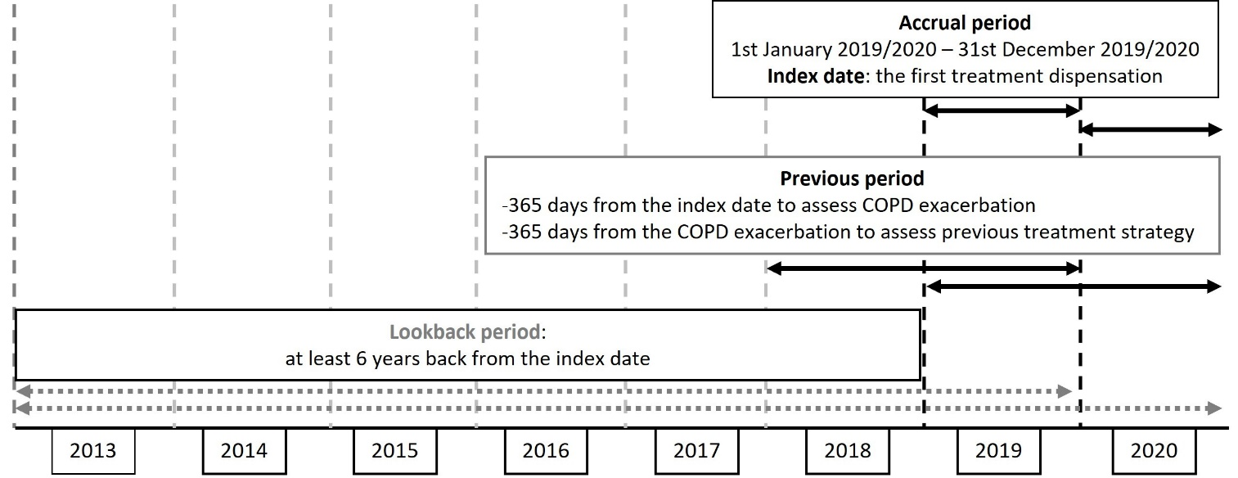

Table S4 - Criteria identifying comorbidities at baseline (i.e., index date and 6-year look-back period) of patients with chronic obstructive pulmonary disease
Diabetes mellitus
At least one hospital discharge form with primary/secondary diagnosis (ICD-9-CM code) |  | Disease waiver claim |  | At least 2 drug supplies within one year before the index date (ATC codes)
250.x – Diabetes mellitus |  | 013 – Diabetes mellitus |  | A10 – Drugs used in diabetes
Dyslipidaemias
At least one hospital discharge form with primary/secondary diagnosis (ICD-9-CM code) |  | Disease waiver claim |  | At least 2 drug supplies within one year before the index date (ATC codes)
272.x - Disorders of lipoid metabolism |  | 025 - Disorders of lipoid metabolism |  | C10A – Lipid modifying agents, plain  C10B - Lipid modifying agents, combinations
Arterial hypertension
At least one hospital discharge form with primary/secondary diagnosis (ICD-9-CM code) |  | Disease waiver claim |  | At least 2 drug supplies within one year before the index date (ATC codes)
401.x – Essential hypertension  402.x – Hypertensive heart disease  403.x – Hypertensive chronic kidney disease  404.x – Hypertensive heart and chronic kidney disease  405.x - Secondary hypertension |  | 031 – Arterial hypertension  0A31 - Arterial hypertension |  | C02 – Antihypertensives  C03 – Diuretics  C07 – Beta blocking agents  C08 – Calcium channel blockers  C09 – Agents acting on the renin-angiotensin system
Heart failure
At least one hospital discharge form with primary/secondary diagnosis (ICD-9-CM code) |  | Disease waiver claim |  | At least 2 drug supplies within one year before the index date (ATC codes)
402.01 – Malignant hypertensive heart disease with heart failure  402.11 – Benign hypertensive heart disease with heart failure  402.91 – Unspecified hypertensive heart disease with heart failure  404.01 – Hypertensive heart and chronic kidney disease, malignant, with heart failure and with chronic kidney disease stage I through stage IV, or unspecified  404.03 – Hypertensive heart and chronic kidney disease, malignant, with heart failure and with chronic kidney disease stage V or end stage renal disease  404.11 – Hypertensive heart and chronic kidney disease, benign, with heart failure and with chronic kidney disease stage I through stage IV, or unspecified  404.13 – Hypertensive heart and chronic kidney disease, benign, with heart failure and chronic kidney disease stage V or end stage renal disease  404.91 – Hypertensive heart and chronic kidney disease, unspecified, with heart failure and with chronic kidney disease stage I through stage IV, or unspecified  404.93 – Hypertensive heart and chronic kidney disease, unspecified, with heart failure and chronic kidney disease stage V or end stage renal disease  428.x - Heart failure |  | 021 – Heart failure |  | C09DX04 – Valsartan and sacubitril
Cerebrovascular disease
At least one hospital discharge form with primary/secondary diagnosis (ICD-9-CM code) |  | Disease waiver claim |  | -
430 – 438.x - Cerebrovascular Disease |  | 002.433; 0B02.433 – Cerebrovascular Disease  002.434; 0B02.434 - Cerebrovascular Disease  002.437; 0B02.437 - Cerebrovascular Disease
Chronic kidney disease
At least one hospital discharge form with primary/secondary diagnosis or procedure (ICD-9-CM code) |  | Disease waiver claim |  | At least one local outpatient specialist service (national tariffs)
Primary/secondary diagnoses:  250.4 – Diabetes with renal manifestations  403.x – Hypertensive chronic kidney disease  404.x – Hypertensive heart and chronic kidney disease  582.x – Chronic glomerulonephritis  583.x – Nephritis and nephropathy not specified as acute or chronic  585.x – Chronic renal failure  586.x – Renal failure unspecified  587.x – Renal sclerosis unspecified  588.x – Disorders resulting from impaired renal function  590.x – Infections of kidney  V42.0 – Organ or tissue replaced by transplant  V56.x – Encounter for dialysis and dialysis catheter care  Procedures:  39.95 – Hemodialysis  54.98 – Peritoneal dialysis  55.6x – Renal transplantation |  | 023 – Chronic renal failure  061 – Chronic kidney disease  052.V42.0 – Renal transplantation |  | 39.95 – Hemodialysis  54.98 - Peritoneal dialysis
Cardiac arrythmias
At least one hospital discharge form with primary/secondary diagnosis (ICD-9-CM code) |  | Disease waiver claim |  | At least 2 drug supplies within one year before the index date (ATC codes)
426.x – Conduction disorders  427.x - Cardiac dysrhythmias |  | 002.426; 0A02.426 – Conduction disorders  002.427; 0A02.427 - Cardiac dysrhythmias |  | C01B – Antiarrhythmics, Class I and III
Depression
At least one hospital discharge form with primary/secondary diagnosis (ICD-9-CM code) |  | Disease waiver claim |  | At least 2 drug supplies within one year before the index date (ATC codes)
296.2x - Major depression, single episode  296.3x - Major depression, recurring episode  296.5x – Bipolar disorder type I, most recent (or current) depressive episode  296.82 – Atypical depressive disorder  298.0x – Depressive psychosis  300.4 - Dysthymic disorder  301.12 - Chronic depressive personality disorder |  | 044.296.2 - Psychosis (major depression, single episode)  044.296.3 - Psychosis (major depression, recurring episode)  044.296.5 - Psychosis (bipolar affective syndrome, depressive episode)  044.296.8 - Psychosis (manic-depressive disorder)  044.298.0 – Psychosis (depressive psychosis) |  | N06A - Antidepressants
Coronary artery disease
At least one hospital discharge form with primary/secondary diagnosis (ICD-9-CM code) |  | Disease waiver claim |  | -
410.x - Acute myocardial infarction  411.x - Other acute and subacute forms of ischemic heart disease  412 - Old myocardial infarction  413.x - Angina pectoris  414.x - Other forms of chronic ischemic heart disease  AND / OR  At least one hospital discharge form with primary/secondary intervention or procedure, among the following:  36.x – Interventions on heart vessels  00.66 – Percutaneous Transluminal Coronary Angioplasty (PTCA) or coronary atherectomy |  | (002.414) 0A02.414 – Diseases of the circulatory system |  | -
Chronic liver diseases
At least one hospital discharge form with primary/secondary diagnosis (ICD-9-CM code) |  | Disease waiver claim |  | At least 2 drug supplies within one year before the index date (ATC codes)
070.x - Viral hepatitis  571.x - Chronic liver disease and cirrhosis  572.x - Liver abscess and sequelae of chronic liver disease  573.x - Other disorders of liver  V42.7 - Liver replaced by transplant |  | 016 – Chronic hepatitis (active)  008 – Hepatic cirrhosis, biliary cirrhosis |  | J05AP - Antivirals for treatment of HCV infections  J05AF08 - adefovir dipivoxil  J05AF10 - entecavir  J05AF11 - telbivudine
Neoplasia (current or history)
At least one hospital discharge form with primary/secondary diagnosis (ICD-9-CM code) | Disease waiver claim |  | At least one local outpatient specialist service  (national tariffs) |  | At least one drug supplies  (ATC codes)
From 140.x to 208.x - Neoplasms  V10.x - Personal history of malignant neoplasm  V58.0 - Radiotherapy  V58.1x – Chemotherapy  AND / OR  At least one hospital discharge form with primary/secondary intervention or procedure, among the following:  00.10 - Implantation of chemotherapeutic agents  99.25 - Injection or infusion of chemotherapy substances for cancer  99.28 - Injection or infusion of biological response modifying agents (BRM)  92.2x - Therapeutic radiology and nuclear medicine  92.3x – Stereotactic radiosurgery as antineoplastic agents | 048 – Patients affected by malignant neoplasms and tumors of uncertain behavior |  | 99.25 - Injection or infusion of chemotherapy substances for cancer  99.24.1 - Infusion of hormonal substances  92.24.1 - teletherapy with linear accelerator  92.25.1 - electron teletherapy to one or more fixed fields  92.27.1 – endocavitary brachytherapy  92.27.3 - surface brachitherapy (HDR)  92.27.5 - betatherapy  92.28.3 - endocavitary treatment  92.28.4 – monoclonal antibody treatment  92.28.5 - monoclonal antibody treatment  92.28.6- palliative pain therapy from bone metastases |  | L01 - Antineoplastic agents

Figure S3 - Selection of patients with chronic obstructive pulmonary disease and treated with respiratory drugs in 2020
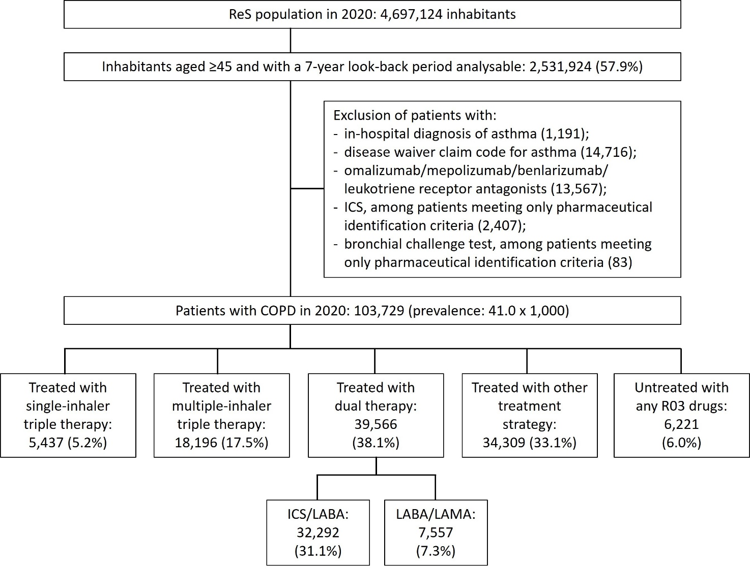

COPD: chronic obstructive pulmonary disease; ICS: inhaled corticosteroid; LABA: long-acting beta agonist; LAMA: long-acting muscarinic antagonist

Table S5 - Description of patients with COPD and treated with respiratory drugs in 2020, by treatment strategy
 | Patients treated with single-inhaler triple therapy (N=5437) | Patients treated with multiple-inhaler triple therapy (N=18,196) | Patients treated with double therapy (N=39,566) | Patients treated with other treatment strategies (N=34,309)
Mean age (SD) | 75 (9) | 76 (10) | 72 (12) | 75 (12)
Median ages (Q1; Q3) | 76 (69; 82) | 77 (70; 84) | 73 (63; 82) | 77 (68; 85)
Males (n; n/N%) | 4187; 77.0 | 12,183; 67.0 | 21,411; 54.1 | 19,197; 56.0
Distribution by age group (n; n/N%)
45-49 | 44; 0.8 | 219; 1.2 | 1834; 4.6 | 1005; 2.9
50-54 | 82; 1.5 | 302; 1.7 | 2305; 5.8 | 1253; 3.7
55-59 | 220; 4.0 | 702; 3.9 | 3013; 7.6 | 1817; 5.3
60-64 | 436; 8.0 | 1230; 6.8 | 3553; 9.0 | 2433; 7.1
65-69 | 672; 12.4 | 1916; 10.5 | 4439; 11.2 | 3396; 9.9
70-74 | 1024; 18.8 | 3180; 17.5 | 6020; 15.2 | 4899; 14.3
≥75 | 2959; 54.4 | 10,647; 58.5 | 18,402; 46.5 | 19,506; 56.9
Comorbidities (n; n/N%)
Arterial hypertension | 4590; 84.4 | 15,084; 82.9 | 28,970; 73.2 | 27,712; 80.8
Dyslipidaemias | 2375; 43.7 | 7924; 43.5 | 14,581; 36.9 | 14,785; 43.1
Diabetes | 1483; 27.3 | 4741; 26.1 | 8482; 21.4 | 9130; 26.6
Heart failure | 1359; 25.0 | 3295; 18.1 | 4255; 10.8 | 5504; 16.0
Neoplasia | 1207; 22.2 | 3185; 17.5 | 5907; 14.9 | 5764; 16.8
Cardiac arrythmias | 1199; 22.1 | 3386; 18.6 | 4965; 12.5 | 6720; 19.6
Coronary artery disease | 1121; 20.6 | 3124; 17.2 | 4318; 10.9 | 5478; 16.0
Depression | 1097; 20.2 | 3752; 20.6 | 7468; 18.9 | 7468; 21.8
Chronic kidney disease | 635; 11.7 | 1737; 9.5 | 3142; 7.9 | 4128; 12.0
Cerebrovascular diseases | 635; 11.7 | 1975; 10.9 | 3142; 7.9 | 3144; 9.2
Chronic liver disease | 480; 8.8 | 1190; 6.5 | 2066; 5.2 | 2114; 6.2
COPD exacerbation occurring during the year preceding index date (n patients; n/N%)
Moderate/severe exacerbation | 3076; 56.6 | 6810; 37.4 | 11,560; 29.2 | 10,139; 29.7
Moderate exacerbation | 1958; 63.7 | 5820; 85.5 | 10,460; 90.5 | 9071; 89.5
Severe exacerbation | 1118; 36.3 | 990; 14.5 | 1100; 9.5 | 1068; 10.5
COPD: chronic obstructive pulmonary disease; SD: standard deviation; Q1; Q3: first quartile; third quartile
Table S5 shows the characterization of patients with COPD and treated with drugs for obstructive airway disease, and rate of exacerbations during the year preceding index date in 2020, by treatment strategy.

