Additional File 1. Correlation of Sputum MPO and HNL/NGAL levels and serum neutrophils
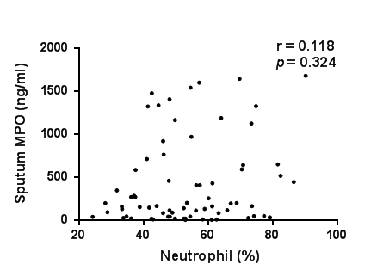
(a)

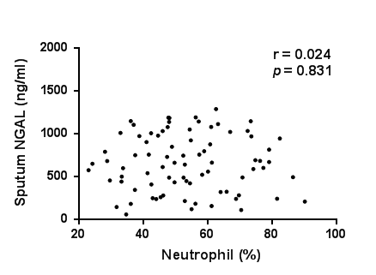
(b)

Regarding neutrophils in the blood, no association was observed between sputum MPO and HNL/NGAL levels and serum neutrophils.
MPO, myeloperoxidase; NGAL, neutrophil gelatinase-associated lipocalin

