Figure S1. TRIM11 gene reduced inflammation in vitro model of asthma
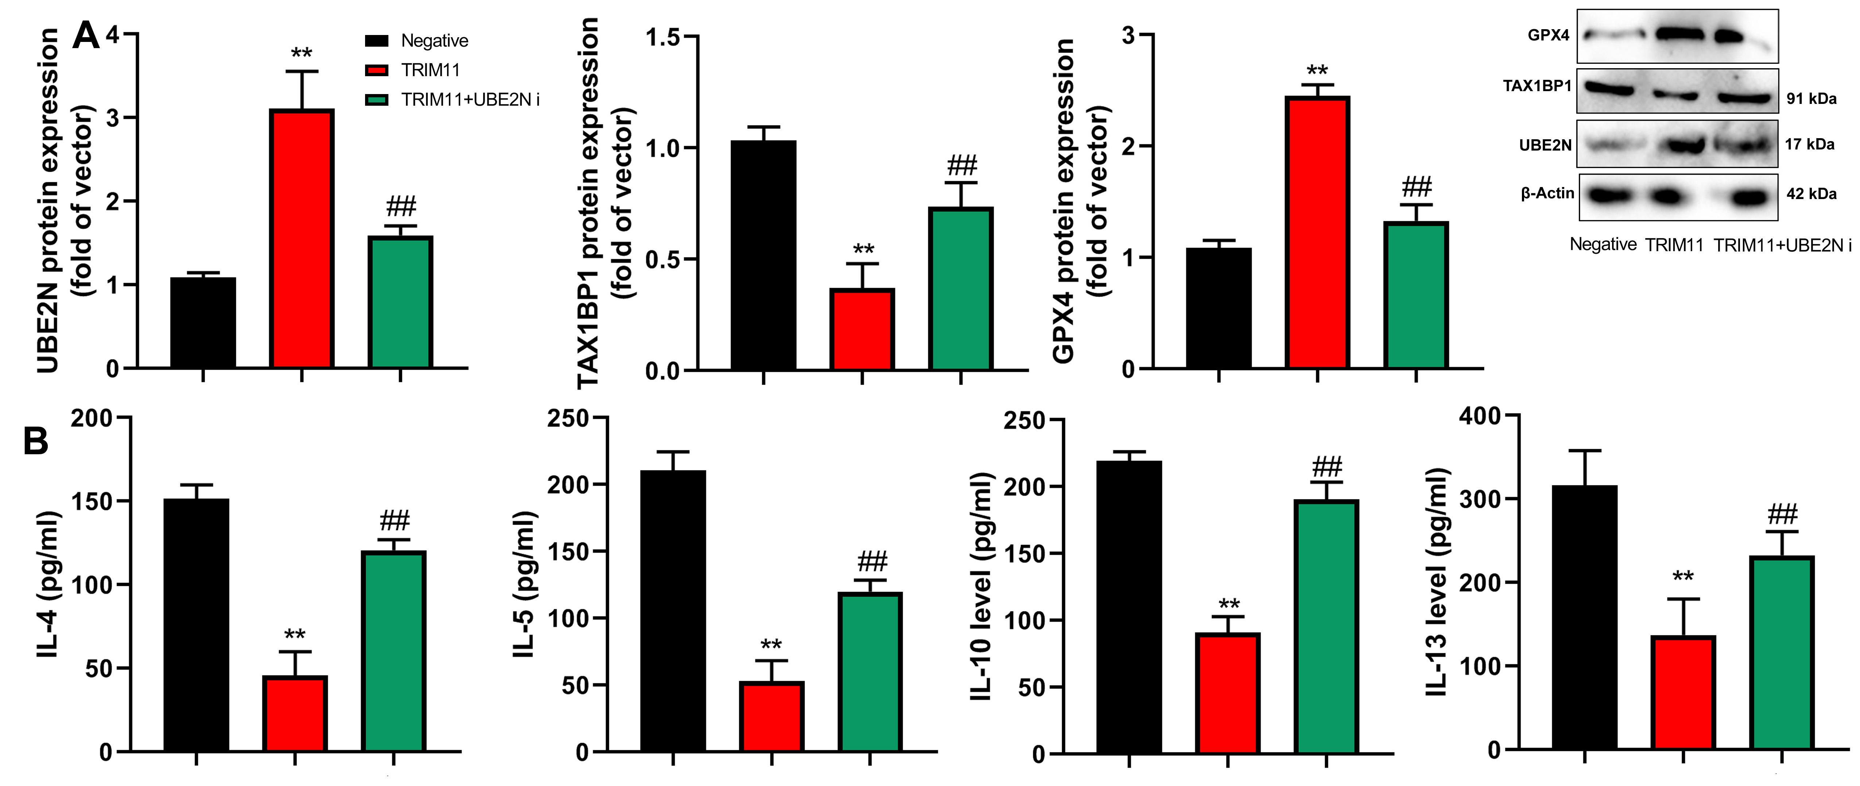
TRIM11/UBE2N/ TAX1BP protein (A), IL-4/IL-5/IL-10/IL-13 activity levels (B).
**p<0.01 compared with negative group, ##p<0.01 compared with TRIM11 group. Number of vitro model = 3, number of mice = 6.

