Figure S2. TRIM11 gene reduced Ferroptosis in model of asthma
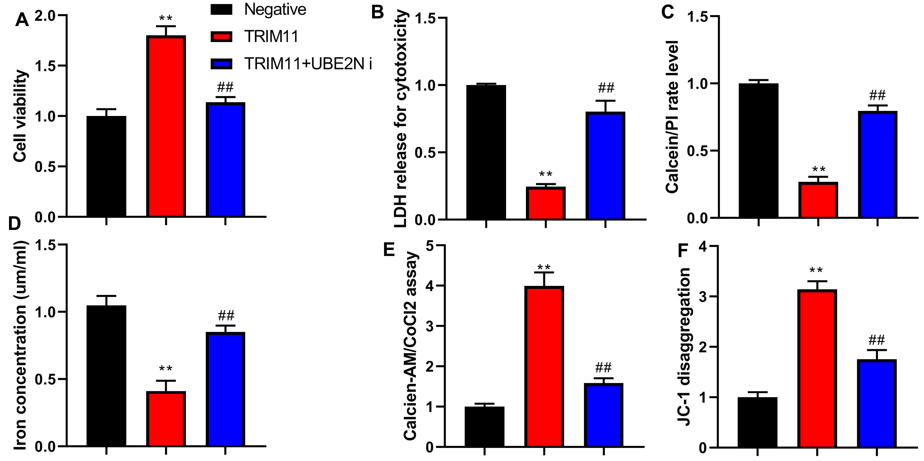
Cell viability (A), LDH and PI positive cells (B, C), iron content (D), calcien-AM/CoCl2 levels (E), JC-1 (F).
**p<0.01 compared with negative group, ##p<0.01 compared with TRIM11 group. Number of vitro model = 3.

